# WORLD’S SHORTEST COW GETS BELATED RECOGNITION

*Weeks after her demise she was recognised as the world’s shortest cow*

In Dhaka, Bangladesh, India, this cow has won posthumous recognition as the shortest cow on the planet, just weeks after it died.

Rani was only 50.8cm high and became an internet celebrity with people flocking to the farm where she lived just outside Dhaka. They all wanted to see Rani and take pictures of her.

Rani died of internal gas build-up shortly after its owner, Kazi Mohammed Abu Sufian, applied to Guinness World Records. He received an email from Guinness World Records saying that Rani had been accepted as the world’s shortest cow after Rani had died.

The previous world-record holding cow, Manikyam, also from India, and was 61 cm high.

Kazi said, “We sent several videos of Rani that were in line with Guinness World Records prescriptions. We also sent them the post-mortem report and Rani’s medical records to prove that there was nothing unusual about her death, after they had asked whether she had received any hormone injections. We have mixed feelings after Rani got the recognition. We are happy that she got her due honours, but at the same time we are sad that she is not with us anymore.”

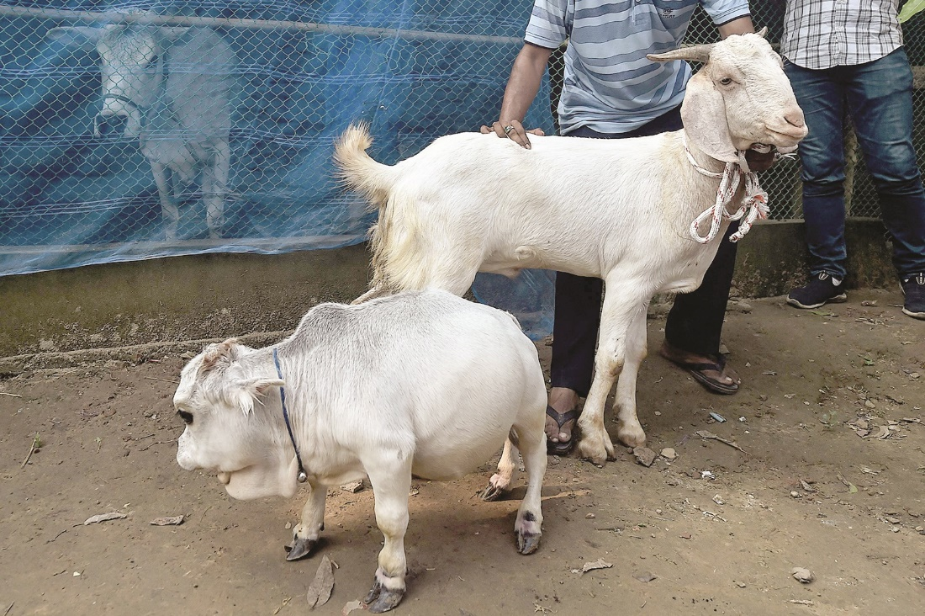

## Questions

1. QUESTION1
   1. ANSWER
2. QUESTION2
   1. ANSWER
3. …

## Collocations and Difficult Words

* **WORD** – DEFINITION
* **WORD** – DEFINITION
* …

## Countries, Languages, and Demonyms

* China Mandarin Chinese

## Highlighted Vocabulary

*Remove?*