# GROOM BARS HIS FAMILY FROM HIS WEDDING

*He excluded his family from his wedding because of a prank*

A groom shared his story on Twitter about how his mom, stepmom, aunts, women cousins, stepsister, and grandmother test the women who are to become part of the family.

He says, “They tease and test every new woman that enters the family by marriage. They do this by setting up ‘tests' to see if the bride-to-be deserves to be part of the family. These ‘tests’ often end up damaging confidence and affecting self-esteem. After a few months of teasing, they would announce that they have finally welcomed these women into the family.”

He added that the newest addition to the family will then also participate in “testing” other new members to the family.

Before the wedding, the groom’s brother warned him that to test the bride, all the women in the family were going to wear white to the wedding (normally only the bride will wear white). This was to be the bride’s “ultimate test.” The groom confronted his family whereupon they said that they would never do such a thing.

Imagine the groom and bride’s shock when, on their wedding day, all the women in the family arrive at the church dressed in white!

He promptly asked them to leave. His mother and aunts refused, and he threatened to take harsher action, so all the women left the wedding.

“My cousin blasted me on social media later, saying I excluded all the women from the wedding, because my wife was insecure and that she could not handle another woman’s presence at the wedding,” said the groom.

He had an argument with his mother who said, “It was just supposed to be a prank and that we wanted to see if she was a “bridezilla.” His mother also said that the wedding couple should apologise to the women who were not allowed to attend the wedding.

He said, “I have not seen them in two weeks, and they have excluded me from everything.”

How do you feel about his actions? Do you think his actions towards his family were fair?

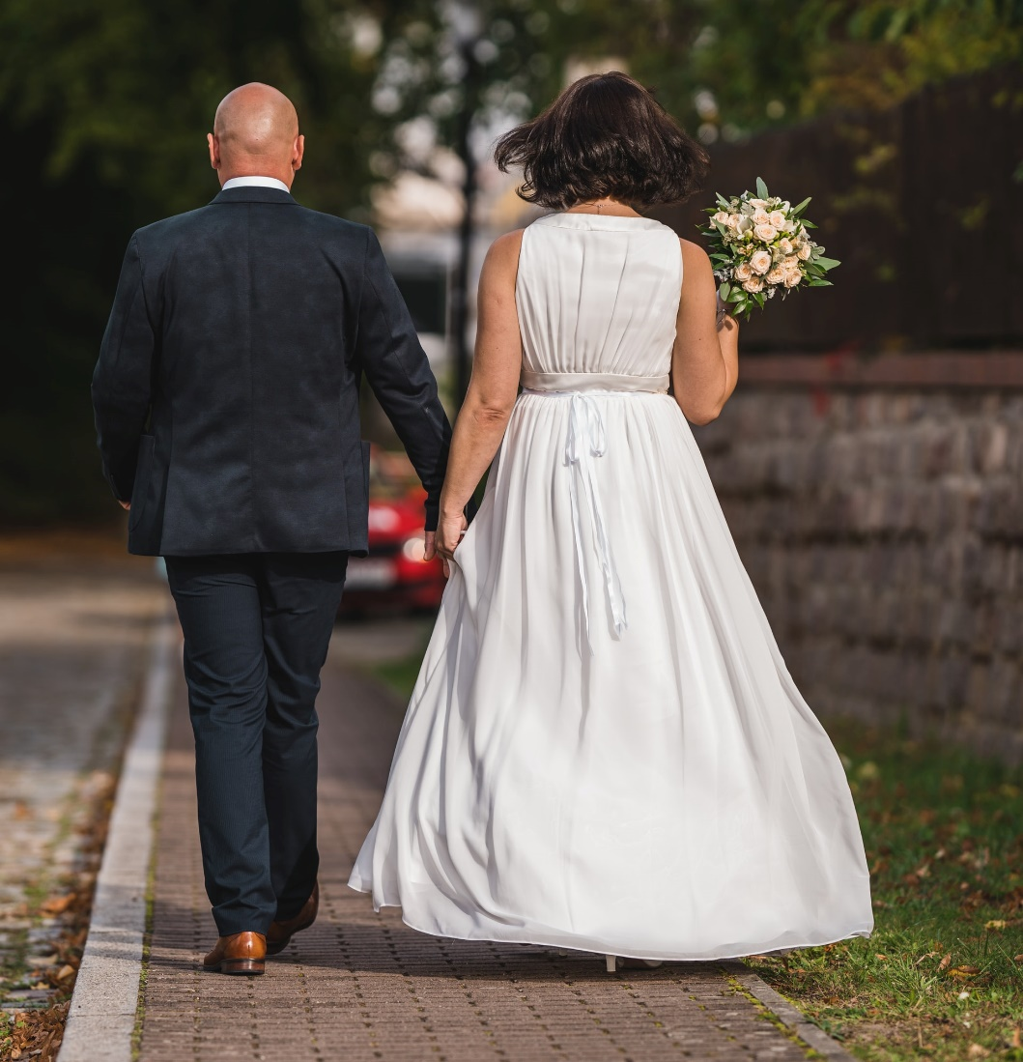

## Questions

1. QUESTION1
   1. ANSWER
2. QUESTION2
   1. ANSWER
3. …

## Collocations and Difficult Words

* **WORD** – DEFINITION
* **WORD** – DEFINITION
* …

## Countries, Languages, and Demonyms

* China Mandarin Chinese

## Highlighted Vocabulary

*Remove?*