# HOW UK MOTORISTS CAN UNLEASH PENT-UP RAGE

*A UK company is offering a service called “destruction therapy”*

In 2020, a company in Hampshire, England, realised that people had a very stress filled year because of Covid, and needed a way to get rid of that stress, worry, and pent-up rage. The company is called Scrap Car Comparison and their service allows customers to destroy scrap cars with shotguns and a heavy-duty armoured tank.

Dan Gick, MD of the company said, “We are giving customers a way to release all the stress that 2020 has brought into our lives. Our Rage Yard experience provides you with chance to (safely) shoot scrap cars before trampling over them in a huge, armoured tank.”

“The cars are heading to the scrap heap anyway, so after the year we have all had, it made sense to offer this exhilarating experience that should help people let go of their built-up frustrations, and in turn, feel a bit more calm and serene.”

The Rage Yard is outdoors in the fields of Northamptonshire, and there the customers will find a scrap car with the year 2020 painted on it. Customers will first use a shotgun to fire at the car before getting into the cockpit of a souped-up Chieftan battle tank.

Chartered Psychologist, Dr Samie Latif says, “Certain individuals find that relieving tension in an overt physical manner is much more therapeutic and a form of stress relief that works better for them.”

“This is known as “Destruction Therapy” and it does allow people to relieve stress within a controlled environment.”

“In 2020, some people have been overwhelmed with stress and tension, and some people are more inclined to need physical exertion at greater levels than knitting needles or paintbrushes!”

The price of a Rage Yard experience was only 20.20 pounds in 2020, which is not considered expensive, but who knows what they charge now!

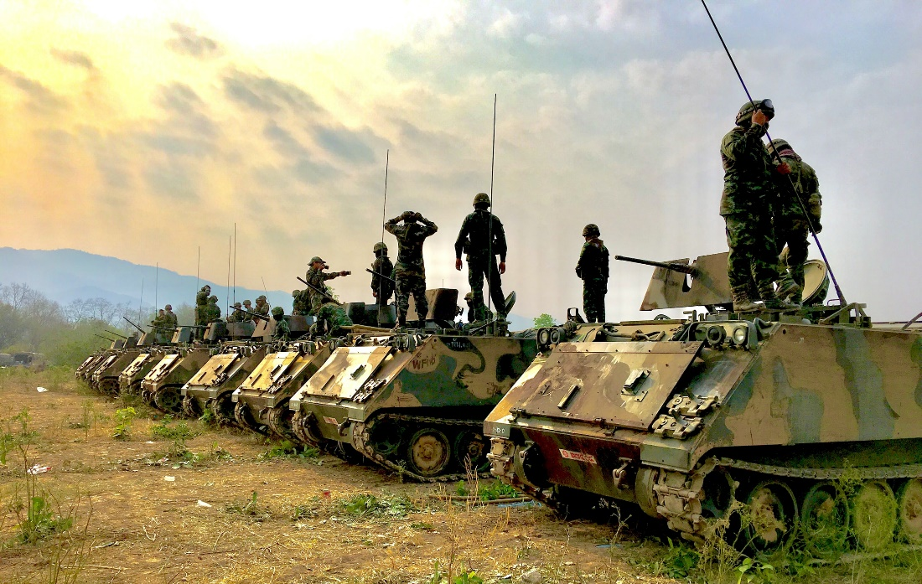

## Questions

1. QUESTION1
   1. ANSWER
2. QUESTION2
   1. ANSWER
3. …

## Collocations and Difficult Words

* **WORD** – DEFINITION
* **WORD** – DEFINITION
* …

## Countries, Languages, and Demonyms

* China Mandarin Chinese

## Highlighted Vocabulary

*Remove?*