# INDIA WANTS TO REPLACE CAR HOOTER NOISE

*The transport minister wants to impose a new law on car hooter noises.*

Nitin Gadkari wants to make it mandatory for car horns in India to play music. He wants sounds of the sitar, flute table, and violin to fill the air.

Gadkari said, “I am studying this, and plan to impose a law soon, where all vehicle horns should emanate sounds of Indian musical instruments only. It will be more pleasant to hear than the harsh noise vehicle hooters currently make. I also want to replace the ’irritating’ siren sounds used by ambulances and police vehicles, with soothing tunes.”

India, with all its rickshaws, buses, taxis, weaving motorbikes, and private cars fighting for space on the traffic clogged roads, has some of the noisiest cities in the world.

The horn is accepted as being more important than the side mirrors when driving, and nearly as important as the gas pedal. The horn is used more to warn other vehicles of your presence than it is to reprimand them.

Noise pollution can cause hearing problems, cardiovascular problems, cognitive impairment, stress, and depression, according to the World Health Organisation.

Imagine hearing all these different tunes coming from cars rather than just one sound. Do you think it is a good idea?

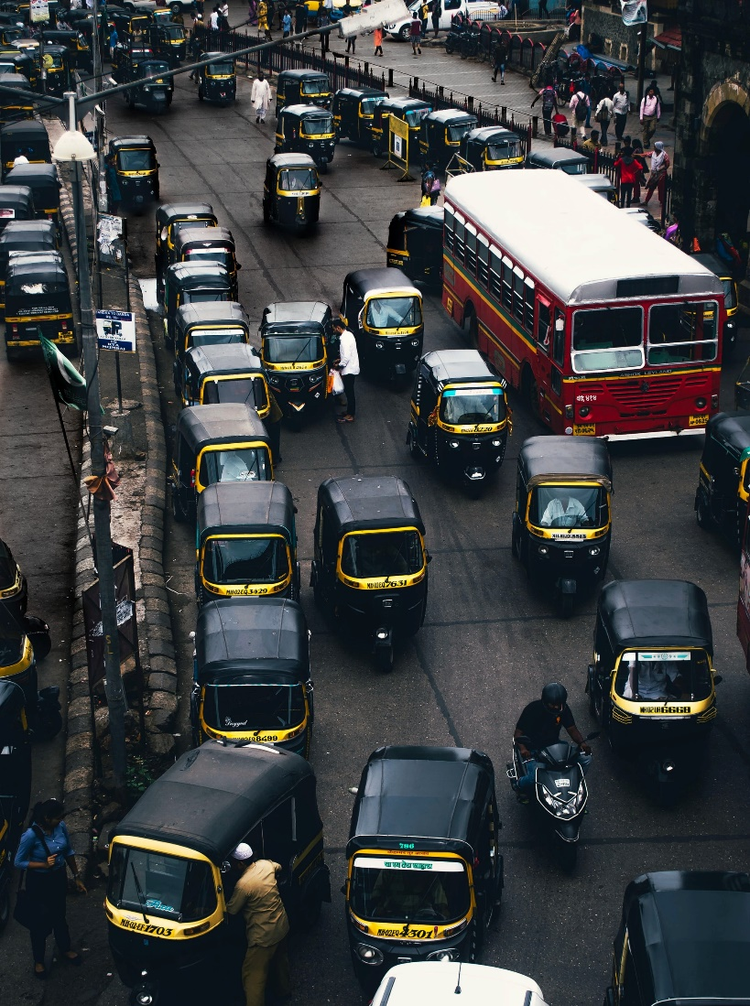

## Questions

1. QUESTION1
   1. ANSWER
2. QUESTION2
   1. ANSWER
3. …

## Collocations and Difficult Words

* **WORD** – DEFINITION
* **WORD** – DEFINITION
* …

## Countries, Languages, and Demonyms

* China Mandarin Chinese

## Highlighted Vocabulary

*Remove?*