# MAN BUILDS ROTATING HOUSE FOR HIS WIFE

*Wife is bored with the view from her house*

Vojin Kusic, a 72-year-old man from Srbac, Bosnia, says he built the rotating house to please his wife. She had wished for a more diversified view from their house.

He began thinking of how to make this possible, as he was tired of her complaints and her refurbishing their home constantly. Their house is situated on a fertile plain in northern Bosnia, outside Srbac.

It took Vojin six years to complete the house that now attracts plenty of visitors who come to view it. He designed a 7-metre axis on which the house rotates, which gives his wife a view of cornfields, farmland, forests, and the river.

The speed at which the house rotates can also be adjusted. He can make the house turn full circle in 24 hours, which is the slowest rotating speed, or he can change it to 22 seconds full rotation, which is the fastest speed.

Vojin comes from a poor family which could not afford a good education for him. This, he says, forced him to look for ways to make things himself.

He said, “I was inspired by Serbian American inventors Nikola Tesla and Mihajlo Pupin. This is not an innovation, it only requires will and knowledge, and I had enough time and knowledge and I built it all on my own. My house is also more resistant to earthquake damage than stationary houses.”

“The project took me six years to complete with time off for a stay in hospital due to a heart condition. I asked doctors to try and prolong my life for at least a year, because I have this project in my head, and nobody else will know how to complete it.”

His wife did not want to comment on their new house.

Do you think she refused to comment because she is unhappy with the house?

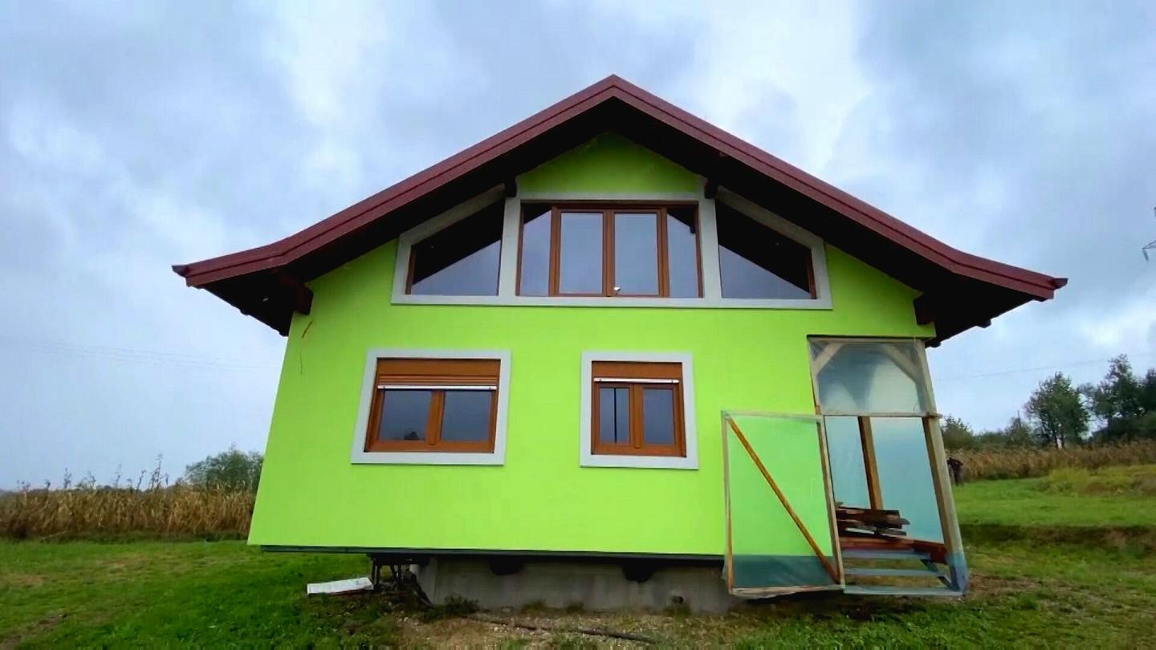

## Questions

1. QUESTION1
   1. ANSWER
2. QUESTION2
   1. ANSWER
3. …

## Collocations and Difficult Words

* **WORD** – DEFINITION
* **WORD** – DEFINITION
* …

## Countries, Languages, and Demonyms

* China Mandarin Chinese

## Highlighted Vocabulary

*Remove?*