How to Get this demo to run on your machine:
In netbeans, show the Services tab by going to Window > Services
Add a Server
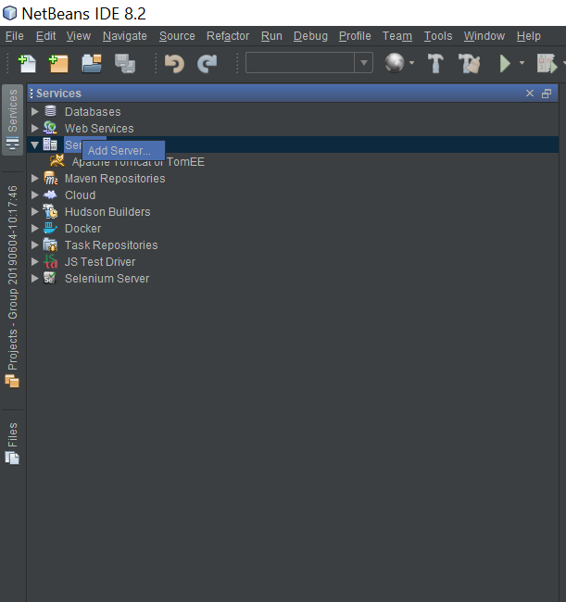
Figure 1 Add a server
It’s an Apache Tomcat server, be sure to give it a unique name.
Point it toward the vanilla Apache Tomcat instance I’ve included in the branch.
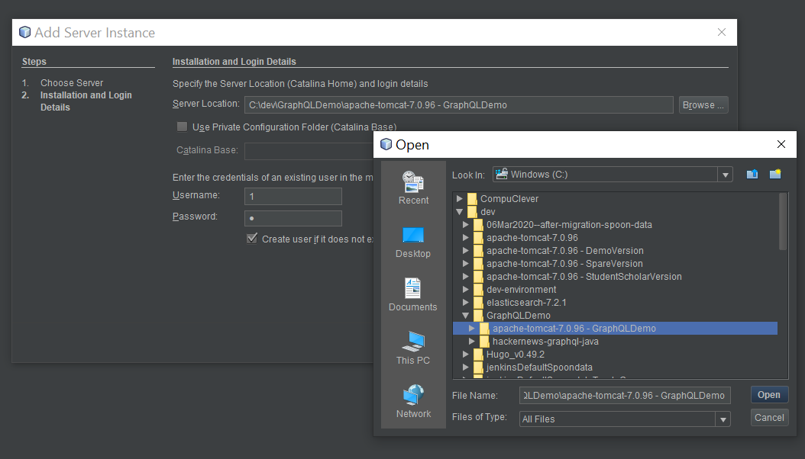

Now open the Project’s code in netbeans by going File> Open Project >…. Open the “hackernews-graphql-java”’s Maven-thingy from the window, like so:
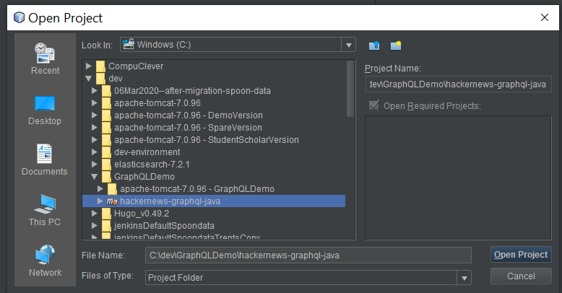
Clean and Build the new project the usual way (I assume you know). Then start the server, either by right-clicking the project and picking “Run”, or by going to the services section and right-clicking start there too.
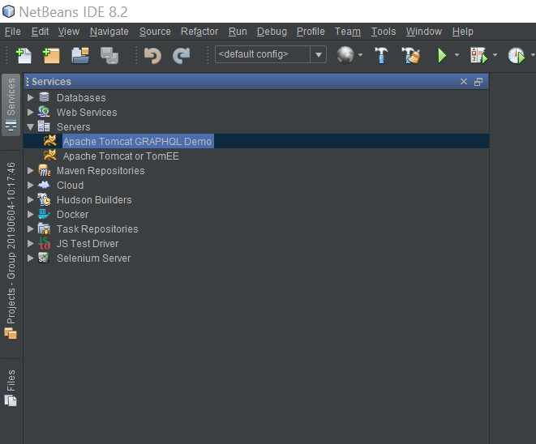

Now you should see this when you go to
http://localhost:8080/
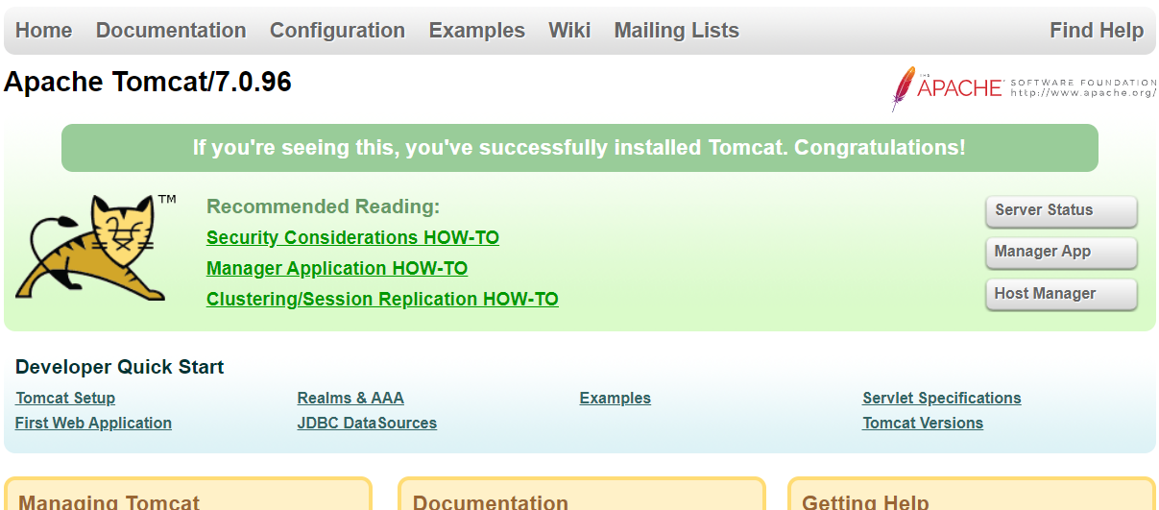

No go to http://localhost:8080/hackernews/:


Accoding to the docs, I should be able to go to
http://localhost:8080/graphql?query={allLinks{url}}
but this throws an error on the server. Acutally an error is through on start up that has something to do with not being able to find a text file. The text file in question is the schema. I’m still working through this.
Also, did you not have to fix some error related to tomcat 7 not being able understand utf-8? Would that have a bearing on how the server reads the url above?

