**Task2**

**Project: Student Database Management System(PostgreSQL)**

Objective: Design and implement a student database management system using PostgreSQL that allows storing and retrieving student information efficiently. The project will include the following tasks:

**1.Database Setup**

Create a database named "student database."

Create a table called " student_table " with the following columns: Student_id (integer), Stu_name (text), Department (text), email_id (text ),Phone_no (numeric), Address (text), Date_of_birth (date), Gender (text), Major (text), GPA (numeric),Grade (text) should be A, B,C etc.

CREATE DATABASE student_database;

CREATE TABLE student_table (

Student_id INT PRIMARY KEY,

Stu_name TEXT,

Department TEXT,

email_id TEXT,

Phone_no NUMERIC,

Address TEXT,

Date_of_birth DATE,

Gender TEXT,

Major TEXT,

GPA NUMERIC,

Grade TEXT CHECK (Grade IN ('A', 'B', 'C','D','E','F'))

);

1. **Data Entry**

Insert 10 sample records into the "student_table" using INSERT command.

Insert into student_table values

('001','Std1','CSE','Std1@amazon.com','1234567890','Bangalore','6-07-1994','M','CS','8.2','B'),

('006','Std6','ECE','Std6@amazon.com','1234567891','Chennai',' 07-06-1994','F','Maths','4.6','E'),

('003','Std3','ECE','Std3@amazon.com','1234567892','Bangalore',' 07-06-1994','M','CS','3.5','D'),

('005','Std5','MECH','Std5@amazon.com','1234567893','Bangalore',' 07-06-1994','F','Maths','4.9','D'),

('008','Std8','IT','Std8@amazon.com','1234567894','Chennai',' 07-06-1994','M','CS','6.2','C'),

('009','Std9','CIVIL','Std9@amazon.com','1234567895','Chennai',' 07-06-1994','F','Maths','7.5','C'),

('0010','Std10','CIVIL','Std10@amazon.com','1234567896','Chennai',' 07-06-1994','M','CS','8.2','B'),

('004','Std4','EEE','Std4@amazon.com','1234567897','Bangalore',' 07-06-1994','F','Maths','8.5','B'),

('002','Std2','CSE','Std2@amazon.com','1234567898','Bangalore',' 07-06-1994','M','CS','9.2','A'),

('007','Std7','IT','Std7@amazon.com','1234567899','Chennai',' 07-06-1994','F','Maths','9.2','A');

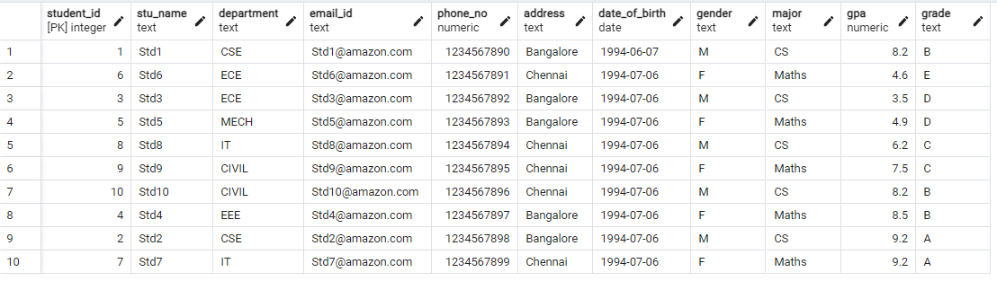

1. **Student Information Retrieval**

Develop a query to retrieve all students' information from the "student_table" and sort them in descending order by their grade.

SELECT *

FROM student_table

ORDER BY Grade DESC;

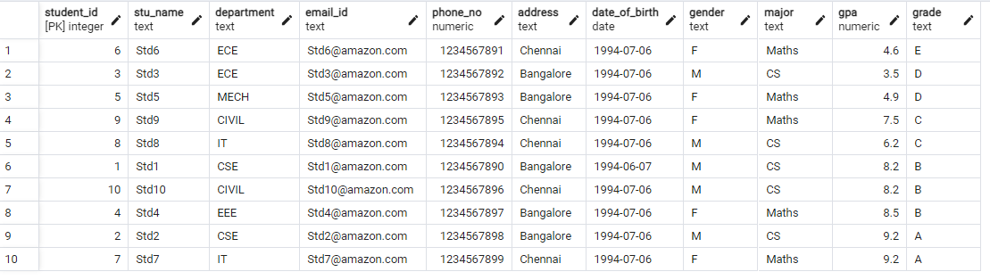

1. **Query for Male Students:**

.Implement a query to retrieve information about all male students from the "student_table."

SELECT *

FROM student_table

WHERE Gender = 'M';

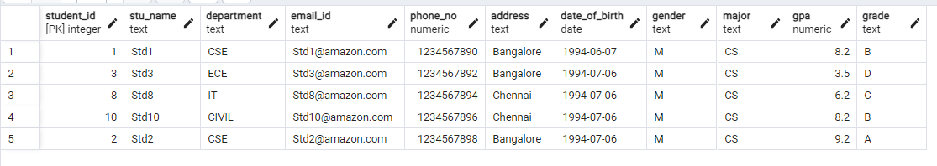

**S.Query for Students with GPA less than 5.0**

Create a query to fetch the details of students who have a GPA less than 5.0 from the "student table."

SELECT *

FROM student_table

WHERE gpa < 5;

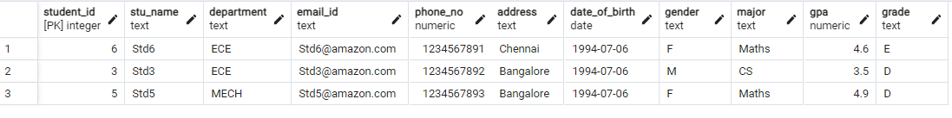

1. **Update Student Email and Grade**

Write an update statement to modify the email and grade of a student with a specific ID in the "student_table."

UPDATE student_table

SET email_id = ‘update@amazon.com’,Grade = ‘A’

Where student_id = 1

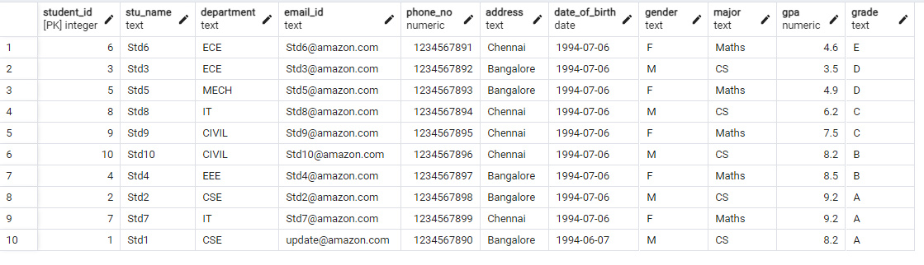

1. **Query for Students with Grade "B"**

Develop a query to retrieve the names and ages of all students who have a grade of "B" from the "student_table."

select stu_name

,Age(date_of_birth) as Age

from student_table

where grade = 'B'

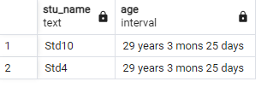

1. **Grouping and Calculation**

Create a query to group the "student_table" by the "Department" and "Gender" columns and calculate the average GPA for each combination .

Select department

,gender

,AVG(GPA) as average GPA

From student_table

Group by department, gender

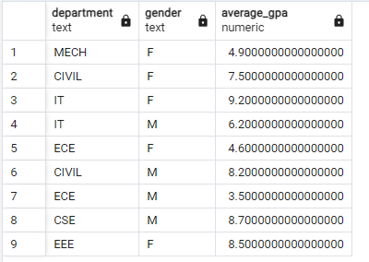

1. **Table Renaming**

Rename the "student_table" to "student_info" using the appropriate SQL statement .

ALTER TABLE student_table RENAME TO student_info;

1. **Retrieve Student with Highest GPA**

Write a query to retrieve the name of the student with the highest GPA from the "student info" table.

SELECT Stu_name

FROM student_info

ORDER BY GPA DESC

LIMIT 1;

