**Task 3**

**Project: Event Management System using PostgreSQL.**

Objective: To develop the application that allows users to create and manage events, track attendees, and handle event registrations efficiently. The project will include the following tasks:

1. **Database Creation**

Create a database named "EventsManagement."

CREATE DATABASE EventsManagement;

Create tables for Events, Attendees, and Registrations.

Events- Event_ld, Event_Name, Event_Date, Event_Location, Event_Description

CREATE TABLE Events (

Event_id SERIAL PRIMARY KEY,

Event_Name VARCHAR(255),

Event_Date DATE,

Event_Location VARCHAR(255),

Event_Description TEXT

);

Attendees- Attendee_ld, Attendee_Name, Attendee_Phone, Attendee_Email, Attendee_ City

CREATE TABLE Attendees (

Attendee_id SERIAL PRIMARY KEY,

Attendee_Name VARCHAR(255),

Attendee_Phone VARCHAR(15),

Attendee_Email VARCHAR(255),

Attendee_City VARCHAR(255)

);

Registrations-Registration_id, Event_ld, Attendee_ld, Registration_Date,Registration_Amount.

The FOREIGN KEY constraint in the Registrations table references the Event_ld column in the Events table and the Attendee_ld column in the Attendees table.

CREATE TABLE Registrations (

Registration_id SERIAL PRIMARY KEY,

Event_id INT REFERENCES Events(Event_id),

Attendee_id INT REFERENCES Attendees(Attendee_id),

Registration_Date DATE,

Registration_Amount DECIMAL(10, 2)

);

1. **Data Creation**

Insert some sample data for Events, Attendees, and Registrations tables with respective fields.

**--insert into Events table**

insert into events values (001,'Event1','2023-11-12','Bangalore','Tech conference'),

(002,'Event2','2023-11-12','Bangalore','Tech conference'),

(003,'Event3','2023-10-15','Mysore','workshop'),

(004,'Event4','2023-11-03','Madur','Tech conference'),

(005,'Event5','2023-12-30','Bangalore','workshop');

**--insert into Attendees table**

insert into Attendees values (001,'user2','8973772165','rahuman@amazon.com','Bombay'),

(002,'user1','9876543211','yuvan@amazon.com','Delhi'),

(003,'user3','9600652234','vasu@amazon.com','Ladakh'),

(004,'user4','9988776655','prakash@amazon.com','Madurai'),

(005,'user5','8899007766','antony@amazon.com','leh');

--insert into registrations table

insert into registrations values (001,001,001,'2023-10-29','5000'),

(002,002,002,'2023-10-30','15000'),

(003,003,003,'2023-11-05','7000'),

(004,004,004,'2023-11-15','9000'),

(005,005,005,'2023-12-06','14000');

1. **Manage Event Details**

a} Inserting a new event.

insert into events(Event_id,Event_name,Event_date,Event_location,Event_description) values

('006','Event6','2023-11-12','Chennai','workshop');

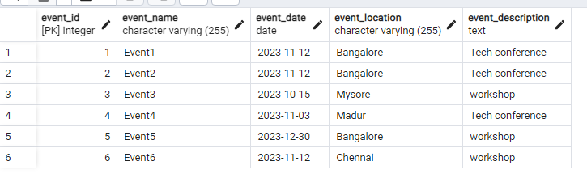

b} Updating an event's information.

Update events set event_name='Event1_updated' where Event_id='1';

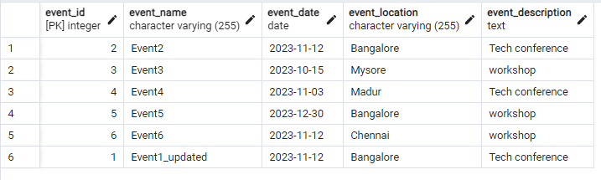

c} Deleting an event.

DELETE FROM Events

WHERE Event_id = 6;

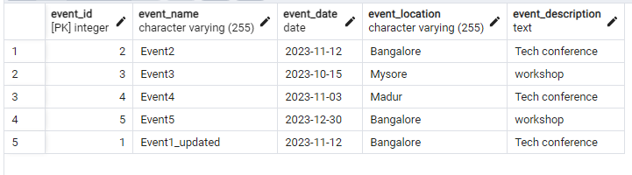

1. **Manage Track Attendees & Handle Events**

a}lnserting a new attendee.

insert into attendees (Attendee_id,Attendee_name,Attendee_phone,Attendee_email,Attendee_city) values

(006,'user6','687945321','kanimo@amazon.com','Mysore');

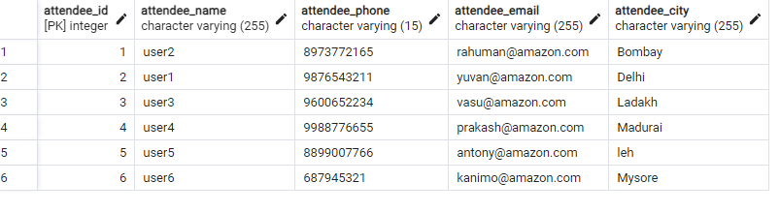

b}Registering an attendee for an event.

insert into registrations (Registration_id,Event_id,Attendee_id,Registration_date,Registration_amount) values

(006,005,006,'2023-12-05','40000');

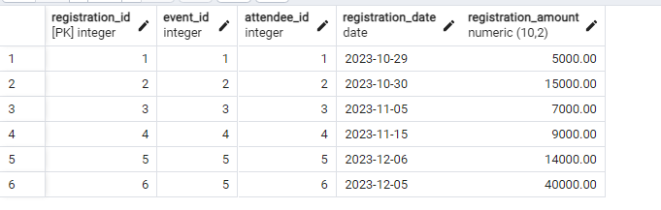

5.Develop queries to retrieve event information, generate attendee lists, and calculate event attendance statistics.

**--Retrive event info**

Select * from events_table;

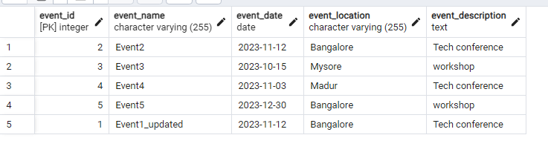

**--Generate attendee lists**

Select attendee_name from attendees;

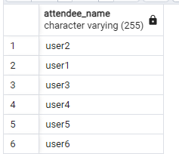

**--Calculate event attendance statistics.**

SELECT Event_Name, COUNT(Registration_id) AS Attendee_Count

FROM Events E

LEFT JOIN Registrations R ON E.Event_id = R.Event_id

GROUP BY Event_Name;

