**Task4**

Develop the queries to retrieve information from the OLAP operations performed and to gain a deeper understanding of the sales data through different dimensions, aggregations, and filters .

**Project: OLAP Operations (using Redshift or PostgreSQL)**

Objective: Perform OLAP operations (Drill Down, Rollup, Cube, Slice, and Dice) on the "sales_sample" table to analyze sales data. The project will include the following tasks:

1. **Database Creation**

Create a database to store the sales data (Redshift or PostgreSQL). Create a table named "sales_sample" with the specified columns: Product_ld (Integer)

Region (varchar(SO))-like East ,West etc Date (Date)

Sales_Amount (int/numeric)

CREATE TABLE sales_sample (

Product_Id INTEGER,

Region VARCHAR(50),

Date DATE,

Sales_Amount NUMERIC

);

1. **Data Creation**

Insert 10 sample records into the "sales_sample" table, representing sales data.

INSERT INTO sales_sample (Product_Id, Region, Date, Sales_Amount)

VALUES

(1, 'East', '2023-01-01', 1000.50),

(2, 'West', '2023-01-01', 750.25),

(1, 'North', '2023-01-02', 1250.75),

(3, 'South', '2023-01-02', 600.00),

(2, 'East', '2023-01-02', 850.60),

(3, 'West', '2023-01-02', 1100.25),

(1, 'North', '2023-01-03', 950.40),

(2, 'South', '2023-01-03', 1150.75),

(3, 'East', '2023-01-03', 700.25),

(1, 'West', '2023-01-03', 1020.90);

1. **Perform OLAP operations**
2. Drill Down-Analyze sales data at a more detailed level. Write a query to perform drill down from region to product level to understand sales performance.

SELECT Region, Product_Id, SUM(Sales_Amount) AS TotalSales

FROM sales_sample

GROUP BY Region, Product_Id

ORDER BY Region, Product_Id;

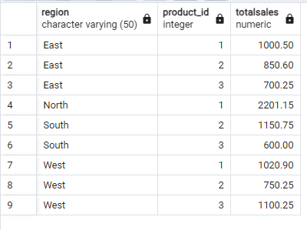

1. Rollup- To summarize sales data at different levels of granularity. Write a query to perform roll up from product to region level to view total sales by region.

SELECT Product_Id, Region, SUM(Sales_Amount) AS TotalSales

FROM sales_sample

GROUP BY Product_Id, Region

ORDER BY Product_Id, Region;

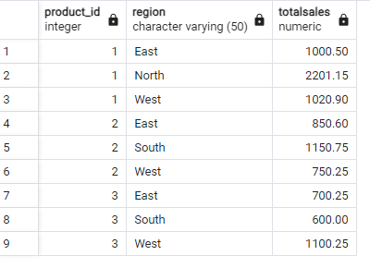

1. Cube - To analyze sales data from multiple dimensions simultaneously. Write a query to Explore sales data from different perspectives, such as product, region, and date.

SELECT Product_Id, Region, Date, SUM(Sales_Amount) AS TotalSales

FROM sales_sample

GROUP BY CUBE (Product_Id, Region, Date)

ORDER BY Product_Id, Region, Date;

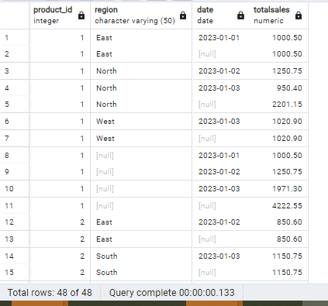

1. Slice- To extract a subset of data based on specific criteria. Write a query to slice the data to view sales for a particular region or date range.

SELECT Region, Date, SUM(Sales_Amount) AS TotalSales

FROM sales_sample

WHERE Region = 'East' AND Date BETWEEN '2023-01-01' AND '2023-01-02'

GROUP BY Region, Date

ORDER BY Date;

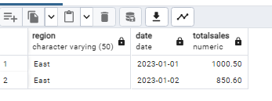

1. Dice - To extract data based on multiple criteria. Write a query to view sales for specific combinations of product, region, and date

SELECT Product_Id, Region, Date, SUM(Sales_Amount) AS TotalSales

FROM sales_sample

WHERE (Product_Id = 1 OR Product_Id = 2) AND Region = 'West' AND Date = '2023-01-01'

GROUP BY Product_Id, Region, Date;

