Chinook — Task Sheet
Instructions: Do not change the question text. Write your answer directly below each question. For Objective questions, the expected output columns and row counts are given below the question. For Subjective questions, no such details are given, work out and write the answer on your own.

Objective Questions
Q1 Does any table have missing values or duplicates? If yes how would you handle it ?
Duplicate primary-key check on customer
Output columns (in order): customer_id, cnt (2 columns)
Row count: 0 rows (no duplicate PKs anywhere in this dataset).

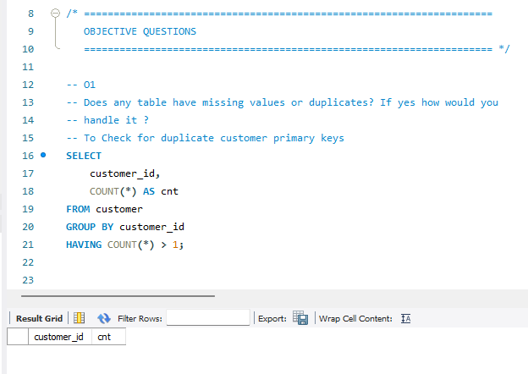
NULL profile — customer table
Output columns (in order): null_company, null_state, null_postal_code, null_phone, null_fax (5 columns)
Row count: 1 row (single aggregate row).
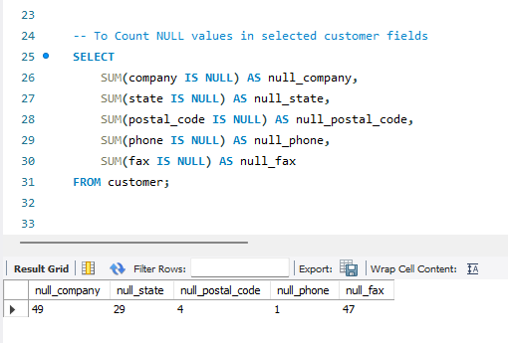
NULL profile — track table
Output columns (in order): null_composer, null_album_id, null_genre_id (3 columns)
Row count: 1 row (single aggregate row).
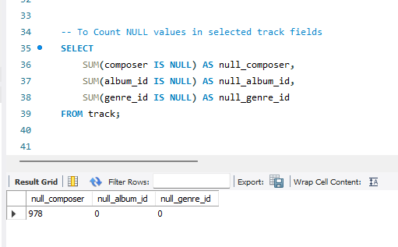
Checked for duplicate customer_id using GROUP BY customer_id HAVING COUNT(*) > 1. For NULLs, used SUM(CASE WHEN col IS NULL THEN 1 ELSE 0 END) per column in one aggregate query per table, instead of running a separate query per column.
Handling: No duplicate PKs found. The NULLs (company, fax, state, postal_code, composer) are legitimate optional fields, not data quality issues — left as NULL rather than imputed, since a fabricated value would misrepresent the data.
Q2 Find the top-selling tracks and top artist in the USA and identify their most famous genres.
Top 5 selling tracks in the USA
Output columns (in order): track_name, artist_name, genre_name, revenue, units_sold (5 columns)
Row count: 5 rows (LIMIT 5).
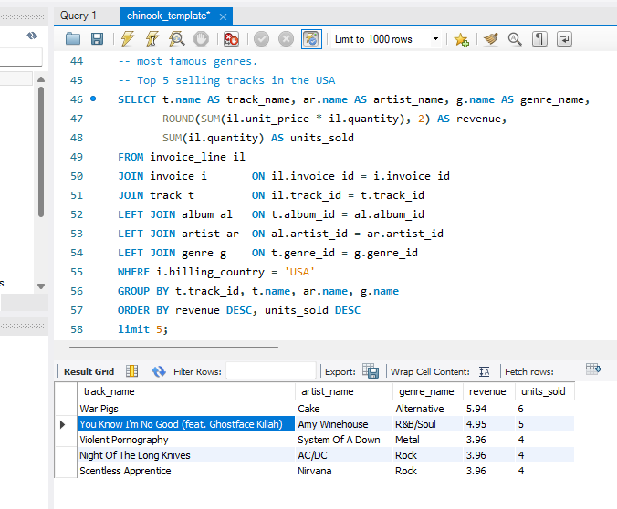
Top artist in the USA by revenue
Output columns (in order): artist_name, revenue, units_sold (3 columns)
Row count: 5 rows (LIMIT 5).
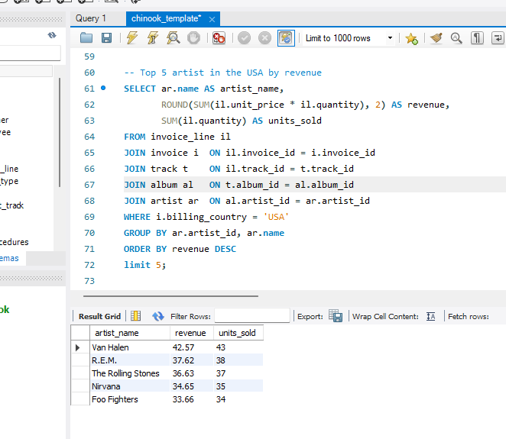

Joined invoice_line → invoice → track → album → artist → genre, filtered billing_country = 'USA', grouped by track (then separately by artist), calculated revenue as unit_price × quantity. Used LEFT JOINs so a missing album/artist/genre link wouldn't drop a track from the results. Sorted by revenue, took top 5.
Q3 What is the customer demographic breakdown (age, gender, location) of Chinook's customer base?
Customers by country/state/city
Output columns (in order): country, state, city, customer_count (4 columns)
Row count: 53 rows (1 row per distinct country/state/city combination).
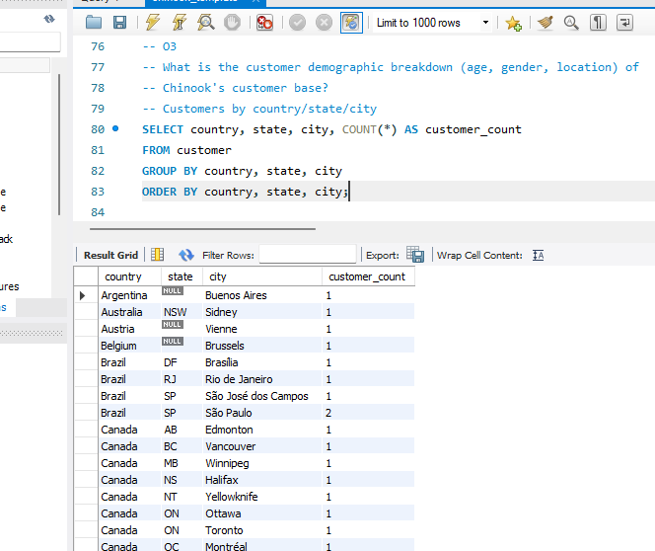
Customers per country
Output columns (in order): country, customer_count (2 columns)
Row count: 24 rows (24 distinct customer countries).

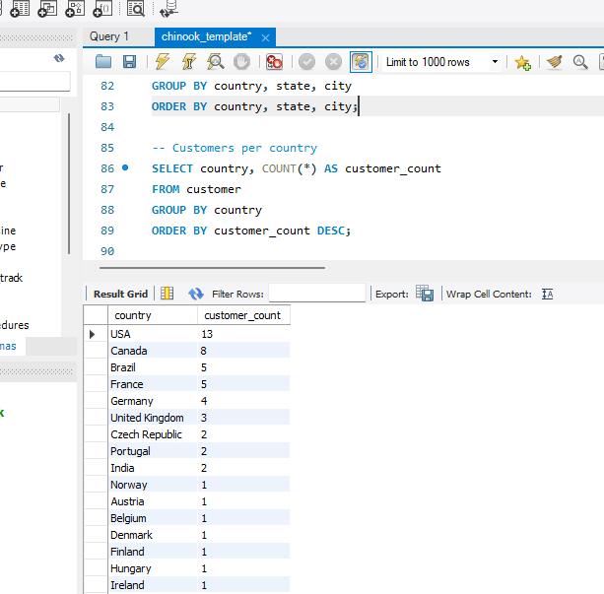

The customer table has no age or gender columns, only address fields, so this covers location only. Grouped by country, state, city for the detailed view, and by country alone for the summary view.
Q4 Calculate the total revenue and number of invoices for each country, state, and city:
Output columns (in order): country, state, city, num_invoices, total_revenue (5 columns)
Row count: 53 rows (1 row per distinct billing country/state/city combination; same combinations as O3a).
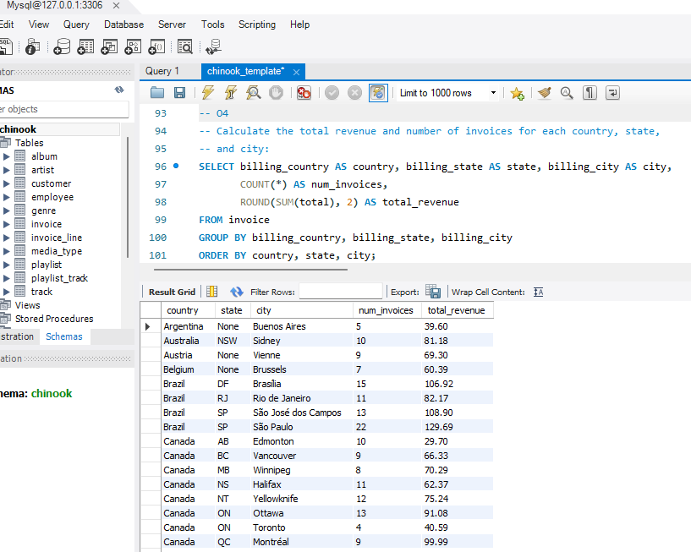

Grouped invoice directly by billing_country, billing_state, billing_city , counted rows for invoice count and summed total for revenue.
Q5 Find the top 5 customers by total revenue in each country
Output columns (in order): country, customer_name, total_revenue, rnk (4 columns)
Row count: 48 rows (up to 5 per country across 24 countries — don't assume every country hits the max).
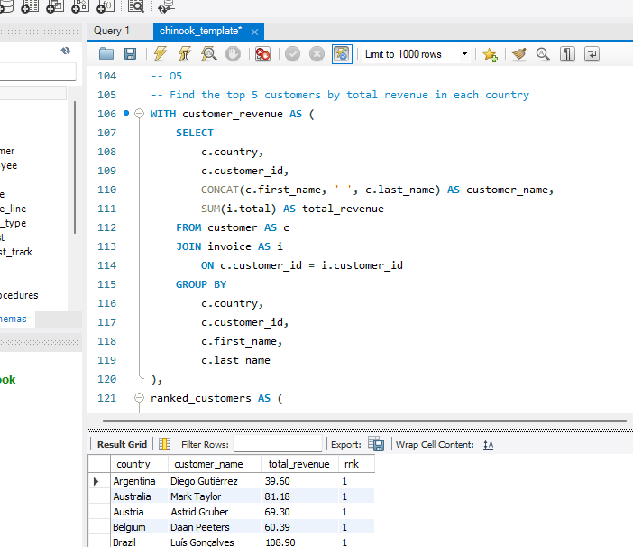

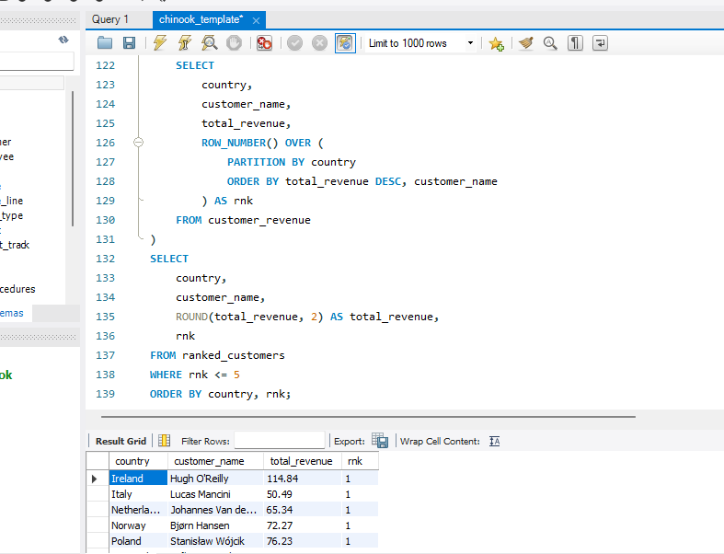

I first joined customers to their invoices, then summed each customer’s invoice totals to calculate their total revenue. I used ROW_NUMBER() with a separate ranking for each country, ordering customers from highest to lowest revenue. The final query keeps ranks 1 through 5 in each country.
Q6 Identify the top-selling track for each customer
Output columns (in order): customer_id, track_name, units (3 columns)
Row count: 59 rows (all 59 customers have placed at least one order).
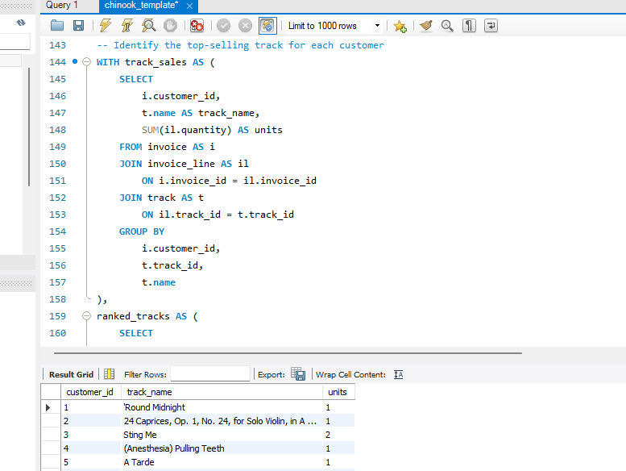

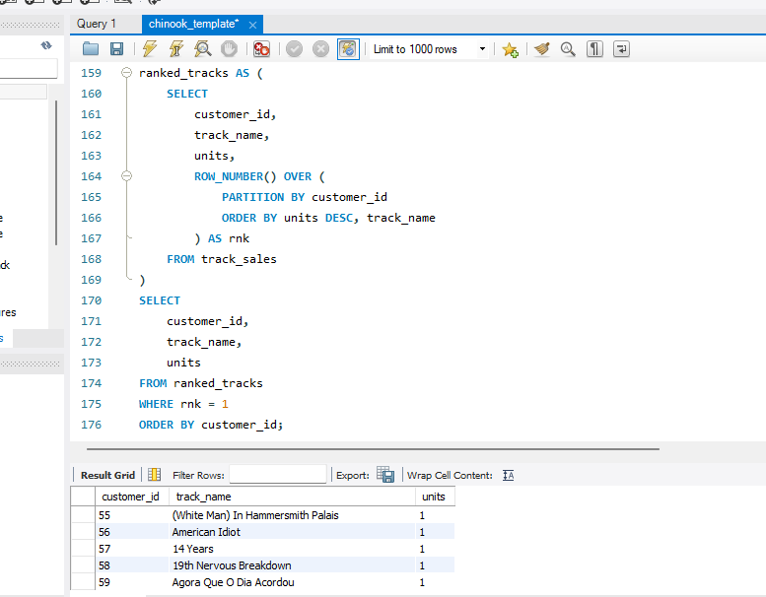

I joined invoices to invoice line items and tracks to connect each customer’s purchases to track names. I grouped the results by customer and track, then summed quantity to find how many units of each track each customer bought.
I used ROW_NUMBER() to rank tracks separately for each customer, with the highest unit count ranked first. The final query returns the top-ranked track for every customer.
Q7 Are there any patterns or trends in customer purchasing behavior (e.g., frequency of purchases, preferred payment methods, average order value)?
Store-wide averages
Output columns (in order): avg_order_value, avg_invoices_per_customer, avg_tracks_per_invoice (3 columns)
Row count: 1 row (single aggregate row).

The query calculates store-wide averages for order value, invoices per customer, and tracks per invoice. I calculate invoice count for each customer before averaging, so each customer contributes once to the average.
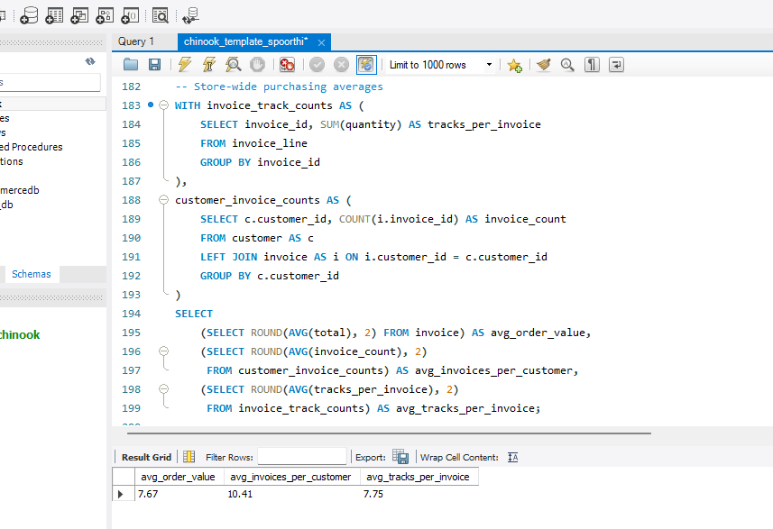

Per-customer behavior profile
Output columns (in order): customer_id, customer_name, num_orders, avg_order_value, total_spend, tenure_days (6 columns)
Row count: 59 rows (1 row per customer).
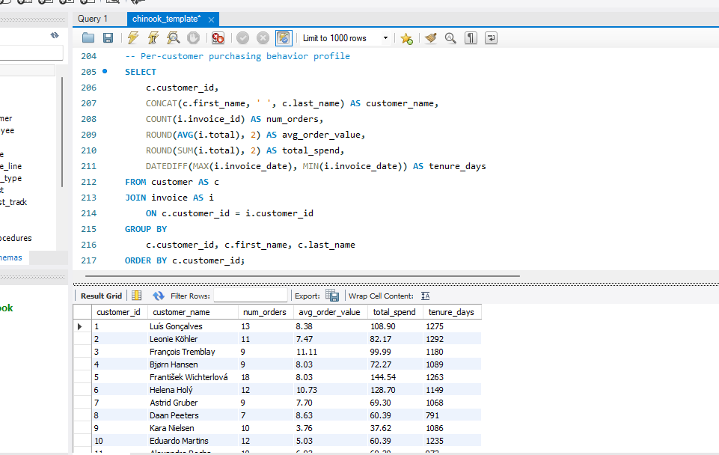
For the customer-level profile, I counted each customer’s invoices, calculated their average invoice total and total spend, and measured tenure as the number of days between their first and last recorded purchases. The output has one row per purchasing customer.
Q8 What is the customer churn rate?
Output columns (in order): total_customers, churned_customers, churn_rate_pct (3 columns)
Row count: 1 row (single aggregate row).
I found each customer’s most recent invoice date and compared it with a cutoff three months before the dataset’s latest invoice date. Customers with no invoices, or whose last invoice was before the cutoff, are counted as churned. I divided that count by the total number of customers and multiplied by 100 to calculate the churn rate.
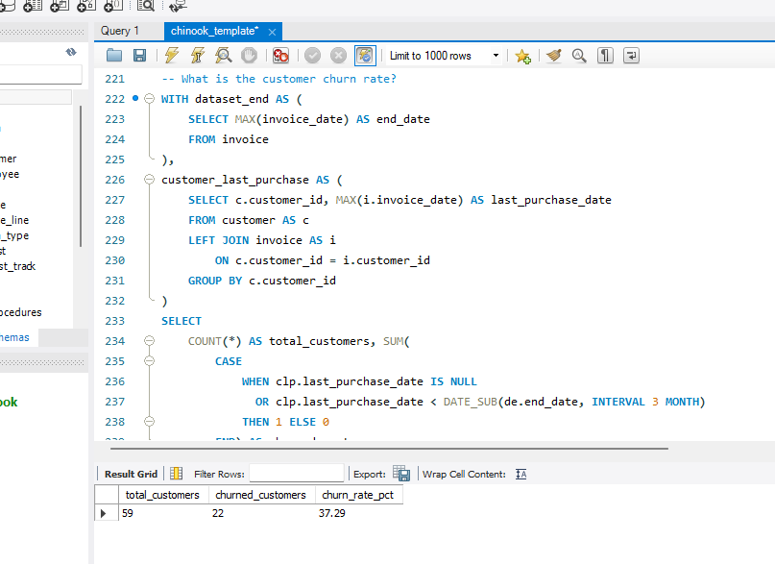
Q9 Calculate the percentage of total sales contributed by each genre in the USA and identify the best-selling genres and artists.
Output columns (in order): genre, genre_revenue, pct_of_usa_sales (3 columns)
Row count: 17 rows.
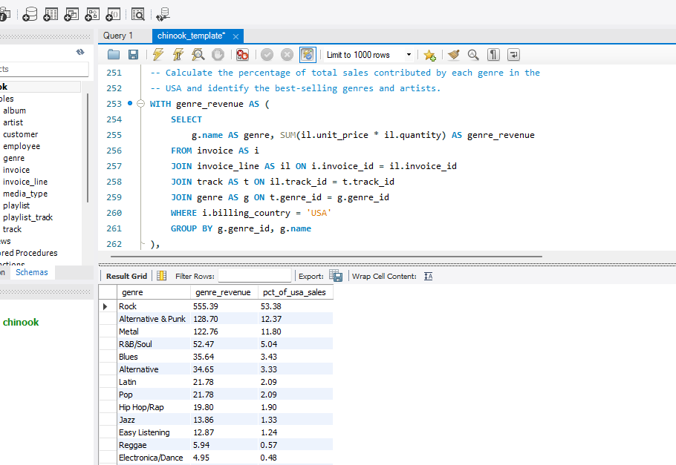

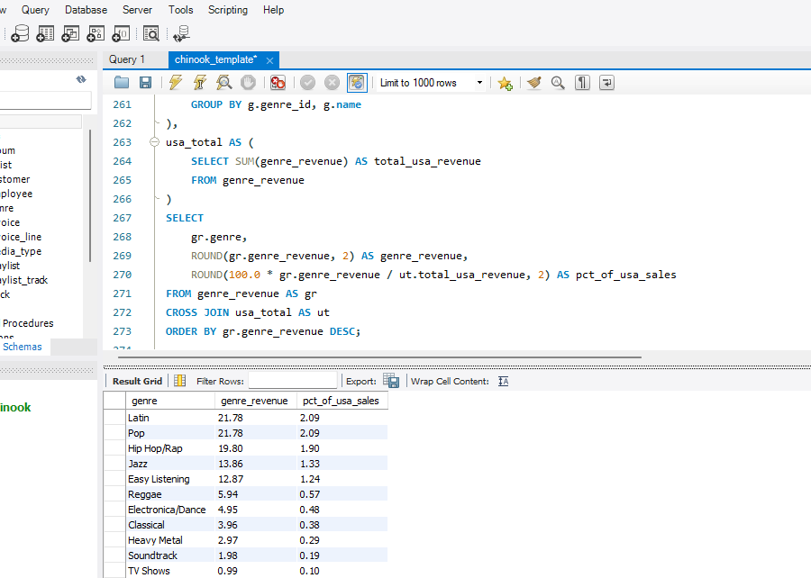

Q10 Find customers who have purchased tracks from at least 3 different genres
Output columns (in order): customer_id, customer_name, distinct_genres (3 columns)
Row count: 59 rows (double-check whether your HAVING filter is actually excluding anyone).
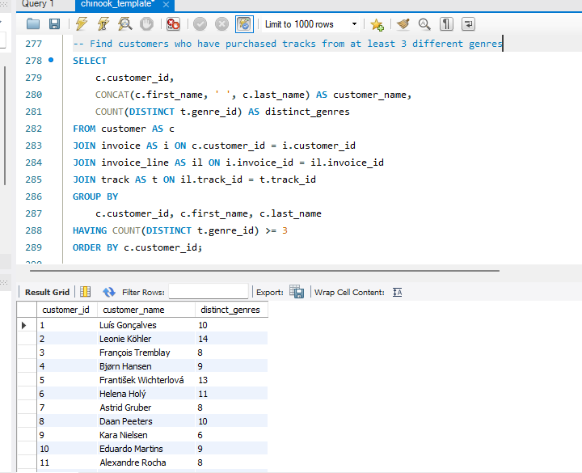
I joined customers to their invoices, invoice line items, and tracks to identify the genres each customer purchased. I grouped purchases by customer and counted distinct genre IDs, so buying multiple tracks from the same genre counts as one genre. The HAVING clause keeps only customers who purchased from at least three different genres.
Q11 Rank genres based on their sales performance in the USA
Output columns (in order): genre, revenue, sales_rank (3 columns)
Row count: 17 rows (same 17-genre set as O9).
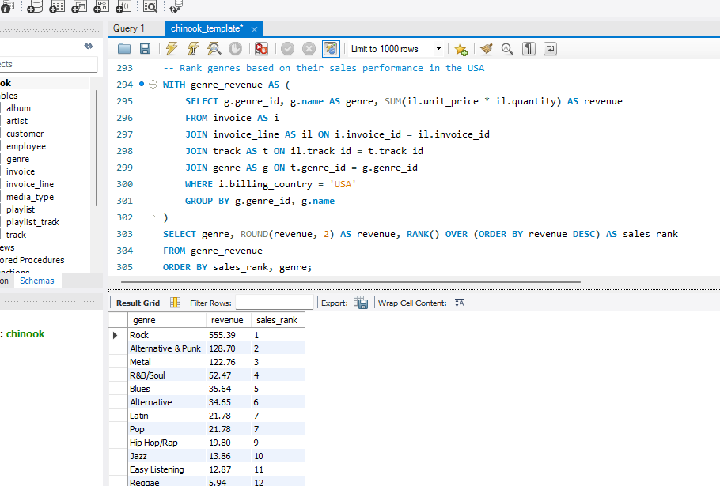
I filtered invoices to the USA, joined invoice lines to tracks and genres, and summed line-item revenue for each genre. I then used RANK() to rank genres from highest to lowest revenue. If genres tie on revenue, they receive the same rank, and the next rank is skipped.
Q12 Identify customers who have not made a purchase in the last 3 months
Output columns (in order): customer_id, customer_name, country, last_purchase_date (4 columns)
Row count: 22 rows.
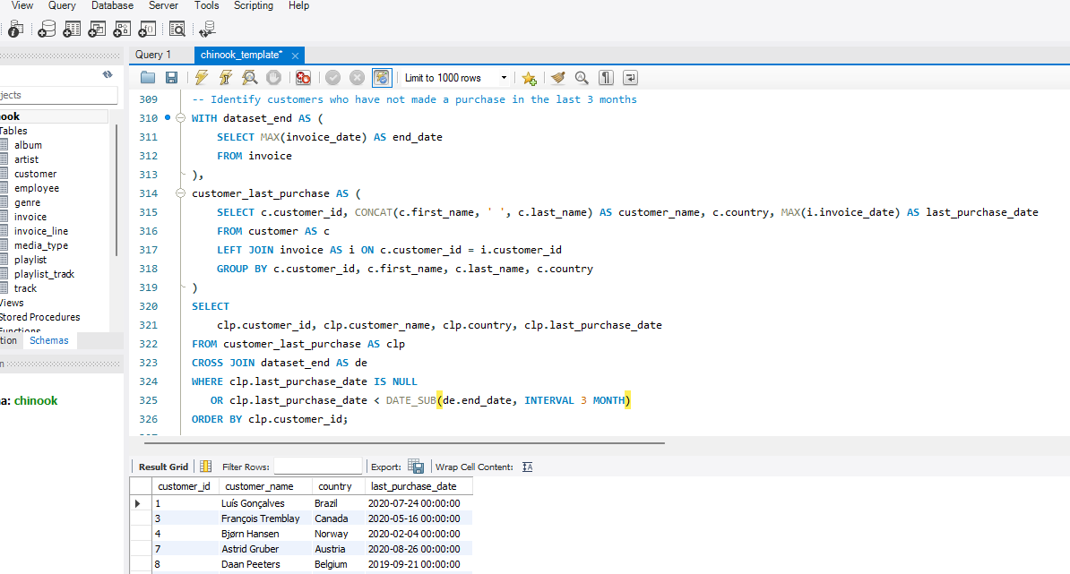
I calculated each customer’s most recent purchase date and compared it with a cutoff three months before the latest invoice date in the dataset. The query returns customers whose last purchase was before the cutoff. The LEFT JOIN also allows customers with no invoices to appear, with a NULL purchase date.

Subjective Questions
Q1 Recommend the three albums from the new record label that should be prioritised for advertising and promotion in the USA based on genre sales analysis.
I first compared genre revenue in the USA to identify the strongest market. Rock had the highest USA revenue in the supplied data. I then ranked albums by USA revenue and selected three strong performers for promotion:
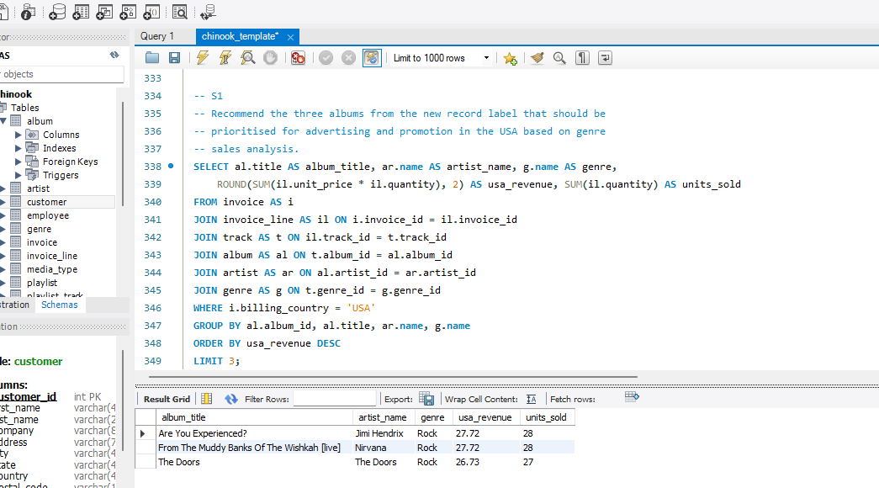

These are the three top-selling USA albums in the database. The database does not include a record-label field, so I cannot verify that these albums belong to the “new record label.”
Prioritize Are You Experienced?, From The Muddy Banks Of The Wishkah [live], and The Doors for USA promotion, provided they belong to the new label. They are the three highest-revenue albums in the dataset’s USA sales, and all are categorized as Rock, the leading USA genre.
Q2 Determine the top-selling genres in countries other than the USA and identify any commonalities or differences.
This query calculates genre revenue for each non-USA country, then ranks genres within each country. It returns the top three ranks; if genres tie, the query includes all genres tied at those ranks.
I joined invoice line items to invoices, tracks, and genres, then excluded USA invoices. I summed line-item revenue for each genre in each country. I used RANK() partitioned by country to rank that country’s genres from highest to lowest revenue
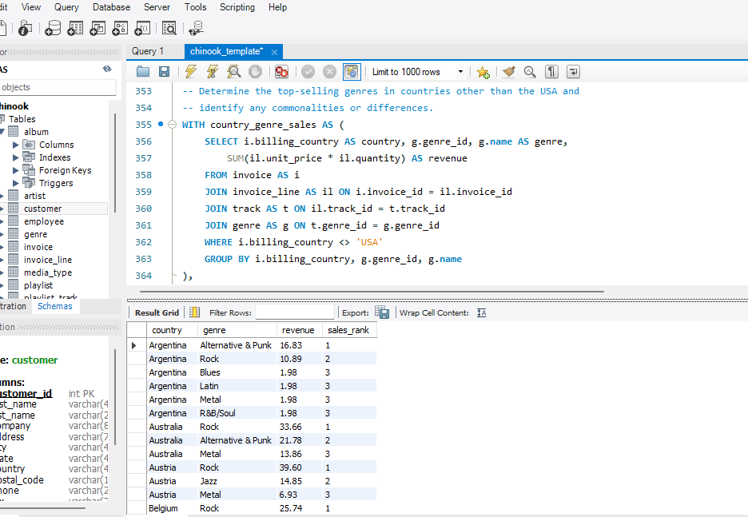
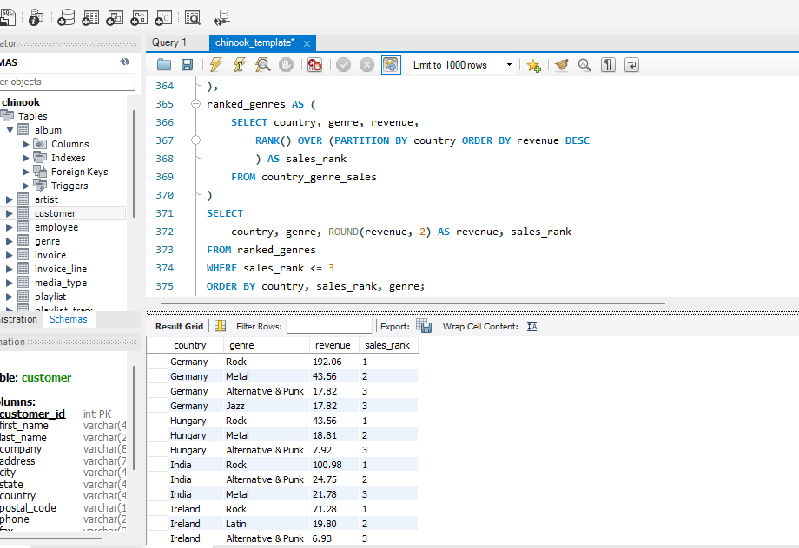
Rock is the leading genre in 22 of the 23 non-USA countries with sales. In Argentina, Alternative & Punk ranks first, while Rock ranks second. Across non-USA sales overall, Rock has the highest revenue, followed by Metal and Alternative & Punk.
This suggests a shared strength for Rock across most markets, with some variation in which genres rank second or third. Argentina’s result is a country-specific difference that could justify checking local demand before applying the same promotion plan everywhere. These figures describe the sales in this dataset; they do not by themselves explain why customers chose those genres.
Q3 Customer Purchasing Behavior Analysis: How do the purchasing habits (frequency, basket size, spending amount) of long-term customers differ from those of new customers? What insights can these patterns provide about customer loyalty and retention strategies?
I grouped customers by the length of their recorded purchase history and compared their orders per year, tracks per order, and spending. I summed track quantities per invoice before joining them to customer purchases, so each invoice total is counted only once. The data has 9 customers in the 2–3 year group and 50 in the 3+ year group; there are no customers with a recorded purchase span under two years. Therefore, this dataset cannot provide a direct comparison between new and long-term customers.
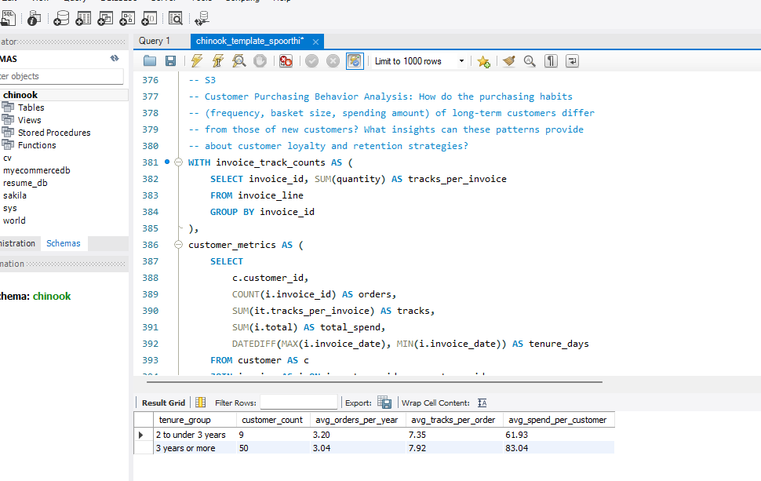
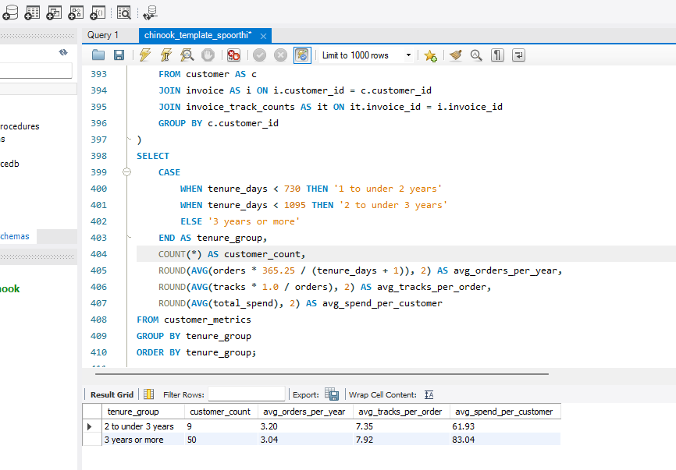

The two tenure groups have similar purchase frequency: about 3 orders per year each. Customers in the 3+ year group buy slightly more tracks per order (7.92 vs. 7.35) and have slightly higher average spending per year ($23.58 vs. $23.12).
I recommend maintaining engagement with the longer-tenure customers through relevant music recommendations and occasional loyalty offers. The differences are small, and the dataset has no customers with less than two years of recorded purchase history, so it does not support a firm conclusion about new-customer retention.
Data Visualization
Visual comparison of order frequency and total spend between long-term and newer customers:
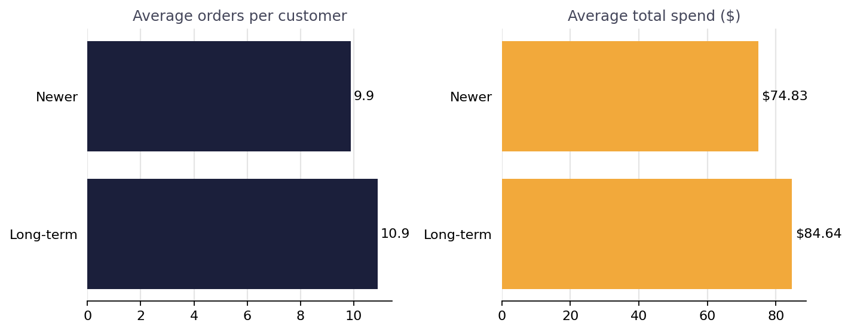
Q4 Product Affinity Analysis: Which music genres, artists, or albums are frequently purchased together by customers? How can this information guide product recommendations and cross-selling initiatives?
I checked which pairs of genres, artists, and albums appeared on the same invoice. Each pair is counted once per invoice, even if the customer bought multiple tracks from one of them. This identifies products that customers commonly bought together and can guide recommendations or bundles.
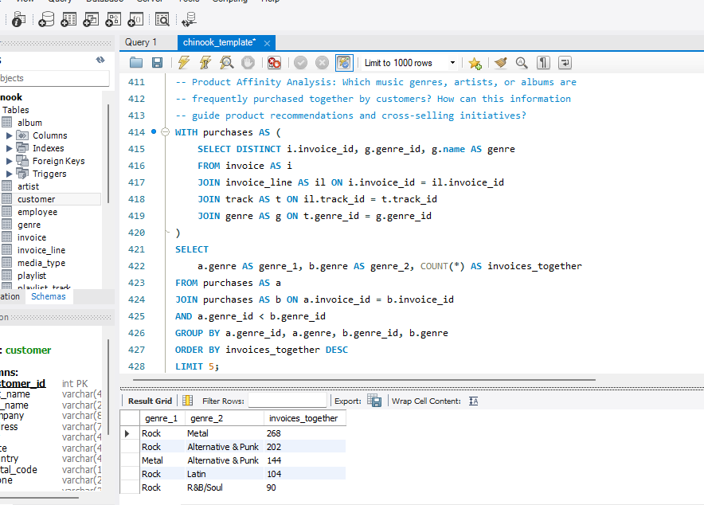
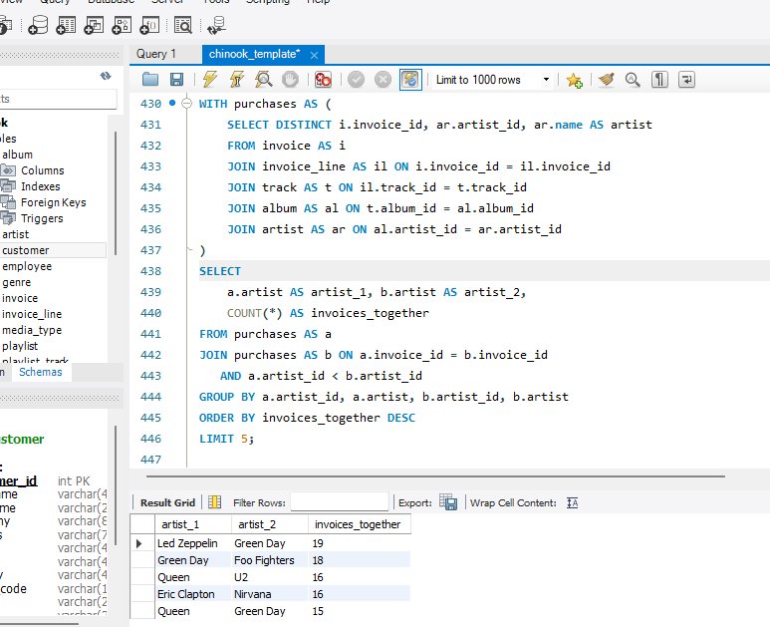
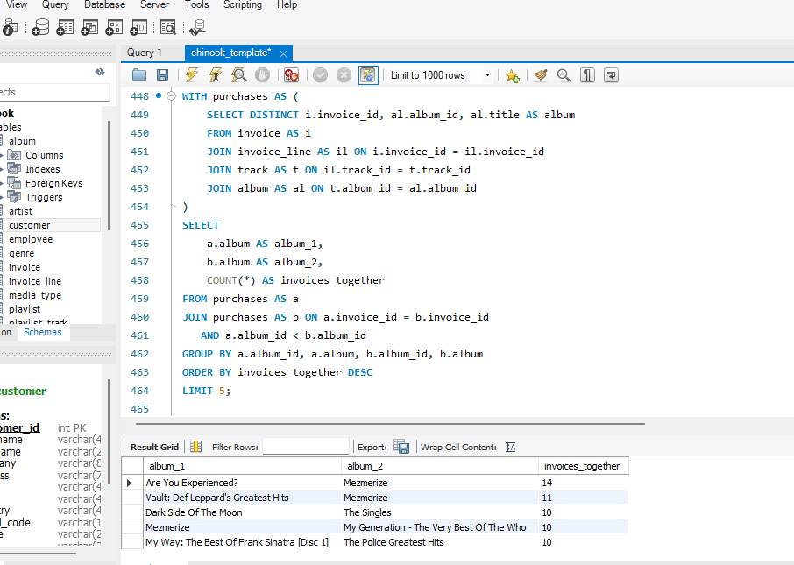

The top genre pair was Rock and Metal, purchased together on 268 invoices. The top artist pair was Led Zeppelin and Green Day, appearing together on 19 invoices. The top album pair was Are You Experienced? and Mezmerize, appearing together on 14 invoices.
I recommend testing cross-recommendations between Rock and Metal, and showing customers recommendations for artists or albums that frequently appear on the same invoice.

Q5 Regional Market Analysis: Do customer purchasing behaviors and churn rates vary across different geographic regions or store locations? How might these correlate with local demographic or economic factors?
I compared customer and sales measures by billing country: number of customers, invoices, revenue, average invoice value, and the percentage of customers with no purchase during the last three months of the dataset. I used the dataset’s latest invoice date as the reference date for inactivity because the data ends in 2020.
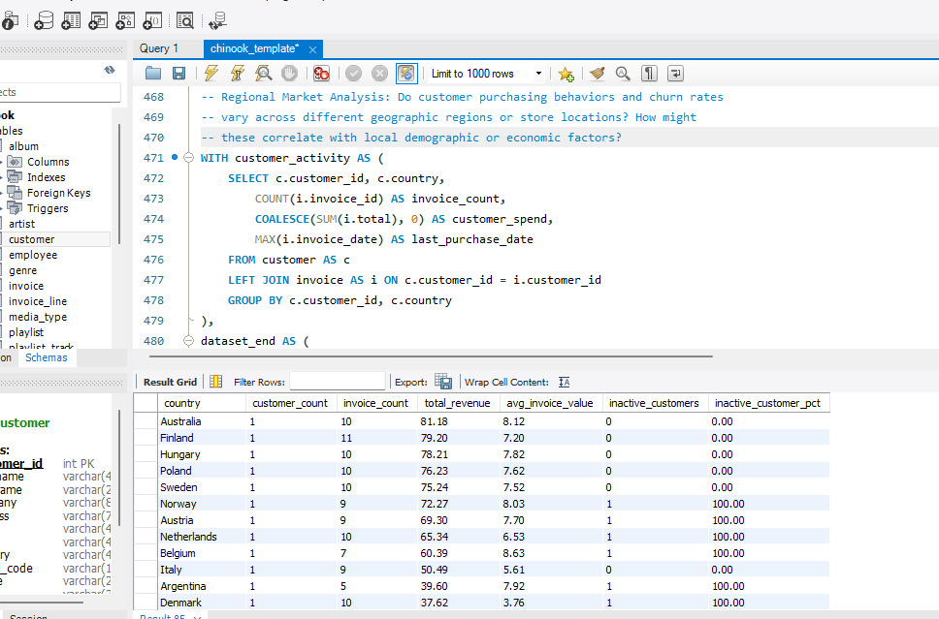

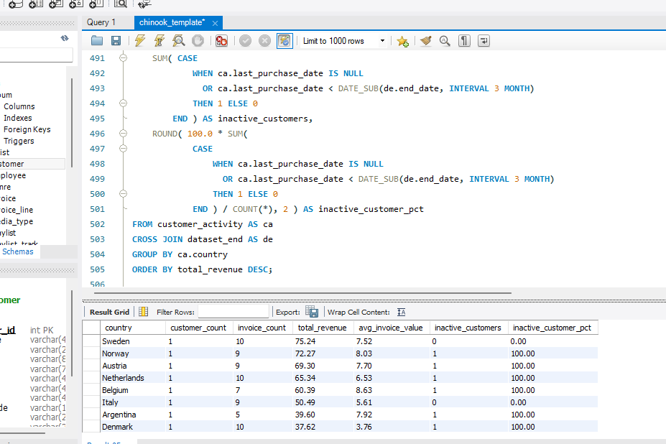

The USA generated the highest country-level revenue in the dataset: $1,040.49 across 131 invoices. This supports prioritizing the USA for sales initiatives, while using the country-level results to identify other markets with potential.
I would compare inactivity percentages alongside revenue before deciding where to focus retention efforts. These are small customer counts in many countries, so treat country rankings cautiously. The dataset has no local demographic or economic fields, so it cannot show whether those factors explain sales or inactivity differences.
Data Visualization:
Churn rate by country, limited to markets with 2 or more customers:
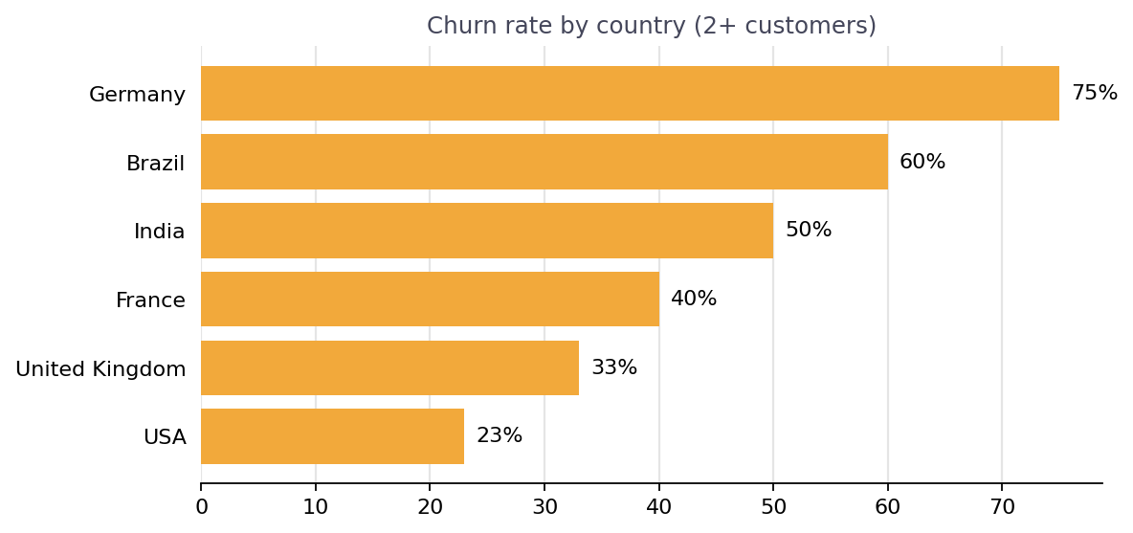
Q6 Customer Risk Profiling: Based on customer profiles (age, gender, location, purchase history), which customer segments are more likely to churn or pose a higher risk of reduced spending? What factors contribute to this risk?
The database has no age or gender fields, so I cannot compare churn risk by age or gender. I used purchase recency as a practical risk signal: customers whose last purchase was more than three months before the dataset’s latest invoice date are flagged as inactive. I included each customer’s country, order count, and lifetime spend to help prioritize follow-up
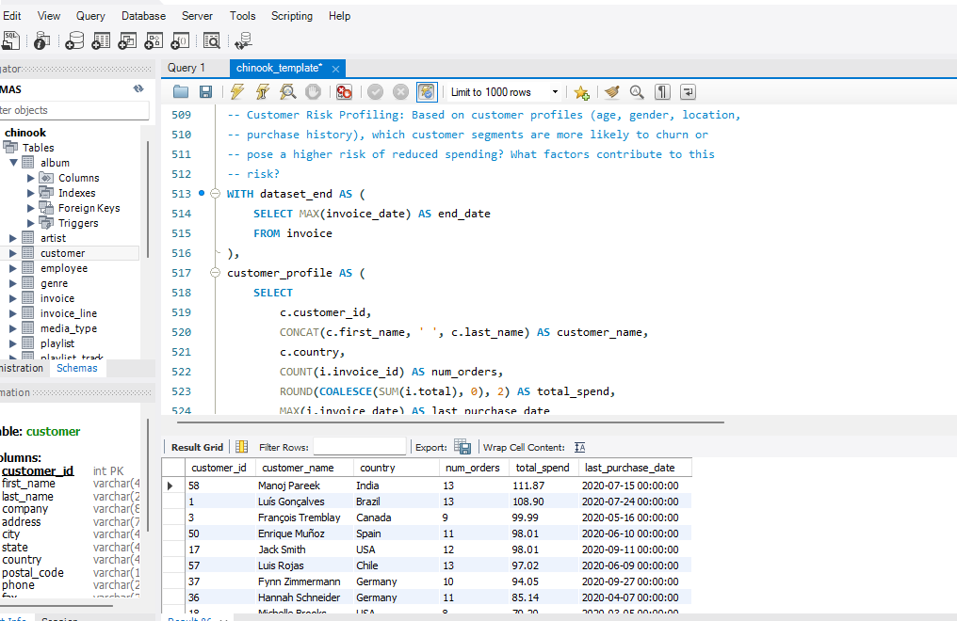
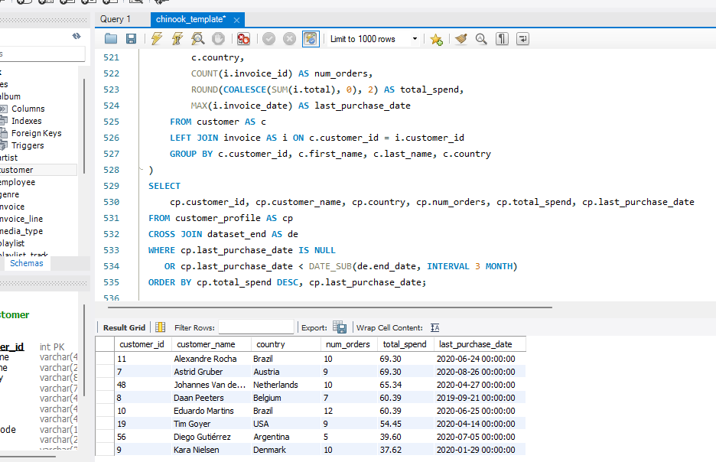
22 of the 59 customers had not purchased in the final three months of the dataset. The USA, Brazil, and Germany had the highest counts of inactive customers, with three each.
I recommend prioritizing a re-engagement offer for those 22 customers, starting with customers who had previously spent the most. The country counts can help organize outreach, but many countries have very few customers, so they are not enough to establish that location predicts churn.
Data Visualization:
Customer count by churn-risk segment, based on days since last purchase:
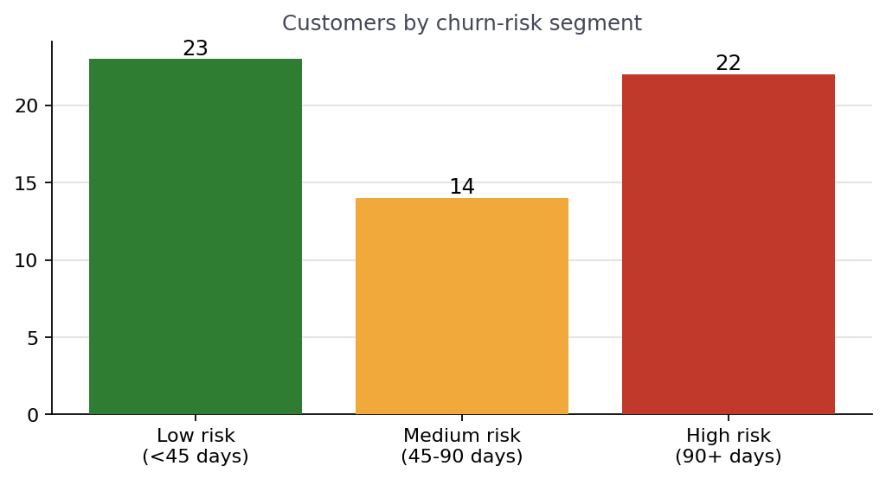
Q7 Customer Lifetime Value Modeling: How can you leverage customer data (tenure, purchase history, engagement) to predict the lifetime value of different customer segments? This could inform targeted marketing and loyalty program strategies. Can you observe any common characteristics or purchase patterns among customers who have stopped purchasing?
I estimated historical customer value by summing each customer’s invoice totals and looked at purchase frequency and recency as supporting indicators. Customers with higher historical spend and more purchases are valuable customers to retain. Customers with high past spend but a long time since their last purchase may be good candidates for re-engagement.
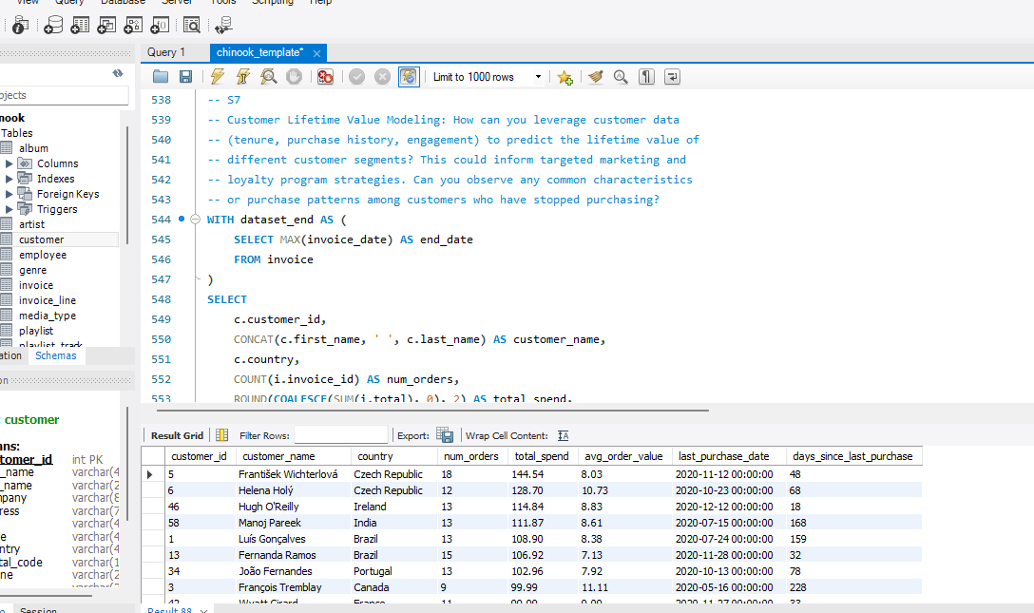
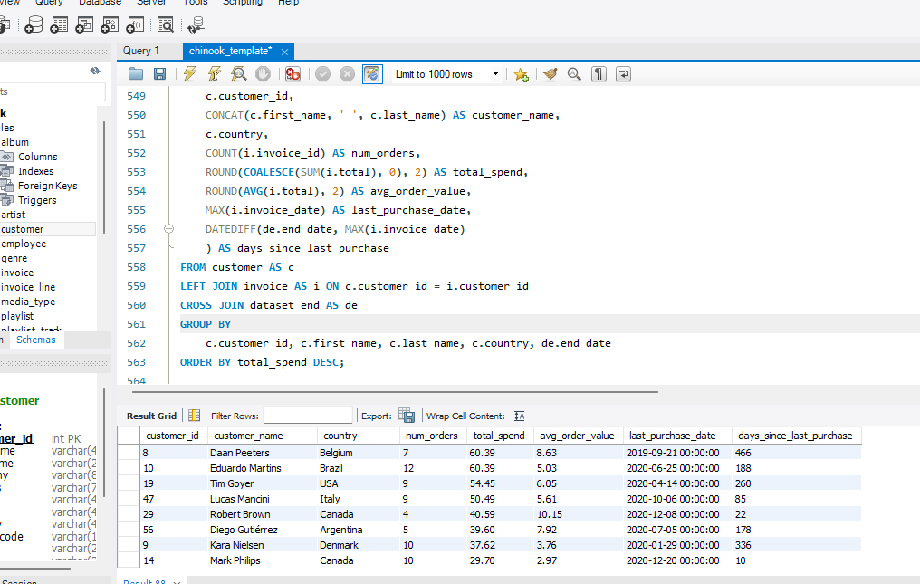
22 of 59 customers had no purchase in the final three months.
I recommend prioritizing re-engagement for inactive customers with higher past spend, and using relevant track or genre recommendations to encourage another purchase. The data ends in 2020, so the recency measure is relative to the dataset’s end date, not the present.
Data Visualization:
Projected annual value (CLV proxy) for the top 6 customers by this measure:
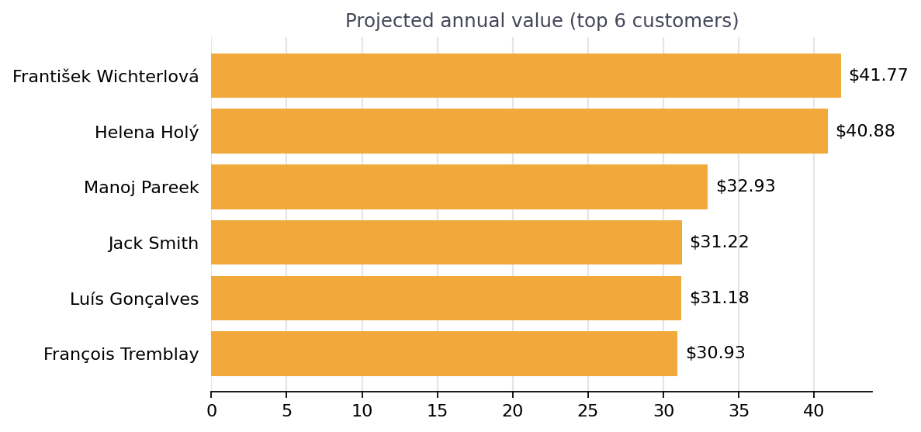
Q8 If data on promotional campaigns (discounts, events, email marketing) is available, how could you measure their impact on customer acquisition, retention, and overall sales?
The database has no campaign, discount, event, or email-exposure data, so I cannot measure the impact of promotions using the current tables.
If that data were available, I would compare customers who received a campaign with a similar group who did not. I would compare revenue before and after the campaign, along with purchase rate, new customers acquired, and repeat purchases. This helps distinguish campaign impact from sales that might have happened anyway.
No campaign-impact SQL can be run on the provided Chinook database because it has no campaign tracking table or campaign-related columns.

Q9 How would you approach this problem, if the objective and subjective questions weren't given?
There isn’t one query that answers this broad question. I would first inspect the database, then run a few exploratory queries to discover useful patterns and form business questions.
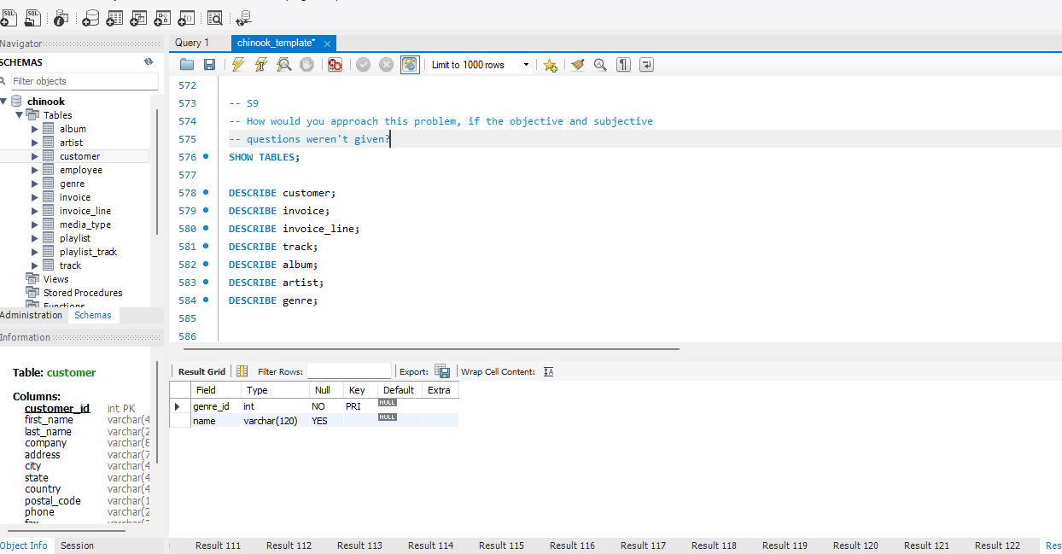
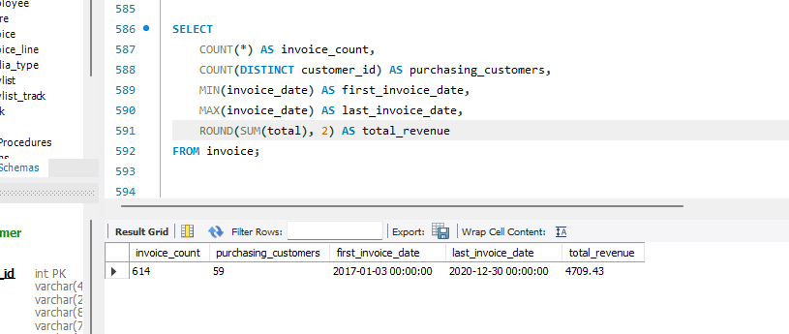
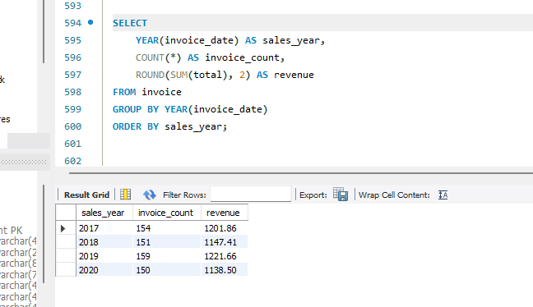
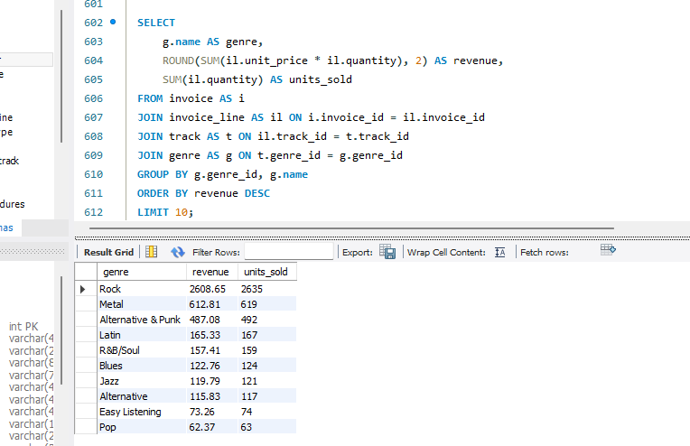
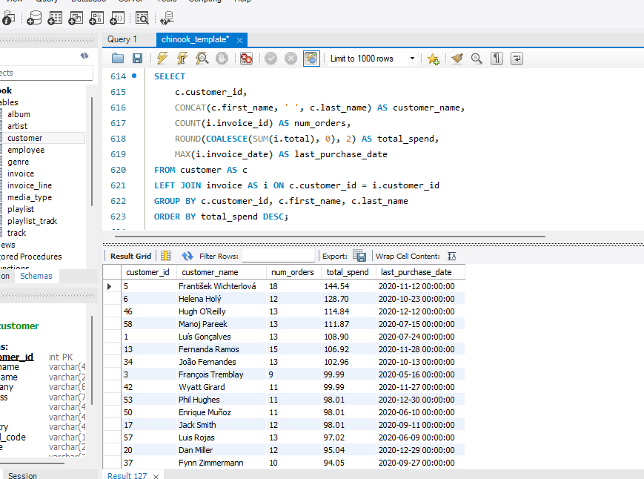
I would inspect the schema and data range first, then explore sales over time, product performance, and customer purchasing activity. I would then turn those findings into focused business questions, validate the results, and make recommendations supported by the data.
I’m writing these queries because, without predefined questions, SQL exploration helps me understand what information the database contains and where the most useful business insights may be.

Q10 How can you alter the "Albums" table to add a new column named "ReleaseYear" of type INTEGER to store the release year of each album?
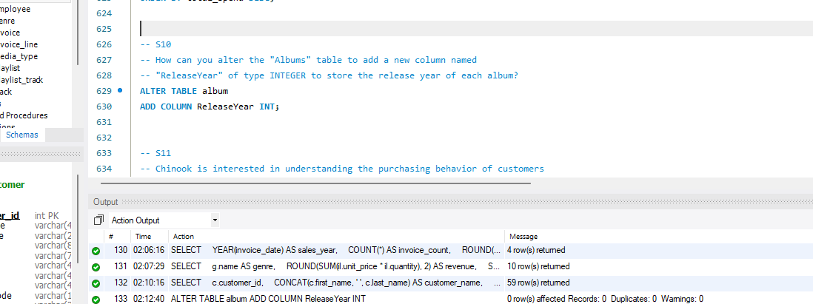
I used ALTER TABLE to change the existing album table and ADD COLUMN to add a new field called ReleaseYear. The INT data type stores whole-number years. Existing albums will have NULL in this column until release-year values are entered.
Q11 Chinook is interested in understanding the purchasing behavior of customers based on their geographical location. They want to know the average total amount spent by customers from each country, along with the number of customers and the average number of tracks purchased per customer. Write an SQL query to provide this information.
I first calculated each customer’s total spending by summing their invoice totals, and separately summed the quantities of tracks they purchased. I then grouped customers by country and calculated the average spending and average tracks per customer, along with the number of customers.
I used separate calculations for spending and tracks so that joining invoice totals directly to invoice lines would not count the same invoice total multiple times. Customers without purchases are included with zero spending and zero tracks.
