MAJOR PROJECT PROPOSAL
AgileGraph
Graph-Learned Crypto-Agility Risk Scoring for Post-Quantum Migration
Heterogeneous GNN Risk Propagation + Explainable Migration Prioritization
Cryptographic Risk Modeling for Real-World PQC Migration Programs
Students | [Your Name(s) Here]
Program | B.Tech Cybersecurity — Final Year
Institution | [Your Institution]
Target | Q1 Journal Publication + Academic Major Project
Timeline | 4–6 Months (Phased)

1. Problem Statement
Quantum computers will eventually break the encryption (RSA, ECC) that protects almost everything online today. New quantum-safe algorithms already exist (ML-KEM, ML-DSA, SLH-DSA), so the fix is available. The real problem is that most organizations don't know where their weak cryptography is hiding in the first place — inside old libraries, forgotten certificates, and code nobody has touched in years.
This isn't a future problem. Attackers can already record encrypted data today and decrypt it later once quantum computers are ready — a tactic called “harvest-now, decrypt-later.” So the clock is already running.
Right now, finding this weak cryptography is done by hand: security teams manually search codebases, check certificates, and inspect network traffic. It's slow, error-prone, and doesn't tell you which weak spots actually matter most. A tool might tell you “this certificate is outdated,” but not “fixing this certificate first will protect the most sensitive data with the least effort.”
This project builds a system that automatically maps how cryptography, code, certificates, and sensitive data are all connected — as a graph — and uses AI (a Graph Neural Network) to figure out which weak points are the most dangerous if left unfixed. The output is a simple, ranked to-do list for migration: fix this first, this second, and here's why.

2. Why This Is Not Just Another Scanning Tool
Feature | Existing Tools (scanners/inventory) | This Project
Finding weak cryptography | Manual search or basic scanning | Automatic, from code + live network scans
Deciding what to fix first | Flat list, no clear priority | Ranked list based on real impact if it breaks
Understanding “what if this breaks” | Not addressed at all | Core feature: traces the ripple effect across systems
How risk scores are decided | Unclear, vendor's own formula | Open, documented formula anyone can check
Explaining “why is this risky” | No explanation given | Plain-language reason for every flagged item
Planning the migration order | Not addressed | Simulates different migration orders and compares results
Cost / access | Paid, closed tools (Keyfactor, AppViewX, etc.) | Free, open, and fully explainable
In short: existing tools tell you what cryptography you have. This project tells you what actually breaks if you don't fix it — and what to fix first.

3. Technical Architecture

3.1 Scanning & Data Collection
- Scan source code to find every place cryptography is used (RSA, ECDSA, AES, etc.) across Java, Python, and Go projects
- Scan live websites/servers to check their certificates and encryption settings
- Check project dependency files to see which code libraries are outdated or no longer supported
- Store everything in a graph database so relationships between all of this can be mapped out

3.2 Building the Risk Graph [Core Contribution]
- Map 6 types of things onto the graph: code files, crypto usage, certificates, network endpoints, libraries, and sensitive data
- Map 7 types of connections between them (e.g. “this code uses this certificate,” “this certificate protects this data”)
- Score each item's starting risk using a simple, published formula: how long the data needs to stay safe, vs. how long migration will take, vs. how soon quantum computers are expected

3.3 The AI Model
- An AI model (GATv2, a type of Graph Neural Network) looks at the whole graph and learns how risk spreads from one item to another
- For every risky item, the model gives a plain-language reason why it's risky
- The model's rankings are compared against simpler methods (basic scoring, popularity-style ranking) to prove it's actually better, not just fancier

3.4 Dashboard
- A simple web dashboard (React) where you scan a project and see a ranked migration to-do list
- A backend (FastAPI) that runs the scanning and AI model behind the scenes
- Each item on the list comes with a plain-English explanation and shows how much risk is reduced if you fix it

4. System Architecture
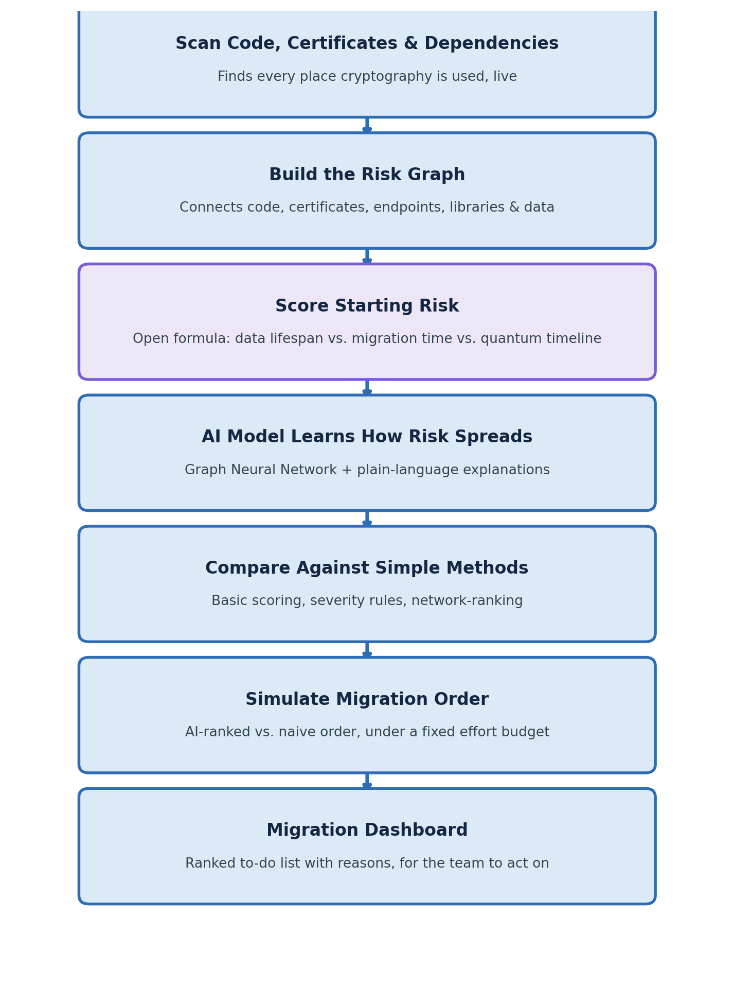

5. Research Novelty & Publication Angle
AI models that learn how risk spreads across a network already exist in other fields — fraud detection, credit risk, supply-chain failures. Separately, there's plenty of research on quantum-safe cryptography itself. But nobody has combined the two: using graph-based AI to figure out which weak cryptography matters most across a whole system. This project fills that specific gap. Two clear claims:

Claim 1: A new way to map cryptographic risk
This is the first system to connect code, certificates, network endpoints, libraries, and sensitive data into one graph for post-quantum migration planning — with an open, checkable formula for the starting risk scores instead of a hidden vendor formula.

Claim 2: AI-based ranking that's provably better than simple methods
The AI model is shown, with side-by-side examples, to catch risky combinations that simple scoring and basic ranking methods miss — and it explains its reasoning for every flagged item, so the results aren't a black box.
Target journals and conferences: Computers & Security (Elsevier, Q1), IEEE Transactions on Dependable and Secure Computing (Q1), ACM CCS / ASIACCS, USENIX Security. All regularly publish work in this space at this level of evidence.

6. Evaluation Plan
A clear, honest evaluation is what makes this project credible. The plan:

Testing the AI Model
- Data: 3–5 real open-source projects, plus real certificate data, plus some generated test data to check it works at larger scale
- Compare against: basic scoring, standard security-severity rules, and simple network-ranking methods
- How we measure success: does the AI's ranking match what human experts would rank as most urgent? Does following the AI's order fix the most risk for the least effort, compared to other methods?
- Extra check: try a couple of different AI model designs to see which works best, and why

Checking the Risk Scores Are Fair
- Take a sample of ~50–100 items, have the advisor and a couple of reviewers rank them by hand (without seeing the formula's answer), and compare
- Test the formula under a few different assumptions about how soon quantum computers arrive, to show the results hold up either way

Checking the Explanations Make Sense
- Pick a handful of flagged items and manually check: does the AI's explanation actually match what's really going on?
- Show 2–3 clear examples where the AI catches something the simpler methods miss, and explain why in plain terms

7. Execution Roadmap
Month | Phase | Deliverable
Month 1 | Planning + Design | Graph layout finalized; risk-scoring formula agreed with advisor
Month 2 | Building the Scanners | Code, certificate, and dependency scanners built; graph populated from 3–5 real projects
Month 3 | Training the AI Model | AI model trained; simple comparison methods built alongside it
Month 4 | Testing + Validation | Expert-reviewed sample collected; results compared against simpler methods
Month 5 | Dashboard | Web dashboard built showing the ranked migration list with explanations
Month 6 | Writeup | Final results, examples, and report/paper draft completed

8. Tech Stack
Layer | Technology | Why
AI Model | PyTorch Geometric, GATv2 | Standard, well-supported toolkit for graph-based AI
Code Scanning | Semgrep / custom scripts | Finds cryptography usage across multiple languages
Certificate Scanning | tlsx, testssl.sh, sslyze, CT logs | Free, industry-standard tools for real certificate data
Graph Storage | Neo4j or NetworkX | Stores and queries the relationships between items
Backend | FastAPI (Python) | Runs the scanning and AI model behind the scenes
Frontend | React + Tailwind | The dashboard people actually see and use
Evaluation | Python, scikit-learn, SciPy, matplotlib | For comparing results and making charts

9. Why This Project — Honest Self-Assessment
Two honest reasons this project was chosen:

The problem is real, not made up.
Security vendors and NIST guidance both point to the same thing: finding weak cryptography, not fixing it, is what's actually slowing organizations down right now. This project goes after a problem the industry has already admitted it hasn't solved.

The data and the risk are both manageable for a student project.
Certificate data is public and freely available. Open-source projects give real code to scan. NIST's guidance on which algorithms are weak is also public. The hard, original part of this project — and where the real work goes — is building the graph and designing a fair, checkable way to score risk, both of which are already planned out in Sections 3.2 and 6.
What this project is not: a basic severity calculator, a certificate-expiry checker, or a popularity-ranking tool dressed up with cryptography terms. It's a system that reasons about how one weak point can put a lot of other things at risk — something no existing tool currently does.

10. Connection to Broader Goals
Cybersecurity internship / placement | Graph-based AI, quantum-safe migration, security scanning, and explainable AI are all in-demand skills right now
Q1 journal / IEEE publication | This is a real, unsolved gap in the research — a clear, testable claim that's easy to explain
Academic major project marks | Clear metrics, a fair evaluation process, and real data sources cover every part of a strong rubric
Portfolio differentiation | Not another checklist tool. A system that reasons about knock-on risk the way security teams think about cascading failures — easy to explain in one sentence in an interview

