@title Quantitative Reasoning Shadow Set A

@description 25 MCQ shadow questions inspired by provided base set with images where applicable

@question If n − 7 = 5, what is the value of n?

@instruction Solve for n.

@difficulty easy

@Order 1

@option 10

@@option 12

@option −2

@option 2

@option 7

@explanation

Add 7 to both sides: n = 5 + 7 = 12.

@subject Quantitative Math

@unit Numbers and Operations

@topic Computation with Whole Numbers

@plusmarks 1

@question The shapes repeat every 4 (circle, square, triangle, star). Which shape is 12th?

@instruction Use modular arithmetic.

@difficulty easy

@Order 2

@option Circle

@option Square

@option Triangle

@@option Star

@option Hexagon

@explanation

12 mod 4 = 0, so it is the 4th shape in the cycle: Star.

@subject Quantitative Math

@unit Numbers and Operations

@topic Sequences & Series

@plusmarks 1

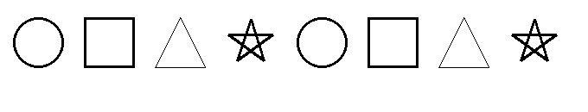

@question A box has 15 marbles. You add x more. Which expression is the total?

@instruction Model with a variable.

@difficulty easy

@Order 3

@option 15/x

@option x/15

@option 15x

@option 15 − x

@@option 15 + x

@explanation

Start with 15 and add x, giving 15 + x.

@subject Quantitative Math

@unit Algebra

@topic Interpreting Variables

@plusmarks 1

@question The number 4,□32 is less than 4,532. What is the greatest possible value of □?

@instruction Compare by place value.

@difficulty easy

@Order 4

@option 2

@option 3

@@option 4

@option 5

@option 9

@explanation

Hundreds digit must be < 5; the greatest such digit is 4.

@subject Quantitative Math

@unit Numbers and Operations

@topic Basic Number Theory

@plusmarks 1

@question What is the sum of 5/12 and 7/18?

@instruction Find a common denominator.

@difficulty moderate

@Order 5

@option 11/36

@option 17/30

@@option 29/36

@option 41/36

@option 5/30

@explanation

LCM(12,18)=36; 5/12=15/36 and 7/18=14/36; sum = 29/36.

@subject Quantitative Math

@unit Numbers and Operations

@topic Fractions, Decimals, & Percents

@plusmarks 1

@question A hiker starts at 200 m and ends at 550 m after 4 hours. What is the altitude gain?

@instruction Compute the difference.

@difficulty easy

@Order 6

@option 100

@option 200

@option 300

@@option 350

@option 400

@explanation

Final − initial = 550 − 200 = 350 m.

@subject Quantitative Math

@unit Data Analysis & Probability

@topic Interpretation of Tables & Graphs

@plusmarks 1

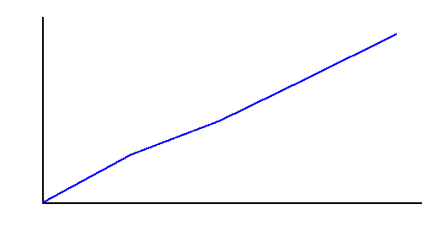

@question What is 0.4 × 12.5 × 0.2?

@instruction Multiply stepwise.

@difficulty easy

@Order 7

@option 0.1

@@option 1.0

@option 0.8

@option 0.5

@option 0.04

@explanation

0.4×12.5=5; 5×0.2=1.0.

@subject Quantitative Math

@unit Numbers and Operations

@topic Fractions, Decimals, & Percents

@plusmarks 1

@question Using 1c, 5c, 10c, and 25c coins (ten of each available), least number of coins to make 37 cents?

@instruction Minimize the count of coins.

@difficulty moderate

@Order 8

@option 2

@option 3

@@option 4

@option 5

@option 6

@explanation

25 + 10 + 1 + 1 uses 4 coins.

@subject Quantitative Math

@unit Reasoning

@topic Word Problems

@plusmarks 1

@question What is (1/2) × (2/3 × 3/4)?

@instruction Simplify inside first.

@difficulty easy

@Order 9

@option 1/8

@@option 1/4

@option 1/3

@option 1/2

@option 2/3

@explanation

(2/3×3/4)=1/2; then 1/2×1/2=1/4.

@subject Quantitative Math

@unit Numbers and Operations

@topic Fractions, Decimals, & Percents

@plusmarks 1

@question On line RV, T is the midpoint of RV and S is the midpoint of RT. If ST = 10, what is SV?

@instruction Use midpoint ratios.

@difficulty moderate

@Order 10

@option 10

@option 15

@option 20

@@option 30

@option 40

@explanation

ST = (1/4)RV ⇒ RV=40. Then SV = RV − RS = 40 − 10 = 30.

@subject Quantitative Math

@unit Geometry and Measurement

@topic Lines, Angles, & Triangles

@plusmarks 1

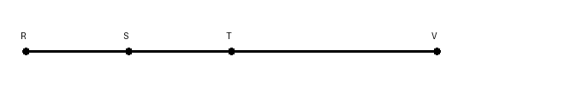

@question Let b be a nonzero whole number such that b = b^2 − 2b. What is b?

@instruction Solve the quadratic and use the nonzero condition.

@difficulty moderate

@Order 11

@option 0

@option 1

@option 2

@@option 3

@option 4

@explanation

b=b^2−2b ⇒ 0=b^2−3b ⇒ b(b−3)=0. Nonzero b gives b=3.

@subject Quantitative Math

@unit Algebra

@topic Quadratic Equations & Functions (Finding roots/solutions, graphing)

@plusmarks 1

@question A uniform consists of 1 shirt and 1 pair of pants. If there are 4 shirt colors and 3 pants colors, how many different uniforms are possible?

@instruction Apply the multiplication principle.

@difficulty easy

@Order 12

@option 7

@option 10

@@option 12

@option 24

@option 36

@explanation

4 × 3 = 12.

@subject Quantitative Math

@unit Data Analysis & Probability

@topic Counting & Arrangement Problems

@plusmarks 1

@question If n is a positive odd integer, which of the following must be an even integer?

@instruction Test each option with parity rules.

@difficulty easy

@Order 13

@@option 3n − 1

@option 2n + 3

@option 2n − 1

@option n + 2

@option (3n)/2

@explanation

Odd×3 = odd, and odd−1 is even. Others are odd or not guaranteed integers.

@subject Quantitative Math

@unit Numbers and Operations

@topic Basic Number Theory

@plusmarks 1

@question A car travels 180 miles using $27 of gasoline. At the same rate, how many miles for $40?

@instruction Use direct proportion.

@difficulty easy

@Order 14

@option 240

@option 260

@@option 267

@option 280

@option 300

@explanation

Miles per dollar = 180/27 = 6.666…; ×40 ≈ 266.7 ≈ 267.

@subject Quantitative Math

@unit Reasoning

@topic Word Problems

@plusmarks 1

@question Which fraction is closest to 41%?

@instruction Compare decimal values.

@difficulty moderate

@Order 15

@option 1/3

@option 2/5

@option 3/7

@option 3/8

@@option 5/12

@explanation

5/12 ≈ 41.67% is closest to 41%.

@subject Quantitative Math

@unit Numbers and Operations

@topic Fractions, Decimals, & Percents

@plusmarks 1

@question There are 100 students forming 3 clubs with sizes that differ by at most 1. What is the least possible club size?

@instruction Distribute as evenly as possible.

@difficulty moderate

@Order 16

@option 30

@option 31

@option 32

@@option 33

@option 34

@explanation

100/3 ≈ 33.33 ⇒ sizes 33, 33, 34; least is 33.

@subject Quantitative Math

@unit Problem Solving

@topic Problem Solving

@plusmarks 1

@question A rectangle is divided into 6 congruent squares; 3 are shaded as shown. What fraction is shaded?

@instruction Count shaded squares over total squares.

@difficulty easy

@Order 17

@@option 1/2

@option 3/5

@option 3/6

@option 2/3

@option 5/6

@explanation

3 of the 6 equal squares are shaded.

@subject Quantitative Math

@unit Geometry and Measurement

@topic Area & Volume

@plusmarks 1



@question If 3 gold = 12 silver and 4 silver = 28 copper, how many copper for 5 gold?

@instruction Convert units step by step.

@difficulty moderate

@Order 18

@option 35

@option 40

@option 56

@option 70

@@option 140

@explanation

1 gold = 4 silver; 1 silver = 7 copper ⇒ 1 gold = 28 copper ⇒ 5 gold = 140 copper.

@subject Quantitative Math

@unit Numbers and Operations

@topic Rational Numbers

@plusmarks 1

@question A straight bar is formed by segments of 6 cm, 8 cm, and 10 cm placed end-to-end. Two square caps of side 2 cm are attached at the two joints, extending length by one side each. What is the total length n (cm)?

@instruction Add the segment lengths and the two added side lengths.

@difficulty moderate

@Order 19

@option 24

@option 26

@@option 28

@option 30

@option 32

@explanation

6 + 8 + 10 + 2 + 2 = 28 cm.

@subject Quantitative Math

@unit Geometry and Measurement

@topic Perimeter

@plusmarks 1

@question Compute: 5 + (8 × 2^3 ÷ 4) + 2^2

@instruction Follow order of operations.

@difficulty easy

@Order 20

@option 19

@option 21

@option 23

@@option 25

@option 27

@explanation

2^3=8 ⇒ 8×8/4=64/4=16; then 5+16+4=25.

@subject Quantitative Math

@unit Numbers and Operations

@topic Order of Operations

@plusmarks 1

@question A figure is reflected across a vertical line. Which transformation describes this?

@instruction Identify the transformation type.

@difficulty easy

@Order 21

@option Rotation

@option Translation

@@option Reflection

@option Dilation

@option Shear

@explanation

Flipping across a line is a reflection.

@subject Quantitative Math

@unit Geometry and Measurement

@topic Transformations (Dilating a shape)

@plusmarks 1

@question If n is even, which expression must be an integer?

@instruction Let n = 2k and test.

@difficulty easy

@Order 22

@@option (n + 2)/2

@option (3n)/4

@option (n + 1)/2

@option (n + 6)/4

@option (3n + 3)/2

@explanation

n=2k ⇒ (n+2)/2 = (2k+2)/2 = k+1, always an integer.

@subject Quantitative Math

@unit Numbers and Operations

@topic Rational Numbers

@plusmarks 1

@question On Monday, Aidan reads 1/4 of a book. On Tuesday, he reads 1/5 of the remaining pages. He has 90 pages left. How many pages are in the book?

@instruction Track the remaining fraction.

@difficulty moderate

@Order 23

@@option 150

@option 180

@option 225

@option 300

@option 360

@explanation

Remaining after Monday: 3/4. After Tuesday: (4/5)(3/4) = 3/5. If 3/5 = 90, total = 150.

@subject Quantitative Math

@unit Reasoning

@topic Word Problems

@plusmarks 1

@question A square has area 196 square inches. What is the circumference of the largest inscribed circle?

@instruction Relate side length to circle diameter.

@difficulty moderate

@Order 24

@@option 14π

@option 28π

@option 42π

@option 56π

@option 196π

@explanation

Side = √196 = 14 = diameter ⇒ circumference = πd = 14π.

@subject Quantitative Math

@unit Geometry and Measurement

@topic Circles (Area, circumference)

@plusmarks 1

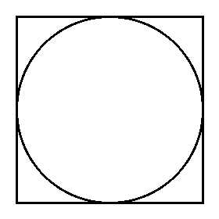

@question A number 200 is increased by 20% and then decreased by 25% to give x. What is x?

@instruction Use successive multipliers.

@difficulty easy

@Order 25

@option 140

@option 150

@option 160

@option 170

@@option 180

@explanation

1.20 × 0.75 = 0.9 ⇒ 200 × 0.9 = 180.

@subject Quantitative Math

@unit Numbers and Operations

@topic Fractions, Decimals, & Percents

@plusmarks 1