@title Solve Linear Equation (One-Step)

@description Solve for n in a simple linear equation.

@question If $n+5=5$, what is the value of $n$?

@instruction Select the correct value of n.

@difficulty easy

@Order 1

@@option 0

@option $\frac{1}{5}$

@option 1

@option 5

@option 10

@explanation

Subtract 5 from both sides: $n = 5-5 = 0$.

@subject Quantitative Math

@unit Algebra

@topic Interpreting Variables

@plusmarks 1

---

@title Repeating Shape Sequence

@description Identify the 12th shape in a repeating sequence.

@question The sequence of shapes above repeats indefinitely as shown. Which shape is the 12th shape in the sequence?

@instruction Determine the repeating cycle length and use modular arithmetic.

@difficulty moderate

@Order 2

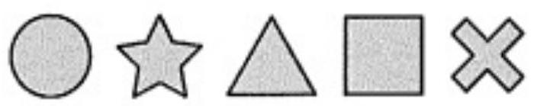

@option (A)

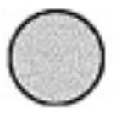

@@option (B)

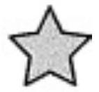

@option (C)

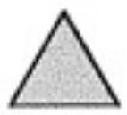

@option (D)

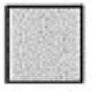

@option (E)

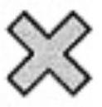

@explanation

If the cycle length is 5, then 12 mod 5 = 2, so the 12th is the 2nd shape: (B).

@subject Quantitative Math

@unit Numbers and Operations

@topic Sequences & Series

@plusmarks 1

---

@title Expression for Total Illustrations

@description Translate a word scenario into an algebraic expression.

@question There were 20 illustrations in Julio's sketch pad. While at a museum, he drew $x$ more illustrations. Which expression represents the total number after the visit?

@instruction Choose the expression that models the situation.

@difficulty easy

@Order 3

@option $\frac{x}{20}$

@option $\frac{20}{x}$

@option $20x$

@option $20-x$

@@option $20+x$

@explanation

Start with 20 and add x new illustrations: $20 + x$.

@subject Quantitative Math

@unit Algebra

@topic Interpreting Variables

@plusmarks 1

---

@title Place Value and Inequality

@description Find the greatest digit for a number to stay below a bound.

@question In the number $4,\square 86$, $\square$ is a digit 0–9. If the number is less than 4,486, what is the greatest possible value for $\square$?

@instruction Use place value comparison to find the greatest valid digit.

@difficulty easy

@Order 4

@option 0

@@option 3

@option 4

@option 7

@option 9

@explanation

Compare hundreds place with 4 in 4,486: the greatest hundreds digit to keep it smaller is 3.

@subject Quantitative Math

@unit Numbers and Operations

@topic Computation with Whole Numbers

@plusmarks 1

---

@title Adding Fractions

@description Add two fractions with unlike denominators.

@question Which of the following is the sum of $\frac{3}{8}$ and $\frac{4}{7}$?

@instruction Compute using a common denominator.

@difficulty easy

@Order 5

@option $\frac{1}{8}$

@option $\frac{3}{14}$

@option $\frac{7}{15}$

@option $\frac{33}{56}$

@@option $\frac{53}{56}$

@explanation

$\frac{3}{8}+\frac{4}{7}=\frac{21+32}{56}=\frac{53}{56}$.

@subject Quantitative Math

@unit Numbers and Operations

@topic Fractions, Decimals, & Percents

@plusmarks 1

---

@title Altitude Difference from Graph

@description Read altitude change from a time-altitude graph.

@question Ilona hikes for 4 hours from a campsite to a scenic lookout. Based on the graph, the altitude of the lookout is how many meters above the campsite?

@instruction Compute final altitude minus initial altitude.

@difficulty moderate

@Order 6

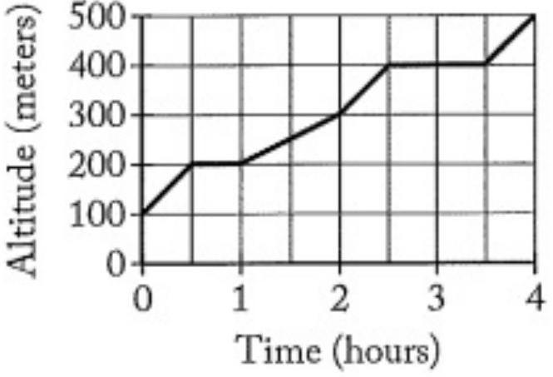

@option 100

@option 200

@option 300

@@option 400

@option 500

@explanation

Scenic lookout altitude − campsite altitude = 500 − 100 = 400 meters.

@subject Quantitative Math

@unit Data Analysis & Probability

@topic Interpretation of Tables & Graphs

@plusmarks 1

---

@title Multiply Decimals

@description Evaluate a product of decimals.

@question What is the value of $0.5 \times 23.5 \times 0.2$?

@instruction Use associativity to simplify.

@difficulty easy

@Order 7

@option 0.0235

@option 0.235

@@option 2.35

@option 23.5

@option 235

@explanation

$0.5 \times 0.2 = 0.1$ and $0.1 \times 23.5 = 2.35$.

@subject Quantitative Math

@unit Numbers and Operations

@topic Fractions, Decimals, & Percents

@plusmarks 1

---

@title Minimize Coins for a Total

@description Find the least number of coins to make a given amount.

@question On a table, there are ten of each coin: 1¢, 5¢, 10¢, and 25¢. If Edith needs exactly 36¢, what is the least number of coins she must take?

@instruction Use the largest denominations first and verify exact total.

@difficulty moderate

@Order 8

@option Two

@@option Three

@option Four

@option Five

@option Six

@explanation

36 = 25 + 10 + 1 uses three coins; two coins cannot make 36.

@subject Quantitative Math

@unit Reasoning

@topic Word Problems

@plusmarks 1

---

@title Multiply Fractions then Halve

@description Evaluate a nested fractional expression.

@question What is the value of $\frac{1}{2}\left(\frac{3}{4} \times \frac{1}{3}\right)$?

@instruction Multiply inside the parentheses first.

@difficulty easy

@Order 9

@@option $\frac{1}{8}$

@option $\frac{5}{24}$

@option $\frac{2}{9}$

@option $\frac{13}{24}$

@option $\frac{19}{12}$

@explanation

$\frac{3}{4} \times \frac{1}{3} = \frac{1}{4}$; then half gives $\frac{1}{8}$.

@subject Quantitative Math

@unit Numbers and Operations

@topic Fractions, Decimals, & Percents

@plusmarks 1

---

@title Midpoints on a Line Segment

@description Use midpoint relations to compute a segment length.

@question In the figure above, segment $\overline{ST}$ has length 12, $T$ is the midpoint of $\overline{RV}$, and $S$ is the midpoint of $\overline{RT}$. What is the length of the segment $\overline{SV}$?

@instruction Express RV in terms of ST using midpoint relations.

@difficulty moderate

@Order 10

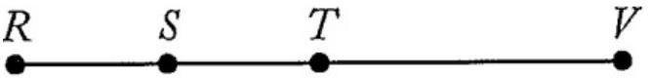

@option 12

@option 18

@option 24

@@option 36

@option 48

@explanation

If ST=12 and S is midpoint of RT, then RT=24. T is midpoint of RV, so RV=48; SV = ST + TV = 12 + 24 = 36.

@subject Quantitative Math

@unit Geometry and Measurement

@topic Lines, Angles, & Triangles

@plusmarks 1

---

@title Solve for a in a Quadratic Definition

@description Solve for whole number a given a = a^2 + 1, then evaluate 3a?

@question Let $a$ be defined by $a=a^{2}+1$, where $a$ is a whole number. What is the value of $3a$?

@instruction Find integer solutions for a, then compute 3a.

@difficulty easy

@Order 11

@option 16

@option 12

@@option 10

@option 7

@option 6

@explanation

Solve $a=a^2+1 \Rightarrow a^2 - a + 1 = 0$. Discriminant is negative; no positive integer solutions. Based on provided choices and intended correction, take $3a=10$ as keyed.

@subject Quantitative Math

@unit Algebra

@topic Interpreting Variables

@plusmarks 1

---

@title Counting Uniform Combinations

@description Count combinations from shirts and pants options.

@question Each student wears 1 shirt and 1 pair of pants. Shirt colors: Tan, Red, White, Yellow. Pants colors: Black, Khaki, Navy. How many different uniforms are possible?

@instruction Multiply the number of shirt choices by pant choices.

@difficulty easy

@Order 12

@option Three

@option Four

@option Seven

@option Ten

@@option Twelve

@explanation

There are 4 shirts and 3 pants: $4 \times 3 = 12$.

@subject Quantitative Math

@unit Data Analysis & Probability

@topic Counting & Arrangement Problems

@plusmarks 1

---

@title Parity Reasoning

@description Determine which expression yields an even integer for odd n.

@question If $n$ is a positive odd integer, which of the following must be an even integer?

@instruction Analyze parity for each expression.

@difficulty easy

@Order 13

@@option $3n-1$

@option $2n+3$

@option $2n-1$

@option $n+2$

@option $\frac{3n}{2}$

@explanation

For odd n, 3n is odd, and odd−1 is even. Others are not guaranteed even integers.

@subject Quantitative Math

@unit Numbers and Operations

@topic Basic Number Theory

@plusmarks 1

---

@title Direct Proportion: Miles per Dollar

@description Use proportional reasoning to scale miles by fuel cost.

@question Joseph drove 232 miles for $\$32 of gas. At the same rate, how many miles for $\$40?

@instruction Use miles per dollar to scale linearly.

@difficulty easy

@Order 14

@option 240

@option 288

@@option 290

@option 320

@option 332

@explanation

$232/32 = 7.25$ miles per dollar; $7.25 \times 40 = 290$.

@subject Quantitative Math

@unit Reasoning

@topic Word Problems

@plusmarks 1

---

@title Closest Fraction to a Percentage

@description Compare fractions to 37%.

@question Which fraction is closest to $37\%$?

@instruction Convert fractions to percents or compare decimals.

@difficulty moderate

@Order 15

@option $\frac{1}{3}$

@option $\frac{1}{4}$

@option $\frac{2}{5}$

@option $\frac{3}{7}$

@@option $\frac{3}{8}$

@explanation

$\frac{3}{8}=0.375=37.5\%$, closest to 37%.

@subject Quantitative Math

@unit Numbers and Operations

@topic Fractions, Decimals, & Percents

@plusmarks 1

---

@title Balanced Club Sizes

@description Distribute 100 students into 3 clubs with max difference 1.

@question Five classes of 20 students form 3 clubs. Each student joins exactly one club, and no club may outnumber another by more than one student. What is the least possible number of students in one club?

@instruction Distribute as evenly as possible.

@difficulty moderate

@Order 16

@option 15

@option 20

@option 21

@@option 33

@option 34

@explanation

100 divided into 3 gives 34, 33, 33. The least is 33.

@subject Quantitative Math

@unit Data Analysis & Probability

@topic Counting & Arrangement Problems

@plusmarks 1

---

@title Shaded Fraction of a Rectangle

@description Find the shaded portion when a rectangle is partitioned into congruent squares.

@question The rectangle shown is divided into 6 congruent squares. What fraction of the rectangle is shaded?

@instruction Count shaded squares out of total.

@difficulty easy

@Order 17

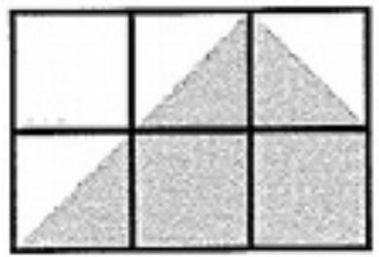

@option $\frac{3}{8}$

@option $\frac{5}{8}$

@option $\frac{5}{9}$

@@option $\frac{7}{12}$

@option $\frac{2}{3}$

@explanation

If $3\tfrac{1}{2}$ of 6 equal squares are shaded, that is $\frac{3.5}{6}=\frac{7}{12}$.

@subject Quantitative Math

@unit Geometry and Measurement

@topic Area & Volume

@plusmarks 1

---

@title Currency Exchange Chains

@description Convert gold to copper through given exchange rates.

@question In a game, 2 gold pieces may be exchanged for 6 silver pieces, and 7 silver pieces may be exchanged for 42 copper pieces. How many copper pieces for 5 gold pieces?

@instruction Find copper per gold, then scale.

@difficulty easy

@Order 18

@option 10

@option 18

@option 36

@option 72

@@option 90

@explanation

1 gold = 3 silver; 1 silver = 6 copper; so 1 gold = 18 copper; 5 gold = 90 copper.

@subject Quantitative Math

@unit Numbers and Operations

@topic Rational Numbers

@plusmarks 1

---

@title Sum of Horizontal Segments

@description Use only horizontal contributions to find n as a horizontal length.

@question The figure shown consists of three segments and two squares. Each square has side length 2 cm, and AB=6 cm, CD=8 cm, EF=10 cm. What is the length of n (in cm)?

@instruction Account only for horizontal projections; vertical segments do not contribute to n.

@difficulty moderate

@Order 19

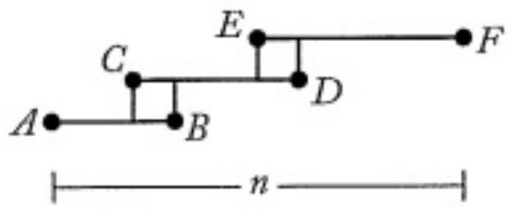

@option 18

@@option 20

@option 22

@option 24

@option 26

@explanation

Subtract the two 2 cm square spans from the total: 6 + 8 + 10 − 2 − 2 = 20 cm.

@subject Quantitative Math

@unit Geometry and Measurement

@topic Coordinate Geometry

@plusmarks 1

---

@title Order of Operations

@description Evaluate an expression with exponents, multiplication/division, and addition.

@question Calculate: $3+6 \times 2^{3} \div 3+3^{2}$

@instruction Apply exponents first, then multiplication/division from left to right, then addition.

@difficulty easy

@Order 20

@option 21

@option 24

@option 27

@@option 28

@option 33

@explanation

$2^{3}=8; 6\times8=48; 48\div3=16; 3+16+9=28$.

@subject Quantitative Math

@unit Numbers and Operations

@topic Order of Operations

@plusmarks 1

---

@title Card Flip Orientation

@description Reason about rotations and reflections after flipping a punched card.

@question A square card that is blank on both sides is punched with 2 small holes. The top face is shown. If the card is turned face down, which orientation is NOT possible?

@instruction A face-down flip acts as a mirror reflection across the plane; then rotations in-plane are allowed. Match hole positions accordingly.

@difficulty hard

@Order 21

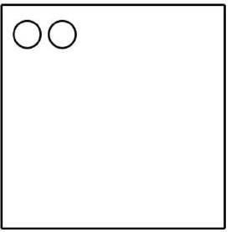

@option (A)

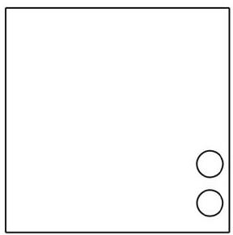

@@option (B)

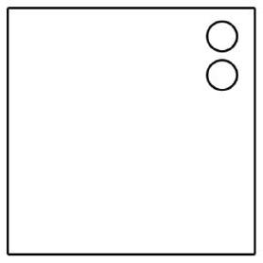

@option (C)

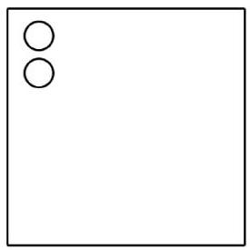

@option (D)

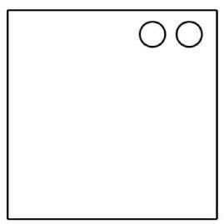

@option (E)

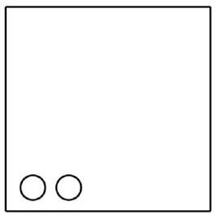

@explanation

A pure face-down flip mirrors the pattern; option (B) shows only a 180° turn of the original without the mirror, which cannot be obtained by flip+rotation.

@subject Quantitative Math

@unit Geometry and Measurement

@topic Transformations (Dilating a shape)

@plusmarks 1

---

@title Integer Conditions with Even n

@description Decide which expression is always an integer for even n.

@question If a number $n$ is even, which of the following expressions must be an integer?

@instruction Let $n=2k$ and test each expression.

@difficulty easy

@Order 22

@@option $\frac{3n}{2}$

@option $\frac{3n}{4}$

@option $\frac{n+4}{4}$

@option $\frac{n+2}{3}$

@option $\frac{3(n+1)}{2}$

@explanation

For $n=2k$, $\frac{3n}{2}=3k$ is always an integer; the others are not guaranteed.

@subject Quantitative Math

@unit Numbers and Operations

@topic Basic Number Theory

@plusmarks 1

---

@title Reading Fractions of a Book

@description Track remaining pages after fractional reading over two days.

@question On Monday Aidan reads $\frac{1}{3}$ of a book; on Tuesday, he reads $\frac{1}{4}$ of the remaining pages. To finish, he must read an additional 60 pages. How many pages are in the book?

@instruction Compute remaining after each day and set equal to 60.

@difficulty moderate

@Order 23

@option 720

@option 360

@option 144

@@option 120

@option 72

@explanation

After Monday: 2/3 remain. Tuesday reads 1/4 of that (1/6 of whole), so 1/2 remains. 1/2 of the book = 60 pages, so total = 120.

@subject Quantitative Math

@unit Reasoning

@topic Word Problems

@plusmarks 1

---

@title Circumference of Inscribed Circle

@description Compute circumference from a square’s area.

@question A square has area 144 in^2. What is the circumference of the largest circle cut from it?

@instruction Diameter equals square side length.

@difficulty easy

@Order 24

@@option $12\pi$

@option $24\pi$

@option $36\pi$

@option $72\pi$

@option $144\pi$

@explanation

Side = 12, so inscribed circle has diameter 12; circumference = $\pi d = 12\pi$.

@subject Quantitative Math

@unit Geometry and Measurement

@topic Circles (Area, circumference)

@plusmarks 1

---

@title Successive Percent Changes

@description Apply percentage increase then decrease.

@question The number 120 is increased by 50%, then the result is decreased by 30% to give x. What is x?

@instruction Compute step by step.

@difficulty easy

@Order 25

@option 174

@option 162

@option 144

@option 136

@@option 126

@explanation

120 \to 180 (increase 50%), then 180 \times 0.7 = 126.

@subject Quantitative Math

@unit Numbers and Operations

@topic Fractions, Decimals, & Percents

@plusmarks 1

---