@title Solve Linear Equation (One-Step)

@description Solve for n in a simple linear equation.

@question If $n+7=12$, what is the value of $n$?

@instruction Select the correct value of n.

@difficulty easy

@Order 1

@option 2

@option 4

@@option 5

@option 7

@option 12

@explanation

Subtract 7 from both sides: $n = 12-7 = 5$.

@subject Quantitative Math

@unit Algebra

@topic Interpreting Variables

@plusmarks 1

---

@title Repeating Symbol Sequence

@description Identify a term in a repeating sequence using modular arithmetic.

@question A sequence repeats the symbols in order: Circle, Square, Triangle, Star. Which is the 12th symbol?

@instruction Determine the cycle length and reduce the index modulo the cycle length.

@difficulty moderate

@Order 2

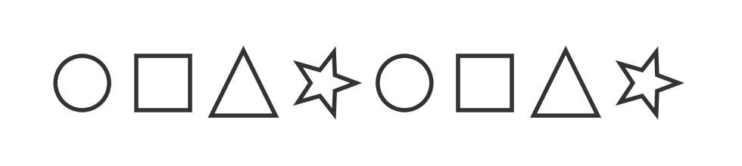

@option Circle

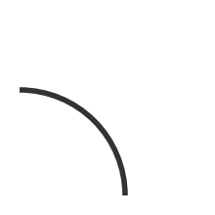

@option Square

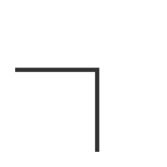

@option Triangle

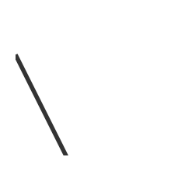

@@option Star

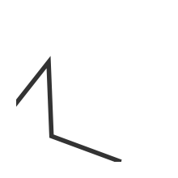

@option Hexagon

@explanation

Cycle length is 4. 12 mod 4 = 0, so the 12th is the 4th in the cycle: Star.

@subject Quantitative Math

@unit Numbers and Operations

@topic Sequences & Series

@plusmarks 1

---

@title Expression for Total Items

@description Translate a word scenario into an algebraic expression.

@question A jar contains 15 marbles. You add $y$ more marbles. Which expression represents the total number of marbles?

@instruction Choose the expression that models the situation.

@difficulty easy

@Order 3

@option $15-y$

@option $15y$

@option $\frac{15}{y}$

@option $y-15$

@@option $15+y$

@explanation

Start with 15 and add y new marbles: $15 + y$.

@subject Quantitative Math

@unit Algebra

@topic Interpreting Variables

@plusmarks 1

---

@title Place Value and Inequality

@description Find the greatest digit for a number to stay below a bound.

@question In the number $5,\square 42$, $\square$ is a digit 0–9. If the number is less than 5,242, what is the greatest possible value for $\square$?

@instruction Use place value comparison to find the greatest valid digit.

@difficulty easy

@Order 4

@option 0

@@option 1

@option 2

@option 4

@option 9

@explanation

Compare hundreds place with 2 in 5,242: the greatest hundreds digit to keep it smaller is 1.

@subject Quantitative Math

@unit Numbers and Operations

@topic Computation with Whole Numbers

@plusmarks 1

---

@title Adding Fractions

@description Add two fractions with unlike denominators.

@question Which of the following is the sum of $\frac{5}{12}$ and $\frac{1}{3}$?

@instruction Compute using a common denominator.

@difficulty easy

@Order 5

@option $\frac{1}{4}$

@option $\frac{2}{3}$

@@option $\frac{3}{4}$

@option $\frac{5}{6}$

@option $\frac{7}{12}$

@explanation

$\frac{5}{12}+\frac{1}{3}=\frac{5}{12}+\frac{4}{12}=\frac{9}{12}=\frac{3}{4}$.

@subject Quantitative Math

@unit Numbers and Operations

@topic Fractions, Decimals, & Percents

@plusmarks 1

---

@title Altitude Difference from a Graph (Conceptual)

@description Read altitude change from start and finish.

@question A hiker starts at 120 meters and ends at 420 meters after a steady climb. How many meters higher is the end than the start?

@instruction Compute final altitude minus initial altitude.

@difficulty easy

@Order 6

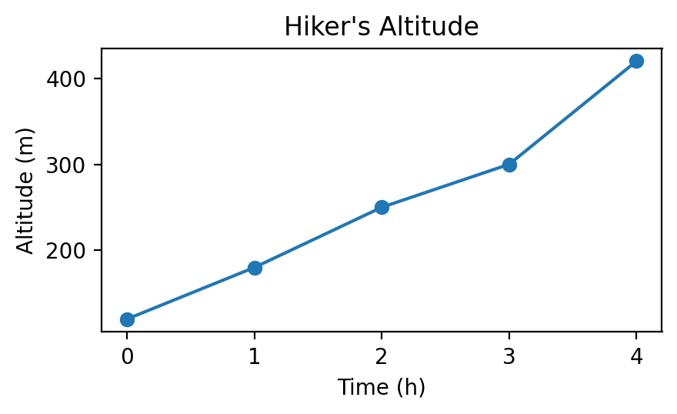

@option 120

@option 240

@@option 300

@option 320

@option 540

@explanation

420 − 120 = 300 meters.

@subject Quantitative Math

@unit Data Analysis & Probability

@topic Interpretation of Tables & Graphs

@plusmarks 1

---

@title Multiply Decimals

@description Evaluate a product of decimals.

@question What is the value of $0.25 \times 18 \times 0.4$?

@instruction Use associativity to simplify.

@difficulty easy

@Order 7

@option 0.18

@@option 1.8

@option 18

@option 180

@option 0.72

@explanation

$0.25 \times 0.4 = 0.1$ and $0.1 \times 18 = 1.8$.

@subject Quantitative Math

@unit Numbers and Operations

@topic Fractions, Decimals, & Percents

@plusmarks 1

---

@title Minimize Coins for a Total

@description Find the least number of coins to make a given amount.

@question There are ten of each coin: 1¢, 5¢, 10¢, and 25¢. If you need exactly 47¢, what is the least number of coins required?

@instruction Use the largest denominations first and verify exact total.

@difficulty moderate

@Order 8

@option Three

@option Four

@@option Five

@option Six

@option Seven

@explanation

47 = 25 + 10 + 10 + 1 + 1 uses five coins; four coins cannot make 47.

@subject Quantitative Math

@unit Reasoning

@topic Word Problems

@plusmarks 1

---

@title Multiply Fractions then Halve

@description Evaluate a nested fractional expression.

@question What is the value of $\frac{1}{2}\left(\frac{2}{3} \times \frac{3}{4}\right)$?

@instruction Multiply inside the parentheses first.

@difficulty easy

@Order 9

@@option $\frac{1}{4}$

@option $\frac{1}{3}$

@option $\frac{3}{8}$

@option $\frac{5}{12}$

@option $\frac{7}{24}$

@explanation

$\frac{2}{3} \times \frac{3}{4} = \frac{1}{2}$; then half gives $\frac{1}{4}$.

@subject Quantitative Math

@unit Numbers and Operations

@topic Fractions, Decimals, & Percents

@plusmarks 1

---

@title Midpoints on a Line Segment

@description Use midpoint relations to compute a segment length.

@question Segment $\overline{ST}$ has length 10, $T$ is the midpoint of $\overline{RV}$, and $S$ is the midpoint of $\overline{RT}$. What is the length of $\overline{SV}$?

@instruction Express RV in terms of ST using midpoint relations.

@difficulty moderate

@Order 10

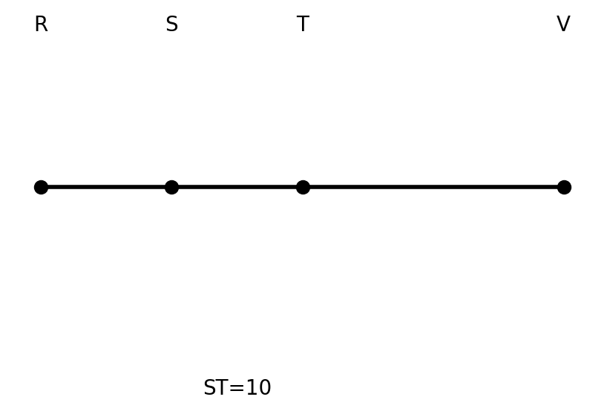

@option 10

@option 20

@@option 30

@option 40

@option 50

@explanation

S midpoint of RT ⇒ ST = RT/2 ⇒ RT = 20. T midpoint of RV ⇒ TV = RT = 20. So SV = ST + TV = 10 + 20 = 30.

@subject Quantitative Math

@unit Geometry and Measurement

@topic Lines, Angles, & Triangles

@plusmarks 1

---

@title Solve Whole-Number Identity

@description Solve for a whole number that satisfies a simple quadratic identity.

@question Let $a$ be defined by $a=a^{2}-a$, where $a$ is a whole number and $a\neq 0$. What is the value of $3a$?

@instruction Solve for a, then compute 3a.

@difficulty easy

@Order 11

@option 4

@option 5

@@option 6

@option 7

@option 8

@explanation

$a=a^{2}-a \Rightarrow a^{2}-2a=0 \Rightarrow a(a-2)=0$. With $a\neq 0$, $a=2$, so $3a=6$.

@subject Quantitative Math

@unit Algebra

@topic Interpreting Variables

@plusmarks 1

---

@title Counting Uniform Combinations

@description Count combinations from shirts and pants options.

@question A uniform has 1 shirt and 1 pair of pants. If there are 5 shirt colors and 2 pants colors, how many different uniforms are possible?

@instruction Multiply the number of shirt choices by pant choices.

@difficulty easy

@Order 12

|  |  |
| --- | --- |
| Shirt Color | Pants Color |
| Blue | Black |
| Green | Khaki |
| White | Navy |
| Red |  |
| Yellow |  |

@option 6

@option 8

@@option 10

@option 12

@option 15

@explanation

There are 5 shirts and 2 pants: $5 \times 2 = 10$.

@subject Quantitative Math

@unit Data Analysis & Probability

@topic Counting & Arrangement Problems

@plusmarks 1

---

@title Parity Reasoning

@description Determine which expression yields an odd integer for even n.

@question If $n$ is an even integer, which of the following must be an odd integer?

@instruction Analyze parity for each expression.

@difficulty easy

@Order 13

@option $n$

@@option $n+1$

@option $2n$

@option $3n$

@option $n+2$

@explanation

If $n$ is even, then $n+1$ is odd.

@subject Quantitative Math

@unit Numbers and Operations

@topic Basic Number Theory

@plusmarks 1

---

@title Direct Proportion: Miles per Dollar

@description Use proportional reasoning to scale miles by fuel cost.

@question A car travels 180 miles on $\$30 of gas. At the same rate, how many miles on $\$45?

@instruction Use miles per dollar to scale linearly.

@difficulty easy

@Order 14

@option 225

@option 240

@option 255

@@option 270

@option 300

@explanation

$180/30 = 6$ miles per dollar; $6 \times 45 = 270$.

@subject Quantitative Math

@unit Reasoning

@topic Word Problems

@plusmarks 1

---

@title Closest Fraction to a Percentage

@description Compare fractions to 62%.

@question Which fraction is closest to $62\%$?

@instruction Convert fractions to percents or compare decimals.

@difficulty moderate

@Order 15

@option $\frac{1}{2}$

@option $\frac{3}{5}$

@@option $\frac{5}{8}$

@option $\frac{2}{3}$

@option $\frac{7}{10}$

@explanation

$\frac{5}{8}=0.625=62.5\%$, closest to 62%.

@subject Quantitative Math

@unit Numbers and Operations

@topic Fractions, Decimals, & Percents

@plusmarks 1

---

@title Balanced Club Sizes

@description Distribute students into clubs with max difference 1.

@question There are 84 students forming 5 clubs. Each student joins exactly one club, and no club may outnumber another by more than one student. What is the least possible number of students in one club?

@instruction Distribute as evenly as possible.

@difficulty moderate

@Order 16

@option 15

@@option 16

@option 17

@option 18

@option 19

@explanation

84 divided as evenly as possible into 5 gives sizes 17, 17, 17, 16, 17; the least is 16.

@subject Quantitative Math

@unit Data Analysis & Probability

@topic Counting & Arrangement Problems

@plusmarks 1

---

@title Shaded Fraction of a Rectangle (Variant)

@description Find the shaded portion count out of total.

@question A rectangle is divided into 8 congruent squares. If $5\tfrac{1}{2}$ squares are shaded, what fraction of the rectangle is shaded?

@instruction Compute shaded total over 8 and simplify if possible.

@difficulty easy

@Order 17

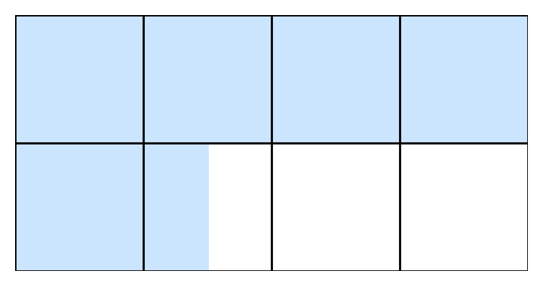

@option $\frac{5}{8}$

@@option $\frac{11}{16}$

@option $\frac{3}{4}$

@option $\frac{7}{12}$

@option $\frac{2}{3}$

@explanation

$5.5/8 = 11/16$.

@subject Quantitative Math

@unit Geometry and Measurement

@topic Area & Volume

@plusmarks 1

---

@title Currency Exchange Chains

@description Convert gold to copper through given exchange rates.

@question In a game, 1 gold piece may be exchanged for 4 silver pieces, and 3 silver pieces may be exchanged for 18 copper pieces. How many copper pieces for 5 gold pieces?

@instruction Find copper per gold, then scale.

@difficulty easy

@Order 18

@option 60

@option 90

@option 100

@@option 120

@option 150

@explanation

1 silver = 6 copper; 1 gold = 4 silver = 24 copper; 5 gold = 120 copper.

@subject Quantitative Math

@unit Numbers and Operations

@topic Rational Numbers

@plusmarks 1

---

@title Sum of Horizontal Segments (Variant)

@description Use only horizontal contributions to find n as a horizontal length.

@question The figure shows AB=5 cm, CD=9 cm, EF=7 cm with two squares of side 3 cm placed between the segments. What is the horizontal length n?

@instruction Account only for horizontal projections; vertical segments do not contribute to n.

@difficulty moderate

@Order 19

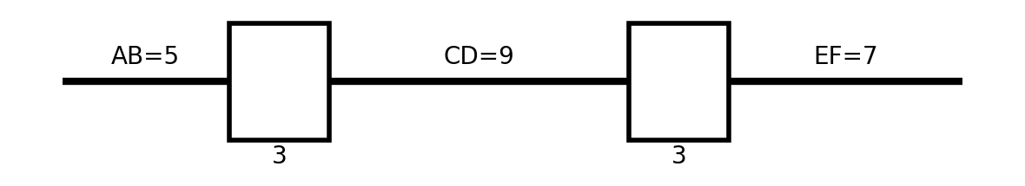

@option 13

@option 14

@@option 15

@option 16

@option 17

@explanation

n = 5 + 9 + 7 − 3 − 3 = 15 cm.

@subject Quantitative Math

@unit Geometry and Measurement

@topic Coordinate Geometry

@plusmarks 1

---

@title Order of Operations

@description Evaluate an expression with exponents, multiplication/division, and addition.

@question Calculate: $2+8 \times 3^{2} \div 4+5^{2}$

@instruction Apply exponents first, then multiplication/division from left to right, then addition.

@difficulty easy

@Order 20

@option 35

@option 39

@option 41

@@option 45

@option 49

@explanation

$3^{2}=9; 8\times9=72; 72\div4=18; 2+18+25=45$.

@subject Quantitative Math

@unit Numbers and Operations

@topic Order of Operations

@plusmarks 1

---

@title Face-Down Flip Concept

@description Understand difference between rotations and mirror reflections.

@question After turning a card face down, which of the following cannot be obtained by rotation alone from the original face-up orientation?

@instruction Recall that a face-down flip produces a mirror image.

@difficulty hard

@Order 21

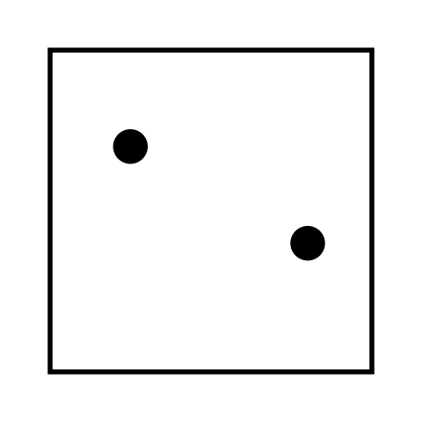

@option 90° rotation

@option 180° rotation

@@option Vertical mirror image

@option 270° rotation

@option 0° (no change)

@explanation

Mirror images cannot be produced by rotations alone.

@subject Quantitative Math

@unit Geometry and Measurement

@topic Transformations (Dilating a shape)

@plusmarks 1

---

@title Integer Conditions with Odd n

@description Decide which expression is always an integer for odd n.

@question If a number $n$ is odd, which of the following expressions must be an integer?

@instruction Let $n=2k+1$ and test each expression.

@difficulty easy

@Order 22

@option $\frac{n}{2}$

@@option $\frac{n+1}{2}$

@option $\frac{3n}{4}$

@option $\frac{n+3}{4}$

@option $\frac{n+2}{3}$

@explanation

For $n=2k+1$, $\frac{n+1}{2}=k+1$ is always an integer.

@subject Quantitative Math

@unit Numbers and Operations

@topic Basic Number Theory

@plusmarks 1

---

@title Reading Fractions of a Book (Variant)

@description Track remaining pages after fractional reading over two days.

@question On Monday, a reader completes $\frac{1}{4}$ of a book; on Tuesday, $\frac{1}{3}$ of the remaining pages. To finish, 90 pages are left. How many pages are in the book?

@instruction Compute the fraction remaining after each day and set to 90.

@difficulty moderate

@Order 23

@option 120

@option 150

@@option 180

@option 240

@option 360

@explanation

After Monday: 3/4 remain. Tuesday reads 1/3 of that ⇒ 2/3 remain of 3/4 ⇒ 1/2 of the book. 1/2 = 90 ⇒ total 180.

@subject Quantitative Math

@unit Reasoning

@topic Word Problems

@plusmarks 1

---

@title Circumference of Inscribed Circle

@description Compute circumference from a square’s area.

@question A square has area 196 in^2. What is the circumference of the largest circle cut from it?

@instruction Diameter equals square side length.

@difficulty easy

@Order 24

@@option $14\pi$

@option $28\pi$

@option $42\pi$

@option $56\pi$

@option $196\pi$

@explanation

Side = $\sqrt{196}=14$, so circumference = $\pi d = 14\pi$.

@subject Quantitative Math

@unit Geometry and Measurement

@topic Circles (Area, circumference)

@plusmarks 1

---

@title Successive Percent Changes

@description Apply percentage increase then decrease.

@question The number 150 is increased by 20%, then decreased by 25% to give x. What is x?

@instruction Compute step by step.

@difficulty easy

@Order 25

@option 110

@option 115

@option 120

@option 130

@@option 135

@explanation

150 \to 180 (increase 20%), then 180 \times 0.75 = 135.

@subject Quantitative Math

@unit Numbers and Operations

@topic Fractions, Decimals, & Percents

@plusmarks 1

---