@title Right Triangle Hypotenuse

@description Find the hypotenuse of a right triangle using the Pythagorean theorem.

@question In the right triangle shown, the legs have lengths 6 and 8 units. What is the length of the hypotenuse?

@instruction Select the correct value of the hypotenuse.

@difficulty easy

@Order 1

@option 7

@option 8

@option 9

@@option 10

@option 14

@explanation

By the Pythagorean theorem, c = \sqrt{6^{2} + 8^{2}} = \sqrt{36 + 64} = \sqrt{100} = 10.

@subject Quantitative Math

@unit Geometry and Measurement

@topic Right Triangles & Trigonometry

@plusmarks 1

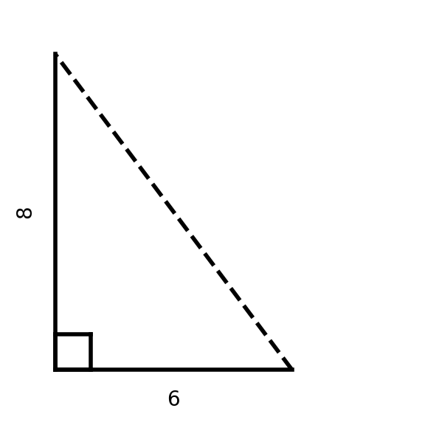

---

@title Average Fruit Count

@description Compute the mean from a bar chart of three categories.

@question The bar chart shows the counts of Apples, Bananas, and Cherries collected by a class. What is the mean (average) count across the three fruits?

@instruction Choose the mean of the displayed counts.

@difficulty moderate

@Order 2

@option 6

@option 6.5

@@option 7

@option 7.5

@option 8

@explanation

If the counts are 4, 7, and 10, then mean = (4+7+10)/3 = 21/3 = 7.

@subject Quantitative Math

@unit Data Analysis & Probability

@topic Mean, Median, Mode, & Range

@plusmarks 1



