CPSC 5011 - HW3 Design / CRC cards:

Group 3: Divya Arisetty, Grant Bishop, Tong Ding, Yi Niu, Neha Sahu

**0. Problem statement**

The key nouns (to potentially be classes) and **verbs** (part of use cases) in the problem statement where identified:

On SU Online, students are able to **search and register** for classes. In order to **add** a course, students need to meet the prerequisites and the class may not be full. Students may also **drop** a class they decide not to take before the registration deadline. Students can only take a maximum of 18 credits if undergrad or 12 credits if grad student.

Students must be **logged into** SU Online before attempting to add or drop, but can search for classes either logged in or not. If the class is full, students must **send** an email to their advisor with their name, SUID, and the course they want to take; students will be put on a waitlist for the requested course. If space allows, students will be automatically **enrolled** in the order they are listed on the waitlist.

**1. Use Cases**

The following flowchart provides an end-users perspective of all available actions:

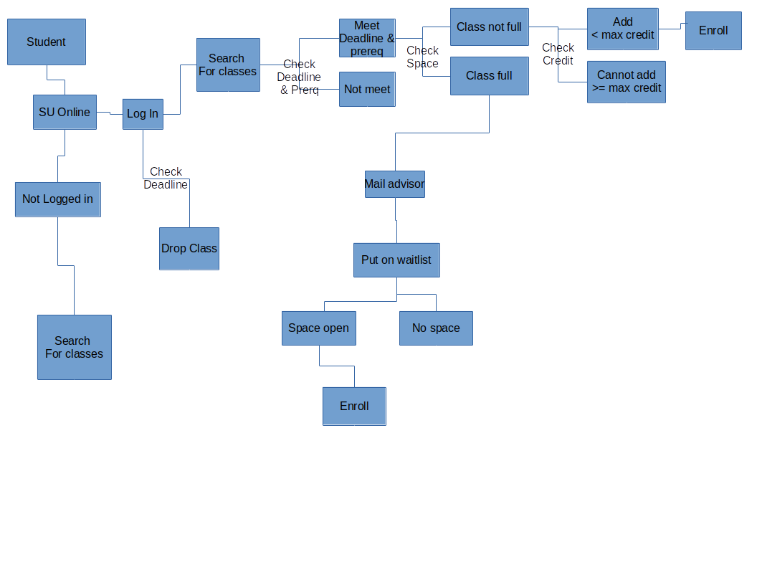

**Figure 1.** The flowchart indicating possible use cases. Detailed word explanations are followed.

* A student searches a course on SU Online without logging in.
* A student logs in on SU Online, searches for a course but cannot add/drop it because the registration deadline has been passed.
* A student logs in on SU Online to drop a course before the registration deadline.
* A student logs in on SU Online, searches for a course to add but cannot add it because the student hasn’t taken all prerequisites.
* A student logs in on SU Online, searches for a course to add. The course is not full, but the student cannot add it because that will exceed his/her maximum credits.
* A student logs in on SU Online, searches for a course to add, and adds the course.
* A student logs in on SU Online, searches for a course to add. The course is full, so the student emails his/her advisor to be put on the waitlist. Eventually, the student may or may not be enrolled depending on whether or not spots open up.

**2. Class identification**

After Identifying all the important nouns in (0. Problem statement), potential classes were listed:

|  |  |  |
| --- | --- | --- |
| Probably | Possibly | Rejected |
| SU Online  Student  Course | Waitlist - a FIFO queue  Advisor - joins student and waitlist  Registration - allows a student to add/drop classes after he/she logged in SU Online  Class - a course may contain several classes (different sessions). In this case, we simplified this scenario by using the course instead. | Prerequisites: the property of the class  Name: the property of the student  SUID: the property of the student  Space: the property of the class  Deadline: the property of the registration system or class |

**Table 1.** Identified “probably”, “possibly”, and “rejected” class candidates.

**Class candidates:** SU Online, Student, Course, Registration, Waitlist, Advisor

Decisions making in more detail:

**SUOnline / ‘Registration System’**: There need to be one or more classes that deal with the ‘front-end,’ providing actions to the users. These may be analogous to the Driver and Menu classes in HW 2.

**SUOnline**: allows the user to search for classes. Contains actions apply to all types of users. Stores schedule (course) information -> class

**Registration**: allows the *logged in user* to register for classes (or drop or add to the waitlist) if conditions are met. -> class

**Student**: There is a lot of student-specific data to store (name, GPA, previous classes taken, &c). There are undergraduate and graduate student types. -> class, subclasses

**Class/Course**: As the student, there are a lot of important attributes to store (title, number of credits, prerequisites), and most importantly a list of enrolled students. A class has a list of enrolled students and a waitlist. A course also may have multiple sections -> class, subclasses

**Name**: a property of student -> not a class

**SUID**: a property of student -> not a class

**Deadline**: a property of the class (if different for each class) or of registration (if the same for all classes) -> not a class (existing Date class?)

**Waitlist**: the waitlist is a queue of students. Each class will have a waitlist. Students will be added to the waitlist, and may be removed when enrolled -> class, specialized queue (inherits from / composed of?)

**Advisor**: Receives emails and adds students to the waitlist. May have other functionality? (Creating / editing courses?) -> class

**Prerequisites**: a course has a list of prerequisite classes, and a student has a list of classes that they have already taken. -> not a class

**Space** (number of spaces in a class): just an int value or number of indices in a list -> not a class

**3. Relationships between classes**

**Dependency:**

The ‘collaborators’ as seen in the CRC cards depend on each other - the diagram in (4.) shows the connections between the classes.

**Inheritance:**

An [undergraduate/graduate] student is a Student

A CourseSection is a Course

**Aggregation and composition:**

Class has-a waitlist

Student has-a for many classes

(and the inverse, classes have many students)

**Other:**

Waitlist could either inherit from a queue or have a queue. (inheritance vs. composition)

**4. CRC cards**



**Figure 2.** Proposed relationships between identified class candidates. The responsibilities of each class are not showed here but listed in the following CRC cards.

