JAVA_HOME : JAVA 17

JAVA Compiler project bytecode version :17

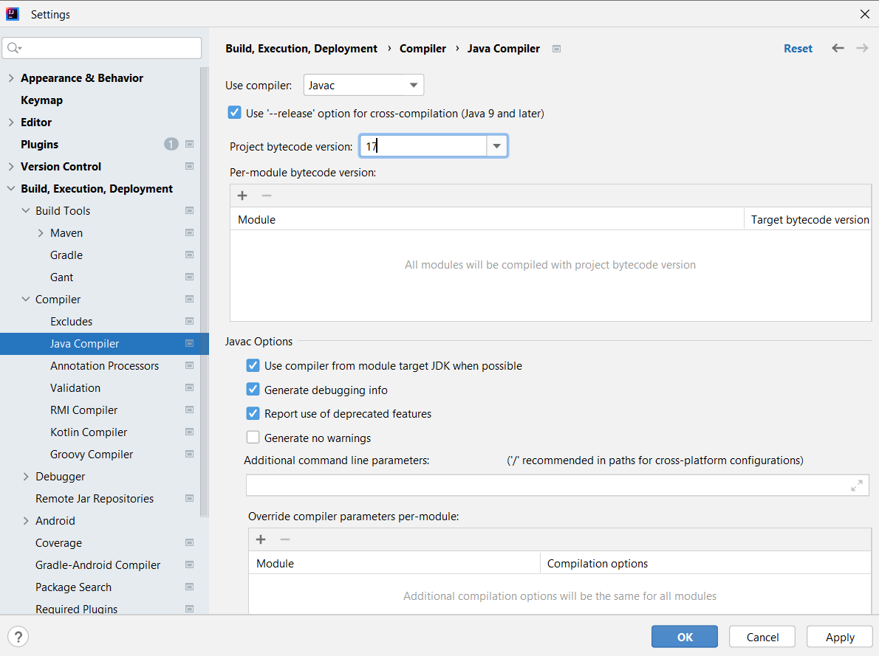

Gradle JVM and Gradle wrapper.properties

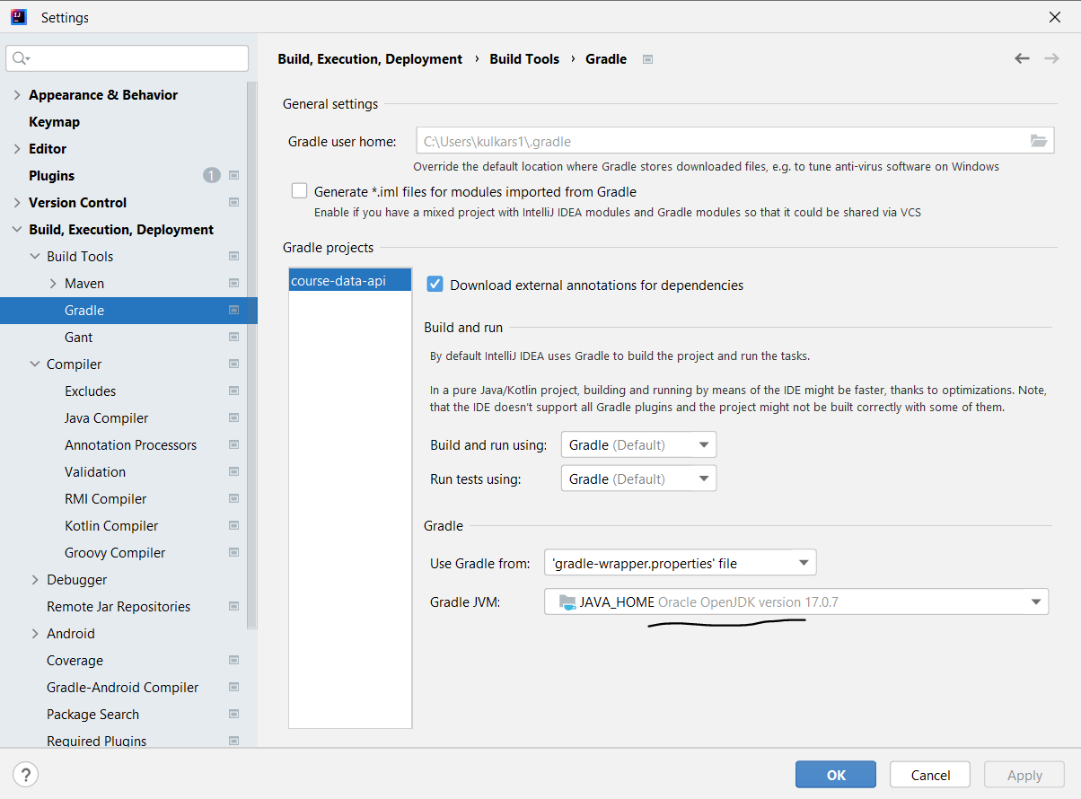

SDK 17 java version 17.0.7

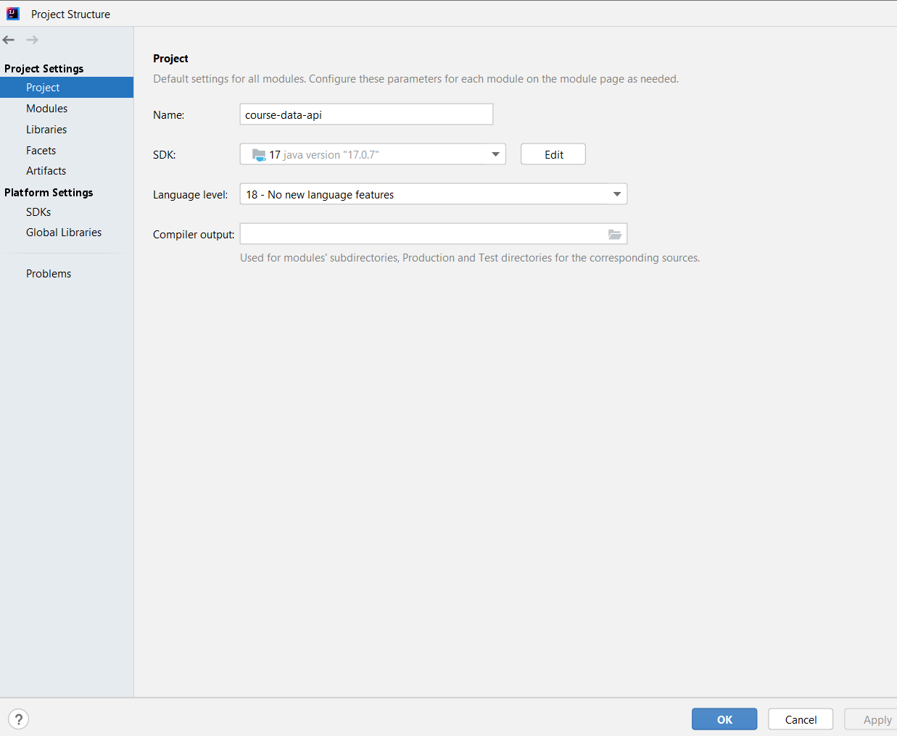

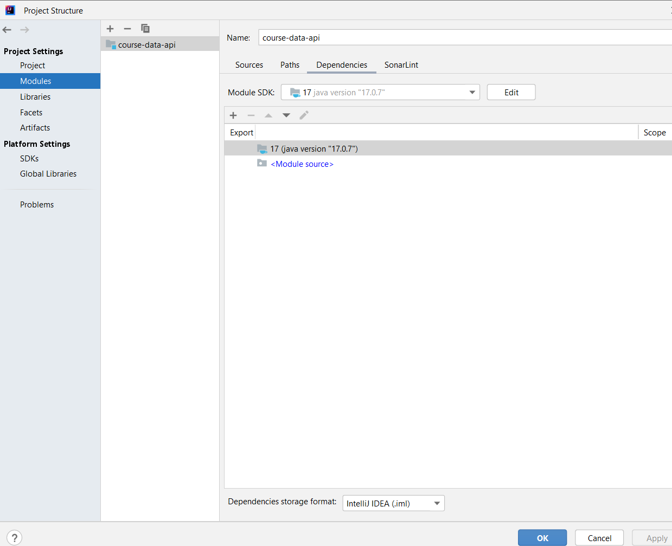

Modules : 17

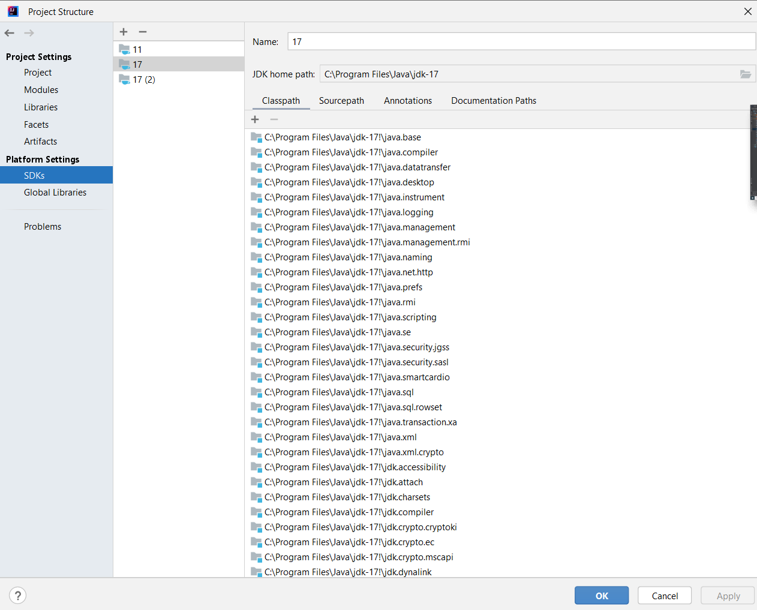

SDKs : 17