WEEK 5
1)1)Write a Program to design Lexical Analyzer in C/C++/Java/python language(to recognize any five keywords,identifiers,numbers,operators and punctuation)

kwd=['int','float','char','if','else']
oper=['+','-','*','/','%']
punct=['.',',','!']

def func():
txt=input("Enter text")
txt=txt.split()
for token in txt:
if token in kwd:
print(token + "is keyword")
elif (token in oper):
print(token + "is operator")
elif(token in punct):
print(token + "is punctuator")
elif(token.isnumeric()):
print(token + "is number")
elif(not token[0].isnumeric()):
print(token + "is identifier")
else:
print(token + "is not valid identifier")
func()

OUTPUT:
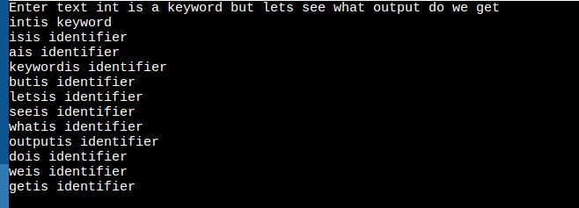

2)2)Write a Lex Program that copies a file,replacing each nonempty sequence of white spaces by a single blank.

%{
#include<stdio.h>
char fname[200];
%}
%%
[a-zA-Z0-9]+ {printf("%s",yytext);}
[" "|\n|\t]+ {printf(" "); }
%%
int yywrap()
{
}
int main()
{
printf("enter filename:");
scanf("%s",fname);
yyin=fopen(fname,"r");
yylex();
return 0;
fclose(yyin);
}

OUTPUT:

