

A Course End Project Report on
Student Feedback Analyzer

A9513- Python Programming Laboratory

Submitted by K.Revanth 25881A05B1
M.Spoorthi 25881A05C1

Course Facilitator

Ms P.S.Madhavi
Assistant Professor Computer Science and Engineering

Department of Computer Science and Engineering Vardhaman College of Engineering, Hyderabad



Autonomous Institute, Affiliated to JNTUH,
Approved by AICTE, Accredited by NAAC with A++ Grade Kacharam, Shamshabad, Hyderabad- 501 218, Telangana, India.

DEPARTMENT OF COMPUTER SCIENCE AND ENGINEERING

This is to certify that the Course End Project titled “Student Feedback analyzer” is carried out by K.Revanth,M.Spoorthi with Roll Numbers 25881A05B1,25881A05C1 towards A9513 –Python Programming Laboratory course in partial fulfilment of the requirements for the award of degree of Bachelor of Technology in Computer Science and Engineering during the Academic year 2026-27.

Signature of the Course Faculty Ms P.S. Madhavi
Assistant Professor, Computer Science and Engineering
Signature of the HOD Dr.Y.Vijayalata
Professor,Head of the Department & Dean (Student Mentoring)
Department Computer Science and Engineering,
Vardhaman College of Engineering, Hyderabad

Contents
- Introduction 1
- Literature Review 2
- Objectives 3
- Methodology 4
  - Architectural Diagram 5
  - Hardware and Software Requirements 6
  - Working Principle 7
  - Software Implementation 8
- Results and Discussion 14
- Mapping POs , P S O s and SDGs 18
  - Program Outcomes (POs) Mapping 18
  - Sustainable Development Goals (SDGs) Mapping 19
- Conclusion 20
Bibliography 21

Abstract

The Student Feedback Analyzer is a Python-based project designed to simplify the process of collecting, processing, and analyzing student feedback in educational institutions. Student feedback provides valuable information about teaching quality, course content, communication, classroom environment, and overall student satisfaction. However, analyzing a large number of responses manually can be time-consuming and may lead to difficulties in identifying common opinions and areas that require improvement. This project aims to address these challenges by developing a simple automated system that processes student responses and generates meaningful results.
The system collects feedback in the form of numerical ratings and written comments. The collected data is stored in an organized manner and processed using Python programming concepts such as lists, dictionaries, loops, conditional statements, functions, and file handling. The analyzer calculates average ratings for different parameters and can classify feedback as positive, neutral, or negative using predefined rules. The analyzed results are presented in a clear and understandable format, helping users identify strengths and areas for improvement.
The proposed system reduces the effort involved in manual feedback analysis and improves the organization of student responses. It also demonstrates the practical application of Python programming in solving a real-world problem in the education sector. In the future, the project can be enhanced with graphical representations, database connectivity, a graphical user interface, and advanced sentiment analysis techniques. Overall, the Student Feedback Analyzer provides a simple and efficient approach to understanding student opinions and supporting continuous improvement in the teaching and learning process.

Keywords: Student Feedback Analyzer, Python Programming, Data Analysis, Feedback Management, Sentiment Analysis, Educational Technology.

Introduction

Student feedback plays an important role in improving the quality of education and understanding the learning experiences of students. It provides valuable information about different aspects of teaching, such as teaching effectiveness, course content, communication, classroom environment, learning resources, and overall satisfaction. By collecting feedback regularly, educational institutions can understand the strengths of their teaching methods and identify areas that require improvement.
Traditionally, student feedback is often collected through paper forms or basic online forms. Although these methods are useful for gathering responses, analyzing a large number of responses manually can be time-consuming and may make it difficult to identify common trends. Teachers or administrators may need to go through individual responses, calculate ratings, and summarize the results manually. This creates a need for a simple automated system that can process feedback efficiently.
The Student Feedback Analyzer is a Python-based project developed to address this problem. The system collects feedback from students and analyzes the responses to generate a meaningful summary. It can process ratings given for different parameters and calculate their average values. The system can also analyze textual feedback and classify responses based on their nature, such as positive, neutral, or negative, depending on the implementation.
Python is suitable for developing this application because it provides simple programming structures and powerful features for data processing. Concepts such as variables, lists, dictionaries, conditional statements, loops, functions, and file handling can be used to develop the system. These features allow the collected feedback to be stored, processed, and presented in an organized manner.
The proposed system follows a simple workflow. Students provide their feedback through the input interface, after which the responses are stored in an appropriate data structure or file. The Python program then processes the collected information, calculates ratings, analyzes the responses, and generates a summarized report. The results can help teachers understand the overall perception of students without having to manually examine every response.
Overall, the Student Feedback Analyzer provides a simple and efficient approach to analyzing student opinions using Python. It reduces the effort involved in manual feedback analysis and presents the collected information in a structured and understandable form, making it a useful application for academic feedback management.

Literature Review

Student feedback is an important component of the educational evaluation process. It provides information about students' experiences, satisfaction levels, perceptions of teaching methods, and difficulties faced during a course. Educational institutions commonly collect feedback regarding teaching quality, course structure, communication, classroom environment, learning resources, and overall satisfaction. The information obtained from students can be used to understand the effectiveness of teaching and identify areas that require improvement.
Traditional student feedback systems generally depend on paper-based questionnaires or basic digital forms. In a paper-based system, students provide their responses manually, after which the collected forms need to be reviewed and analyzed by teachers or administrators. This approach can become difficult when the number of students is large. Manually calculating average ratings and identifying frequently occurring opinions requires additional time and effort. There is also a possibility of errors while recording or calculating the results.
The development of computer-based feedback systems has helped reduce some of these difficulties. Digital feedback systems allow responses to be collected and stored electronically. Once the information is stored digitally, programming techniques can be used to process the data automatically. This makes it possible to calculate ratings, count responses, compare different parameters, and generate summaries more efficiently. Data analysis has become increasingly useful in educational applications because large amounts of information can be processed systematically. Instead of examining each response individually, a computer program can identify patterns and summarize the collected information. For example, if students provide ratings from 1 to 5 for teaching quality, the program can calculate the average rating and determine the general level of satisfaction. Similar calculations can be performed for course content, communication, classroom environment, and other parameters.
The proposed Student Feedback Analyzer is designed as a simple Python-based solution for this purpose. It focuses on collecting student responses, organizing the information, processing ratings, and generating an understandable feedback summary. The project is intended to demonstrate how basic programming and data-processing concepts can be applied to a practical educational problem.
The system can also be extended beyond basic rating calculations. Future versions could include graphical representations such as bar charts and pie charts, database storage, a graphical user interface, automated sentiment analysis, student authentication, and online feedback collection. These additions could make the system more suitable for larger educational institutions.
Thus, the literature and existing approaches indicate that automated feedback processing can reduce manual effort and make student responses easier to interpret. The proposed Student Feedback Analyzer applies these concepts using Python and provides a foundation for developing a more advanced educational feedback-analysis system.

Objectives

To develop a Python-based system for collecting student feedback

The primary objective is to develop a simple and functional application using Python that allows students to provide feedback about their learning experience.The system can accept Information such as student responses,ratings,and comments.Different parameters can be included,such as teaching quality,course content,communication,classroom environment and overall satisfaction.

To store feedback responses in an organized manner

Once feedback is collected, it needs to be stored properly so that it can be accessed and analyzed later. This project aims to organize student responses using python data structures such as lists and dictionaries or external files such as CSV files.Proper data organization makes it easier to retrieve individual responses,calculate statistics,and perform further analysis.This approach also makes the system easier to modify and extend in the future.

To help teachers and institutions identify areas that need improvement

This objective is to male the analyzed feedback useful for educational improvement.By examining average ratings and student comments,teachers can identify areas that receive comparatively lower ratings or repeated suggestions.The system does not replace human decision-making.

Methodology

Architectural Diagram
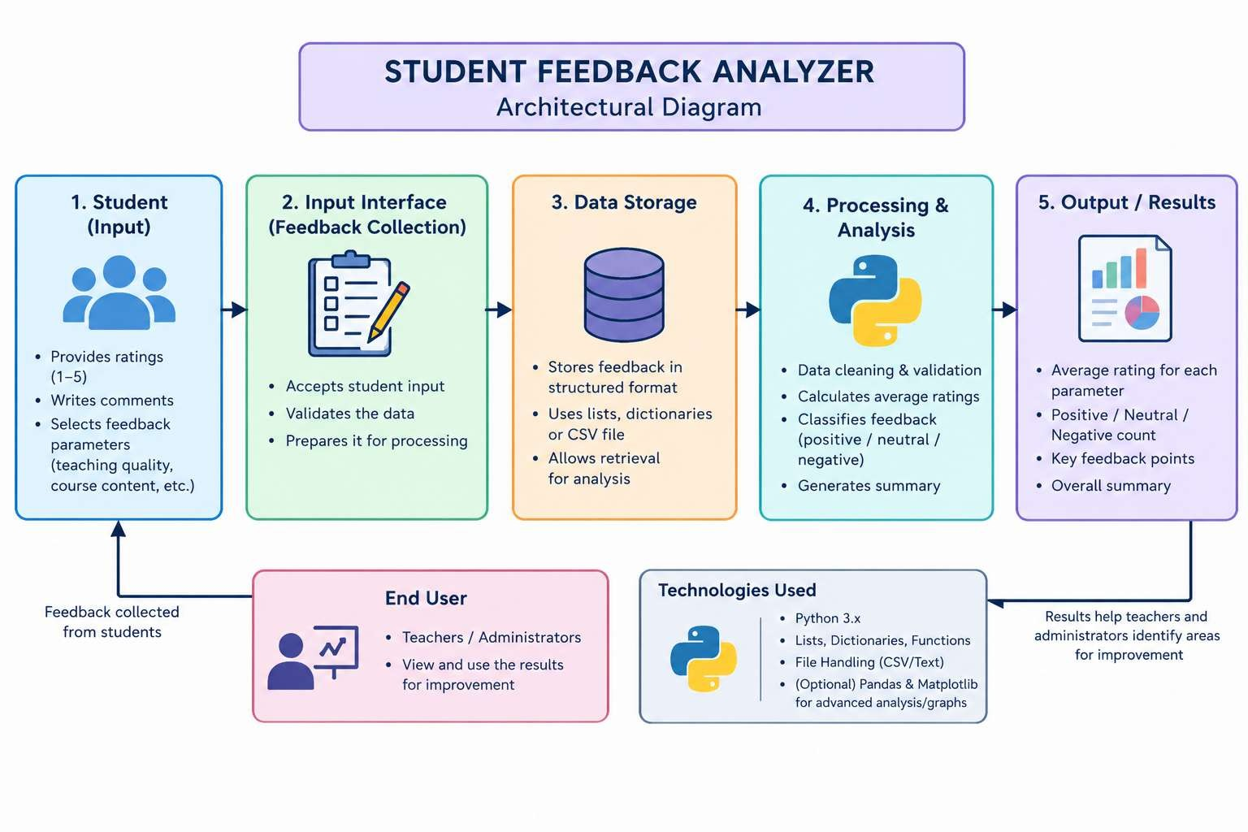
Figure 1: Architectural Diagram
The architectural diagram of the Student Feedback Analyzer represents the complete flow of the system. It begins with students providing ratings and written feedback. The feedback collection module accepts and validates the entered information. The collected data is then stored using Python data structures or files. The stored feedback is passed to the processing and analysis module. Python is used to calculate average ratings and analyze the responses. The system can classify feedback as positive, neutral, or negative. The analyzed information is converted into a simple and understandable summary. The results are presented to teachers or admistrators.

Hardware and Software Requirements

Hardware:
    - Intel/AMD Processor
    - Minimum 4GB RAM
    - Standard Display C Input Devices

Software:
    - Python version(Python 3.x)
    - Data storage(CSV)
    - Any IDE (VS code/IIDLE/PyCharm)

Working Principle

The Student Feedback Analyzer works by accepting feedback from students and processing the collected information.
First, the student enters ratings and feedback for different parameters. The program validates the input and stores the responses using Python data structures or a file. After sufficient feedback has been collected, the analyzer processes the responses.
The program calculates the average rating for each parameter and determines the overall feedback level. Written comments can also be categorized based on predefined keywords or simple sentiment rules. Finally, the system displays the analyzed results to the user.
For example, if students provide ratings for Teaching Quality, Course Content, Communication, and Classroom Environment, the system calculates the average rating for each category. This makes it easier to identify which areas received higher or lower ratings

Software Implementation
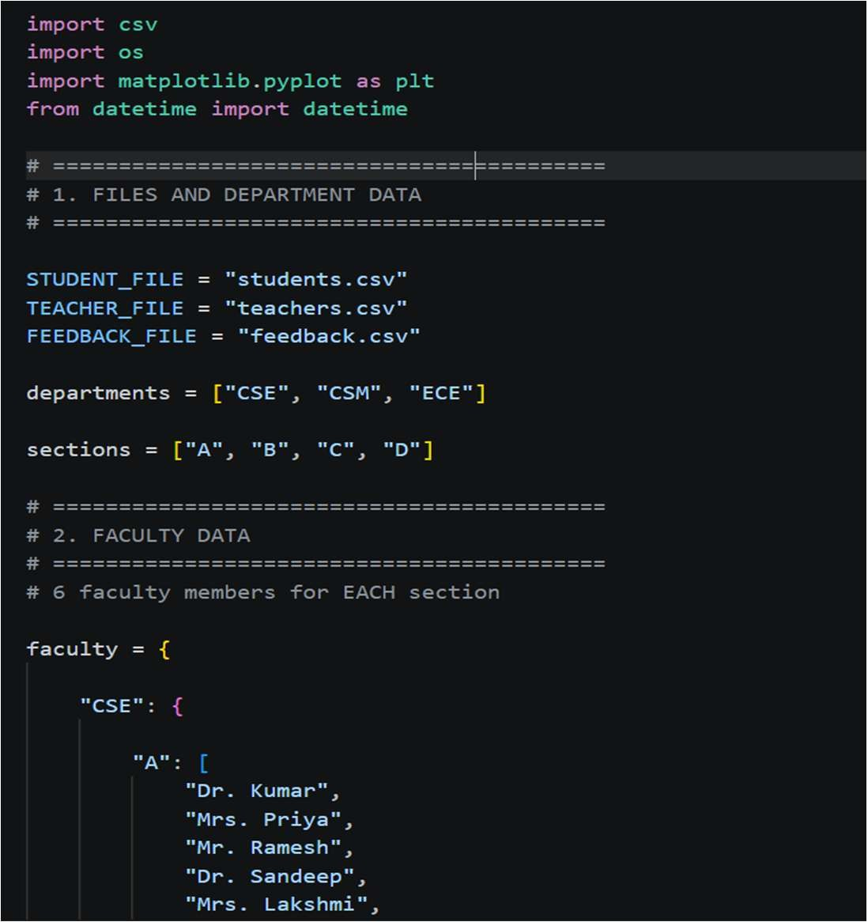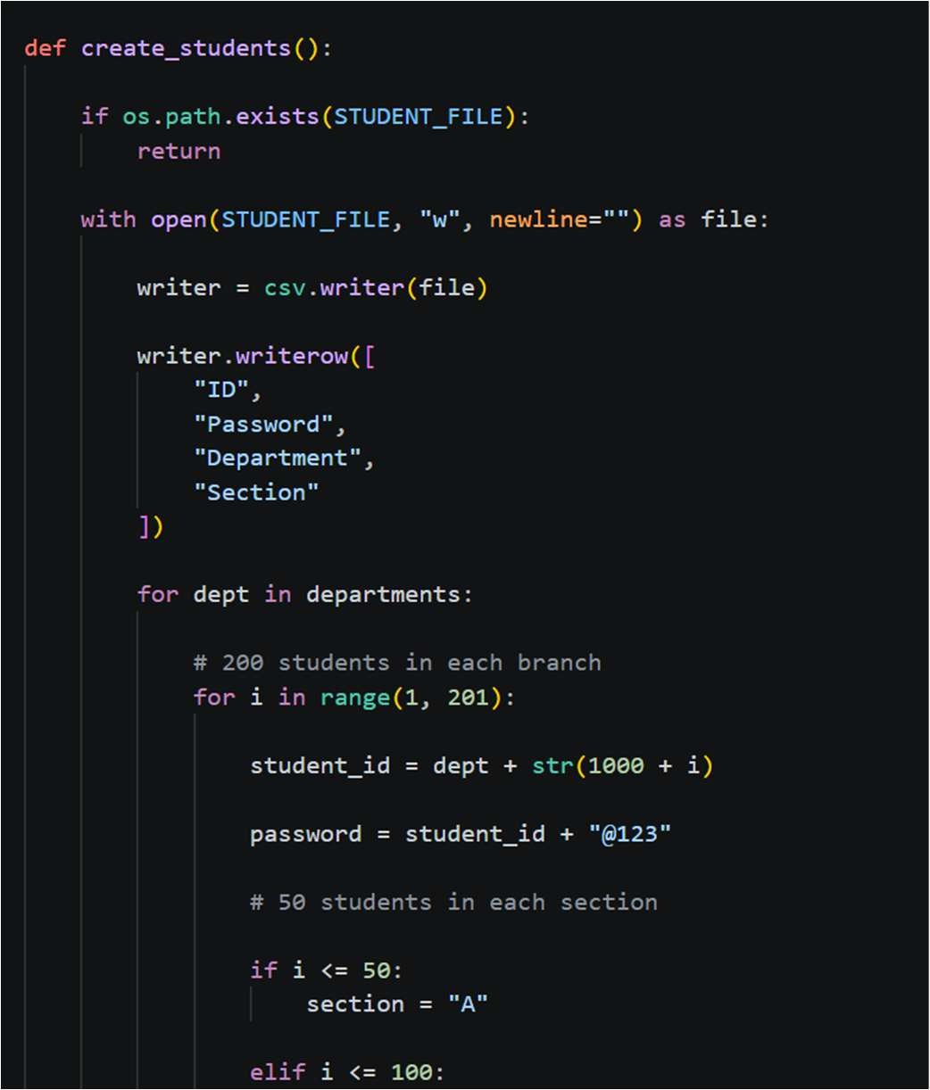

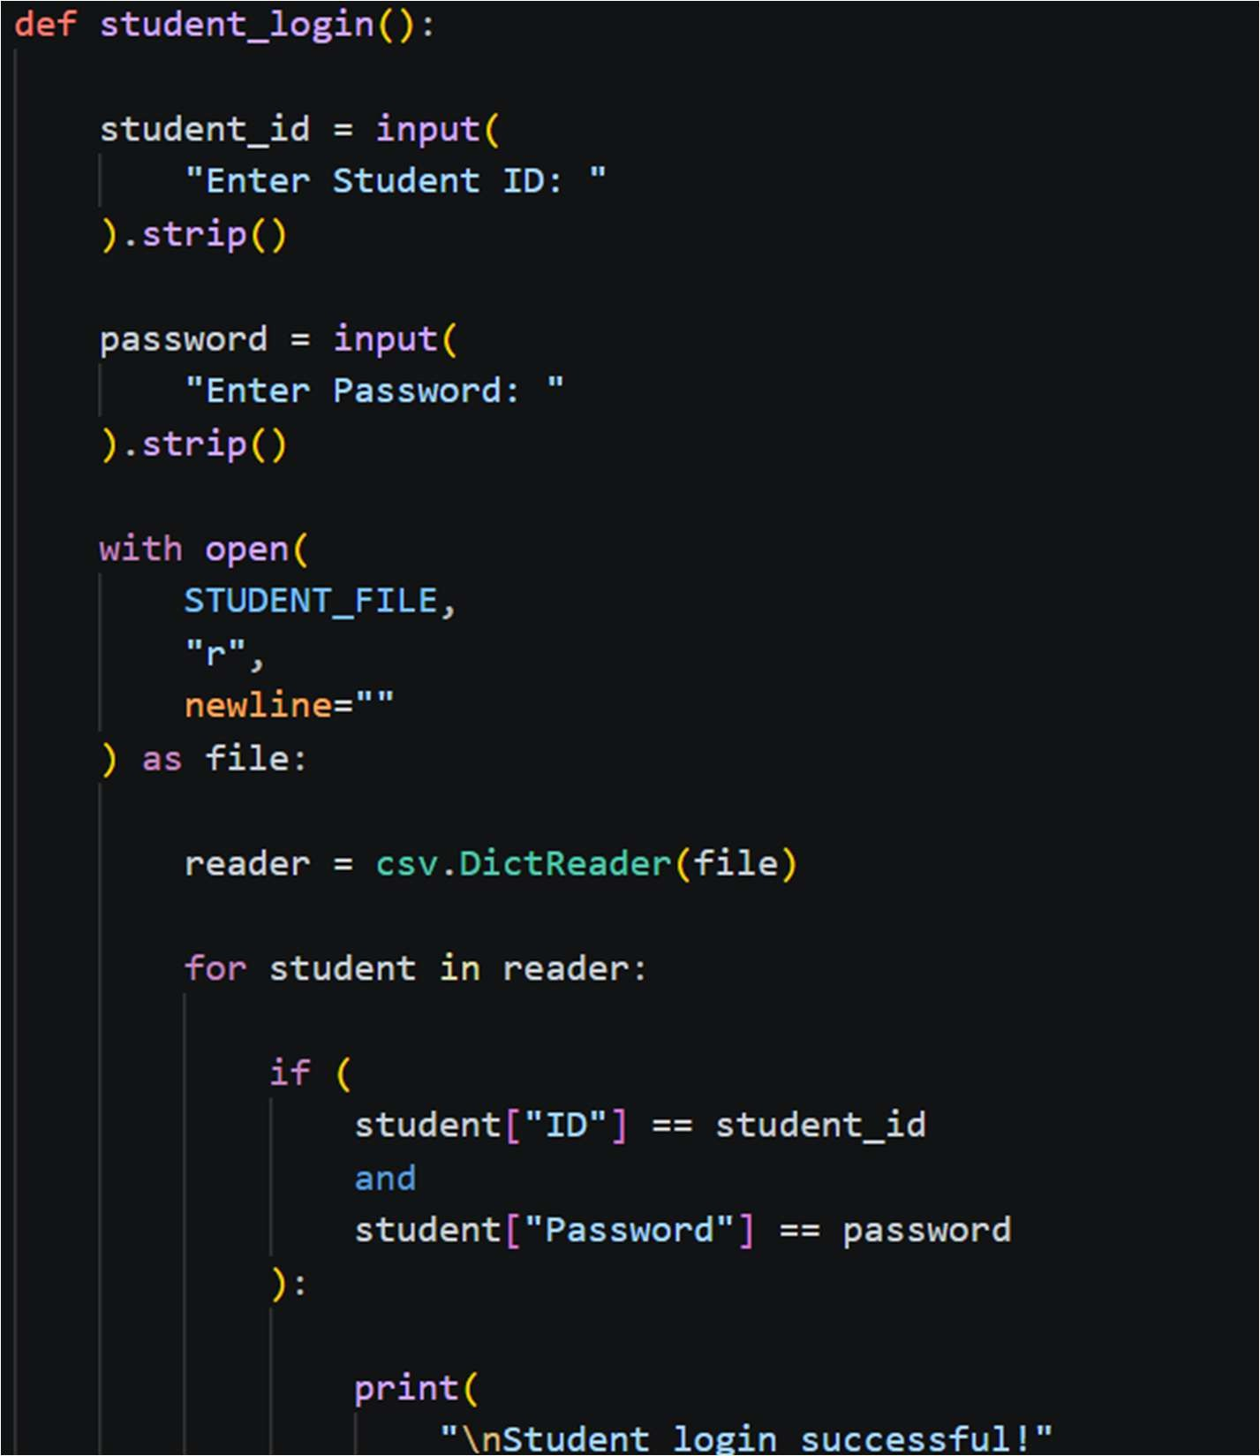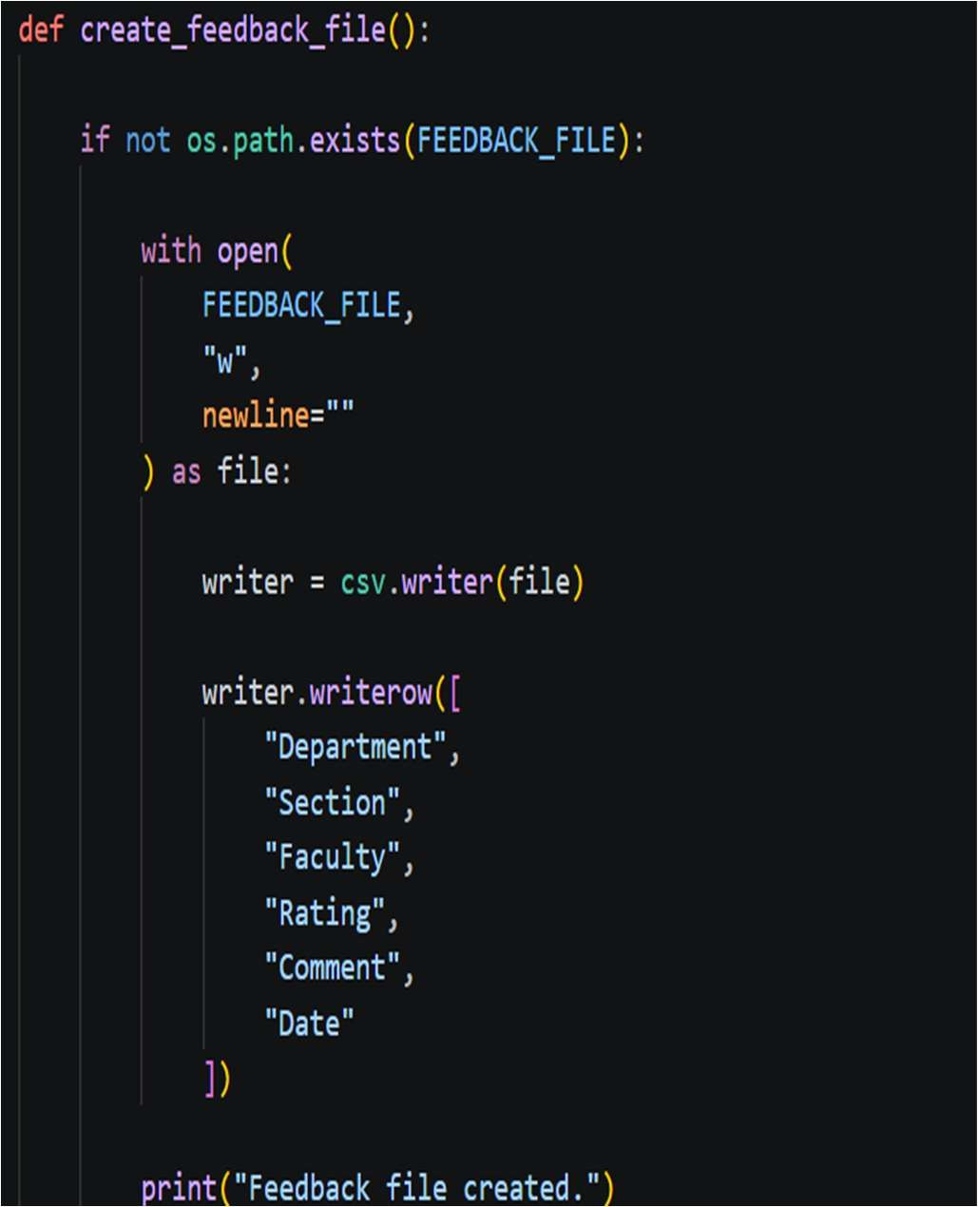

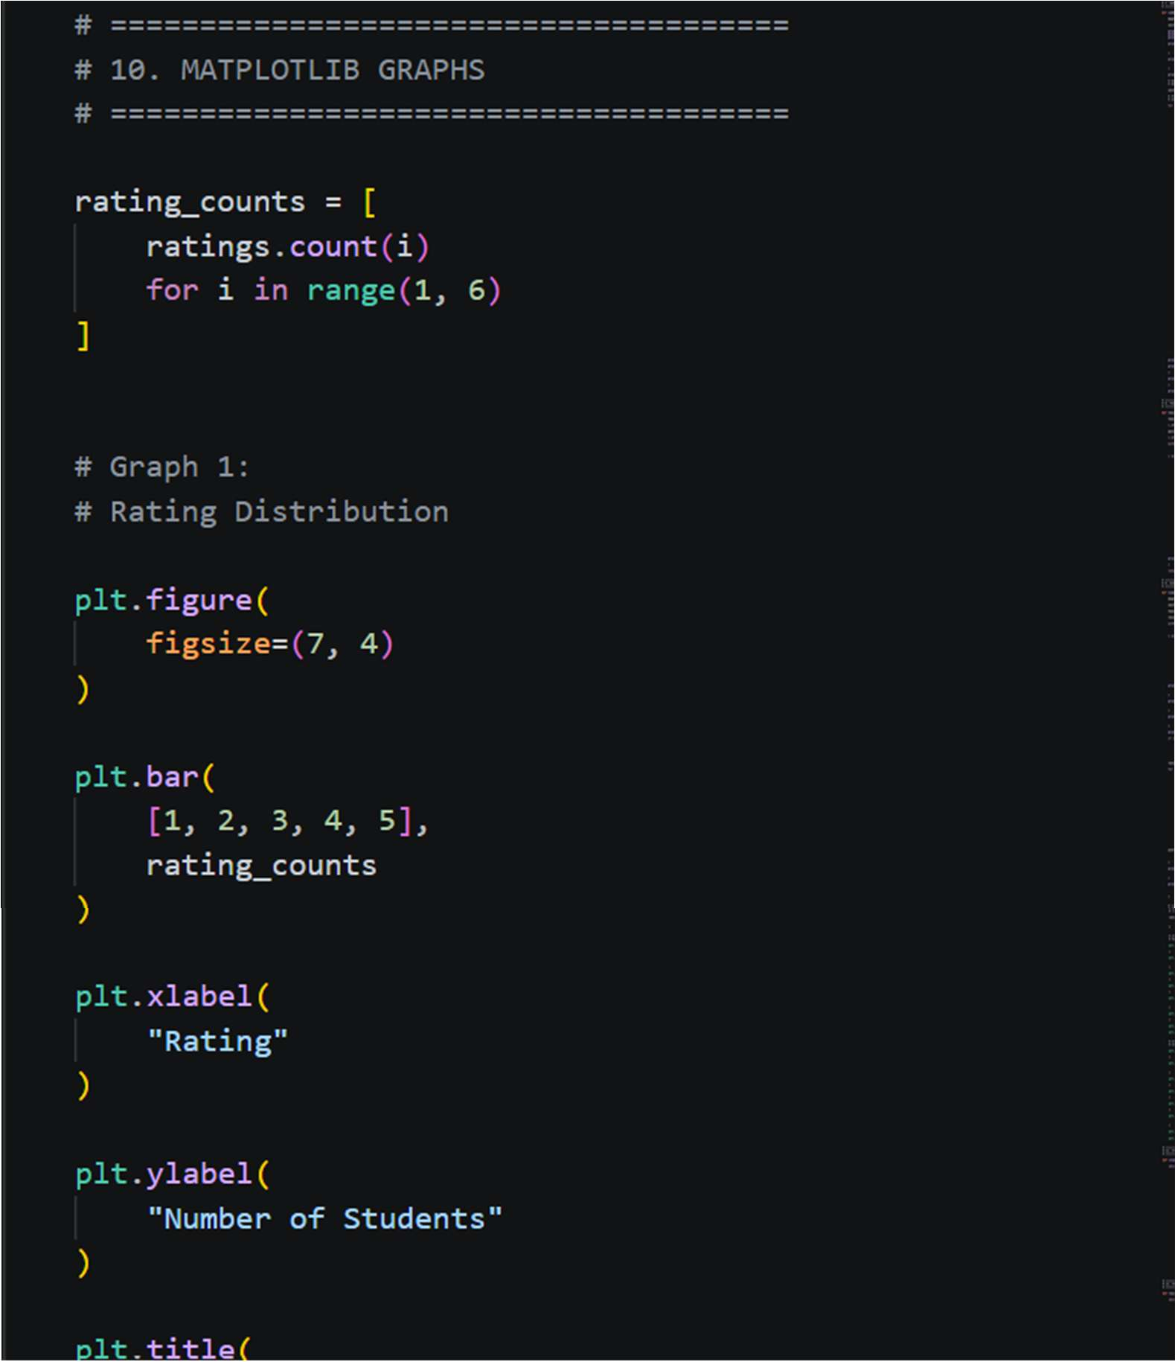

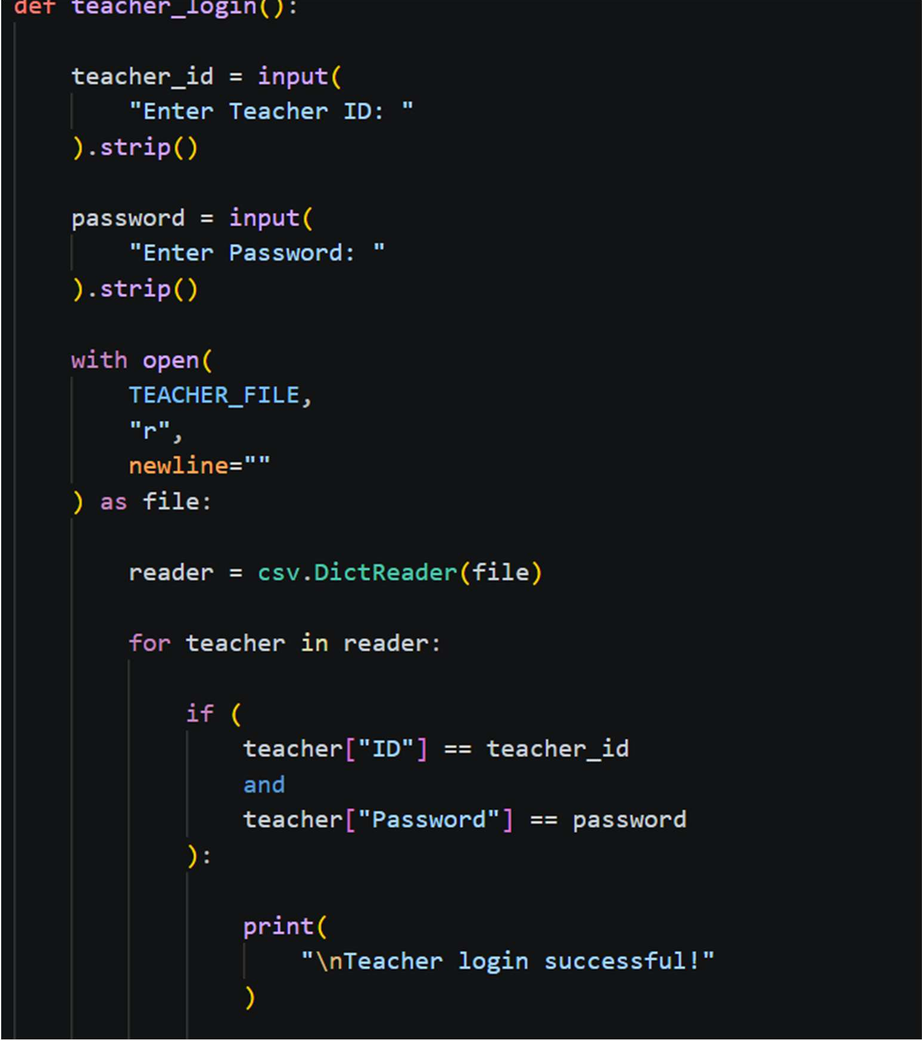

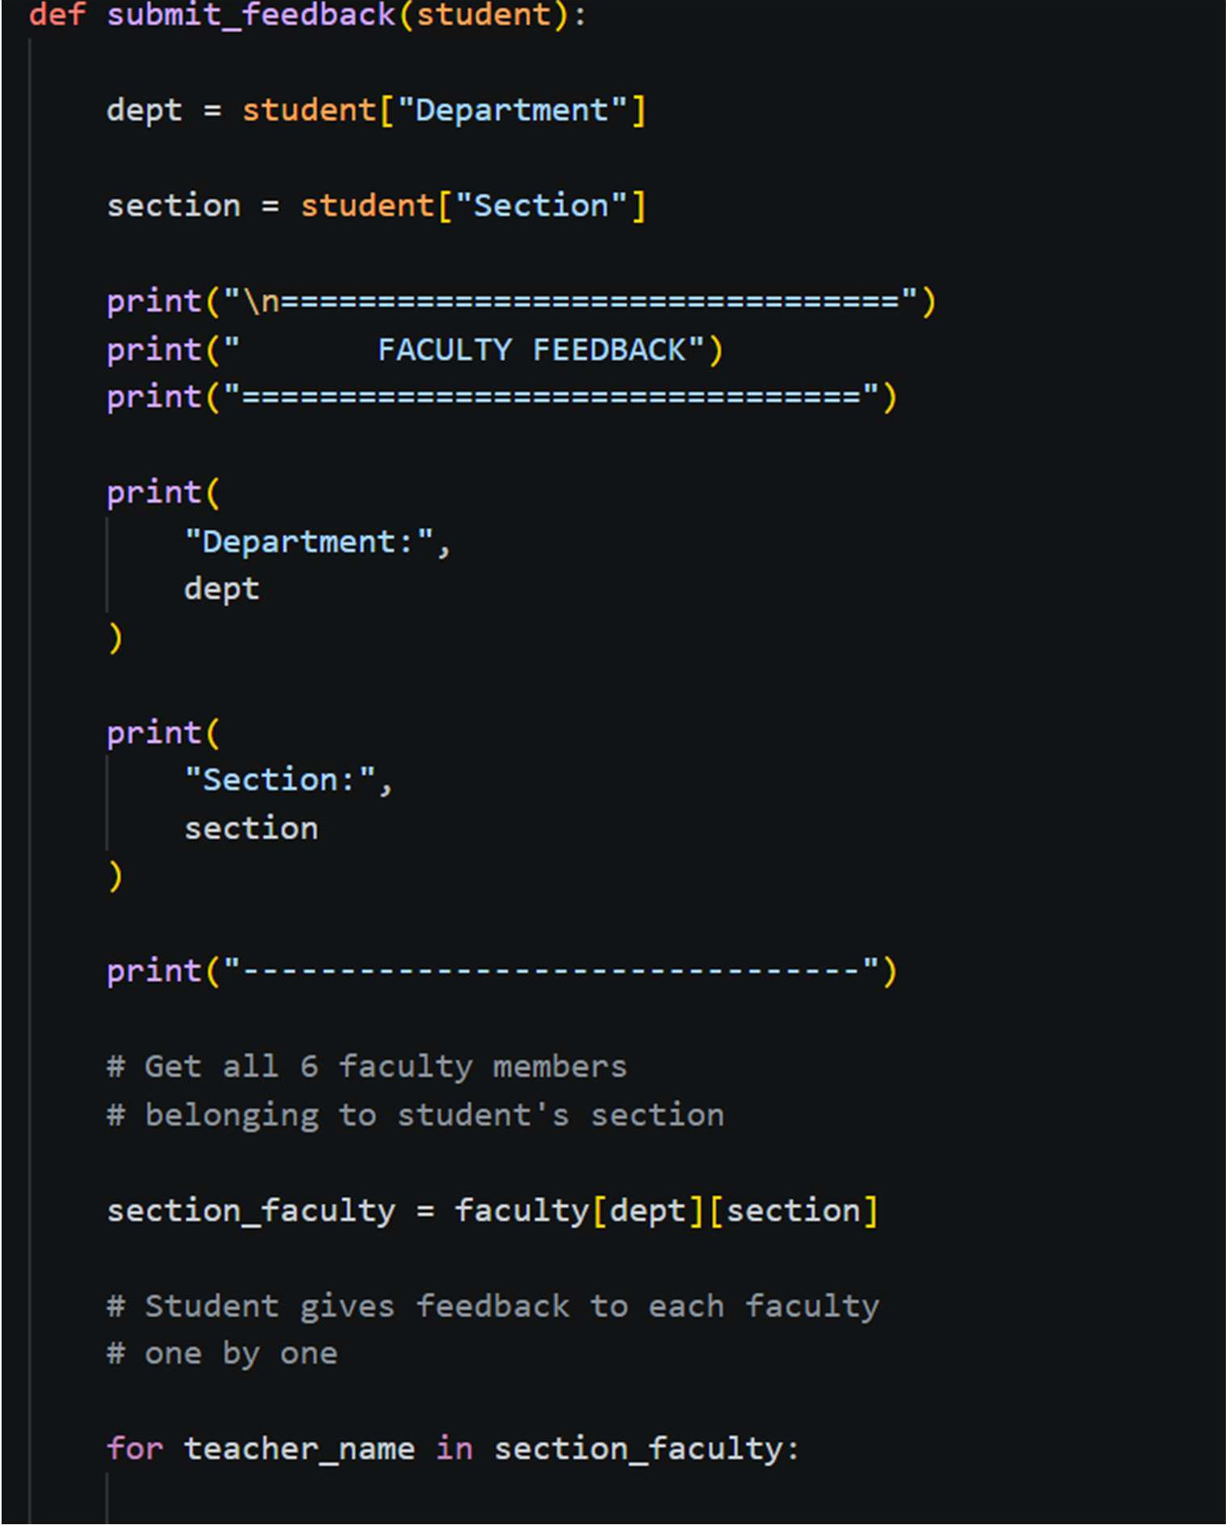

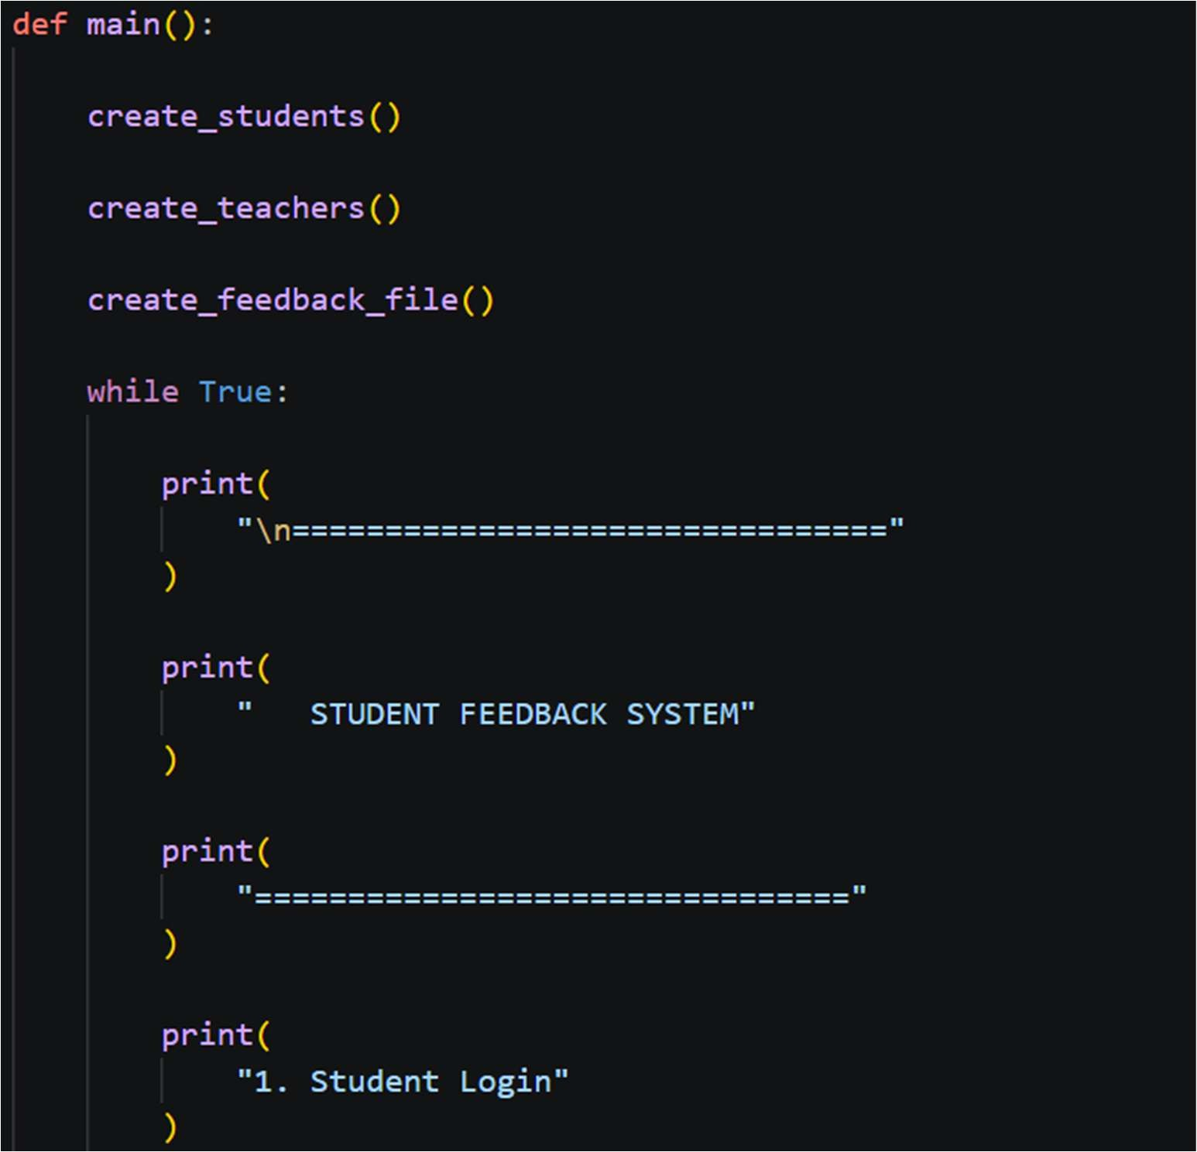

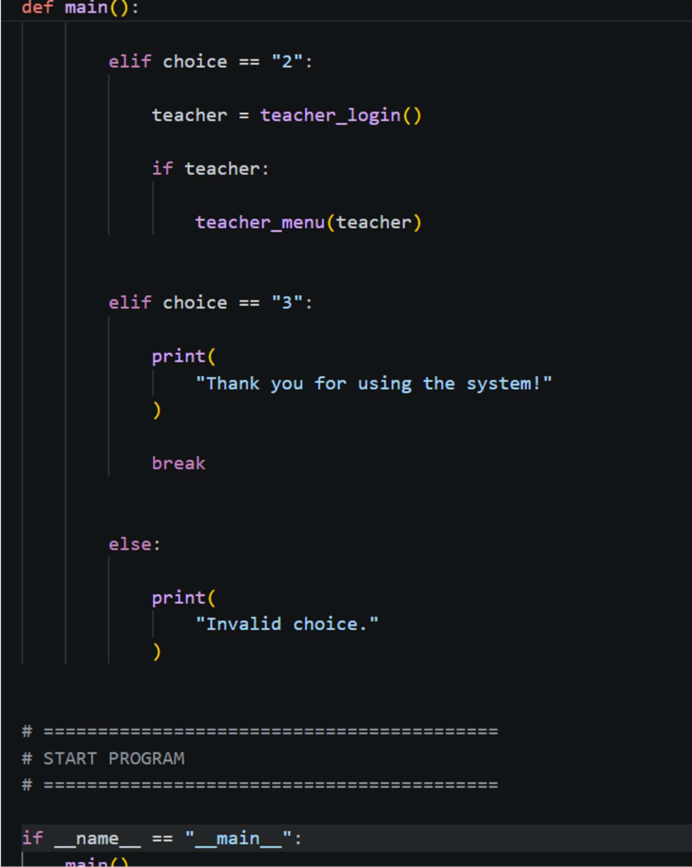
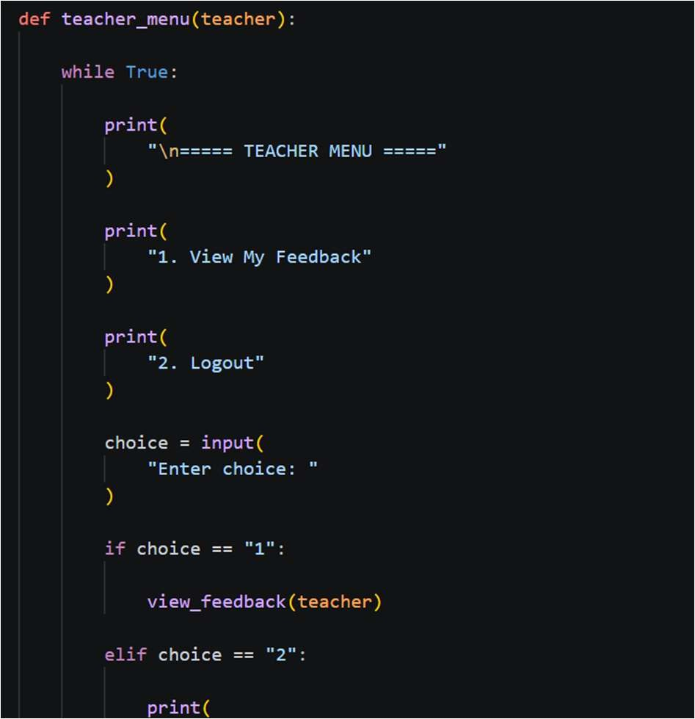

Results and Discussions

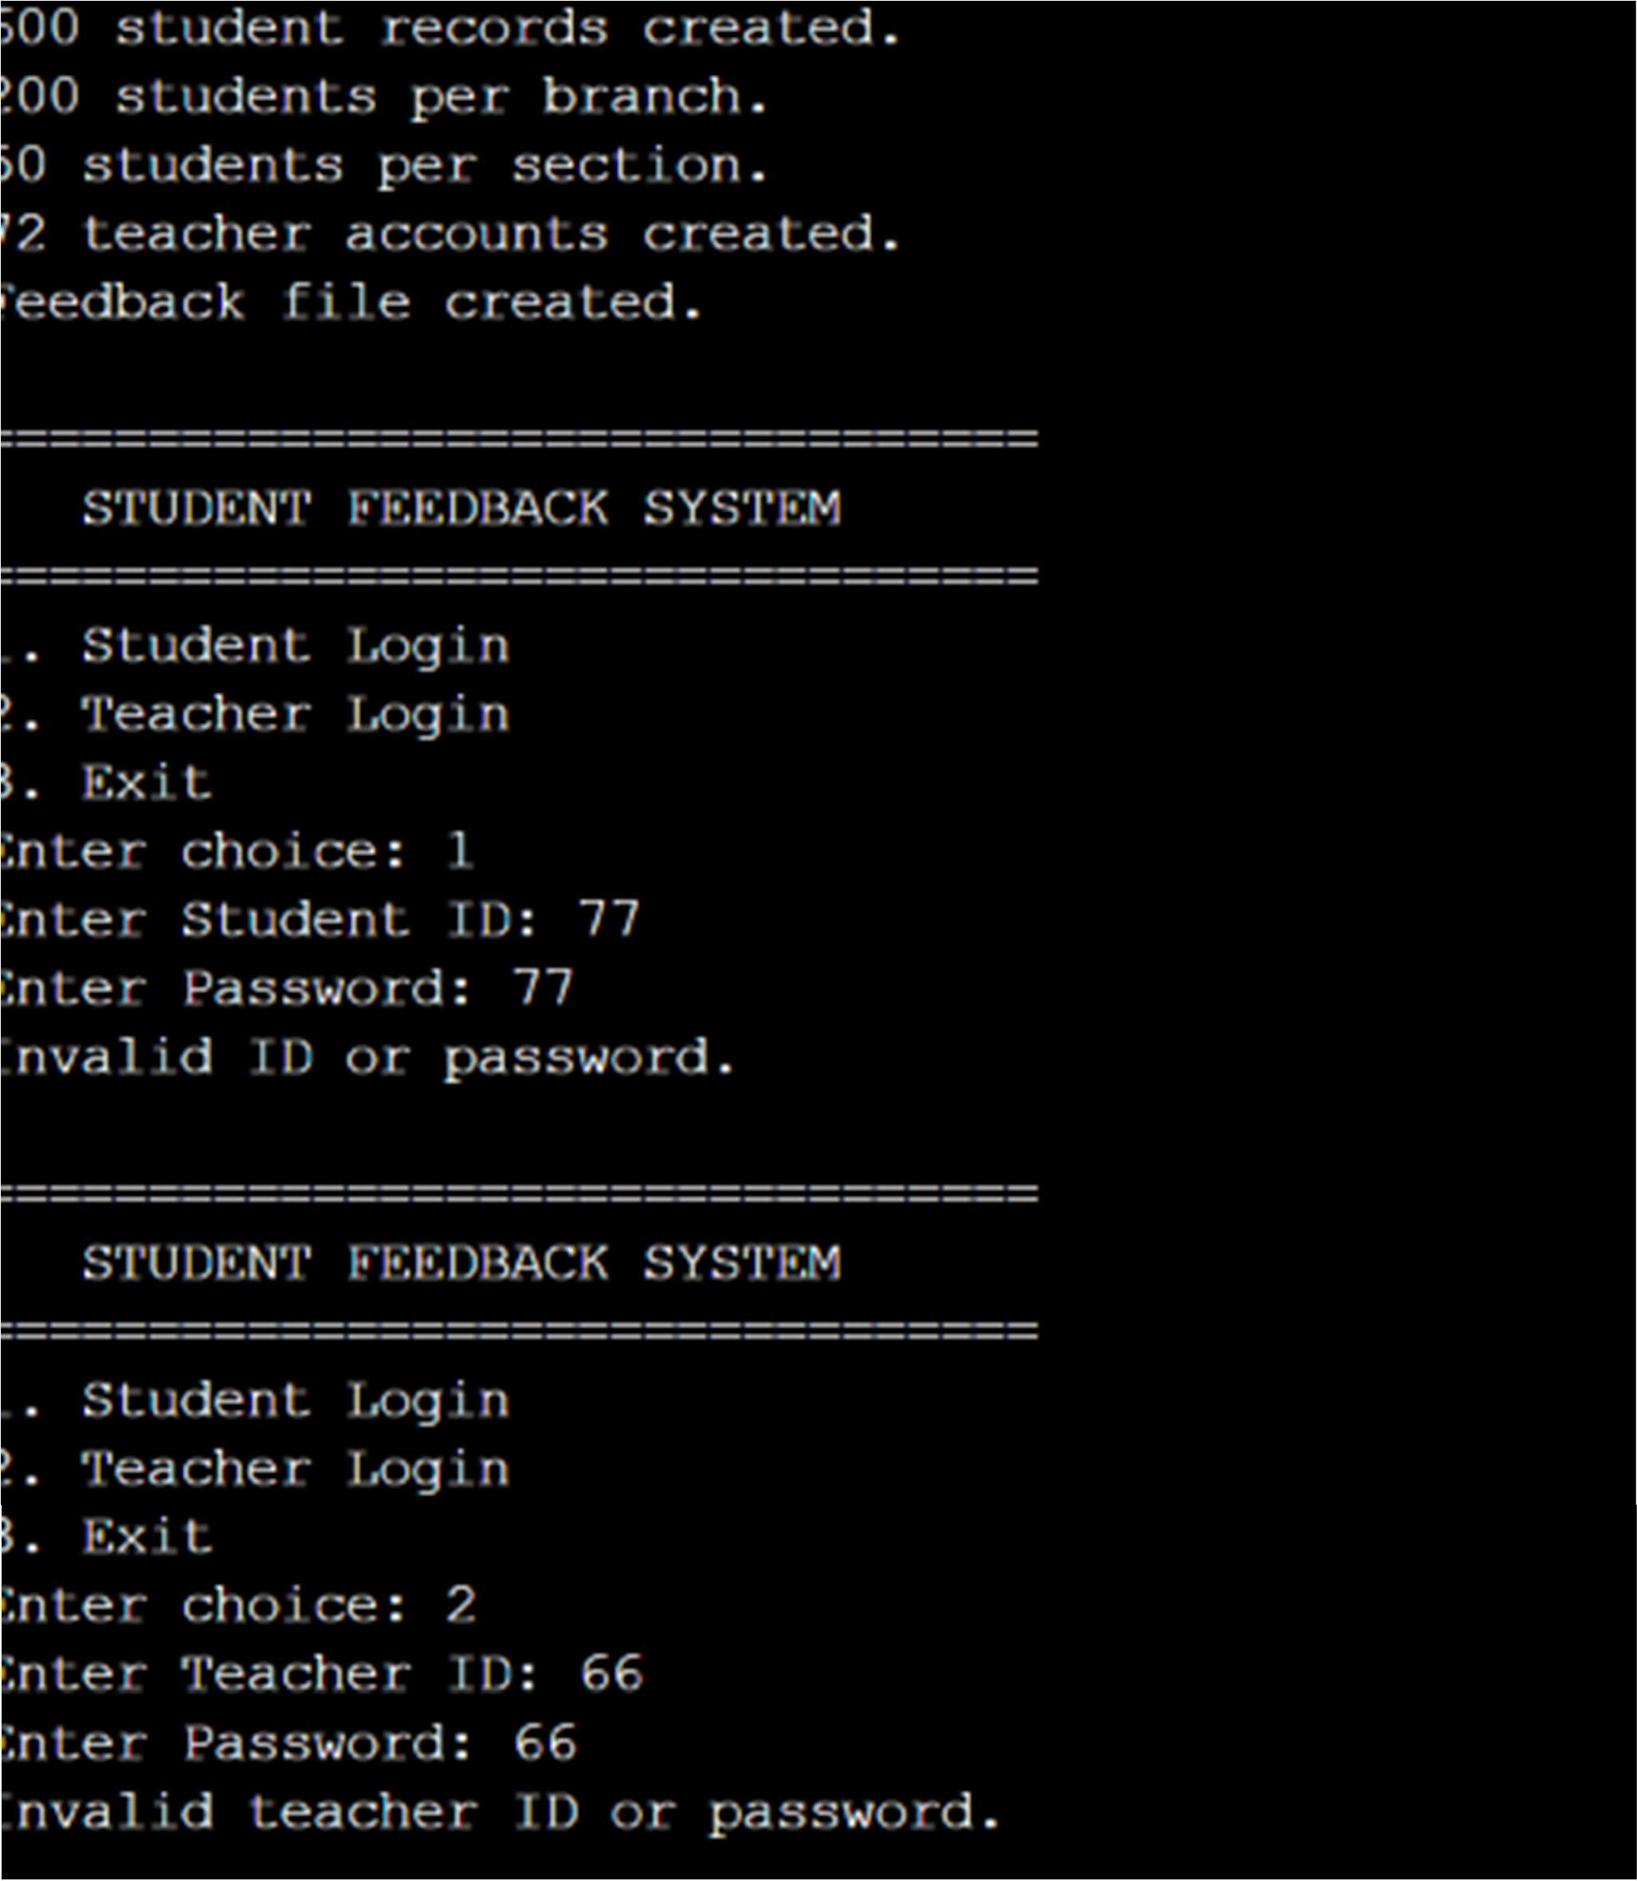

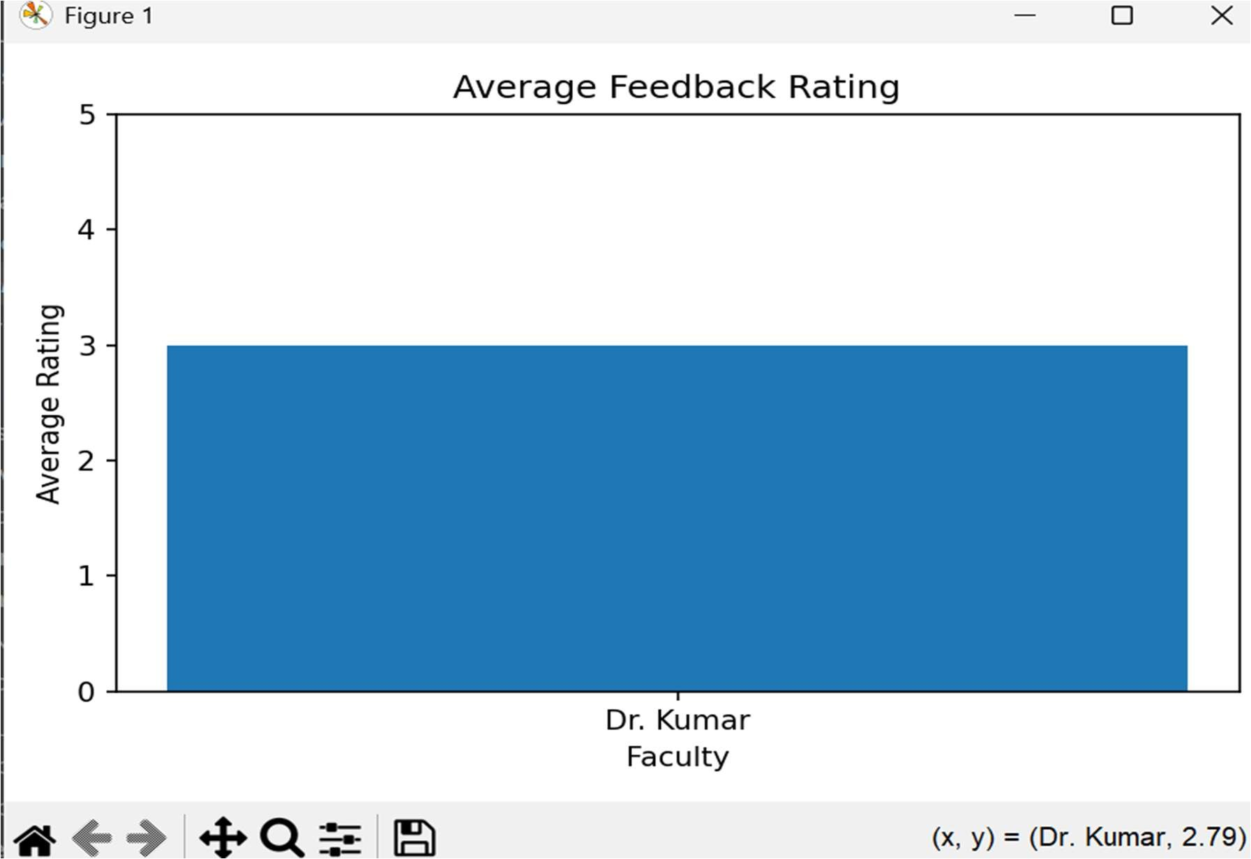
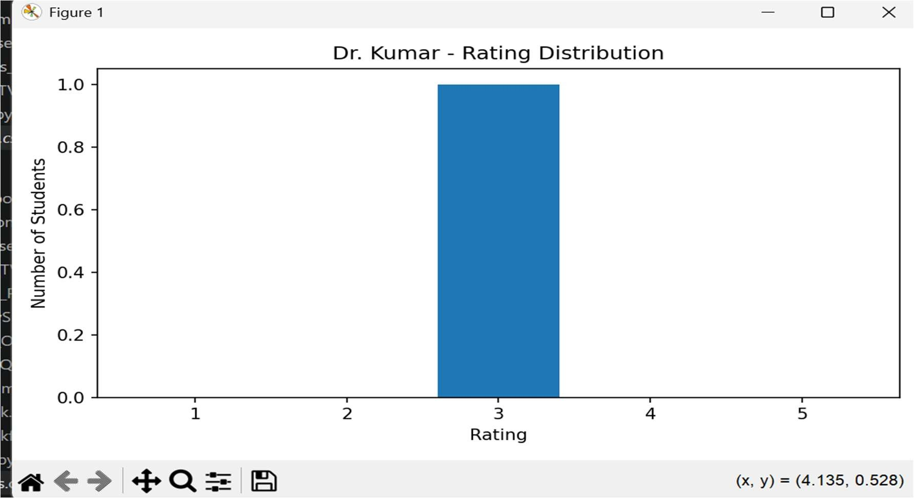

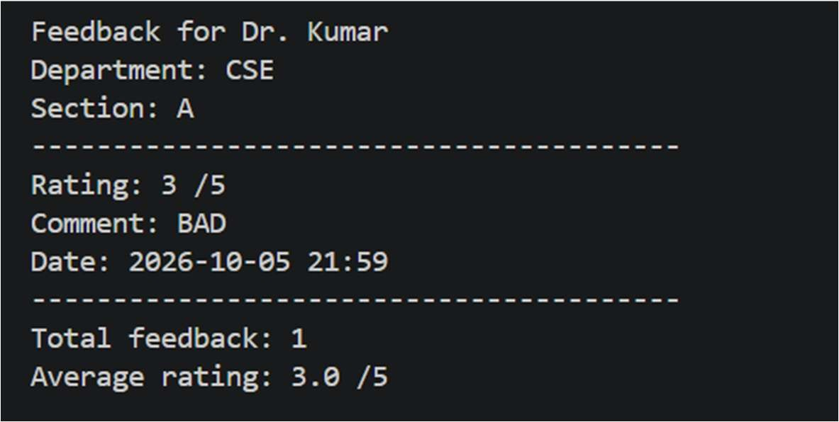

Summary
The Student Feedback Analyzer was successfully implemented using Python with CSV files for data storage and Matplotlib for graphical representation. The system provides separate login facilities for students and faculty members. Students can submit ratings and comments for all assigned faculty members, while faculty members can view their own feedback, rating distribution, and average rating.

The results demonstrate that the system can efficiently collect, organize, and analyze student feedback. The graphical representation makes the feedback easier to understand and helps faculty identify their performance based on student responses. Thus, the project achieves its objective of providing a simple and effective system for managing and analyzing student feedback.

Mapping POs and SDGs

Program Outcomes (POs) Mapping
Table 1: Mapping of Program Outcomes (POs) to Project Relevance
PO No. | Program Outcome | Relevance
PO1 | Engineering Knowledge | Applies programming and computational concepts to develop the system.
PO2 | Problem Analysis | Identifies the problem of manually analyzing solution.
PO3 | Design/Development of Solutions | Designs and implements a Python-based feedback analysis system
PO4 | Conduct Investigations of  Complex Problems | Processes feedback data and interprets the generated results.
PO5 | Engineering Tool Usage | Uses Python and programming tools for data processing and analysis.
PO8 | Individual and Collaborative Team work | Can be developed and tested through individual or collaborative work.
PO9 | Communication | Presents feedback results in a clear and understandable form.
PO11 | Life-Long Learning | Provides experience in applying programming to practical data-analysis problems.

student feedback an

Program Specific Outcomes (PSOs) Mapping

Table 2: Mapping of Program Specific Outcomes(PSOs) to Project Relevance

ng Python, CSV files and M ntations of faculty ratings
PO No. | Program Outcome | Relevance
PSO1 | Problem Solving and Software Development | Designed and implemented a Python-based student feedback analyzer using functions, dictionaries, file handling and data processing techniques to collect, store and analyze faculty feedback efficiently.
PSO2 | Application Development using Modern Tools | Developed a data-driven application usi records and generate graphical represe external frameworks.
PSO3 | Innovation and Career Readiness | Implemented a practical feedback management system with faculty-  specific access, anonymous student feedback and visual analysis,

demonstrating the application of programming and data-analysis skills to
a real-world academic problem.

Sustainable Development Goals (SDGs) Mapping

Table 3: Mapping of Sustainable Development Goals (SDGs) to Project Relevance

SDG No. | Goal | Relevance
SDG 4 | Quality Education | The project is mainly related to SDG 4: Quality Education because student feedback can help educational institutions understand learners' experiences and identify  areas for improvement.
SDG 9 | Industry, Innovation and  infrastructure | The project also demonstrates the use of a digital solution to automate a traditionally manual process. Using Python for feedback collection and analysis promotes technological innovation and the development of  simple digital systems.

Conclusion

The Student Feedback Analyzer is a Python-based application developed to simplify the process of collecting and analyzing student feedback. It provides a systematic method for storing responses, calculating ratings, analyzing feedback, and presenting meaningful results.
The project demonstrates how fundamental Python concepts can be applied to solve a practical problem in the education sector. By reducing manual analysis, the system can save time and make feedback interpretation easier for teachers and administrators.
In the future, the system can be enhanced with a graphical user interface, database integration, graphical dashboards, automated sentiment analysis, and real-time feedback reports. These improvements can make the application more scalable and useful for educational institutions.

Bibliography

Online Resources
- Python Documentation – Used for understanding Python syntax, data structures, functions, conditional statements, loops, https://docs.python.org/3/?utm_source=chatgpt.com
- Python Tutorial – Provides guidance on Python programming concepts such as lists, dictionaries, loops, modules, input/output, and exception handling. https://docs.python.org/3/tutorial/?utm_source=chatg pt.com
- Python Input and Output Documentation – Useful for implementing file reading, writing, and storing feedback data in the project https://docs.python.org/3/tutorial/inputoutput.html?highlight=strin g+formatting&utm_source=chatgpt.com

Research article references
- Python Software Foundation, Python Documentation, Python 3 Documentation.
- Allen B. Downey, Think Python: How to Think Like a Computer Scientist, O'Reilly Media.
- UNESCO, Education 2030: Sustainable Development Goal 4 – Quality Education.

