MAJOR PROJECT REPORT
Spotify Songs' Genre Segmentation
and Content-Based Music Recommendation System
Unsupervised clustering of audio features, playlist-level analysis and a deployable recommender
Submitted by
Spoorthi S Patil
Bachelor of Computer Applications (BCA), Final Year
KLE Technological University, Hubballi, Karnataka
USN: ____________________ Academic Year: ____________
Project Guide: ____________________________

Abstract
Music-streaming services depend on recommendation engines that understand how songs sound. This project builds an automated song-segmentation and recommendation system from a Spotify data set of 26,222 unique songs (32,833 playlist records, 6 playlist genres, 24 sub-genres and 449 playlist names) described by ten audio features such as danceability, energy, loudness, speechiness and valence.
The data were cleaned, explored with 30 figures including the full correlation matrix, reduced with PCA and t-SNE, and clustered with K-Means, Gaussian Mixture, Ward hierarchical clustering and DBSCAN. K-Means with k = 6 was selected and its clusters were named from their audio profiles (for example Feel-Good Dance, Acoustic & Mellow and Spoken-Word / Rap). The clusters were then compared with playlist genres, sub-genres and, at playlist level, with playlist names. A key finding is that audio clusters correspond to playlist genres only partially (adjusted Rand index 0.075); a supervised random forest reaches only 55.1% genre accuracy, showing that genre labels are partly cultural. Grouping at playlist-name level is far more cohesive (silhouette 0.20).
Finally, a cluster-aware content-based recommender was built. It returns songs from the seed's own playlist genre 38.8% of the time against 16.8% for random recommendation (a 2.3-fold lift), answers in about 4 ms, and is packaged as a trained model file and a Streamlit web application.
Keywords: Spotify, audio features, clustering, K-Means, PCA, t-SNE, recommender system, cosine similarity, playlist analysis.

Table of Contents

Right-click the table above and choose "Update Field" if page numbers do not appear.

1. Introduction

1.1 Background
Streaming platforms host catalogues far too large for a listener to browse. Recommendation therefore decides much of what people actually hear. Spotify describes every track with numeric audio features, and songs with similar feature values tend to feel alike. Grouping songs by these features (clustering) reveals the "sonic neighbourhoods" of a catalogue and gives a principled basis for recommending similar tracks.

1.2 Problem statement
Given a table of Spotify tracks, their audio features and the playlists (with genre and sub-genre) they appear in, build an automated system that (a) prepares and explores the data, (b) groups songs into meaningful clusters, (c) relates those clusters to playlist genres and playlist names, and (d) produces a model on which a song-recommendation system can be built.

1.3 Objectives
- Perform data pre-processing: missing values, duplicates, invalid records, skewness, outliers, scaling and date parsing.
- Carry out exploratory data analysis with all relevant plots and derive insights.
- Compute and interpret the correlation matrix of the audio features.
- Find and plot clusters according to playlist genres, sub-genres and playlist names.
- Build, compare and select a clustering model, and use it to implement a working recommendation system with measured accuracy.
- Package the work as a reusable code library, a trained model and an interactive web application.

1.4 Scope and deliverables
The project works only with the supplied data set (no listening-history or lyrics data). Deliverables are: an executed Jupyter notebook, a Python library (src/recsys.py), a saved recommender model, 30 figures and 12 result tables, a Streamlit application, and this report.

2. Background and Concepts

2.1 Spotify audio features
Table 1: Audio features used in the project
Feature | Range | Meaning
danceability | 0 - 1 | Suitability for dancing (tempo stability, beat strength, rhythm regularity)
energy | 0 - 1 | Perceived intensity and activity; fast, loud, noisy tracks score high
loudness | dB (about -46 to +1) | Overall average loudness of the track
speechiness | 0 - 1 | Presence of spoken words; above 0.66 is almost entirely speech
acousticness | 0 - 1 | Confidence that the track is acoustic
instrumentalness | 0 - 1 | Likelihood that the track has no vocals
liveness | 0 - 1 | Presence of an audience; high values suggest a live recording
valence | 0 - 1 | Musical positivity (happy/cheerful vs sad/angry)
tempo | BPM | Estimated beats per minute
duration_ms | ms | Track length
key, mode | 0-11, 0/1 | Pitch class of the key; 1 = major, 0 = minor

2.2 Clustering algorithms used
- K-Means partitions the data into k groups by repeatedly assigning points to the nearest centroid and recomputing centroids to minimise within-cluster variance (inertia).
- Gaussian Mixture Model (GMM) fits k overlapping Gaussian distributions and gives soft, probabilistic memberships.
- Agglomerative (Ward) clustering starts with every point alone and repeatedly merges the pair of clusters that least increases total variance; the merge history is shown as a dendrogram.
- DBSCAN grows clusters from dense regions and labels isolated points as noise; it needs no k but needs a density radius.

2.3 Cluster-quality measures
Silhouette (-1 to 1, higher is better) compares each point's closeness to its own cluster with the nearest other cluster. Calinski-Harabasz (higher is better) is the ratio of between- to within-cluster dispersion. Davies-Bouldin (lower is better) measures the average similarity between each cluster and its most similar neighbour. Because genre labels exist, Adjusted Rand Index (ARI) and Normalised Mutual Information (NMI) are also reported as external measures of agreement with genre; they are not used to select the model, since genre is not expected to equal sonic similarity.

2.4 Dimensionality reduction
Principal Component Analysis (PCA) rotates the data onto orthogonal axes ordered by explained variance and is used both to visualise the clusters and to understand which features drive the variation. t-SNE is a non-linear technique that preserves local neighbourhoods and is used purely for visualisation.

2.5 Content-based recommendation
A content-based recommender represents each item by its attributes and recommends items whose attribute vectors are close to those of items the user likes. Here every song is a vector of ten standardised audio features and closeness is the cosine similarity cos(a, b) = a . b / (|a| |b|). Unlike collaborative filtering, this needs no user history and can recommend new or unpopular songs (it avoids the "cold-start" problem for items).

3. Data Set Description
The supplied CSV file has 32,833 rows and 23 columns. Each row is a track-in-playlist record. The file contains 28,356 unique track ids, 10,692 artists, 471 playlists (449 distinct playlist names), 6 playlist genres (edm, latin, pop, r&b, rap, rock) and 24 sub-genres. Its structure matches the public "Spotify Songs" data set built from the Spotify API.
Table 2: Column groups of the data set
Column group | Columns
Track identity | track_id, track_name, track_artist, track_popularity (0-100)
Album | track_album_id, track_album_name, track_album_release_date
Playlist | playlist_name, playlist_id, playlist_genre, playlist_subgenre
Audio features | danceability, energy, key, loudness, mode, speechiness, acousticness, instrumentalness, liveness, valence, tempo, duration_ms

Raw genre counts are balanced (edm 6,043; rap 5,746; pop 5,507; r&b 5,431; latin 5,155; rock 4,951 rows). Only the three text columns track_name, track_artist and track_album_name contain missing values (5 rows each).

4. Methodology and System Design

4.1 Pipeline
Table 3: Project pipeline
Stage | What is done | Output
1. Ingest & clean | Remove missing/invalid/duplicate rows, parse dates | 26,222 unique songs
2. Feature engineering | log transform, winsorise, standardise 10 audio features | Scaled matrix X (26,222 x 10)
3. Exploration | Distributions, correlations, genre/time/popularity analysis | 16 EDA figures, tables
4. Reduction | PCA and t-SNE | 2-D maps of the songs
5. Clustering | Select k, compare four algorithms, profile clusters | K-Means (k = 6) + named clusters
6. Mapping | Clusters vs genre, sub-genre, playlist name | Heat maps, playlist clusters
7. Validation | Random-forest genre classifier | 55.1% accuracy ceiling
8. Recommender | Cosine kNN restricted to the seed cluster | recommender.joblib + Streamlit app

4.2 Tools
Python 3.12, pandas, NumPy, scikit-learn 1.8 (clustering, PCA, t-SNE, random forest, nearest neighbours), SciPy (dendrograms), Matplotlib and Seaborn (plots), joblib (model persistence), Jupyter (analysis notebook) and Streamlit with Plotly (web application).

4.3 Project structure
Table 4: Deliverable files
Path | Purpose
notebooks/Spotify_Genre_Segmentation.ipynb | Complete executed analysis, 73 cells
src/recsys.py | Cleaning, feature engineering and the SpotifyRecommender class
models/recommender.joblib | Trained scaler, K-Means, PCA, neighbours and song table
app.py | Streamlit web application
outputs/figures/ | 30 PNG figures
outputs/tables/ | Metrics, profiles, clustered songs, playlist clusters
data/spotify_songs.csv | Input data

5. Data Pre-processing
The data-quality review found the issues in the table below. Each was resolved with a documented rule inside clean() and build_features() so the same steps are applied identically to any new data.
Table 5: Data-quality issues and treatments
Issue found | Treatment
5 rows with missing track / artist / album name | Dropped
4,477 repeated track ids (songs in several playlists) | One row per song; all genres kept in `all_genres`
About 2,100 same-title, same-artist re-releases | Most popular version kept
Release date in three formats (YYYY, YYYY-MM, YYYY-MM-DD) | Parsed to `release_year`
Invalid audio: tempo = 0, duration < 30 s, loudness < -30 dB | Rows removed
Skewed features: speechiness, acousticness, instrumentalness, liveness | log1p(10 x value)
Outliers in loudness, tempo, duration | Winsorised at 1st/99th percentile
Different scales (dB, BPM, ms, 0-1) | StandardScaler (mean 0, sd 1)

After cleaning, 26,222 unique songs remain (from 32,833 rows). 1,526 of them (5.8%) appear in playlists of more than one genre. The key and mode columns are kept for exploration but excluded from clustering because key is a circular category and mode is binary. Popularity is excluded because it measures audience behaviour, not sound.
See Figure 1: Raw (grey) versus processed (purple) feature distributions (full-width plate at the end of this chapter)

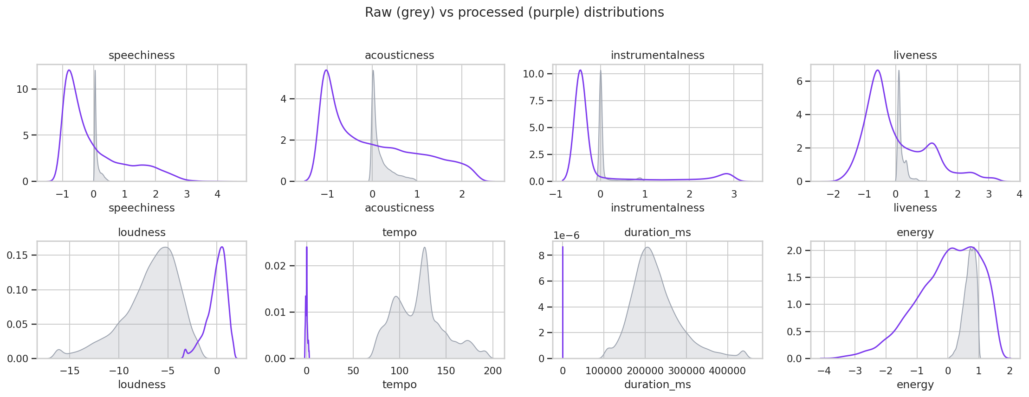
Figure 1: Raw (grey) versus processed (purple) feature distributions

6. Exploratory Data Analysis

6.1 Genres, sub-genres and playlists
Genres and sub-genres are well balanced, so no class-imbalance correction is needed. The three largest sub-genres are progressive electro house, neo soul and southern hip hop; the smallest are new jack swing, post-teen pop and reggaeton.
See Figure 9: Songs per genre, songs per sub-genre and playlists per genre (full-width plate at the end of this chapter)

6.2 Distribution of audio features
Danceability, energy and loudness are left-skewed (most songs are danceable, energetic and loud); speechiness, acousticness, instrumentalness and liveness are right-skewed with many values near zero; valence is almost symmetric. Boxplots confirm extreme outliers in loudness, tempo and duration, which motivated winsorising.
See Figure 10: Histograms with KDE for every audio feature, popularity and key (full-width plate at the end of this chapter)
See Figure 11: Boxplots used to detect outliers (full-width plate at the end of this chapter)

6.3 Audio features by genre
See Figure 12: Distribution of each audio feature by playlist genre (full-width plate at the end of this chapter)
Table 6: Mean audio features per genre (all songs of each genre)
Genre | Dance | Energy | Loud (dB) | Speech | Acoustic | Instr. | Valence | Tempo | Popul.
edm | 0.659 | 0.805 | -5.534 | 0.088 | 0.08 | 0.238 | 0.4 | 126 | 32.4
latin | 0.711 | 0.707 | -6.458 | 0.102 | 0.217 | 0.052 | 0.605 | 119 | 43.5
pop | 0.635 | 0.7 | -6.487 | 0.072 | 0.173 | 0.072 | 0.499 | 121 | 44.3
r&b | 0.665 | 0.586 | -7.975 | 0.117 | 0.272 | 0.03 | 0.528 | 114 | 39.2
rap | 0.713 | 0.648 | -7.166 | 0.198 | 0.2 | 0.086 | 0.501 | 121 | 42.2
rock | 0.518 | 0.731 | -7.545 | 0.058 | 0.15 | 0.069 | 0.527 | 125 | 42.4

- Rap has by far the highest speechiness (0.20 against 0.12 or lower elsewhere) and high danceability.
- EDM is the most energetic (0.81), loudest (-5.5 dB) and most instrumental (0.24), has the lowest valence (0.40) and the lowest popularity (32.4).
- R&B is the calmest (energy 0.59), most acoustic (0.27) and slowest (114 BPM).
- Latin is the happiest (valence 0.61) and nearly as danceable as rap (0.71).
- Rock is the least danceable (0.52) and has the highest share of major-key songs (69%).
- Pop is the most popular genre (44.3) but has no extreme feature value, which is why pop is hard to separate from other genres.
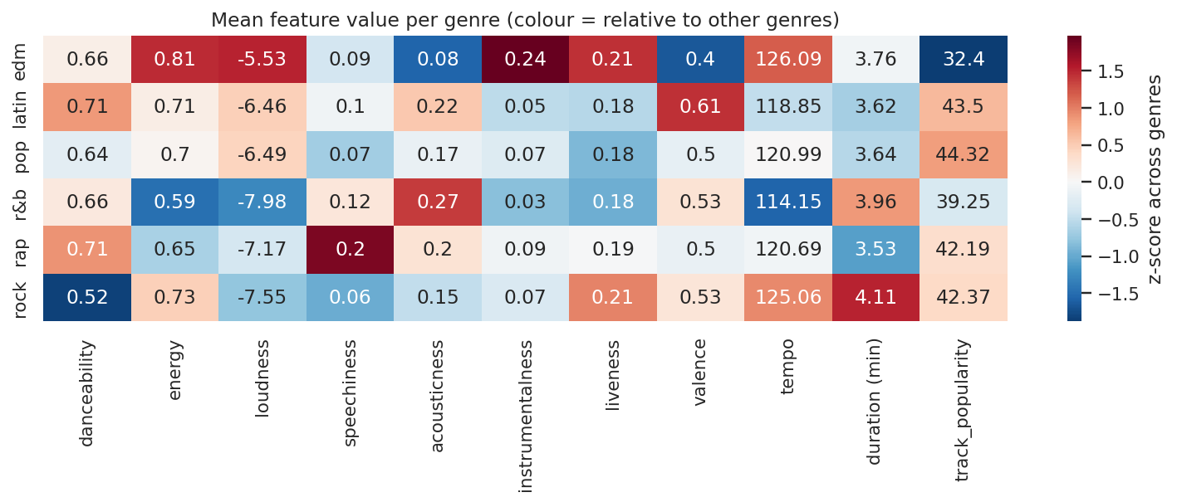
Figure 2: Mean feature value per genre; colour shows the z-score across genres
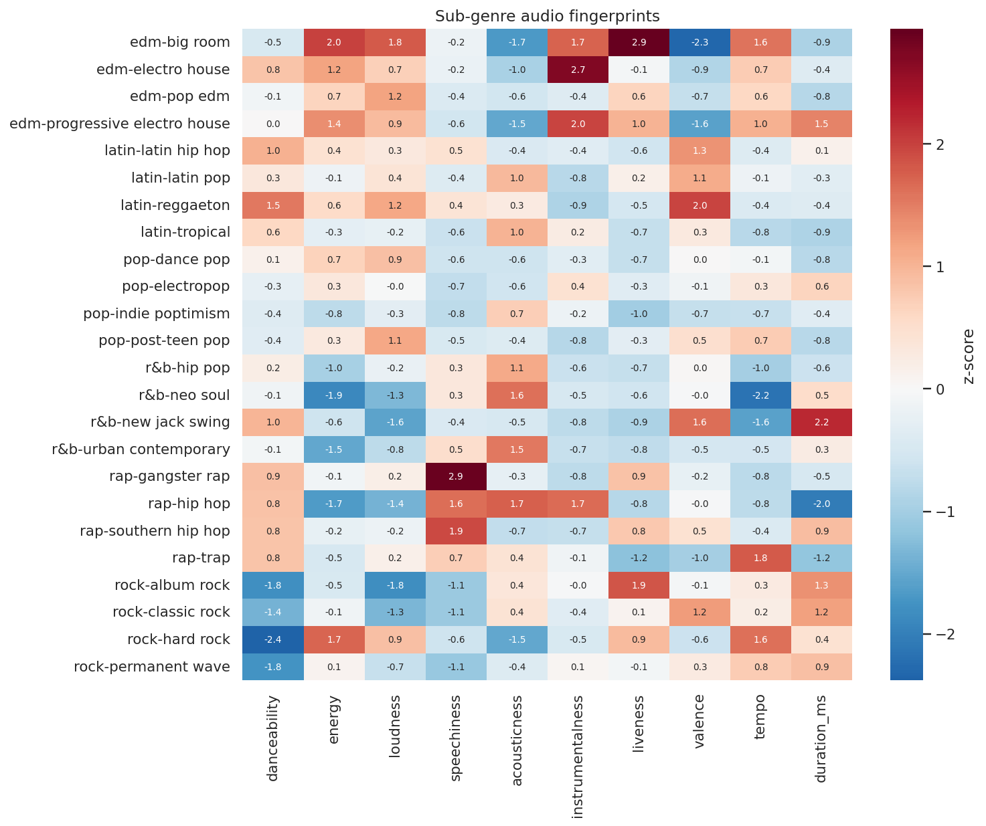
Figure 3: Audio fingerprint of each of the 24 sub-genres

6.4 Correlation matrix
The Pearson correlation matrix (below) shows that audio features are mostly weakly related, which supports using all ten as separate dimensions.
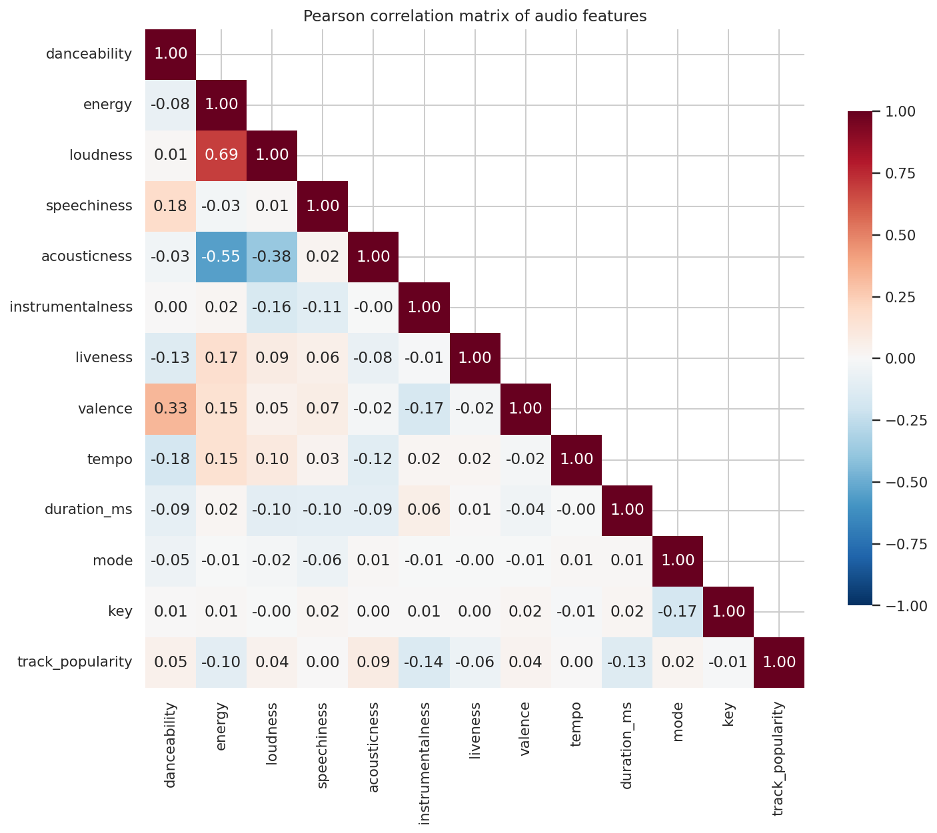
Figure 4: Correlation matrix of the audio features, key, mode and popularity
Table 7: Strongest correlations between features
Feature pair | Pearson r | Interpretation
loudness - energy | +0.69 | Loud songs are perceived as energetic
energy - acousticness | -0.55 | Acoustic songs are calmer
loudness - acousticness | -0.38 | Acoustic recordings are quieter
danceability - valence | +0.33 | Danceable songs sound happier
danceability - speechiness | +0.18 | Rap-like delivery is danceable
danceability - tempo | +0.18 (abs.) | Weak link between speed and danceability

No feature correlates with popularity by more than 0.14 in absolute value (instrumentalness -0.14, duration -0.13, energy -0.10), so popularity cannot be predicted from audio alone. A Spearman rank correlation, which is robust to skew, gives the same ordering.
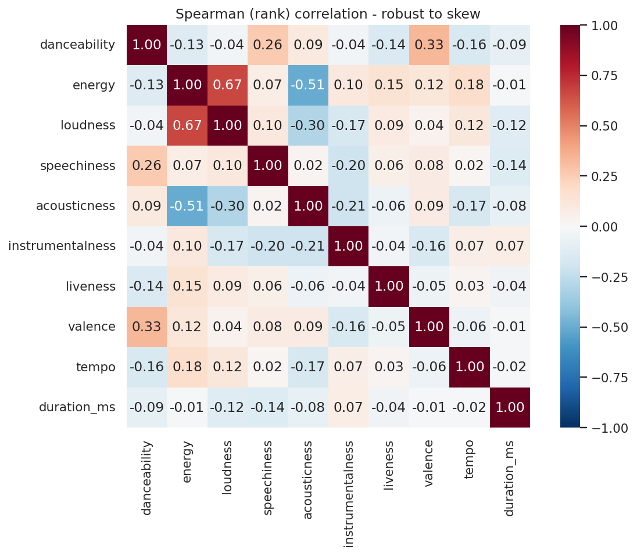
Figure 5: Spearman rank-correlation matrix

6.5 Relationships between features
See Figure 13: Scatter plots with regression line: energy-loudness, energy-acousticness, danceability-valence (full-width plate at the end of this chapter)
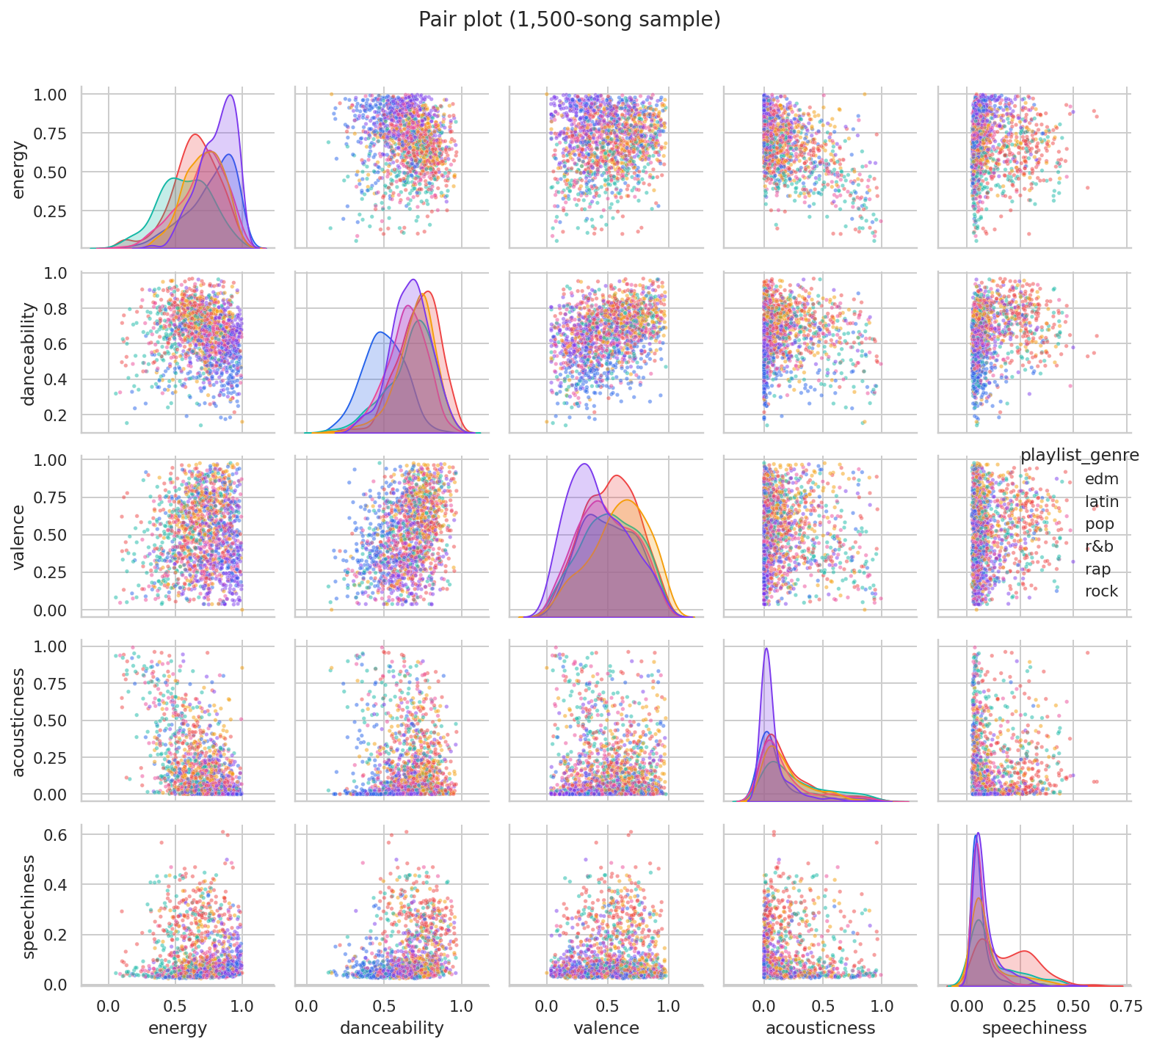
Figure 6: Pair plot of five features coloured by genre (1,500-song sample)

6.6 Popularity and artists
Popularity has median 43; 8.6% of songs score zero. Pop is the most popular genre and EDM the least. Queen has the most songs in the file (111), while Billie Eilish has the highest average popularity among artists with at least ten songs (79).
See Figure 14: Popularity distribution, popularity by genre and correlation with audio features (full-width plate at the end of this chapter)
See Figure 15: Artists with the most songs and the highest average popularity (full-width plate at the end of this chapter)

6.7 Time trends, key and mode
60% of the songs were released in 2015 or later, with 7,232 in 2019 alone, so the data set is a snapshot of recent music. Average valence fell from about 0.62 (1980-2010) to 0.48 in 2019, speechiness roughly doubled (0.06 to 0.115) and danceability rose (0.56 in 1980 to 0.67 in 2019): recent music is more danceable, more spoken and less cheerful.
See Figure 16: Songs per release year, feature trends 1980-2020 and major/minor share by genre (full-width plate at the end of this chapter)

6.8 Genre fingerprints and overlap
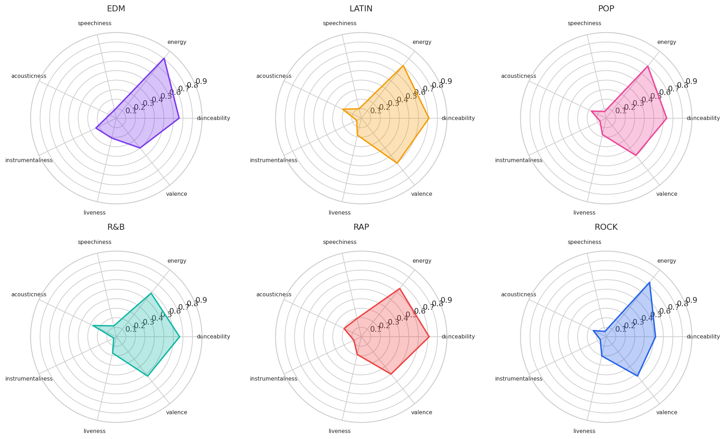
Figure 7: Radar chart of the average profile of each genre
Only 5.8% of songs appear in more than one genre playlist. The most frequent overlaps occur between neighbouring styles, which shows that genre labels are assigned at playlist level and are not mutually exclusive.
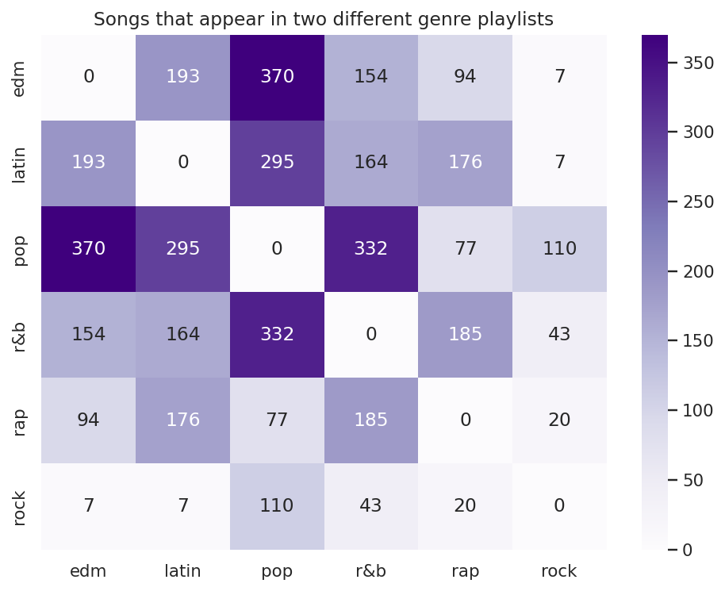
Figure 8: Songs that appear in playlists of two different genres

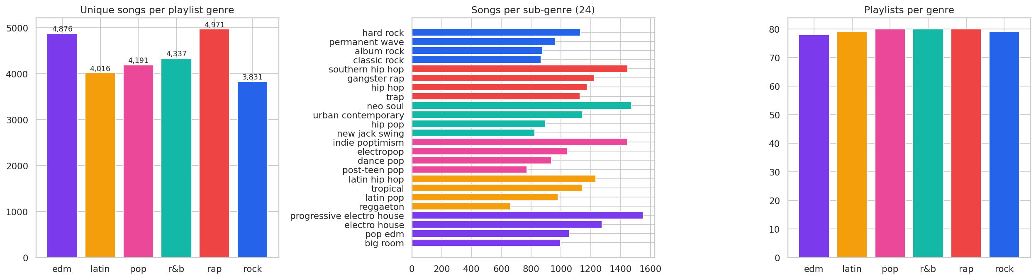
Figure 9: Songs per genre, songs per sub-genre and playlists per genre
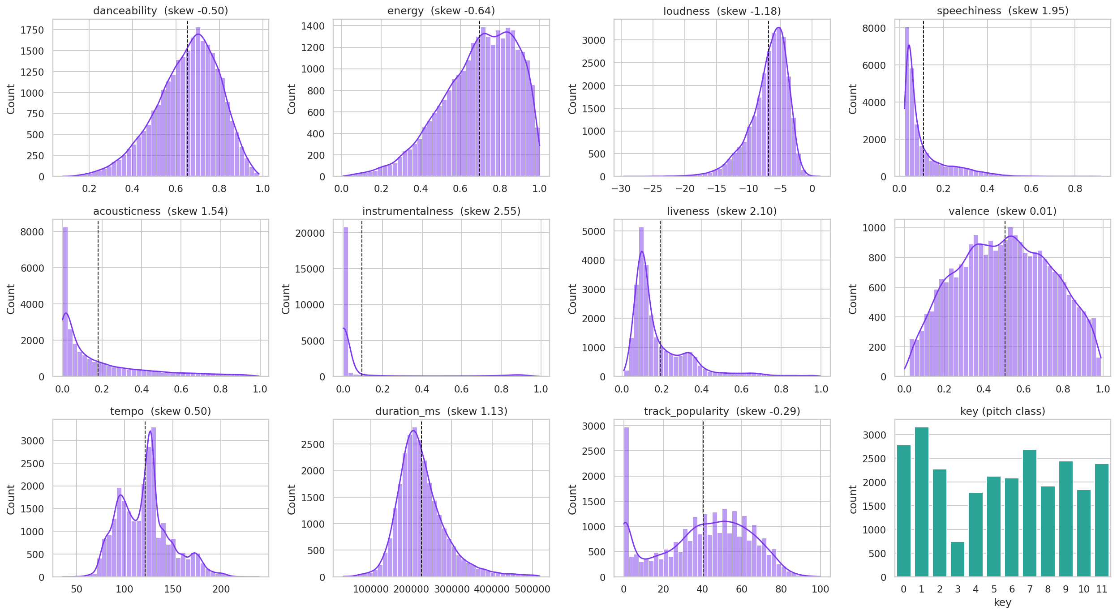
Figure 10: Histograms with KDE for every audio feature, popularity and key
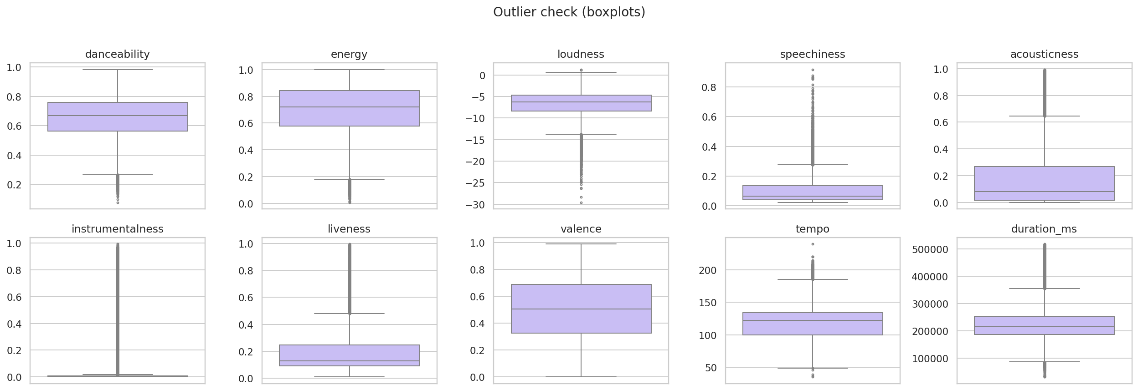
Figure 11: Boxplots used to detect outliers
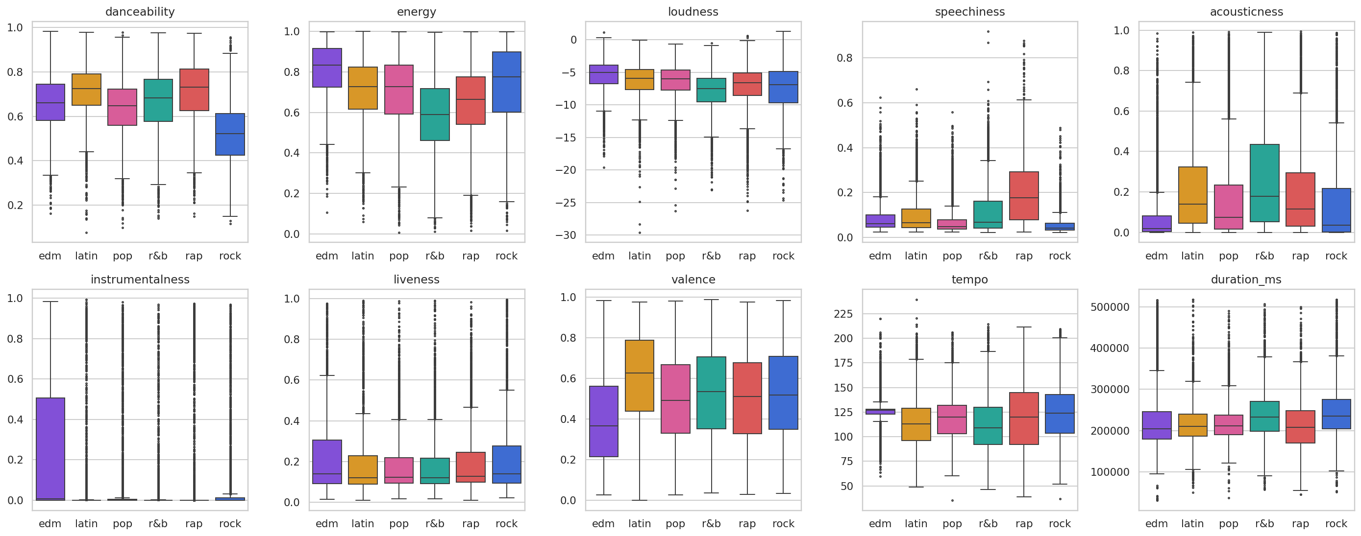
Figure 12: Distribution of each audio feature by playlist genre
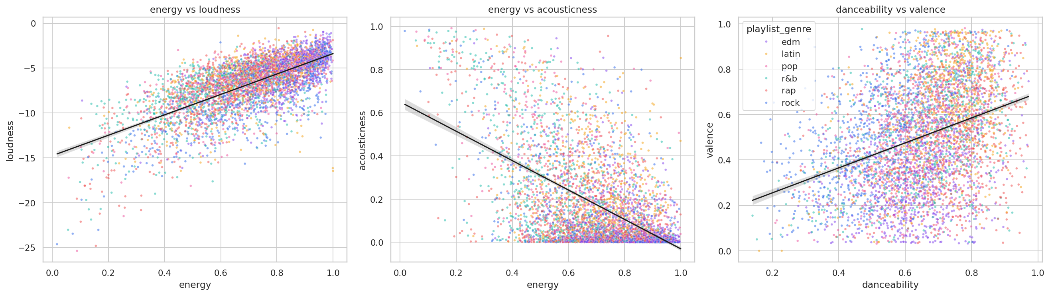
Figure 13: Scatter plots with regression line: energy-loudness, energy-acousticness, danceability-valence
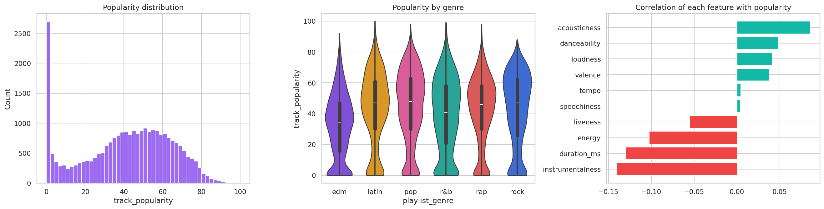
Figure 14: Popularity distribution, popularity by genre and correlation with audio features
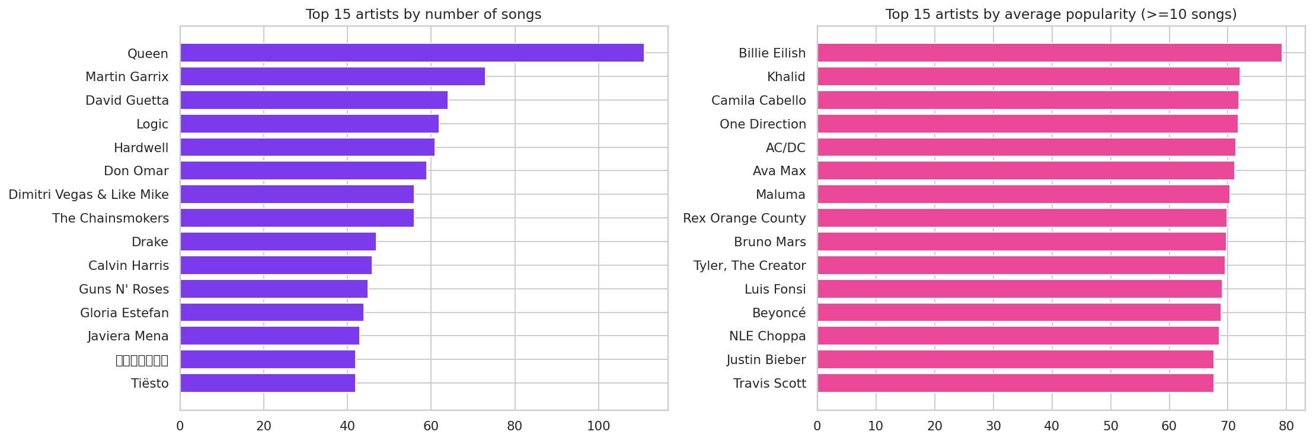
Figure 15: Artists with the most songs and the highest average popularity
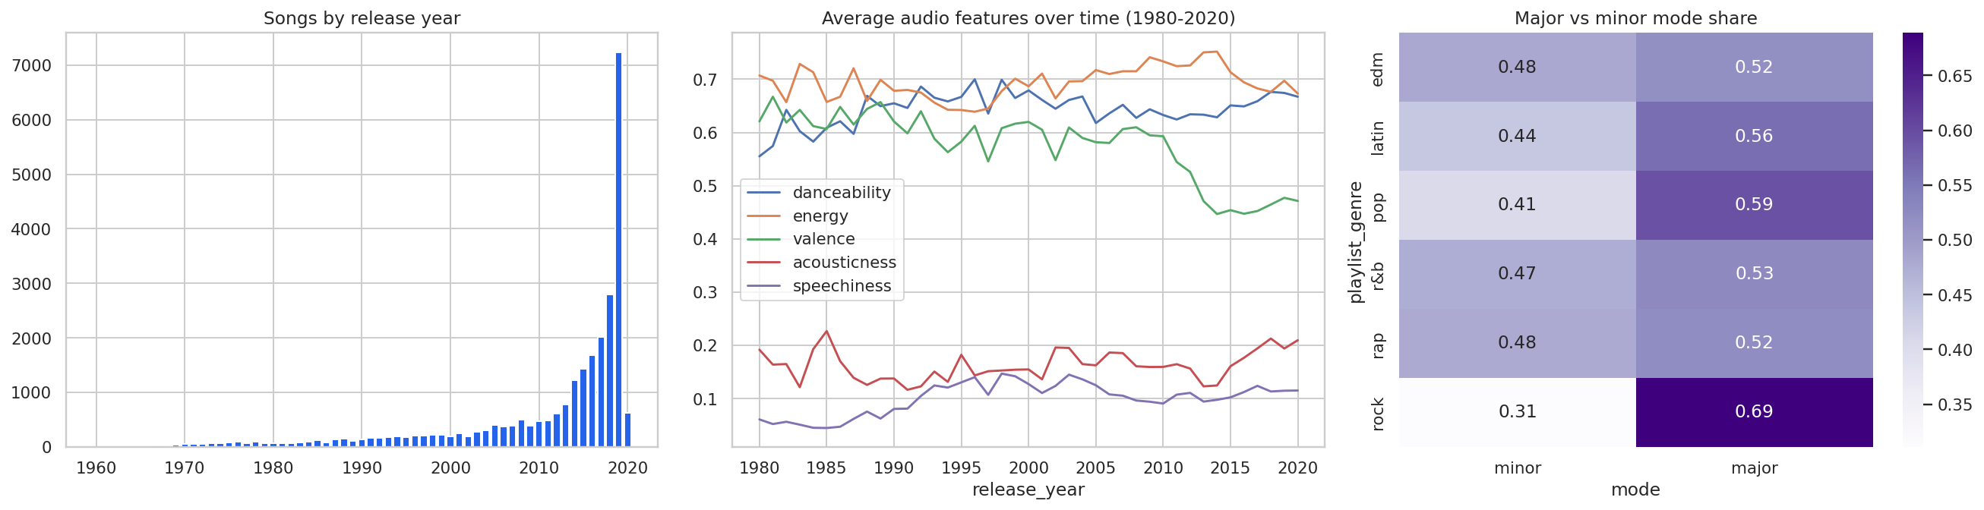
Figure 16: Songs per release year, feature trends 1980-2020 and major/minor share by genre

7. Dimensionality Reduction
The first two principal components explain only 37.5% of the variance, four explain 58.9% and 7 components are needed to reach 80%. Information is therefore spread across the features, with no dominant low-dimensional structure. PC1 is an intensity axis (energy 0.62 and loudness 0.55 against acousticness -0.48); PC2 is a groove/positivity axis (danceability 0.55, valence 0.52, speechiness 0.39).
See Figure 17: PCA scree plot, loadings of the first three components, and PCA map coloured by genre (full-width plate at the end of this chapter)
In both PCA and t-SNE the genres form overlapping clouds with only a gradual drift between them (rap towards the speechiness side; EDM and rock towards high energy). This foreshadows that clusters will be soft neighbourhoods rather than isolated islands.
See Figure 18: t-SNE map (7,000 songs) coloured by genre and by popularity (full-width plate at the end of this chapter)

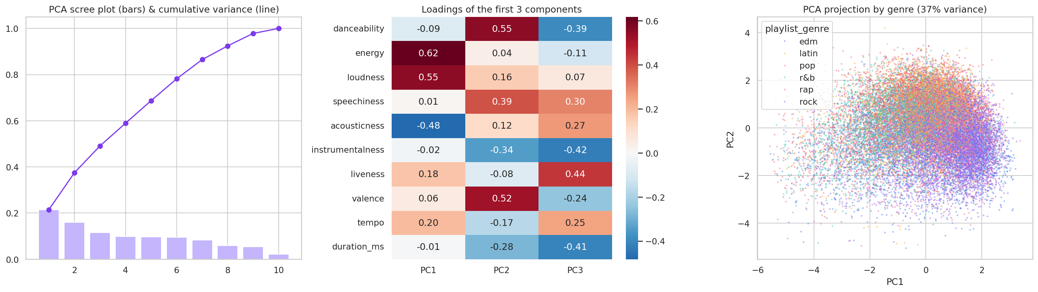
Figure 17: PCA scree plot, loadings of the first three components, and PCA map coloured by genre
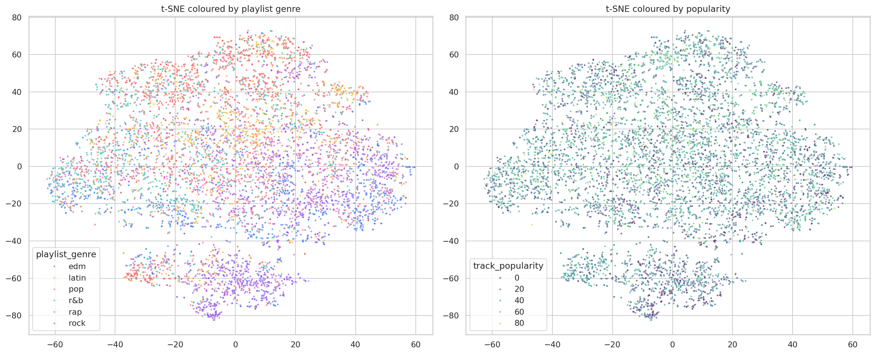
Figure 18: t-SNE map (7,000 songs) coloured by genre and by popularity

8. Clustering

8.1 Choosing the number of clusters
Table 8: K-Means for k = 2 to 12
k | Inertia | Silhouette | Calinski-H. | Davies-B. | ARI vs genre | NMI vs genre
2 | 225,397 | 0.15 | 4,284 | 2.308 | 0.029 | 0.04
3 | 202,853 | 0.122 | 3,837 | 2.212 | 0.076 | 0.092
4 | 186,795 | 0.128 | 3,529 | 2.041 | 0.074 | 0.101
5 | 173,795 | 0.123 | 3,335 | 1.943 | 0.086 | 0.12
6 | 166,033 | 0.115 | 3,038 | 1.912 | 0.075 | 0.105
7 | 159,137 | 0.117 | 2,830 | 1.845 | 0.068 | 0.105
8 | 152,761 | 0.124 | 2,683 | 1.839 | 0.071 | 0.111
9 | 147,245 | 0.126 | 2,559 | 1.784 | 0.066 | 0.106
10 | 142,740 | 0.116 | 2,438 | 1.848 | 0.064 | 0.107
11 | 138,630 | 0.113 | 2,337 | 1.798 | 0.063 | 0.11
12 | 134,885 | 0.114 | 2,249 | 1.774 | 0.063 | 0.113

See Figure 20: Elbow, silhouette, Calinski-Harabasz and Davies-Bouldin curves for K-Means (full-width plate at the end of this chapter)
There is no sharp elbow and the silhouette stays between 0.11 and 0.15 for every k, a real property of the data: audio features vary continuously across songs. k = 6 was chosen because (i) inertia and Davies-Bouldin have already flattened, (ii) the clusters are large enough to interpret and to drive recommendations, and (iii) it matches the six-genre taxonomy so clusters can be compared directly with playlist genre.

8.2 Comparison of algorithms
Table 9: Clustering algorithm comparison (6 clusters where applicable)
Model | Clusters | Noise | Silhouette | Davies-B. | Calinski-H. | ARI
K-Means | 6 | 0% | 0.115 | 1.918 | 3038 | 0.075
Gaussian Mixture | 6 | 0% | -0.008 | 4.436 | 978 | 0.056
Agglomerative (Ward, 8k sample) | 6 | 0% | 0.063 | 2.283 | 620 | 0.055
DBSCAN (eps=1.2) | 4 | 52% | 0.133 | 1.088 | 514 | -0.004

K-Means is the best usable model: it has the best Calinski-Harabasz and Davies-Bouldin among the methods that label every song. The Gaussian Mixture has silhouette near zero because its components overlap heavily. Ward clustering (run on an 8,000-song sample for memory reasons) is weaker. DBSCAN reports the highest silhouette (0.13) only because it discards 52% of the songs as noise and keeps four dense cores, which is unsuitable for a recommender that must cover every song.

8.3 The six sonic clusters
Table 10: Mean feature values of each K-Means cluster
Cluster | Share | Dance | Energy | Loud | Speech | Acoust. | Instr. | Live | Val. | BPM
Instrumental Dance / EDM | 10% | 0.664 | 0.798 | -6.801 | 0.07 | 0.058 | 0.663 | 0.181 | 0.402 | 126
Loud Live-Energy | 15% | 0.623 | 0.814 | -5.347 | 0.095 | 0.09 | 0.021 | 0.437 | 0.527 | 122
Feel-Good Dance | 25% | 0.738 | 0.722 | -6.288 | 0.066 | 0.16 | 0.01 | 0.122 | 0.687 | 114
Fast & Driving | 18% | 0.529 | 0.785 | -5.381 | 0.073 | 0.06 | 0.012 | 0.139 | 0.362 | 136
Acoustic & Mellow | 15% | 0.597 | 0.418 | -10.698 | 0.066 | 0.497 | 0.121 | 0.155 | 0.383 | 113
Spoken-Word / Rap | 17% | 0.737 | 0.653 | -7.007 | 0.287 | 0.205 | 0.01 | 0.174 | 0.553 | 120

See Figure 21: Cluster centroids (z-scores, with original values) and cluster sizes (full-width plate at the end of this chapter)
- Feel-Good Dance (25%): most danceable (0.74) and happiest (valence 0.69); the largest family.
- Fast & Driving (18%): fastest (136 BPM), least danceable (0.53) and dark in mood (valence 0.36).
- Spoken-Word / Rap (17%): speechiness 0.29, four times the data-set average.
- Acoustic & Mellow (15%): acousticness 0.50, energy 0.42 and the quietest sound (-10.7 dB).
- Loud Live-Energy (15%): loudest (-5.3 dB) with by far the highest liveness (0.44).
- Instrumental Dance / EDM (10%): instrumentalness 0.66 and the lowest average popularity (29.6).
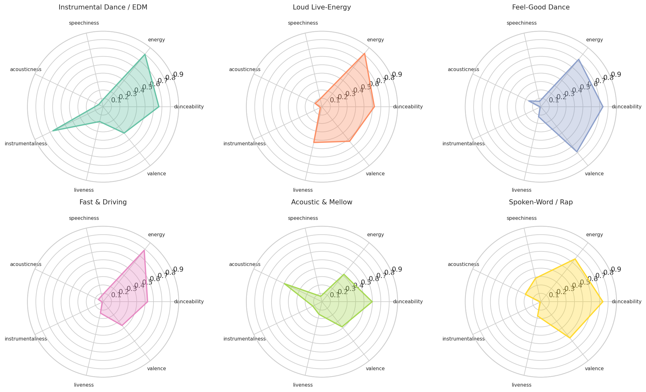
Figure 19: Radar profile of each cluster
See Figure 22: Clusters shown in PCA space and in t-SNE space (full-width plate at the end of this chapter)
The final model has silhouette 0.116 and Davies-Bouldin 1.92. The low silhouette reflects a continuum of styles, so clusters are best read as neighbourhoods of the audio space with soft borders.

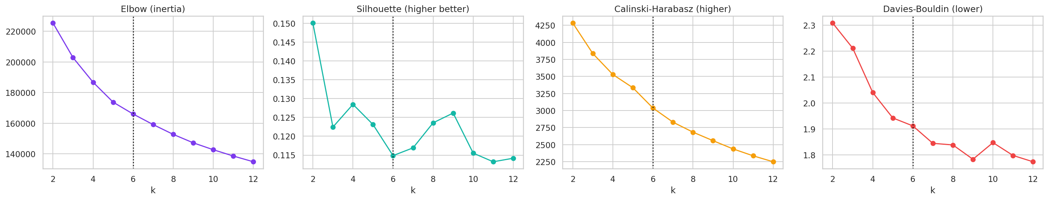
Figure 20: Elbow, silhouette, Calinski-Harabasz and Davies-Bouldin curves for K-Means
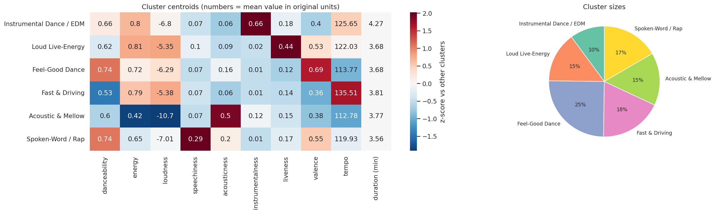
Figure 21: Cluster centroids (z-scores, with original values) and cluster sizes
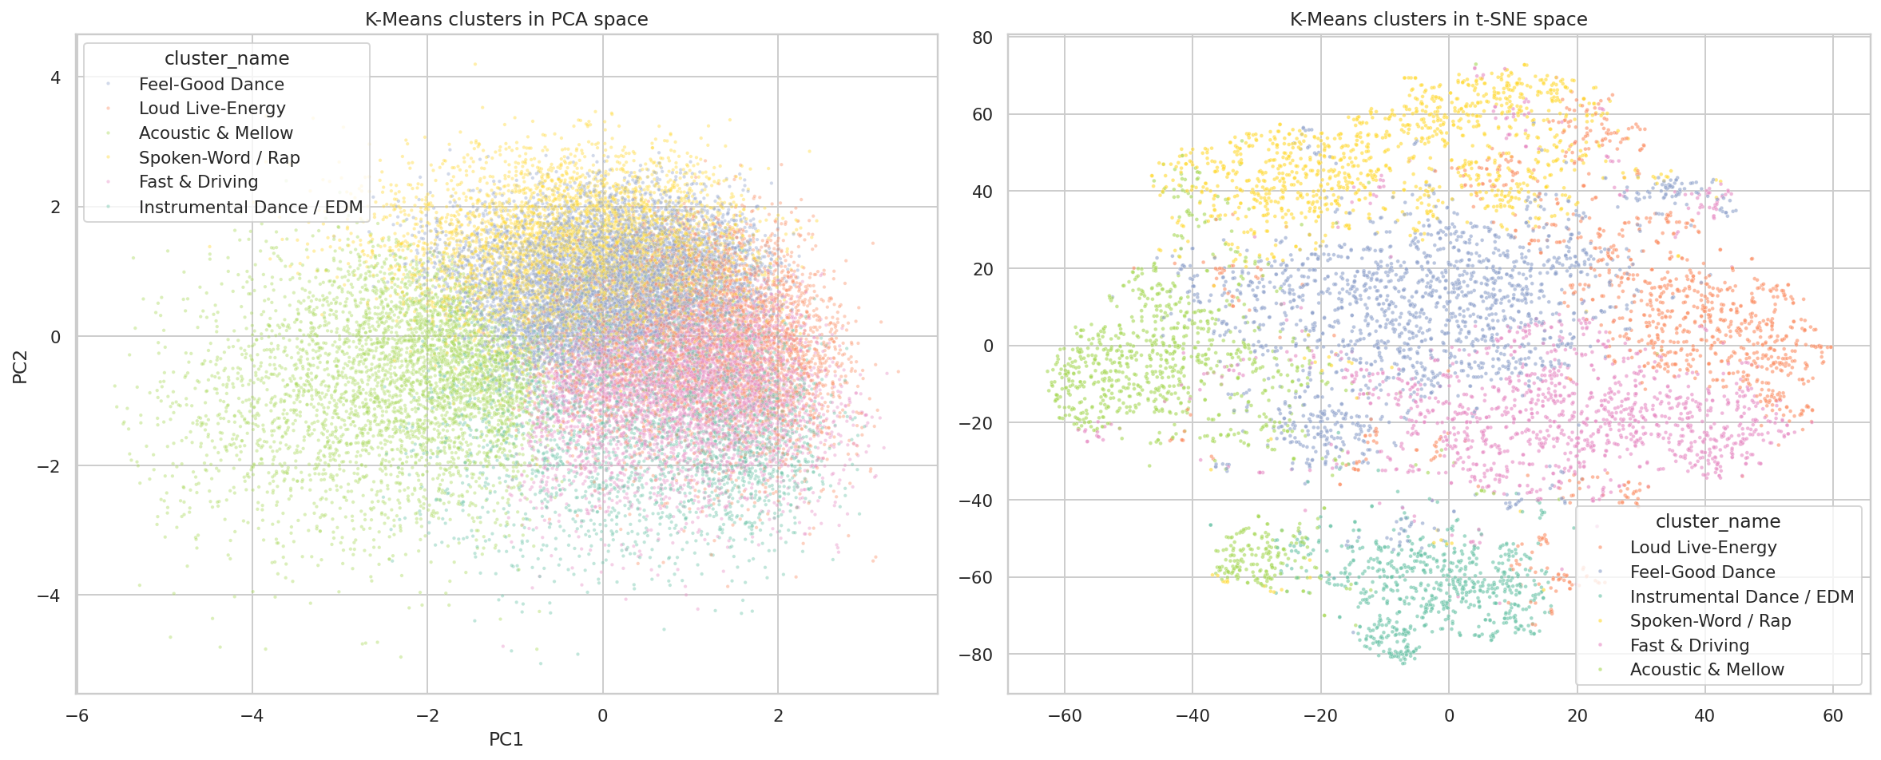
Figure 22: Clusters shown in PCA space and in t-SNE space

9. Clusters by Playlist Genre, Sub-genre and Playlist Name

9.1 Playlist genre
Table 11: Genre make-up of each cluster (share of the cluster's songs)
Cluster | EDM | Latin | Pop | R&B | Rap | Rock
Acoustic & Mellow | 4% | 11% | 17% | 33% | 16% | 19%
Fast & Driving | 26% | 7% | 21% | 8% | 11% | 27%
Feel-Good Dance | 11% | 28% | 20% | 19% | 12% | 11%
Instrumental Dance / EDM | 57% | 8% | 13% | 4% | 8% | 10%
Loud Live-Energy | 27% | 14% | 17% | 10% | 14% | 18%
Spoken-Word / Rap | 6% | 15% | 6% | 20% | 53% | 1%

See Figure 25: Genre composition of the clusters (row %), where each genre falls (column %), and stacked view (full-width plate at the end of this chapter)
Genre and sound are only loosely linked (ARI 0.075, NMI 0.105). Two clusters lean clearly towards a genre: Spoken-Word / Rap is 53% rap (2,287 of 4,348 songs) and contains only 37 rock songs, and Instrumental Dance / EDM is 57% EDM. The others mix genres. The largest, Feel-Good Dance, is 28% Latin, 20% pop, 19% R&B, 12% rap, 11% rock and 11% EDM, and Fast & Driving splits almost evenly between rock (27%) and EDM (26%). Playlist genres come from how a playlist is curated (culture, era, mood), not only from how songs sound.

9.2 Sub-genre
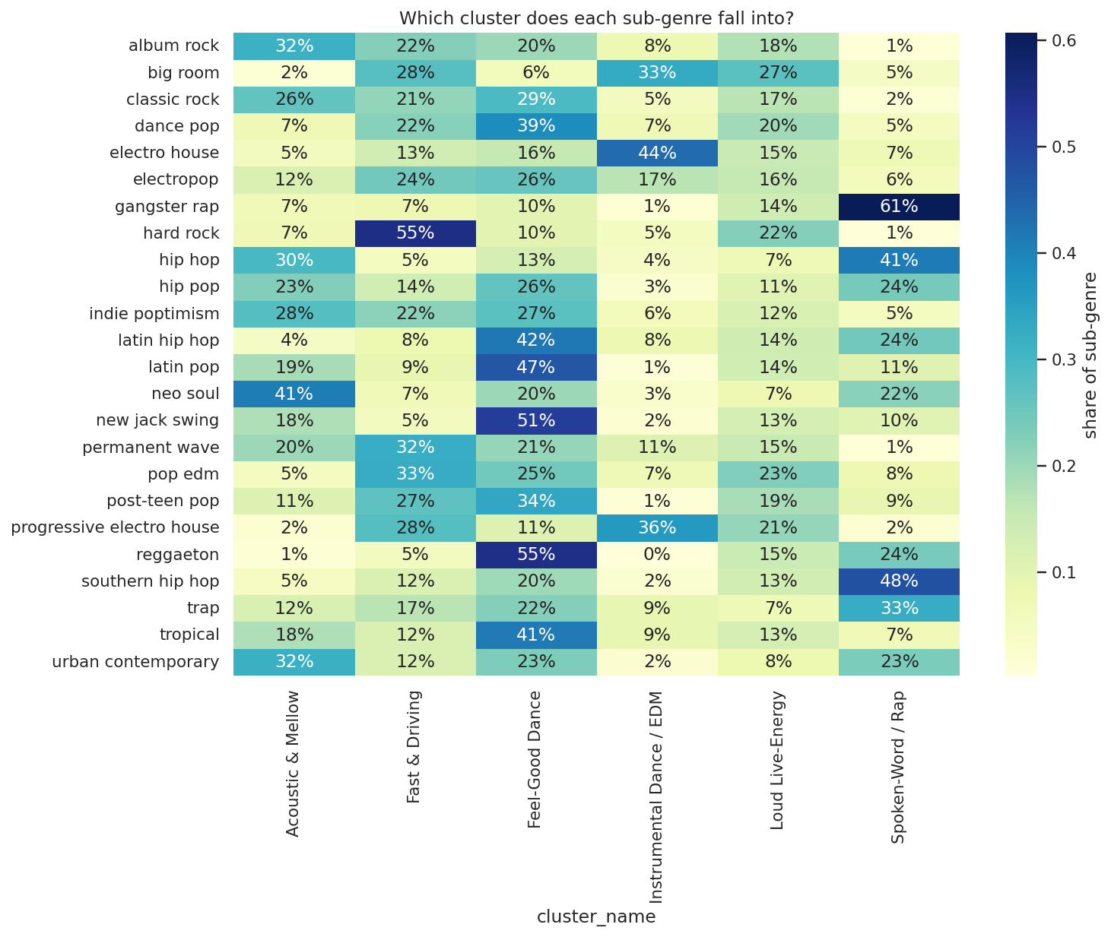
Figure 23: Share of each sub-genre falling into each cluster
At sub-genre level the link is stronger for acoustically distinctive styles (for example hip hop and trap map mostly to Spoken-Word / Rap, electro house and progressive electro house to the EDM and high-energy clusters), and weaker for stylistic labels such as pop or urban contemporary that are not defined by sound.
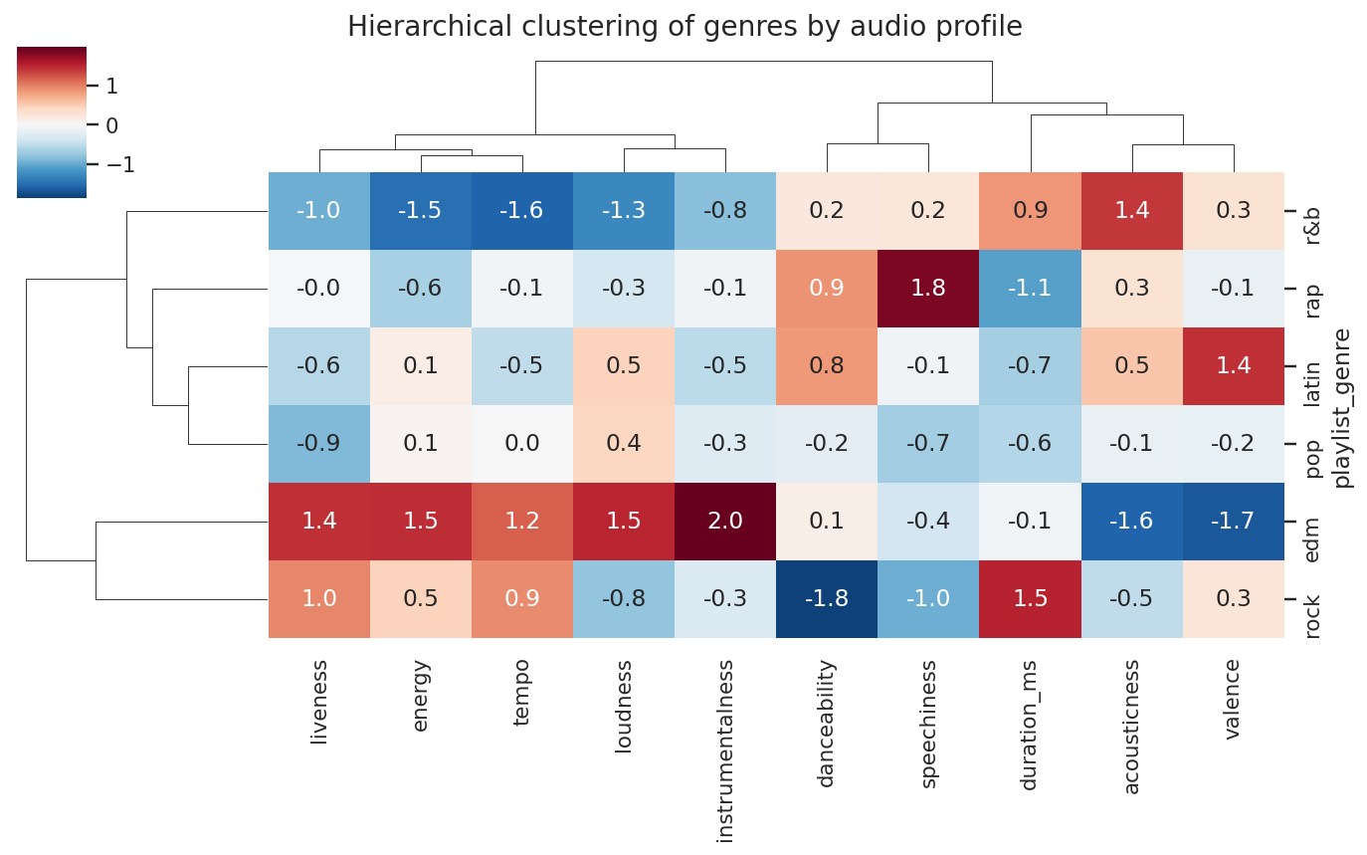
Figure 24: Hierarchical clustering of the six genres by average audio profile
The genre dendrogram first separates a high-energy pair (EDM and rock, both loud, fast and live) from the other four. Within the second group rap, Latin and pop join first and the mellow, acoustic R&B joins last.

9.3 Playlist name
Each of the 449 playlist names was summarised by the mean audio profile of its songs, using every record of the original file, and the playlists were clustered with K-Means (k = 6). Averaging removes song-level noise, so playlist clusters are much more cohesive (silhouette about 0.20, 0.196 to 0.22 for every k from 2 to 10) than song clusters (0.12). Only 5 of the 449 playlist names mix more than one genre.
See Figure 26: Playlist clusters: silhouette by k, PCA map of playlists, and the same playlists coloured by genre (full-width plate at the end of this chapter)
Table 12: Playlist clusters
Cluster | Playlists | Rows | Main genre | Example playlist names
0 | 88 | 6,279 | rock (52%) | Permanent Wave, Classic Rock 70s 80s 90s, Ro, permanent wave
1 | 86 | 6,237 | rap (72%) | Southern Hip Hop, Gangsta Rap/90's Hip-Hop, Gangster Rap Deutsch
2 | 140 | 9,990 | latin (42%) | Indie Poptimism, 2020 Hits & 2019 Hits – Top, Charts 2020 🔥Top 2020🔥Hits 2
3 | 50 | 4,066 | r&b (48%) | Ultimate Indie Presents... B, Urban Contemporary, Urban contemporary
4 | 82 | 6,183 | edm (65%) | Hard Rock Workout, Fitness Workout Electro | Ho, EDM 2020 House & Dance
5 | 3 | 65 | rock (67%) | Rock and Rios, Soda Stereo – El Ultimo Conc, Tropical Nights

- Rock group (88 playlists): Permanent Wave, Classic Rock 70s-90s.
- Hip-hop group (86): Southern Hip Hop, Gangsta Rap / 90s Hip-Hop, Neo-Soul.
- Pop / Latin / dance group (140): Dance Pop, Indie Poptimism, Tropical Vibes, chart playlists.
- Urban / R&B group (50): Urban Contemporary, Sexy Soul 2020.
- EDM and workout group (82): EDM 2020 House & Dance, Hard Rock Workout.
- Outlier group (3): three small playlists with unusual audio profiles.
See Figure 27: Dendrogram of the 45 largest playlists (full-width plate at the end of this chapter)
See Figure 28: Audio profile and genre composition of the playlist clusters (full-width plate at the end of this chapter)

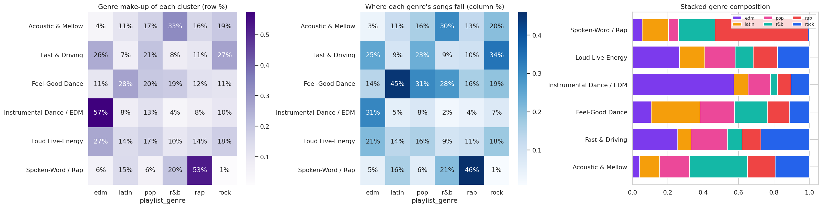
Figure 25: Genre composition of the clusters (row %), where each genre falls (column %), and stacked view
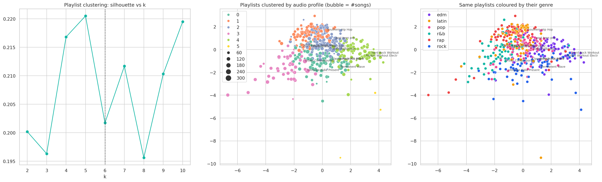
Figure 26: Playlist clusters: silhouette by k, PCA map of playlists, and the same playlists coloured by genre
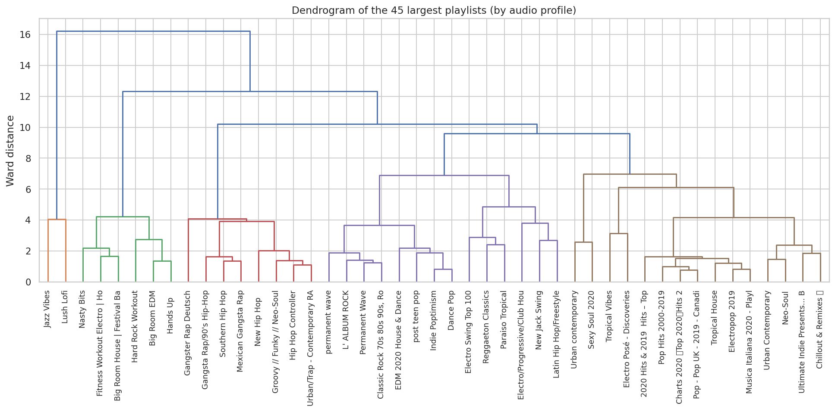
Figure 27: Dendrogram of the 45 largest playlists
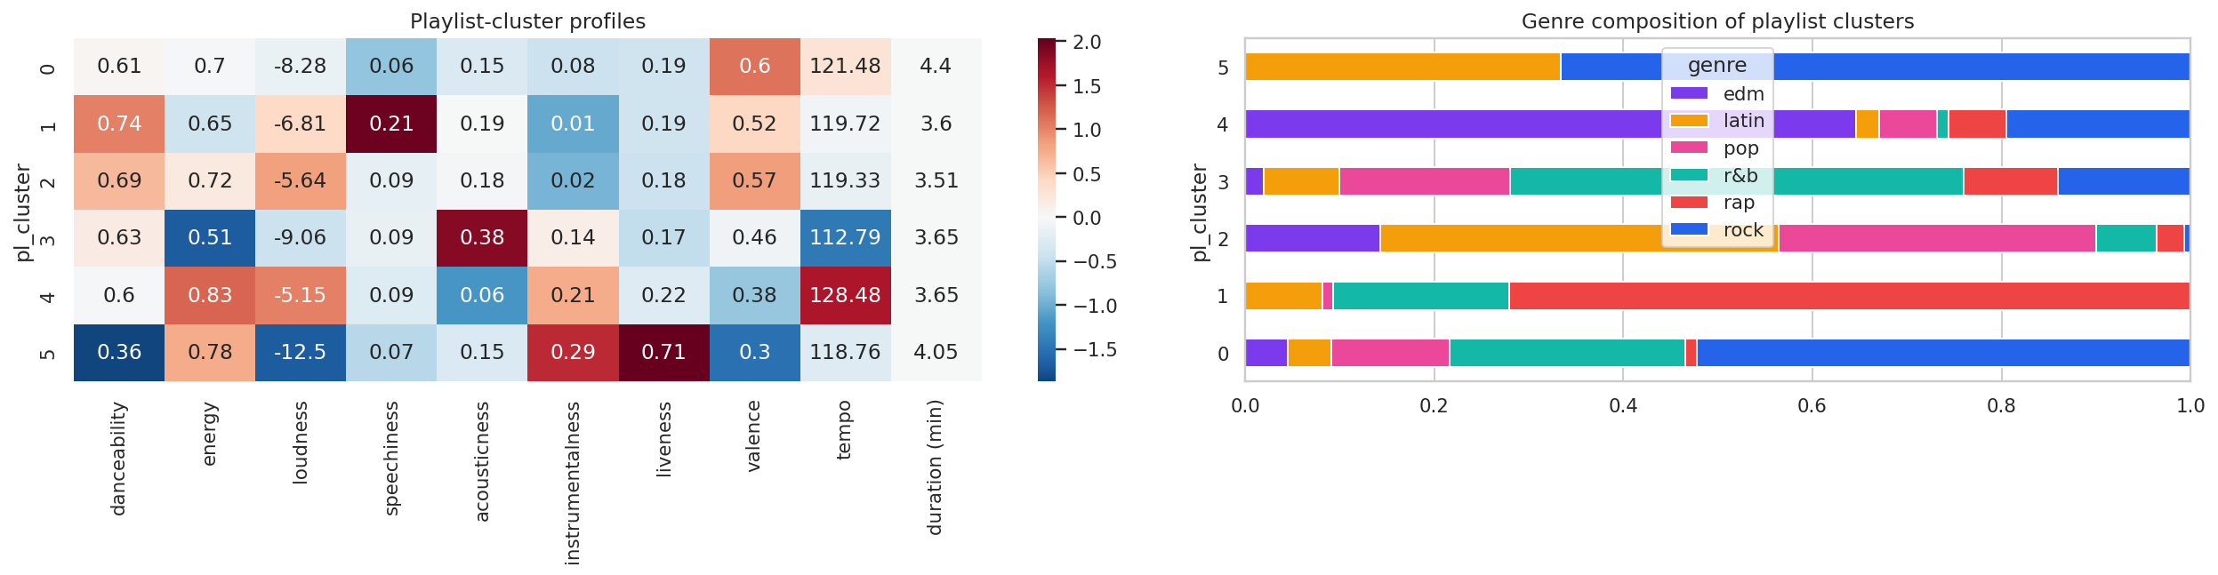
Figure 28: Audio profile and genre composition of the playlist clusters

10. Supervised Sanity Check
To judge how much of genre is explained by sound, a random forest (300 trees) was trained to predict playlist genre from the ten scaled audio features on an 80/20 stratified split. It reaches 55.1% accuracy against 16.7% for chance and 19% for always guessing the largest class. EDM (F1 0.69), rock (0.66) and rap (0.64) are the easiest genres; pop (F1 0.34) and Latin (0.43) are the hardest because they are defined by culture and language more than by sound. The most important features are tempo (0.14), speechiness (0.13) and danceability (0.12).
See Figure 29: Confusion matrix and feature importance of the random-forest genre classifier (full-width plate at the end of this chapter)
This 55% ceiling, obtained with labels available, explains why the unsupervised clusters match genre only partially and sets a realistic expectation for the recommender.

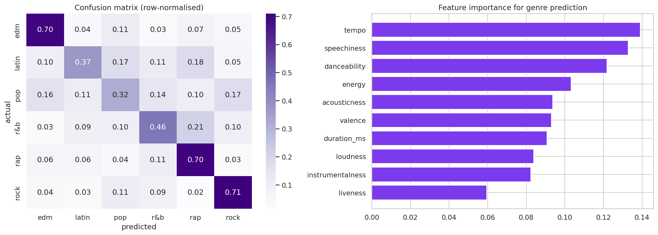
Figure 29: Confusion matrix and feature importance of the random-forest genre classifier

11. Recommendation System

11.1 Design
The recommender (class SpotifyRecommender in src/recsys.py) is a cluster-aware content-based filter:
- Every song is a point in the standardised 10-dimensional audio space.
- Given a seed (one song, several songs, or a hand-set audio profile), candidates are ranked by cosine similarity.
- Candidates are restricted to the seed's K-Means cluster (optional), so results stay in the same sonic family.
- A diversity rule allows at most two songs per artist; optional filters limit minimum popularity and playlist genre.
Table 13: Recommender interface
Method | Input | Use case
recommend_similar() | A song (title or "title - artist") | "More like this"
recommend_for_profile() | Target values such as energy, valence, tempo | Mood or activity playlists (workout, study)
recommend_for_playlist() | Several liked songs | Extend an existing playlist (uses the centroid)
search() | Part of a title or artist | Look up the exact seed

11.2 Example output
Table 14: Songs recommended for "Shape of You - Ed Sheeran" (popularity >= 40)
Song | Artist | Genre | Cluster | Cosine
Me Quedaré Contigo | El Micha | latin | Feel-Good Dance | 0.95
No Vuelvas Más | Darell | latin | Feel-Good Dance | 0.943
Brujeria | El Gran Combo De Puerto Rico | latin | Feel-Good Dance | 0.938
Dónde Están | Anna Carina | latin | Feel-Good Dance | 0.932
Peeping Tom - Original Mix | Jamie Berry | edm | Feel-Good Dance | 0.928
On The Low | Burna Boy | r&b | Feel-Good Dance | 0.923

Table 15: Songs for a "workout" profile (energy 0.92, danceability 0.75, tempo 140 BPM, valence 0.7)
Song | Artist | Genre | Cluster | Cosine
Mais Non - 1920 Version | Klischée | edm | Feel-Good Dance | 0.835
Soy Un Desastre | Timbiriche | latin | Feel-Good Dance | 0.832
Bagsakan | Parokya Ni Edgar | rock | Loud Live-Energy | 0.808
La Bicicleta | Carlos Vives | latin | Loud Live-Energy | 0.785
Sao Paulo Sunset | Saib | rap | Instrumental Dance / EDM | 0.784
Power Up | Red Velvet | pop | Loud Live-Energy | 0.767

11.3 Offline evaluation
No user-listening history is available, so quality was measured with proxy metrics on 2,000 random query songs and the top 10 recommendations for each. A recommendation counts as a hit when it comes from the same playlist genre (or sub-genre) as the query song. Random recommendation is the baseline.
Table 16: Recommender evaluation (2,000 queries, top 10)
Strategy | Genre P@10 | Any-genre P@10 | Sub-genre P@10 | Same cluster | Mean cosine | Mean popul.
Random baseline | 16.8% | 17.8% | 4.3% | 18% | 0.005 | 40.5
Global cosine kNN | 39.4% | 41.1% | 16.4% | 85% | 0.929 | 40.7
Cluster-aware (final) | 38.8% | 40.5% | 16.2% | 100% | 0.924 | 40.6

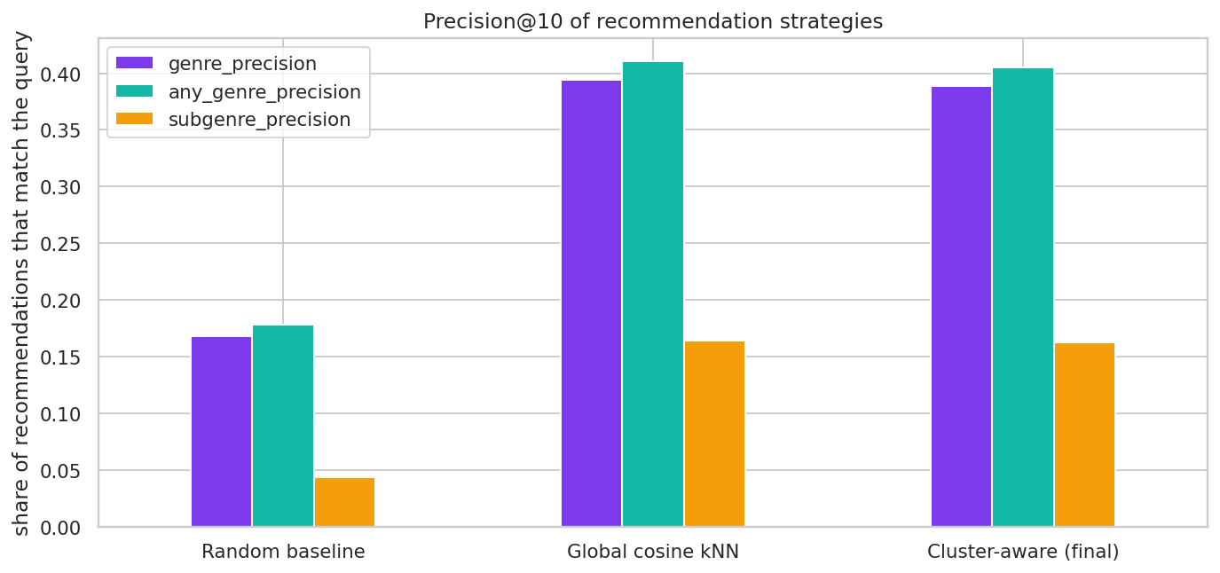
Figure 30: Precision@10 of the three strategies
- The final system matches the query's genre 38.8% of the time versus 16.8% for random (2.3x) and the sub-genre 16.2% versus 4.3% (3.8x).
- Restricting search to the seed's cluster costs only 0.6 percentage points against unrestricted cosine search (39.4%) while guaranteeing 100% same-cluster results. This is a coherence guarantee rather than an accuracy gain; unrestricted search remains available (same_cluster = False).
- Mean popularity of the recommendations (40.6) equals that of the catalogue (40.4), so the engine does not simply push hits.
- A query takes about 4 ms on a single CPU core.
- Because even a supervised classifier reaches only 55% on genre, about 39% is a reasonable result for a purely audio-based approach.

12. Web Application
app.py is a Streamlit application that loads the saved model and exposes four tabs:
- Similar songs: search for a song, choose the seed, and set the number of results, same-cluster option, minimum popularity and genre filter.
- Mood builder: sliders for energy, danceability, positivity, acousticness, speechiness and tempo return the closest songs.
- Cluster explorer: cluster profile heat table, genre make-up of each cluster and an interactive PCA scatter plot of 5,000 songs.
- Playlist clusters: browse the 449 playlist names by cluster.
Run it with streamlit run app.py from the project folder. The application was tested with Streamlit's automated test harness (all four tabs render without errors, and the search box returns results).

13. Results, Conclusion and Future Work

13.1 Summary of results
Table 17: Key results
Question | Answer
How many songs after cleaning? | 26,222 unique songs
Strongest feature correlation? | loudness - energy, r = +0.69
PCA variance in 2 / 4 components? | 37.5% / 58.9%
Best clustering model? | K-Means, k = 6 (silhouette 0.116, Davies-Bouldin 1.92)
Do clusters equal genres? | No: ARI 0.075, NMI 0.105
Can audio predict genre? | Partly: random forest 55.1% (6 classes)
Playlist-level clustering quality? | Silhouette 0.20 on 449 playlists
Recommender genre precision@10? | 38.8% vs 16.8% random

13.2 Conclusion
The project delivered the complete pipeline requested: pre-processing, a broad set of visualisations with the correlation matrix, clusters by genre, sub-genre and playlist name, and a model on which a working recommendation system was built, evaluated and deployed. Songs fall into six interpretable sonic families, but the structure is a continuum and only partly aligned with playlist genres. Some genres have a clear acoustic signature (rap is speech-heavy, EDM is loud and instrumental, R&B is mellow), while pop and Latin are defined more by culture than by sound. Playlist names are a far stronger grouping key than individual songs.

13.3 Limitations
- Genre labels come from playlists and are noisy (some artists appear under surprising genres), so genre match is only a proxy for recommendation quality.
- There is no listening history, so personalisation and real user satisfaction cannot be measured.
- 60% of the songs were released in 2015 or later, so findings describe recent music.
- Silhouette scores are low (about 0.12) because the feature space is continuous; clusters have soft boundaries.
- Ward clustering and the t-SNE maps were computed on samples for memory and speed.

13.4 Future work
- Combine content-based scores with collaborative filtering from listening history (hybrid recommender).
- Add lyrics, artist and release-era metadata and deep audio embeddings.
- Evaluate with online A/B tests or user surveys, and add diversity and novelty re-ranking.
- Deploy the application publicly and add playlist export.

References
- Pedregosa, F. et al. (2011). Scikit-learn: Machine Learning in Python. Journal of Machine Learning Research, 12, 2825-2830.
- MacQueen, J. (1967). Some methods for classification and analysis of multivariate observations. Proceedings of the 5th Berkeley Symposium on Mathematical Statistics and Probability.
- Rousseeuw, P. J. (1987). Silhouettes: a graphical aid to the interpretation and validation of cluster analysis. Journal of Computational and Applied Mathematics, 20, 53-65.
- Caliński, T. and Harabasz, J. (1974). A dendrite method for cluster analysis. Communications in Statistics, 3(1), 1-27.
- Davies, D. L. and Bouldin, D. W. (1979). A cluster separation measure. IEEE Transactions on Pattern Analysis and Machine Intelligence, 1(2), 224-227.
- Hubert, L. and Arabie, P. (1985). Comparing partitions. Journal of Classification, 2, 193-218.
- Ester, M., Kriegel, H.-P., Sander, J. and Xu, X. (1996). A density-based algorithm for discovering clusters in large spatial databases with noise. KDD-96 Proceedings.
- van der Maaten, L. and Hinton, G. (2008). Visualizing data using t-SNE. Journal of Machine Learning Research, 9, 2579-2605.
- Jolliffe, I. T. (2002). Principal Component Analysis (2nd ed.). Springer.
- Ricci, F., Rokach, L. and Shapira, B. (eds.) (2015). Recommender Systems Handbook (2nd ed.). Springer.
- Spotify for Developers. Web API Reference: Get Track's Audio Features. developer.spotify.com.
- Hunter, J. D. (2007). Matplotlib: A 2D graphics environment. Computing in Science & Engineering, 9(3), 90-95.
- Waskom, M. L. (2021). seaborn: statistical data visualization. Journal of Open Source Software, 6(60), 3021.

Appendix A: How to Run the Project
- Install Python 3.10 or later and run pip install -r requirements.txt.
- Open notebooks/Spotify_Genre_Segmentation.ipynb in Jupyter and choose Run All (about 3 minutes) to regenerate every figure, table and the saved model.
- Start the web application with streamlit run app.py.
- Use the library directly: from recsys import SpotifyRecommender; rec = SpotifyRecommender.load("models"); rec.recommend_similar("Shape of You - Ed Sheeran").

Appendix B: Cluster Reference
Table 18: Cluster dictionary
ID | Name | Songs | Avg popularity | Typical genres
0 | Instrumental Dance / EDM | 2,650 | 29.6 | edm 57%, pop 13%
1 | Loud Live-Energy | 3,855 | 39.0 | edm 27%, rock 18%
2 | Feel-Good Dance | 6,548 | 43.3 | latin 28%, pop 20%
3 | Fast & Driving | 4,782 | 40.4 | rock 27%, edm 26%
4 | Acoustic & Mellow | 4,039 | 42.3 | r&b 33%, rock 19%
5 | Spoken-Word / Rap | 4,348 | 42.3 | rap 53%, r&b 20%

