4th Question:
4.1 select * from Customers;
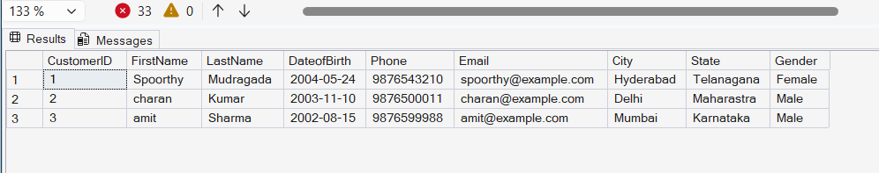
4.2 select CustomerId, PolicyId, StartDate, EndDate from PolicyAssignments;
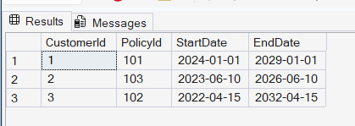
4.3 select * from Policies where PolicyType='Health';
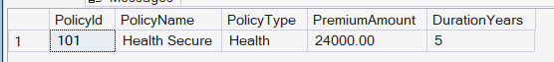
4.4 select * from Policies where PremiumAmount>10000 and DurationYears=1;

4.5 select distinct city from Agents;
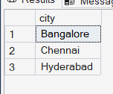

4.6 select * from policies where PolicyType='Life Insurance' or PolicyType='Health' or PolicyType='Auto';
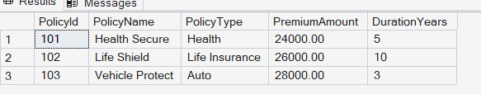
4.7 select * from policies where PolicyType IN('Life Insurance','Health','Auto');
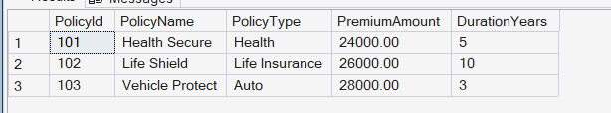
4.8 select * from customers where DateofBirth>='2001-01-01' and DateofBirth<='2020-12-31';
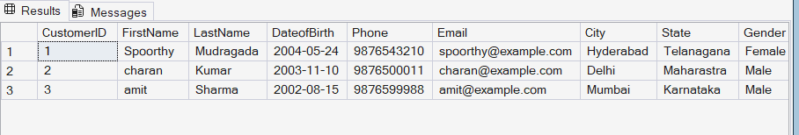
4.9 select * from customers where DateofBirth Between '2001-01-01' and '2020-12-31';
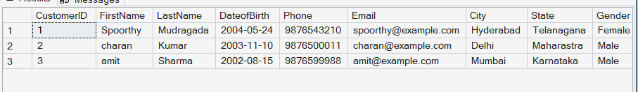
4.10 select * from Claims where ClaimStatus='Rejected';
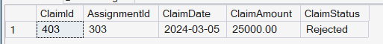
4.11 select * from Agents where City LIKE '_a%';
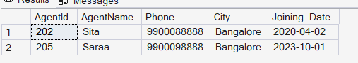
4.12 Select MAX(ClaimAmount) as maximum, MIN(ClaimAmount) as minimum from Claims;
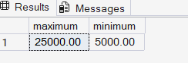
4.13 SELECT * from Claims where ClaimDate=(Select MAX(ClaimDate) from Claims);
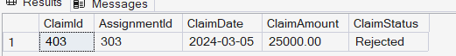
4.14 UPDATE Policies set PremiumAmount=1.10*PremiumAmount where PolicyType='Health';

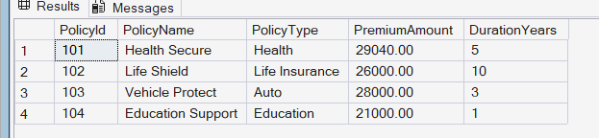

4.15 DELETE FROM Claims WHERE AssignmentId IN (SELECT AssignmentId FROM PolicyAssignments WHERE EndDate < GETDATE());
Delete from PolicyAssignments where EndDate< GETDATE();
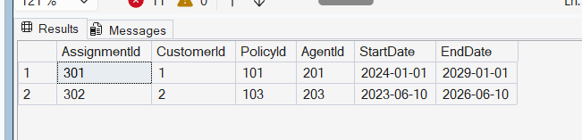

4.16 select count(*) from Claims where ClaimStatus='Rejected';
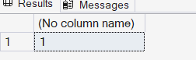
4.17 select PolicyId,PolicyName, PremiumAmount , (PremiumAmount * 0.6) as LocalTaxes, PremiumAmount+(PremiumAmount * 0.6) as PremiumAmountWithTax, (PremiumAmount+(PremiumAmount * 0.6))/12 as MonthlyPremiumAmount FROM Policies ;
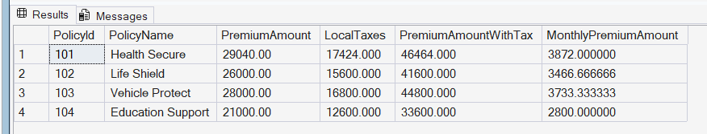
4.18 alter table Customers add address varchar(50);
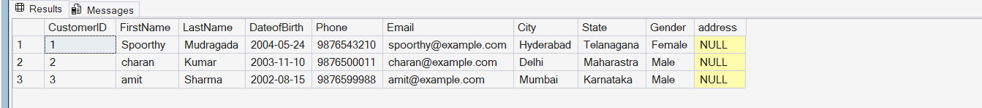
4.19 alter table Agents add DevOfId int;
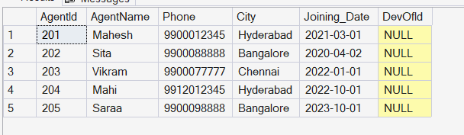
4.20 ALTER TABLE Agents ADD FOREIGN KEY (DevOfId) REFERENCES Agents(AgentId);


5th Question:

5.1 SELECT p.PolicyId, p.PolicyName, p.PolicyType, p.PremiumAmount FROM Policies p JOIN PolicyAssignments pa ON p.PolicyId = pa.PolicyId WHERE pa.CustomerId = 5;


5.2 SELECT c.CustomerID, c.FirstName, c.LastName, p.PolicyId, p.PolicyName, p.PolicyType, p.PremiumAmount, pa.StartDate, pa.EndDate FROM Customers c LEFT JOIN PolicyAssignments pa ON c.CustomerID = pa.CustomerId LEFT JOIN Policies p ON pa.PolicyId = p.PolicyId;
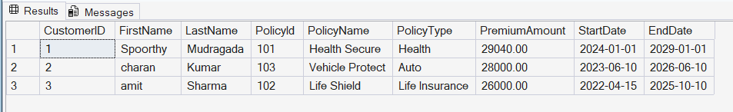

5.3 select c.CustomerId, c.FirstName,c.LastName, cl.ClaimId,cl.ClaimDate, cl.ClaimAmount from Claims as cl Left Join PolicyAssignments as pa on cl.AssignmentId=pa.AgentId Left join Customers as c on c.CustomerID=pa.CustomerId;
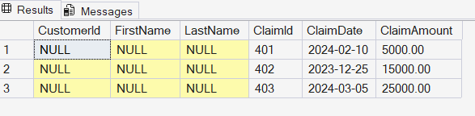
5.4 select c.FirstName ,p.PolicyName, a.AgentName, pa.StartDate, pa.EndDate from Customers as c join PolicyAssignments AS pa on c.CustomerID=pa.CustomerId join Agents as a on pa.AgentId=a.AgentId join Policies as p on p.PolicyId=pa.PolicyId;
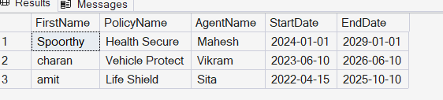

5.5 select c.FirstName,p.PolicyId,cl.ClaimAmount,cl.ClaimStatus,cl.ClaimDate from Customers as c join PolicyAssignments as pa on c.CustomerID=pa.CustomerId join Policies as p on p.PolicyId=pa.PolicyId join Claims as cl on cl.AssignmentId=pa.AssignmentId;
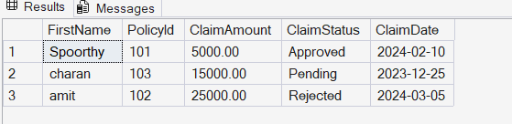

5.6 SELECT c.CustomerID, c.FirstName, c.LastName, pa.PolicyId, pa.StartDate, pa.EndDate FROM Customers c LEFT JOIN PolicyAssignments pa ON c.CustomerID = pa.CustomerId;
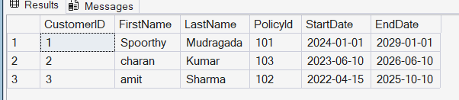

5.7 select c.CustomerId from Customers as c LEFT JOIN PolicyAssignments as pa on c.CustomerID=pa.CustomerId join Claims as cl on pa.AssignmentId=cl.AssignmentId where ClaimId=NULL;


5.8 select c.FirstName, c.LastName , SUM(cl.ClaimAmount) from Customers as c Left join PolicyAssignments as p on c.CustomerId=p.CustomerId left join Claims as cl on p.AssignmentId=cl.AssignmentId Group by c.FirstName, c.LastName;
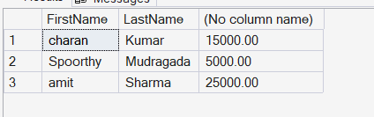

5.9 select c.FirstName, c.LastName , SUM(cl.ClaimAmount) as total_amount from Customers as c Left join PolicyAssignments as p on c.CustomerId=p.CustomerId left join Claims as cl on p.AssignmentId=cl.AssignmentId Group by c.FirstName, c.LastName having SUM(cl.ClaimAmount)>50000;


5.10 Display list with Agent Wise Policy Count.
