**AI ASSITED CODING**

**NAME : GURRALA SAI SPOORTHI**

**YEAR / SEM : II / I**

**BATCH : 01**

**HALL TICKET NO: 2403A52290**

**COURSE TITLE: AI ASSITED CODING**

**Task 1:**

**Use Gemini in Colab to write a function that filters out all negative numbers from a  
given list.**

**PROMPT:**

**Write a python function to figure out negative numbers from a user defined list**

**Description:**

**Use Gemini in collab to write a function using python language to negative numbers from all the user defined elements in a list must be figured out**

**CODE:**

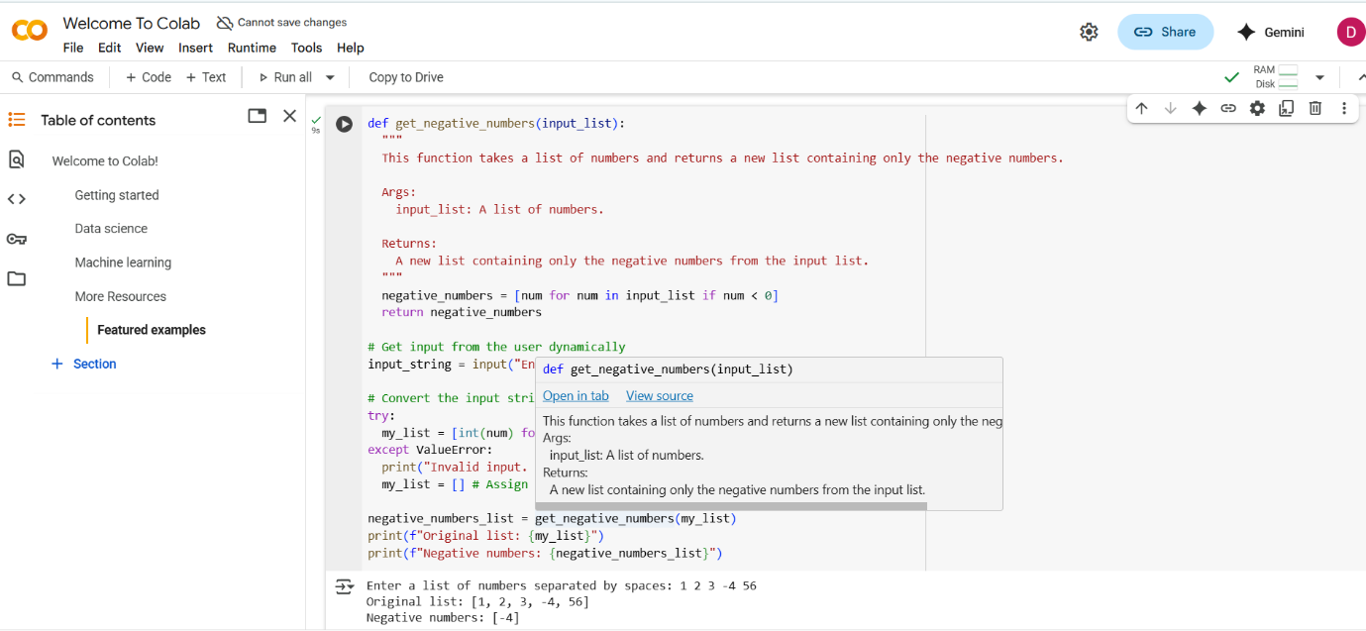

**OUTPUT:**

**Functional code with before/after input and output shown in Colab, plus a screenshot.**



**Observation:**

**I have given different input for above code .All the test cases are accurate as expected**

**Explanation:**

**In the above code,We used Gemini to get the code.We have given the prompt,it has given me the code as per the prompt.**

**We have created an emty list and appended the elements .We used the condition if element<0**

**By using the Condition,it is able to find out the negative numbers**

**Task 2:**

**Ask Gemini to generate code that reads a text file and counts the frequency of each  
word. Then ask it to explain the code.**

**PROMPT:**

**Write a python function which takes a sentence and finds out frequency of each word in it**

**CODE:**

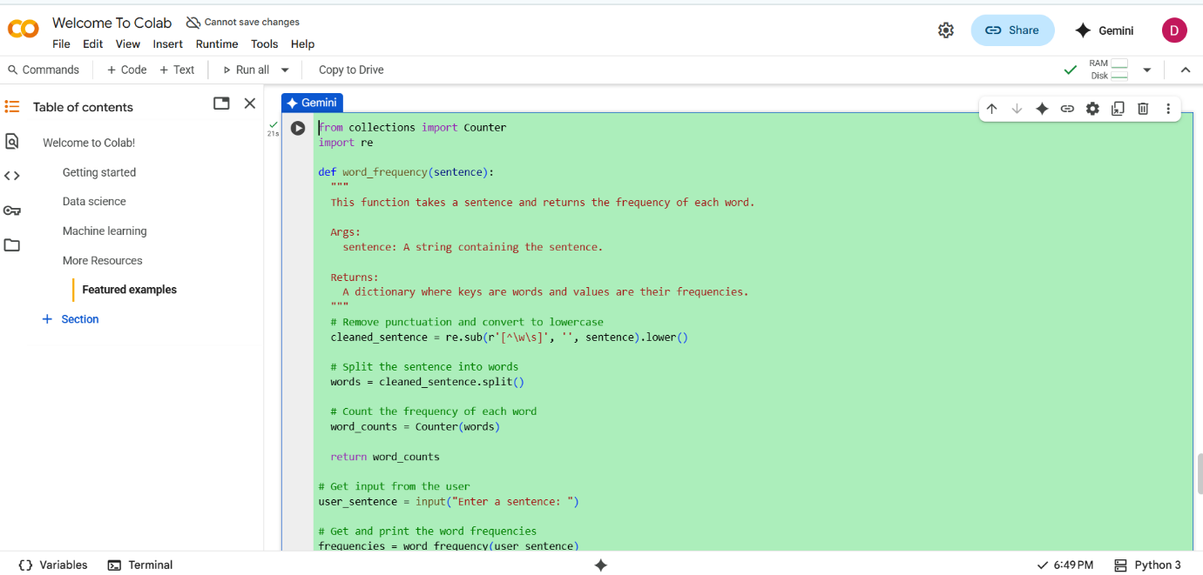

**Output:**

**Working code and Gemini’s explanation side-by-side.**

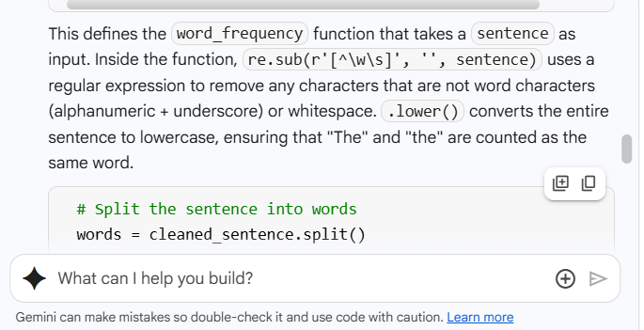

**Code Explanation:**

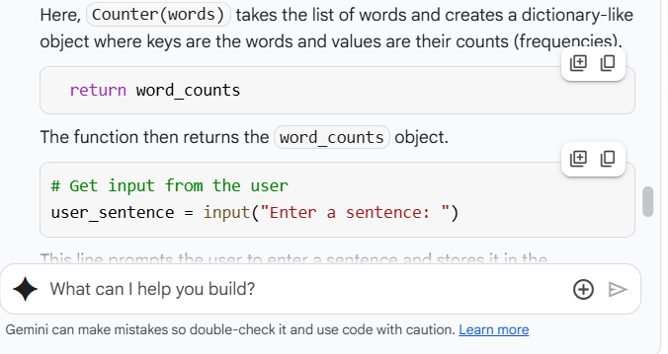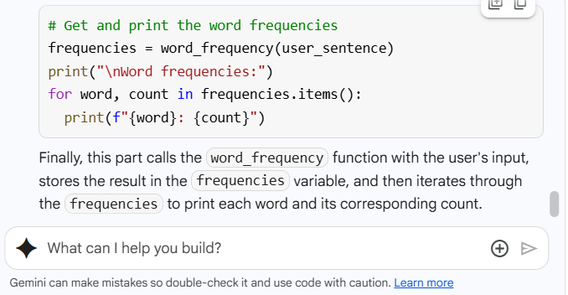

**Observation:**

**The outputs are as expected**

**Task 3:**

**Use Cursor AI to generate a Python class called Book with attributes title, author, and  
a method summary() that prints the details.**

**PROMPT:**

**Write a python class Book with attributes title,author and a method Display which prints information about the class**

**CODE:**

**Code from Gemini in Collab**

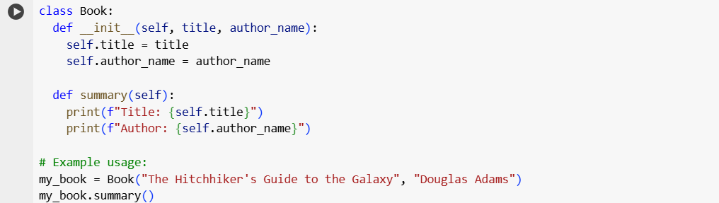

**Code from Copilot**

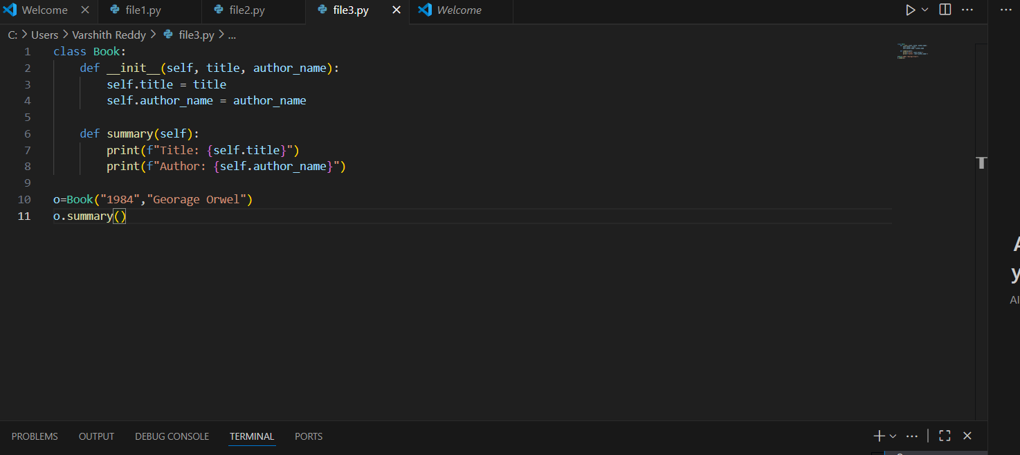

**OUTPUT:**

**Screenshot comparisons and student commentary on code clarity and performance.**

**Output from Gemini in Collab**



**Output from Copilot**



**Student Commentry:**

**I got the code from both Copilot and Gemini in Collab**

**Performance wise Copilot is too good as it is taking less time to give the code and it is user friendly to use**

**Whereas Gemini in Collab is taking more time than Copilot and there is a delay in displaying of Output**

**However both of them gave the same code i.e static way of coding .No where the code is dynamic**

**Observation:**

**The outputs are as expected**

**Task 4:**

**Ask Gemini to write a program that checks whether a number is an Armstrong  
number, and then modify it using Cursor AI to improve performance or structure.**

**PROMPT:**

**Write a python function that takes a user defined number and checks whether it is Armstrong or not**

**Description:**

**Use Python Programming language to take a user defined number and check whether it is Armstrong.Use while loop for better Understanding**

**Code:**

**Code from Gemini in Collab**

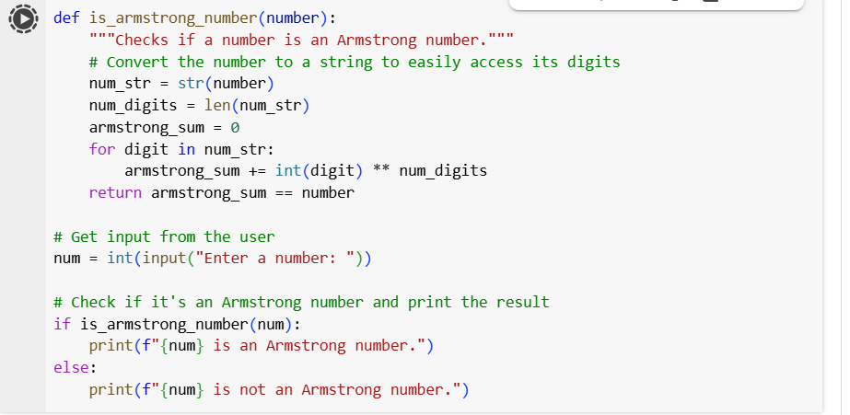

**Output from Gemini in Collab:**

**Two versions of the code with screenshots, and a summary of what changes were  
made by Cursor.**

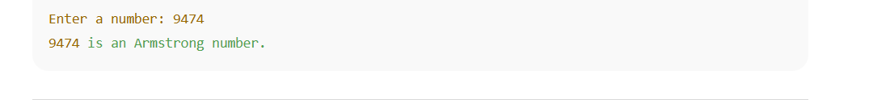

**Code from Copilot:**

**Output from Copilot:**



**Summary:**

**I got two similar codes from Copilot and Gemini in Collab among those two the code from both are good .**

**Coming to their fastness Copilot is a little bit fast**

**We can see in above slides**

**Explanation:**

**In above code they are asking us to enter a number to check whether it is an Armstrong or not.As per the conditions the code is checking .**

**Observation:**

**The outputs are as expected**

**Task 5:**

**Description:**

**Use both Gemini and Cursor AI to generate code for sorting a list of dictionaries by a  
specific key (e.g., age).**

**CODE:**

**Code from Gemini in Collab**

**Code from Copilot:**

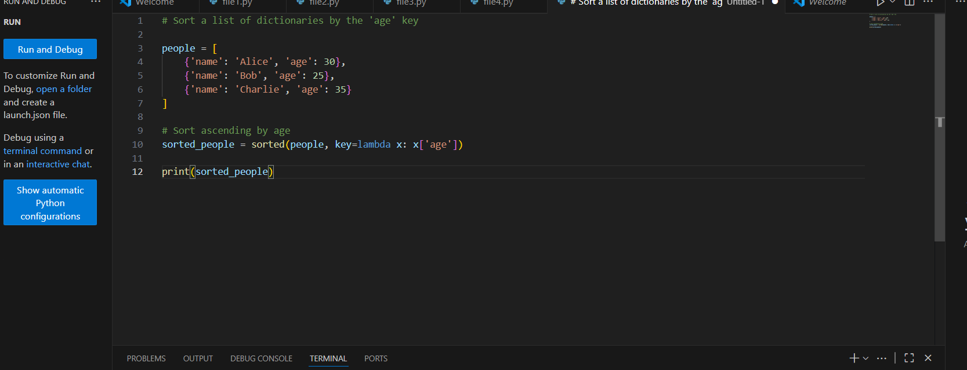

**OUTPUT:**

**Screenshot comparisons and student commentary on code clarity and performance.**

**Output from Gemini in Collab**



**Output from Copilot:**



**Student Commentry:**

**In above two Codes both are giving almost same codes .There is no difference between them.Both of them given static way of code as per the prompt that I have given**

**Explanation:**

**In the above code they have taken a static list of dictionaries and based on the key output is getting displayed based on the Sorting order**

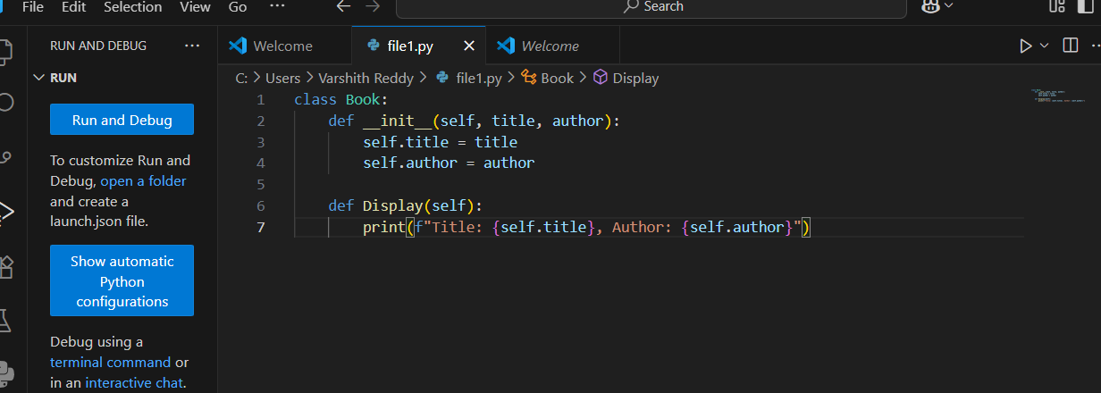

**Observation:**

**The outputs are as expected**