**DAILY ONLINE ACTIVITIES SUMMARY**

|  |  |  |  |  |  |  |  |  |
| --- | --- | --- | --- | --- | --- | --- | --- | --- |
| **Date:** | **10/07/2020** | | | | | **Name:** | **SPOORTHY VV** | |
| **Sem & Sec** | **4th SEM. & ‘B’ SEC.** | | | | | **USN:** | **4AL18CS087** | |
| **Online Test Summary** | | | | | | | | |
| **Subject** | | **Object Oriented Concepts** | | | | | | |
| **Max. Marks** | | **30** | | **Score** | | | **--** | |
| **Certification Course Summary** | | | | | | | | |
| **Course** | **Digital marketting** | | | | | | | |
| **Certificate Provider** | | | **Google digital garage** | | **Duration** | | |  |
| **Coding Challenges** | | | | | | | | |
| **-----** | | | | | | | | |
| **Status : --** | | | | | | | | |
| **Uploaded the report in Github** | | | | | **Yes** | | | |
| **If yes Repository name** | | | | | [lockdown_coding](https://github.com/alvas-education-foundation) | | | |
| **Uploaded the report in slack** | | | | | **Yes** | | | |

**Online Test Summary: Today 18CS45 Descriptive test was conducted,there were 4 questions and the test was from 9:30 AM to 10:15 AM.Test written in A4 sheets and uploaded in Google Classroom.Scores are not yet received.**

**Online Certification course Summary:**

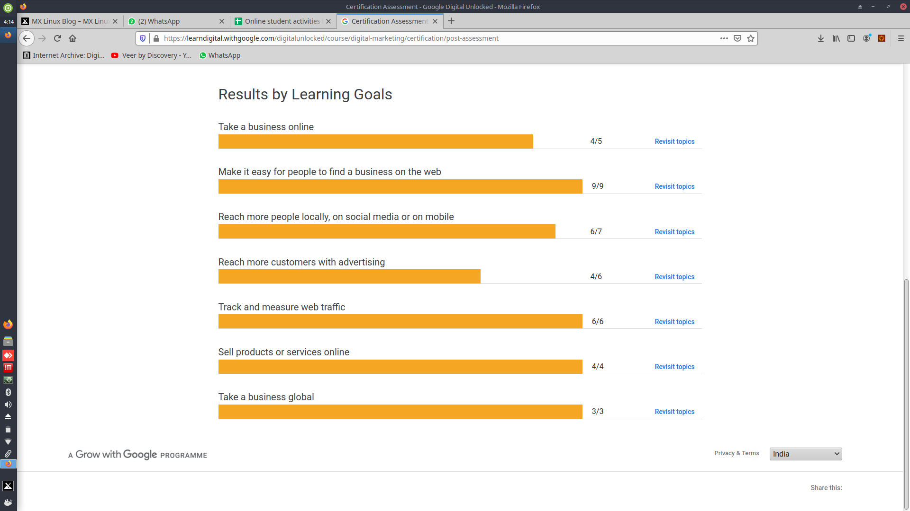

**Online Coding Summary: Today I didn’t receive the program.**