**DAILY ONLINE ACTIVITIES SUMMARY**

|  |  |  |  |  |  |  |  |  |
| --- | --- | --- | --- | --- | --- | --- | --- | --- |
| **Date:** | **13/06/2020** | | | | | **Name:** | **SPOORTHY VV** | |
| **THY Sem & Sec** | **4th SEM. & ‘B’ SEC.** | | | | | **USN:** | **4AL18CS087** | |
| **Online Test Summary** | | | | | | | | |
| **Subject** | | **DATA COMMUNICATION** | | | | | | |
| **Max. Marks** | | **30** | | **Score** | | | **25** | |
| **Certification Course Summary** | | | | | | | | |
| **Course** | **Introduction to Cybersecurity** | | | | | | | |
| **Certificate Provider** | | | **CISCO** | | **Duration** | | | **15Hrs.** |
| **Coding Challenges** | | | | | | | | |
| **Problem Statement 1:Write a C Program to calculate Electricity Bill.** | | | | | | | | |
| **Status: Executed** | | | | | | | | |
| **Uploaded the report in Github** | | | | | **Yes** | | | |
| **If yes Repository name** | | | | | **lockdown_coding** | | | |
| **Uploaded the report in slack** | | | | | **Yes** | | | |

**Online Test Summary: 18CS46 online test was scheduled from 2:00 PM to 2:30 PM.The portion for the IA was 1st and 2nd module there were 30 questions and the time assigned was 30 minutes. The questions were MCQ type and each question carries 1 mark.**

**Online Certification course Summary:**

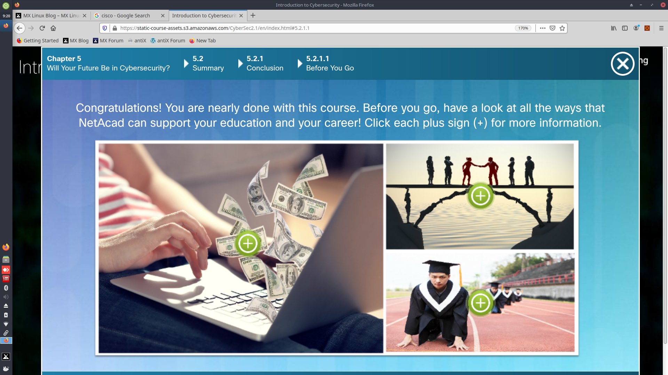

**Online Coding Summary:**

**Today I received one program from prof.Venkatesh CSE Dept . The program is mentioned above in the coding challenges(pg.01). I have also uploaded it to my Github repository.**

Link :https://github.com/spoorthyvv/lockdown_coding