**DAILY ONLINE ACTIVITIES SUMMARY**

|  |  |  |  |  |  |  |  |  |
| --- | --- | --- | --- | --- | --- | --- | --- | --- |
| **Date:** | **16/07/2020** | | | | | **Name:** | **SPOORTHY VV** | |
| **Sem & Sec** | **4th SEM. & ‘B’ SEC.** | | | | | **USN:** | **4AL18CS087** | |
| **Online Test Summary** | | | | | | | | |
| **Subject** | | **-----** | | | | | | |
| **Max. Marks** | | **--** | | **Score** | | | **--** | |
| **Certification Course Summary** | | | | | | | | |
| **Course** | [**HTML, CSS, and Javascript for Web Developers**](https://www.coursera.org/learn/html-css-javascript-for-web-developers) | | | | | | | |
| **Certificate Provider** | | | **Coursera** | | **Duration** | | | **5 weeks** |
| **Coding Challenges** | | | | | | | | |
| **-----** | | | | | | | | |
| **Status : --** | | | | | | | | |
| **Uploaded the report in Github** | | | | | **Yes** | | | |
| **If yes Repository name** | | | | | **-----** | | | |
| **Uploaded the report in slack** | | | | | **Yes** | | | |

**Online Test Summary: No internals conducted.**

**Online Certification course Summary:**

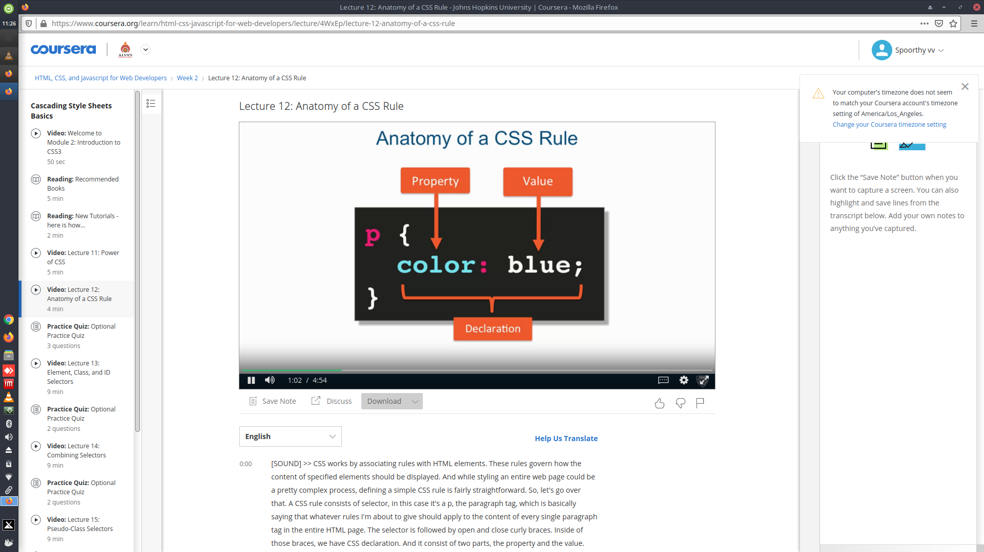

**Online Coding Summary: Didn’t receive any program.**

**Online Training : Today I attended the online training organized by CSE Department AIET.The training was on C Programming done by Prof.Megha Hegde CSE Dept.**