**DAILY ONLINE ACTIVITIES SUMMARY**

|  |  |  |  |  |  |  |  |  |
| --- | --- | --- | --- | --- | --- | --- | --- | --- |
| **Date:** | **16/06/2020** | | | | | **Name:** | **SPOORTHY VV** | |
| **Sem & Sec** | **4th SEM. & ‘B’ SEC.** | | | | | **USN:** | **4AL18CS087** | |
| **Online Test Summary** | | | | | | | | |
| **Subject** | | **COMPLEX ANALYSIS, PROBABILITY AND STATISTICAL METHODS** | | | | | | |
| **Max. Marks** | | **30** | | **Score** | | | **22** | |
| **Certification Course Summary** | | | | | | | | |
| **Course** | **Cloud Foundations** | | | | | | | |
| **Certificate Provider** | | | **Great Learning** | | **Duration** | | | **3Hrs.** |
| **Coding Challenges** | | | | | | | | |
| **Problem Statement 1:Write a C Program to perform the following operations on Triply Linked List (TLL).** | | | | | | | | |
| **Status: Executed** | | | | | | | | |
| **Uploaded the report in Github** | | | | | **Yes** | | | |
| **If yes Repository name** | | | | | [**lockdown_coding**](https://github.com/alvas-education-foundation/spoorti_daroji) | | | |
| **Uploaded the report in slack** | | | | | **Yes** | | | |

**Online Test Summary:18MAT41 online test was scheduled from 3:00 mPM t0 3:40 PM .The portion for the IA was the 1st module. There were 15 questions and the time assigned was 40 minutes. The questions were MCQ type, and each question carries 2 marks.**

**Online Certification course Summary:**

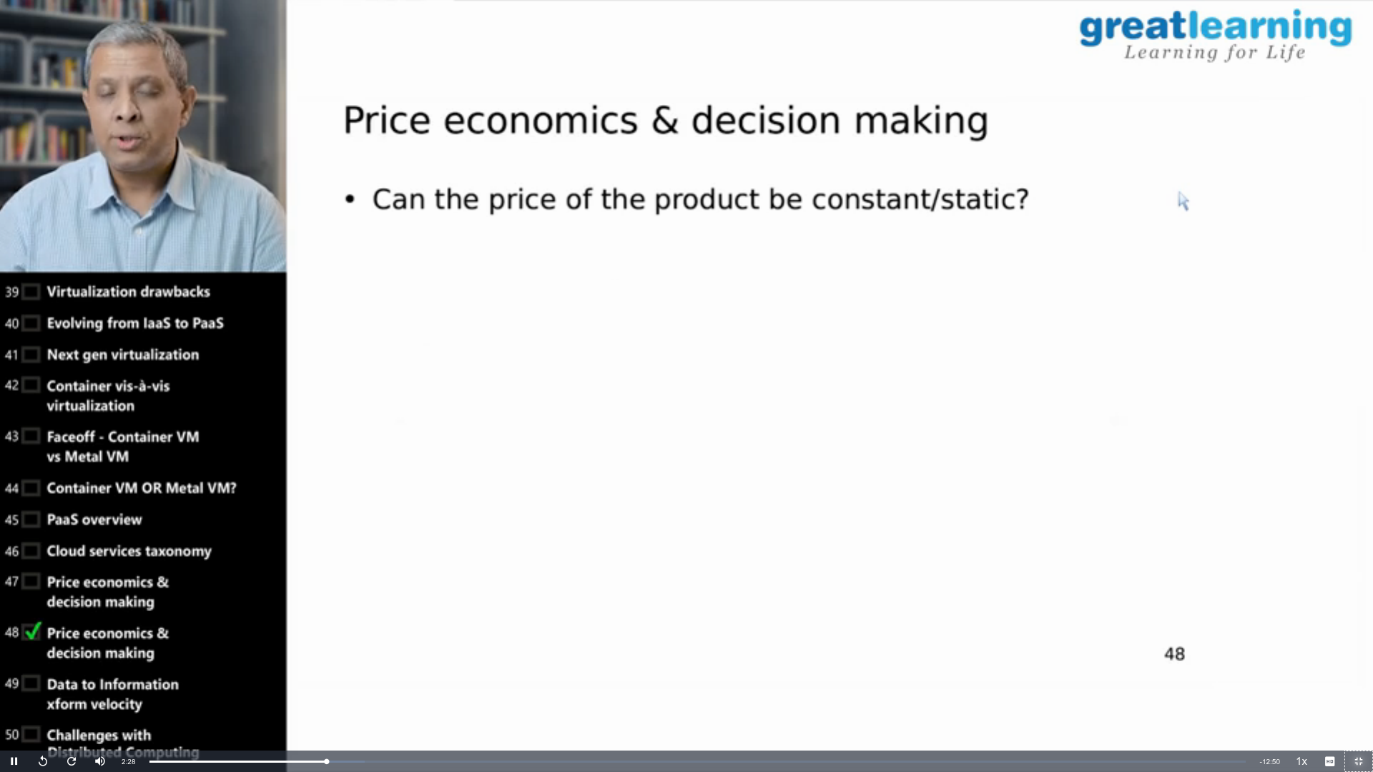

**Online Coding Summary:**

**Today I received one program from prof.Venkatesh CSE Dept . The program is mentioned above in the coding challenges(pg.01). I uploaded it to my Github repository**

**Link :** **https://github.com/spoorthyvv/lockdown_coding**