**DAILY ONLINE ACTIVITIES SUMMARY**

|  |  |  |  |  |  |  |  |  |
| --- | --- | --- | --- | --- | --- | --- | --- | --- |
| **Date:** | **18th May 2020** | | | | | **Name:** | **SPOORTHY VV** | |
| **Sem & Sec** | **4th SEM B SEC** | | | | | **USN:** | **4AL18CS087** | |
| **Online Test Summary** | | | | | | | | |
| **Subject** | | **COMPLEX ANALYSIS,PROBABILITY AND STATISTICAL METHODS** | | | | | | |
| **Max. Marks** | | **30** | | **Score** | | | **-** | |
| **Certification Course Summary** | | | | | | | | |
| **Course** | **Python For Machine Learning** | | | | | | | |
| **Certificate Provider** | | | **Great Learning** | | **Duration** | | | **5 hrs** |
| **Coding Challenges** | | | | | | | | |
| **Problem Statement 1: Given an array of distinct integers .The task is to count all the triplets such that sum of two elements equals the third element. Problem Statement 2: Write a C program to check whether the two strings are Anagram or not.** | | | | | | | | |
| **Status:: 1 executed.** | | | | | | | | |
| **Uploaded the report in Github** | | | | | **Yes** | | | |
| **If yes Repository name** | | | | | **Lockdown Coding** | | | |
| **Uploaded the report in slack** | | | | | **Yes** | | | |

Online Test Summary: 18MAT41 online test was scheduled from 9:30 am t0 10 am And the test scores are not yet received .The portion for the IA was 4th module there were 30 questions and the time assigned was 30minutes the questions were MCQ type.I deeply had time management issues and hence could not complete the test on time.

Online Certification course Summary: I have taken my Online Certification Course in Greatlearning academy the course which I have opted is Python for Machine Learning. Course contains videos, tutorials, assessments and quiz. Today I have gone through the python introduction and I came to know that python is an easy to learn , powerful programming language. We can also use python when our data analysis task needs to be incorporated into a production database. But being a full-fledged programming language, it’s a great tool to implement algorithms for production use.

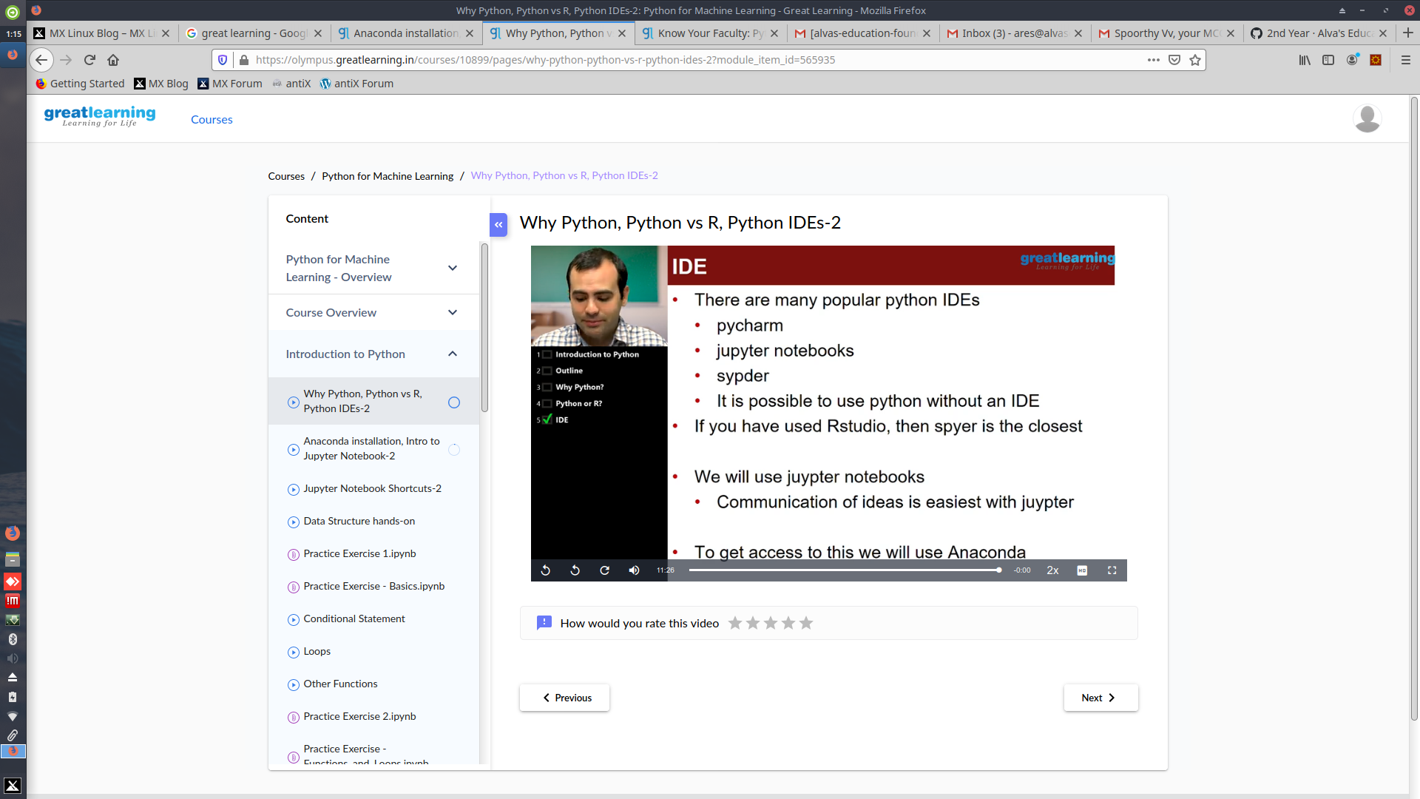Online Coding Summary: Online coding Summary: Today I received one program from Prof.Venkatesh CSE Dept. The program is mentioned above(pg.01). to my GitHub repository

.Link: <https://github.com/spoorthyvv/lockdown_coding>