**DAILY ONLINE ACTIVITIES SUMMARY**

|  |  |  |  |  |  |  |  |  |
| --- | --- | --- | --- | --- | --- | --- | --- | --- |
| **Date:** | **1 June 2020** | | | | | **Name:** | **SPOORTHY VV** | |
| **Sem & Sec** | **4th Sem B Sec** | | | | | **USN:** | **4AL18CS087** | |
| **Online Test Summary** | | | | | | | | |
| **Subject** | | **Mathematics 4** | | | | | | |
| **Max. Marks** | | **30** | | **Score** | | | **28** | |
| **Certification Course Summary** | | | | | | | | |
| **Course** | **Python for data science** | | | | | | | |
| **Certificate Provider** | | | **Congitiveclass** | | **Duration** | | | **9 hrs** |
| **Coding Challenges** | | | | | | | | |
| **Problem Statement:** Define a class Point with two fields x and y each of type double. Also , define a method distance(Point p1, Point p2) to calculate the distance between points p1 and p2 and return the value in double.. Use Math.sqrt( ) to calculate the square root. | | | | | | | | |
| **Status:executed** | | | | | | | | |
| **Uploaded the report in Github** | | | | | **yes** | | | |
| **If yes Repository name** | | | | | [lockdown_coding](https://github.com/Samruddhi1205/lockdown_coding) | | | |
| **Uploaded the report in slack** | | | | | **yes** | | | |

Online Test Details: test was conducted today from 9:30 to 10:10.the test included mcq kind of question .there was 2 rounds of test where each round consist of 10 questions.

Certification Course Details: Python for beginners is the certification course which I have choose to complete during this lock down period .

Python is one of the most important language for the world .To face interviews and other coding in the future days ,learning of python is very important .

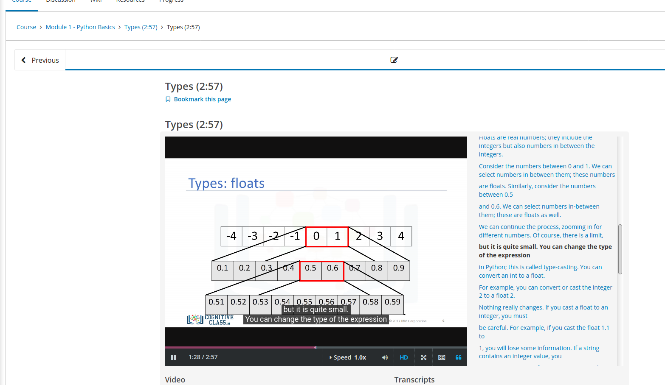

Coding Challenges Details: Everyday we are given with new question of coding related to the language of java and c. it seems interesting how we understand the logic ,break it and then code for it.

Today’s question was : Define a class Point with two fields x and y each of type double. Also , define a method distance(Point p1, Point p2) to calculate the distance between points p1 and p2 and return the value in double.. Use Math.sqrt( ) to calculate the square root.

Link:https://github.com/spoorthyvv/lockdown_coding