**DAILY ONLINE ACTIVITIES SUMMARY**

|  |  |  |  |  |  |  |  |  |
| --- | --- | --- | --- | --- | --- | --- | --- | --- |
| **Date:** | **20th May 2020** | | | | | **Name:** | **SPOORTHY VV** | |
| **Sem & Sec** | **4 th SEM. & ‘B’ SEC.** | | | | | **USN:** | **4AL18CS087** | |
| **Online Test Summary** | | | | | | | | |
| **Subject** | | **OBJECT ORIENTED CONCEPTS** | | | | | | |
| **Max. Marks** | | **30** | | **Score** | | | **19** | |
| **Certification Course Summary** | | | | | | | | |
| **Course** | **Python for machine learning** | | | | | | | |
| **Certificate Provider** | | | **Great learners** | | **Duration** | | | **9 hrs** |
| **Coding Challenges** | | | | | | | | |
| **Problem Statement 1: Write a C Program to Reverse a Linked List (SLL) in groups of given size.**  **Problem Statement 2: Write a C or Java program to implement FCFS and SJF process scheduling. Input: Processes with burst time Output: Process being scheduled** | | | | | | | | |
| **Status:executed** | | | | | | | | |
| **Uploaded the report in Github** | | | | | **yes** | | | |
| **If yes Repository name** | | | | | lockdown_coding | | | |
| **Uploaded the report in slack** | | | | | **yes** | | | |

Online Test Summary: 18CS45 online test was scheduled from 9:30 am t0 10:10 am .The portion for the IA was 1st module, the questions were 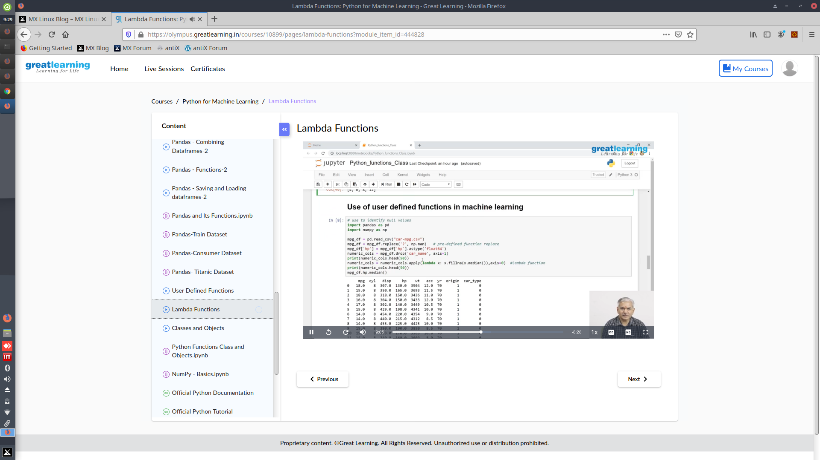MCQ type.Online

Certification course Summary: Today I’ve gone through Lambda functions . This makes the task easier than I have expected.

Online Coding Summary: Today I received a program from prof.Venkatesh CSE Dept, second program was given by prof.Harshitha GM CSE Dept 1) Write a C Program to Reverse a Linked List (SLL) in groups of given size. 2) Write a C or Java program to implement FCFS and SJF process scheduling. I have written programs and uploaded it to my Github repository. link as follows:

link : https://github.com/spoorthyvv/lockdown_coding