**DAILY ONLINE ACTIVITIES SUMMARY**

|  |  |  |  |  |  |  |  |  |
| --- | --- | --- | --- | --- | --- | --- | --- | --- |
| **Date:** | **21th May 2020** | | | | | **Name:** | **SPOORTHY VV** | |
| **Sem & Sec** | **4 th SEM. & ‘B’ SEC.** | | | | | **USN:** | **4AL18CS087** | |
| **Online Test Summary** | | | | | | | | |
| **Subject** | | **MICRO CONTROLLER AND EMBEDDED SYSTEMS** | | | | | | |
| **Max. Marks** | | **30** | | **Score** | | | **19** | |
| **Certification Course Summary** | | | | | | | | |
| **Course** | **Python for machine learning** | | | | | | | |
| **Certificate Provider** | | | **Great learners** | | **Duration** | | | **9 hrs** |
| **Coding Challenges** | | | | | | | | |
| **Problem Statement 1:** [**Write a C Program to**](https://github.com/orgs/alvas-education-foundation/teams/2nd-year/discussions/67) **implement SRTF process scheduling.**  **Input:A set of processes with their burst time and arrival time.**  **Problem Statement 2:**  **Write a C program to construct a SLL by removing duplicate elements in sorted linked list**  **Description:Take a sorted list and traverse the list. Compare the current node element with the next adjacent node. If it is the same then delete the second element, if not retain. Finally print the resulting list.**  **Sample output:**  **Given list {1,2,2,3,3,3,4}**  **Resulting list{1,2,3,4}** | | | | | | | | |
| **Status:executed** | | | | | | | | |
| **Uploaded the report in Github** | | | | | **yes** | | | |
| **If yes Repository name** | | | | | lockdown_coding | | | |
| **Uploaded the report in slack** | | | | | **yes** | | | |

**Online Test Summary: 18CS44 test was scheduled from 10:00AM to 10:30AM.The Portion was for the IA was 1st module there were 30 questions & the time assigned was 30 minutes. The questions were mcq type.**

**Online Certification course Summary:**

**A very good explanation of classes and objects are given in this session.**

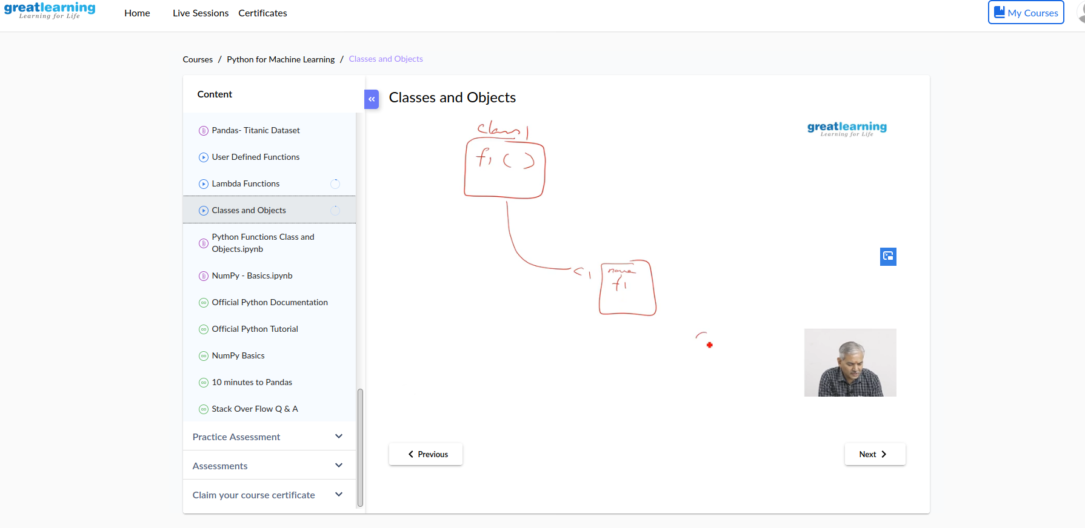

**Online Coding Summary: Today I received the first program from prof.Merlyn Mathias CSE Dept, second program was given by prof.Harshitha GM CSE Dept .**

**The programs are mentioned above in the coding challenges.I have written programs and uploaded it to my Github repository.**

link : https://github.com/spoorthyvv/lockdown_coding