**DAILY ONLINE ACTIVITIES SUMMARY**

|  |  |  |  |  |  |  |  |  |
| --- | --- | --- | --- | --- | --- | --- | --- | --- |
| **Date:** | **22 may 2020** | | | | | **Name:** | **SPOORTHY VV** | |
| **Sem & Sec** | **4th Sem B Sec** | | | | | **USN:** | **4AL18CS087** | |
| **Online Test Summary** | | | | | | | | |
| **Subject** | | **OPERATING SYSTEMS** | | | | | | |
| **Max. Marks** | | **30** | | **Score** | | | **26** | |
| **Certification Course Summary** | | | | | | | | |
| **Course** | **Python for machine learning** | | | | | | | |
| **Certificate Provider** | | | **Great learners** | | **Duration** | | | **9 hrs** |
| **Coding Challenges** | | | | | | | | |
| **Problem Statement:**  [Write a C Program to implement various operations on Singly Linked List Stack.](https://github.com/orgs/alvas-education-foundation/teams/2nd-year/discussions/77) | | | | | | | | |
| **Status:executed** | | | | | | | | |
| **Uploaded the report in Github** | | | | | **yes** | | | |
| **If yes Repository name** | | | | | lockdown_coding | | | |
| **Uploaded the report in slack** | | | | | **yes** | | | |

Online Test Details: test was conducted from 9:15 to 9:55 am dated 22 may 2020 .The test included MCQ kind of questions .

Certification Course Details:

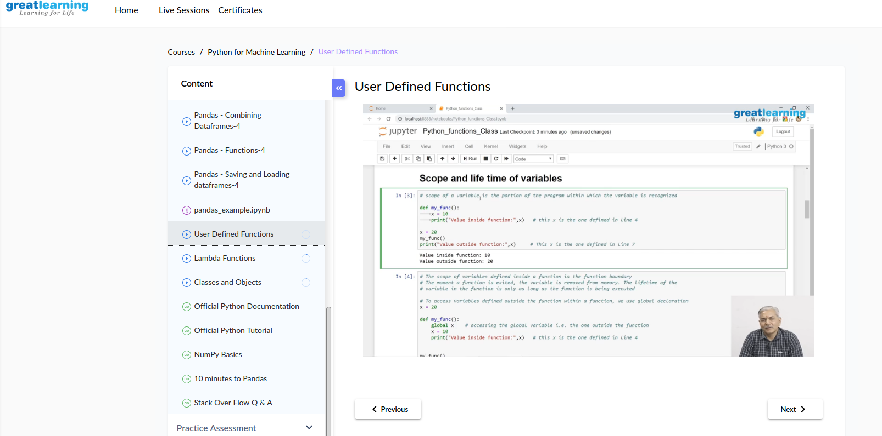

User defined functions had been the major topic today .

Coding Challenges Details: Everyday we are given with new question of coding related to the language of java and c. it seems interesting how we imbibe ourselves in depth to understand the logic break it and then code for it.

Today’s question was :

[Write a C Program to implement various operations on Singly Linked List Stack.](https://github.com/orgs/alvas-education-foundation/teams/2nd-year/discussions/77)

Hint: First Create a Singly Linked List Stack with the node corresponding to First Element is the base of the stack; and its link field must be always Null.  
When you push First Element, It is the First and it is Base of the stack. Its Link must be Null. top pointer pointing to First. (top = First)  
When you push any element, (No need of checking Stack full case because SLL is dynamic) Create a new node called temp using malloc function and insert the a number into Data field, and Link field must be pointing to top; and move the pointer top to point to temp.  
When you pop, First check for stack Empty. if First == NULL, then Stack Empty. If it is not empty, The pointer temp must be pointing to top. Move the pointer top to top->link. delete temp.  
When you display the stack element, First Check for Stack Empty as in pop operation. If it is not empty, Display all the elements of current stack starting from top to First.

**Using the above given hints I have made a c code for the question**

|  |
| --- |
|  |

Link:https://github.com/spoorthyvv/lockdown_coding