**DAILY ONLINE ACTIVITIES SUMMARY**

|  |  |  |  |  |  |  |  |  |
| --- | --- | --- | --- | --- | --- | --- | --- | --- |
| **Date:** | **26/05/2020** | | | | | **Name:** | **SPOORTHY .VV.** | |
| **Sem & Sec** | **4th SEM. & ‘B’ SEC.** | | | | | **USN:** | **4AL18CS087** | |
| **Online Test Summary** | | | | | | | | |
| **Subject** | | **DESIGN AND ANALYSIS OF ALGORITHM** | | | | | | |
| **Max. Marks** | | **30** | | **Score** | | | **24** | |
| **Certification Course Summary** | | | | | | | | |
| **Course** | **Python for Machine Learning** | | | | | | | |
| **Certificate Provider** | | | **Greatlearning**  **academy** | | **Duration** | | | **5 Hrs.** |
| **Coding Challenges** | | | | | | | | |
| **Problem Statement 1: Write a Program in C to print all permutations given string using pointers.**  **Enter the Input String: abcd**  **Expected Result:The permutations of the string are :**  **abcd abdc acbd acdb adcb adbc bacd badc bcad bcda bdca bdac cbad cbda cabd cadb cdab cdba dbca dbac dcba dcab dacb dabc**  **Problem Statement 2: Given an array A of size N where the array elements contain value from 1 to N with duplicates, the task is to find the total number of subarray which start & end with same element**  **Input: A=(1,2,1,5,2) Output:7** | | | | | | | | |
| **Status: Executed.** | | | | | | | | |
| **Uploaded the report in Github** | | | | | **Yes** | | | |
| **If yes Repository name** | | | | | **lockdown_coding** | | | |
| **Uploaded the report in slack** | | | | | **Yes** | | | |

**Online Test Summary: 18CS42 test was scheduled from 9:15AM to 9:55AM.The Portion for the IA was 2nd module there were 30 questions of one mark & the time assigned was 40 minutes. The questions were mcq type.**

**Online Certification course Summary: In today’s session I have learnt about the conditional statements.**

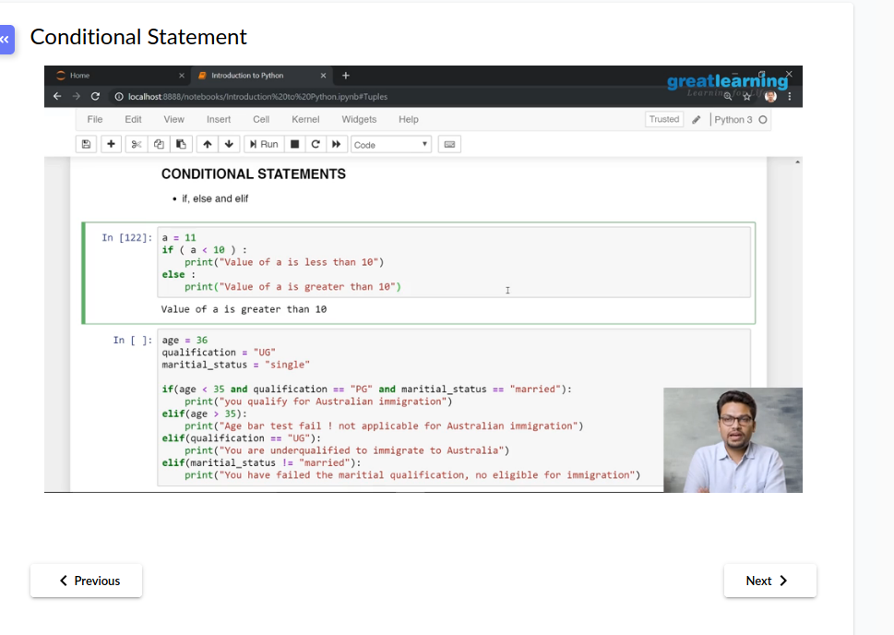

**Online Coding Summary: Today I received the program from prof.Venkatesh CSE Dept, and prof.Vasudev.S CSE Dept.**

**The program is mentioned above in the coding challenges.I have written a program and uploaded it to my Github repository, as shown in the below.**