**DAILY ONLINE ACTIVITIES SUMMARY**

|  |  |  |  |  |  |  |  |  |
| --- | --- | --- | --- | --- | --- | --- | --- | --- |
| **Date:** | **27/05/2020** | | | | | **Name:** | **SPOORTHY VV** | |
| **Sem & Sec** | **4th SEM. & ‘B’ SEC.** | | | | | **USN:** | **4AL18CS087** | |
| **Online Test Summary** | | | | | | | | |
| **Subject** | | **OBJECT ORIENTED CONCEPTS** | | | | | | |
| **Max. Marks** | | **30** | | **Score** | | | **25** | |
| **Certification Course Summary** | | | | | | | | |
| **Course** | **Python for Machine Learning** | | | | | | | |
| **Certificate Provider** | | | **Greatlearning**  **academy** | | **Duration** | | | **5 Hrs.** |
| **Coding Challenges** | | | | | | | | |
| **Problem Statement 1: Given an array arr[] of the positive integers of size N, the task is to find the largest element on the left side of each index which is smaller than the element present at that index. Note: If no such element is found then print -1.**  **Problem Statement 2: In Bubble sort, each pass consists of comparing each element in the file with its successor (i.e. x[i] with x[i+1]) and interchanging two elements if they are not in the proper order. The array may be sorted in any pass. If the array is sorted, then remaining passes should be skipped off.Write a C Program to sort an array of integers in ascending order and display the sorted array and Number of passes performed for sorting.** | | | | | | | | |
| **Status: Executed.** | | | | | | | | |
| **Uploaded the report in Github** | | | | | **Yes** | | | |
| **If yes Repository name** | | | | | lockdown_coding | | | |
| **Uploaded the report in slack** | | | | | **Yes** | | | |

**Online Test Summary: 18CS45 test was scheduled from 9:15AM to 9:45AM.The Portion for the IA was the 5th module there were 30 questions of one mark & the time assigned was 30 minutes. The questions were mcq type.**

**Online Certification course Summary: In today’s session I have learnt about saving and loading numpy Arrays.**

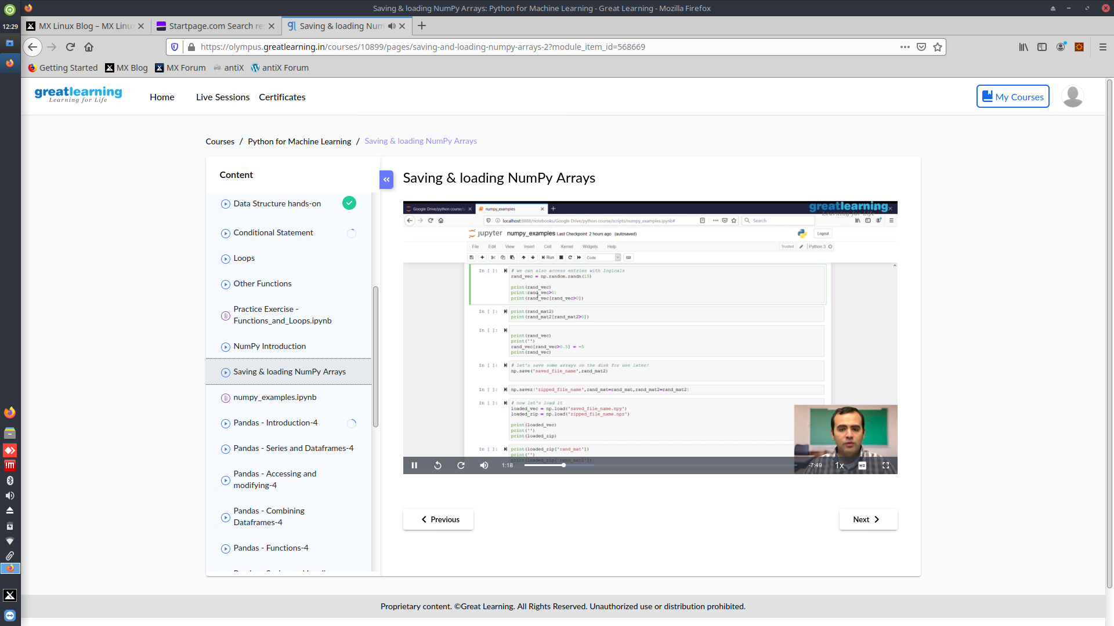**Online Coding Summary: Today I received the program from prof.Venkatesh CSE Dept, and prof.Vasudev.S CSE Dept.**

**The program is mentioned above in the coding challenges.I have written a program and uploaded it to my Github repository, as shown in the below.**