**DAILY ONLINE ACTIVITIES SUMMARY**

|  |  |  |  |  |  |  |  |  |
| --- | --- | --- | --- | --- | --- | --- | --- | --- |
| **Date:** | **27/06/2020** | | | | | **Name:** | **SPOORTHY VV** | |
| **Sem & Sec** | **4th SEM. & ‘B’ SEC.** | | | | | **USN:** | **4AL18CS087** | |
| **Online Test Summary** | | | | | | | | |
| **Subject** | | **DATA COMMUNICATION** | | | | | | |
| **Max. Marks** | | **30** | | **Score** | | | **24** | |
| **Certification Course Summary** | | | | | | | | |
| **Course** | **Network Server Security - Protecting the Server and Client Computers - Revised** | | | | | | | |
| **Certificate Provider** | | | **alison** | | **Duration** | | | **3 Hrs.** |
| **Coding Challenges** | | | | | | | | |
| **Problem Statement1 : Write a C program to print kth digit.** | | | | | | | | |
| **Status: Executed** | | | | | | | | |
| **Uploaded the report in Github** | | | | | **Yes** | | | |
| **If yes Repository name** | | | | | **lockdown_coding** | | | |
| **Uploaded the report in slack** | | | | | **Yes** | | | |

**Online Test Summary: 18CS46 online test was scheduled from 11:30 AM to 12:00 PM .The portion for the IA was 5th module, the questions were MCQ type.There were 30 Questions where each carries 1 Mark.**

**Online Certification course Summary:**

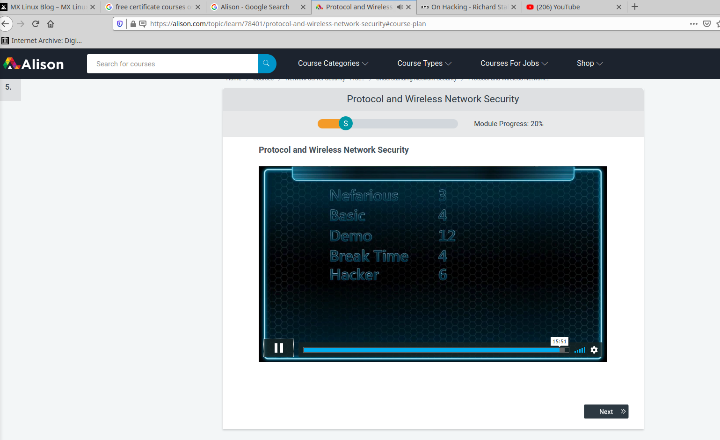**Online Coding Summary: Today I received the program from prof.Shilpa CSE Dept.**

**The program is mentioned above in the coding challenges.I have written a program and uploaded it to my Github repository.**

**Link :** **http://github.com/spoorthyvv/lockdown_coding**

**Online Training : Today I attended the online training organized by CSE Department AIET.The training was on C Programming done by Prof.Megha Hegde CSE Dept.After the session the quiz was conducted.**