**DAILY ONLINE ACTIVITIES SUMMARY**

|  |  |  |  |  |  |  |  |  |
| --- | --- | --- | --- | --- | --- | --- | --- | --- |
| **Date:** | **28 may 2020** | | | | | **Name:** | **SPOORTHYVV** | |
| **Sem & Sec** | **4th Sem B Sec** | | | | | **USN:** | **4AL18CS087** | |
| **Online Test Summary** | | | | | | | | |
| **Subject** | | **MICROPROCESSOR AND EMBEDDED SYSTEMS** | | | | | | |
| **Max. Marks** | | **20** | | **Score** | | | **19** | |
| **Certification Course Summary** | | | | | | | | |
| **Course** | **Python for Machine Learning.** | | | | | | | |
| **Certificate Provider** | | | **Great learners** | | **Duration** | | | **6 hrs** |
| **Coding Challenges** | | | | | | | | |
| **Problem Statement:** [C program to find digital root of a number](https://github.com/orgs/alvas-education-foundation/teams/2nd-year/discussions/84) | | | | | | | | |
| **Status:executed** | | | | | | | | |
| **Uploaded the report in Github** | | | | | **yes** | | | |
| **If yes Repository name** | | | | | [lockdown_coding](https://github.com/Samruddhi1205/lockdown_coding) | | | |
| **Uploaded the report in slack** | | | | | **yes** | | | |

Online Test Details: test was conducted from 12:00 to 12:40 am dated 28 may 2020 .The test included MCQ kind of questions .

Certification Course Details:

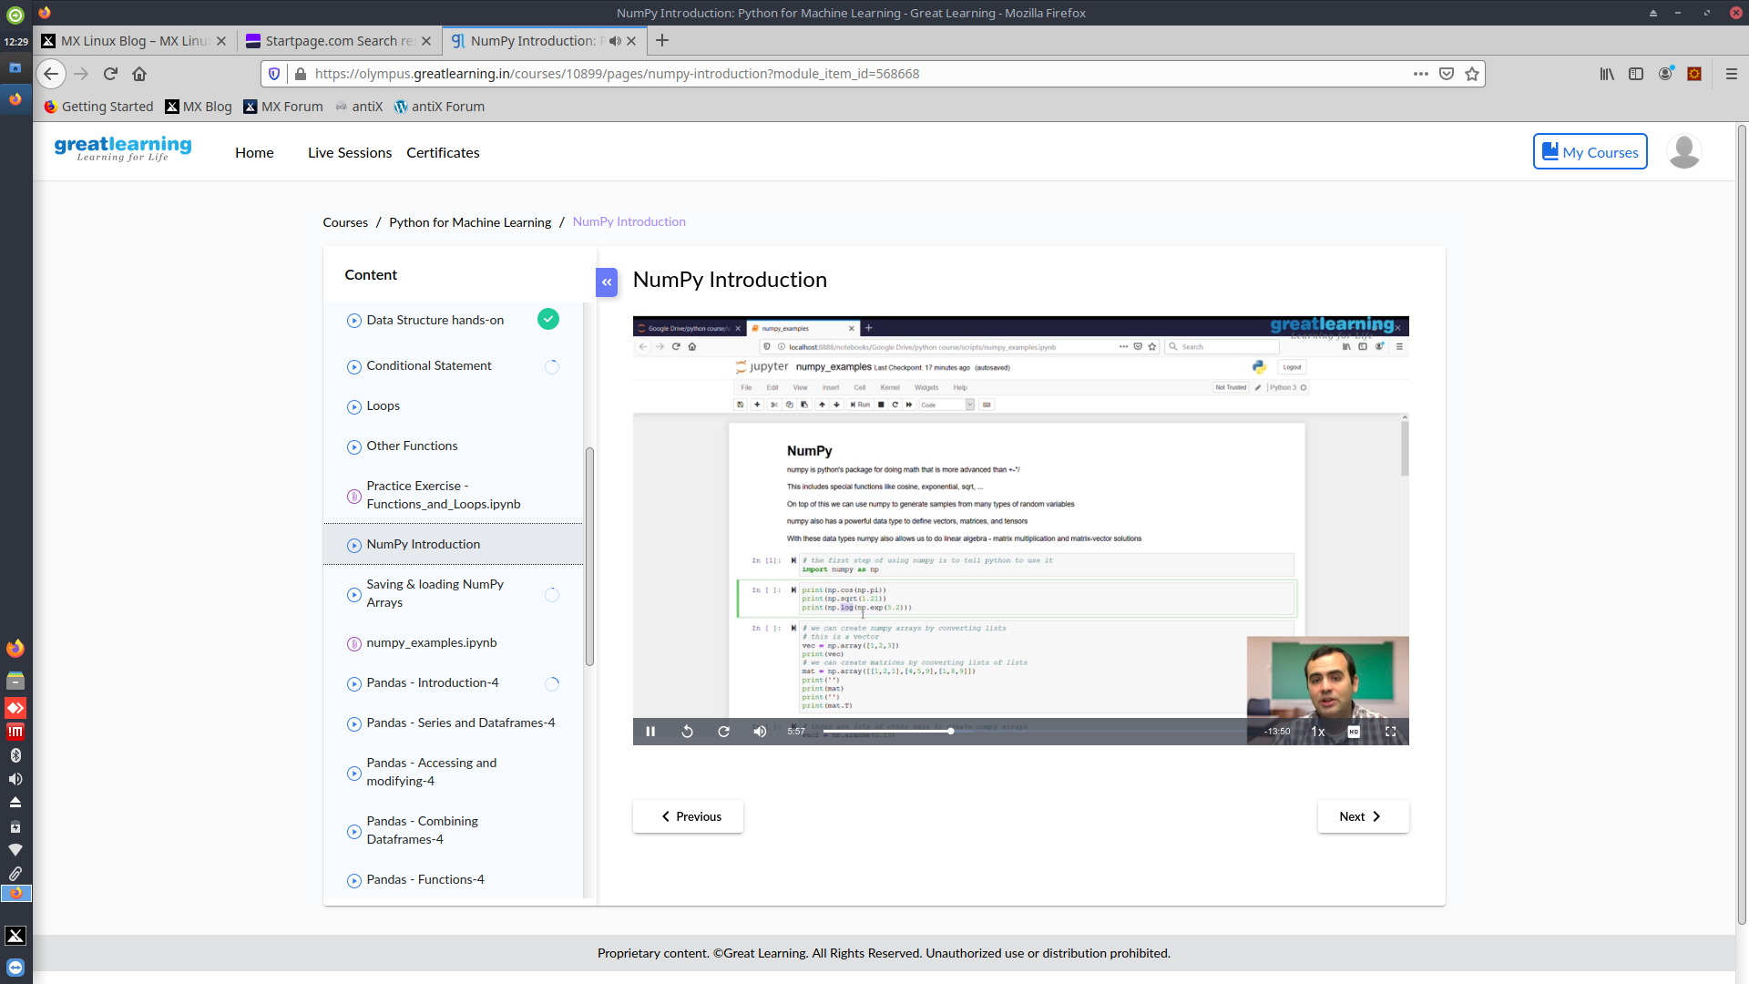

Coding Challenges Details: Everyday we are given with new question of coding related to the language of java and c. it seems interesting how we imbibe ourself in depth to understand the logic break it and then code for it.

Today’s question was : [C program to find digital root of a number](https://github.com/orgs/alvas-education-foundation/teams/2nd-year/discussions/84)

A digital root is the recursive sum of all the digits in a number. Given n, take the sum of the digits of n. If that value has more than one digit, continue reducing in this way until a single-digit number is produced. This is only applicable to the natural numbers.  
digit_root(0)= 0

digital_root(16)  
=> 1 + 6  
=> 7

digital_root(132189)  
=> 1 + 3 + 2 + 1 + 8 + 9  
=> 24 ...  
=> 2 + 4  
=> 6