**DAILY ONLINE ACTIVITIES SUMMARY**

|  |  |  |  |  |  |  |  |  |
| --- | --- | --- | --- | --- | --- | --- | --- | --- |
| **Date:** | **02/07/2020** | | | | | **Name:** | **SPOORTHY VV** | |
| **Sem & Sec** | **4th SEM. & ‘B’ SEC.** | | | | | **USN:** | **4AL18CS087** | |
| **Online Test Summary** | | | | | | | | |
| **Subject** | | **------** | | | | | | |
| **Max. Marks** | | **--** | | **Score** | | | **--** | |
| **Certification Course Summary** | | | | | | | | |
| **Course** | **Intro to game programming** | | | | | | | |
| **Certificate Provider** | | | **udemy** | | **Duration** | | | **5 hrs** |
| **Coding Challenges** | | | | | | | | |
| **Problem Statement 1 : Write a Java Program to minimize the maximum difference between adjacent elements in an array.** | | | | | | | | |
| **Status: Executed** | | | | | | | | |
| **Uploaded the report in Github** | | | | | **Yes** | | | |
| **If yes Repository name** | | | | | lockdown_coding | | | |
| **Uploaded the report in slack** | | | | | **Yes** | | | |

**Online Test Summary: No internals conducted.**

**Online Certification course Summary:**

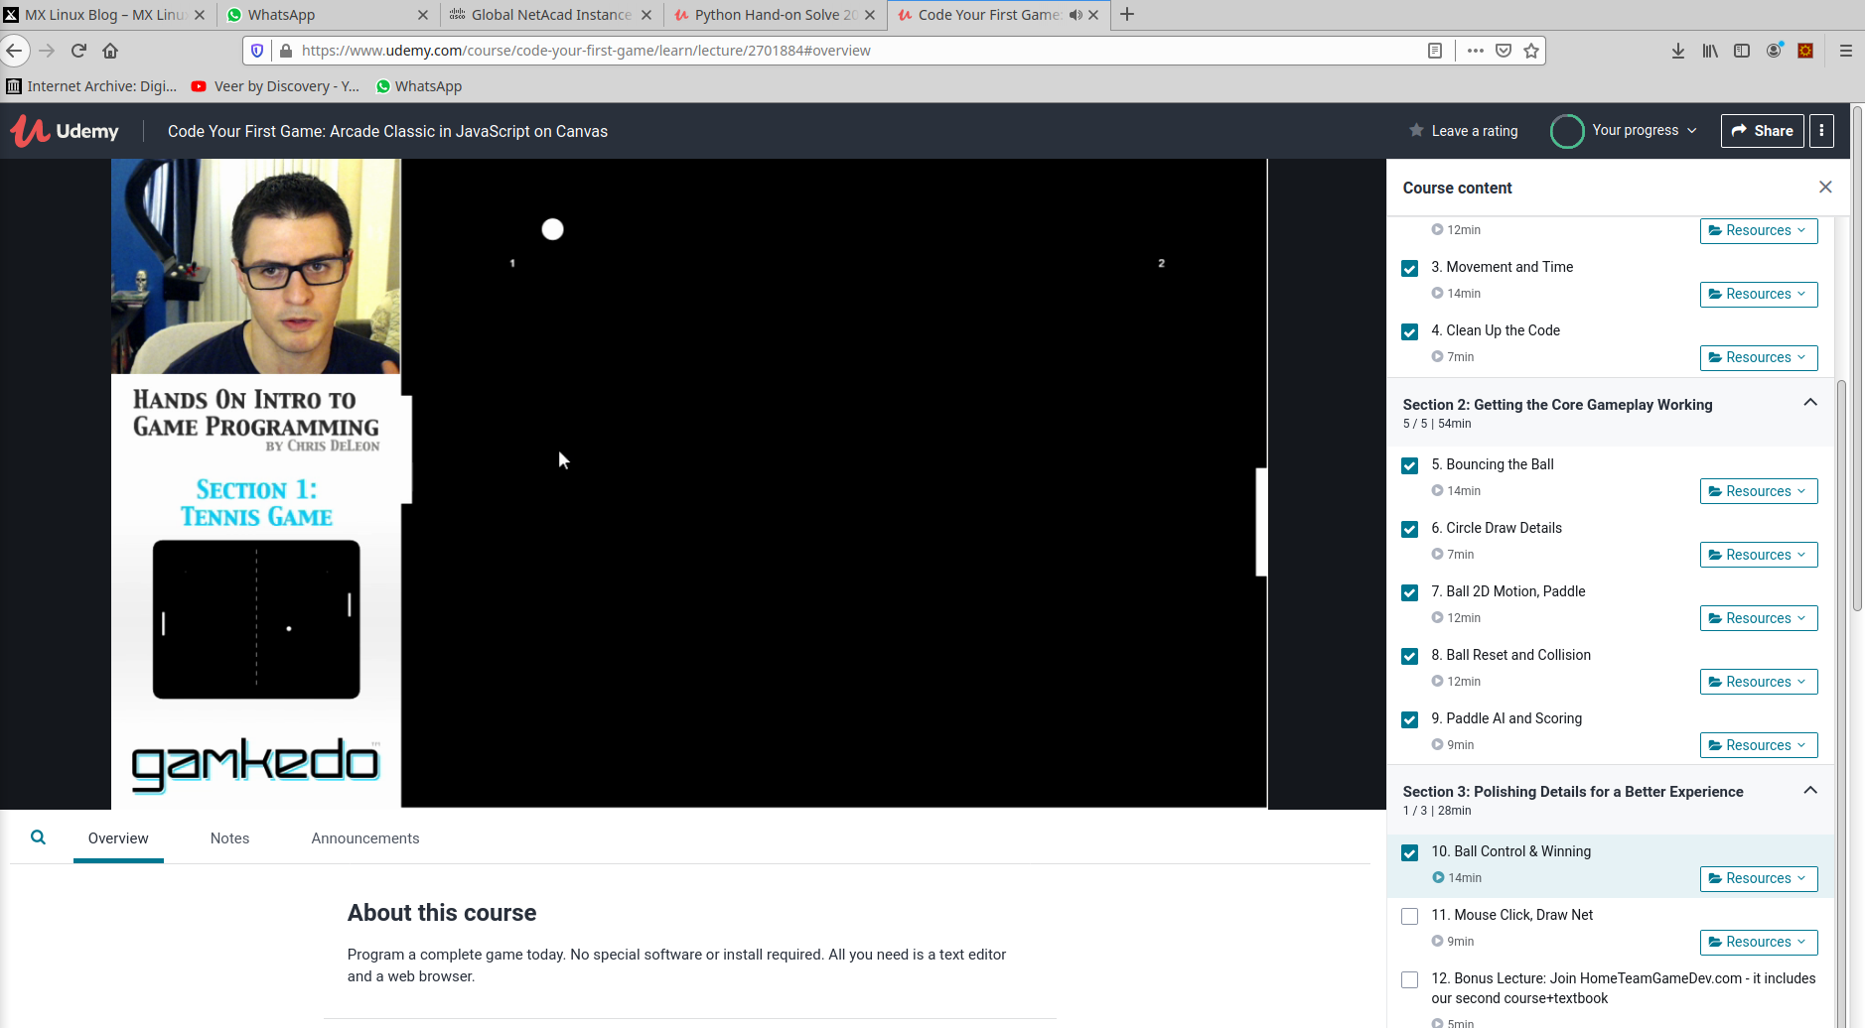

**Online Coding Summary: Today I received the program from prof.Shilpa CSE Dept.The program is mentioned above in the coding challenges.I have written a program and uploaded it to my Github repository, as shown in the below.**

**Link :** **https://github.com/spoorthyvv/lockdown_coding**

**Online Training :Today I attended the online training organized by CSE Department AIET.The training was on C++ Programming done by Prof.Shruti Sheety CSE Dept.Where we learnt about Inheritance Concept, At the End of the session the quiz was conducted on the session.**