**DAILY ONLINE ACTIVITIES SUMMARY**

|  |  |  |  |  |  |  |  |  |
| --- | --- | --- | --- | --- | --- | --- | --- | --- |
| **Date:** | **2 June 2020** | | | | | **Name:** | **SPOORTHY VV** | |
| **Sem & Sec** | **4th Sem B Sec** | | | | | **USN:** | **4AL18CS087** | |
| **Online Test Summary** | | | | | | | | |
| **Subject** | | **Not conducted** | | | | | | |
| **Max. Marks** | | **0** | | **Score** | | | **0** | |
| **Certification Course Summary** | | | | | | | | |
| **Course** | **RPA** | | | | | | | |
| **Certificate Provider** | | | **Guvi** | | **Duration** | | | **3 hrs** |
| **Coding Challenges** | | | | | | | | |
| **Problem Statement:** [Write a Java program to find Perfect Sum Problem](https://github.com/orgs/alvas-education-foundation/teams/2nd-year/discussions/94) | | | | | | | | |
| **Status:executed** | | | | | | | | |
| **Uploaded the report in Github** | | | | | **Yes** | | | |
| **If yes Repository name** | | | | | [lockdown_coding](https://github.com/Samruddhi1205/lockdown_coding) | | | |
| **Uploaded the report in slack** | | | | | **Yes** | | | |

Online Test Details: test was not conducted today

Certification Course Details:RPA for begineers is the next course that I have choosen to complete during this week of lockdown.

Learning RPA to develop ineterst in robotics and robort technology developmaent is one of the important ascpest as being computer science engineer.

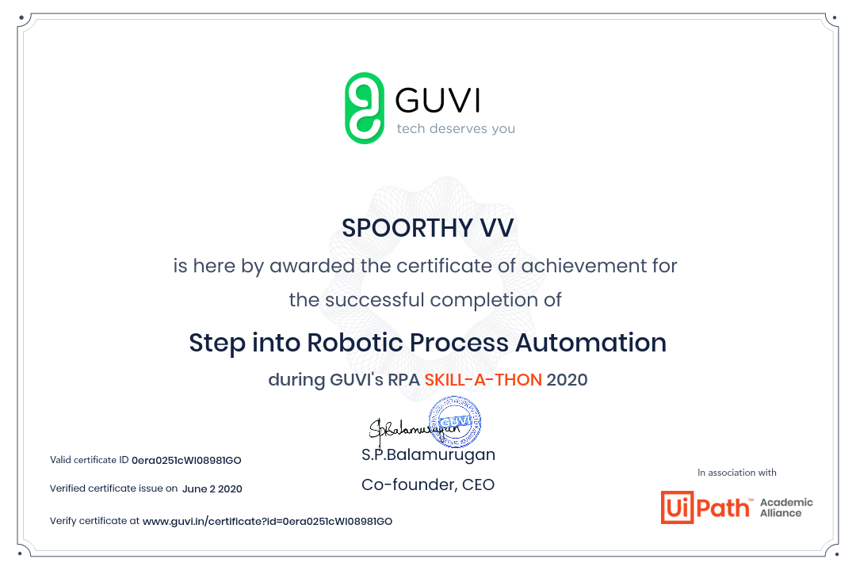Coding Challenges Details: Every day we are given with new question of coding related to the language of java and c. it seems interesting how we imbibe our self in depth to understand the logic ,break it and then code for it.

Today’s question was : [Write a Java program to find Perfect Sum Problem](https://github.com/orgs/alvas-education-foundation/teams/2nd-year/discussions/94)

Given an array arr[] of integers and an integer K, the task is to print all subsets of the given array with the sum equal to the given target K.

**Examples:**

**Input:** arr[] = {5, 10, 12, 13, 15, 18}, K = 30  
**Output:** {12, 18}, {5, 12, 13}, {5, 10, 15}  
**Explanation:**  
Subsets with sum 30 are:  
12 + 18 = 30  
5 + 12 + 13 = 30  
5 + 10 + 15 = 30

Input: arr[] = {1, 2, 3, 4}, K = 5  
Output: {2, 3}, {1, 4}