**DAILY ONLINE ACTIVITIES SUMMARY**

|  |  |  |  |  |  |  |  |  |
| --- | --- | --- | --- | --- | --- | --- | --- | --- |
| **Date:** | **30 may 2020** | | | | | **Name:** | **SPOORTHYVV** | |
| **Sem & Sec** | **4th Sem B Sec** | | | | | **USN:** | **4AL18CS087** | |
| **Online Test Summary** | | | | | | | | |
| **Subject** | | **Data communication**  **Mathematics 4** | | | | | | |
| **Max. Marks** | | **30**  **30** | | **Score** | | | **26**  **30** | |
| **Certification Course Summary** | | | | | | | | |
| **Course** | **Python for data science** | | | | | | | |
| **Certificate Provider** | | | **Congitive class** | | **Duration** | | | **9 hrs** |
| **Coding Challenges** | | | | | | | | |
| **Problem Statement:** [Write a C Program to count Uppercase, Lowercase, special character and numeric values for a given String](https://github.com/orgs/alvas-education-foundation/teams/2nd-year/discussions/88) | | | | | | | | |
| **Status:executed** | | | | | | | | |
| **Uploaded the report in Github** | | | | | **yes** | | | |
| **If yes Repository name** | | | | | lockdown_coding | | | |
| **Uploaded the report in slack** | | | | | **yes** | | | |

Online Test Details: test had been conducted from 9:15 to 10:00 am dated 30 may 2020 .The test included MCQ kind of questions .

Certification Course Details: Python for beginners is the certification course which I have choose to complete during this lock down period .

Python is one of the most important language for the programming world .To face interviews and other coding challenges in the future days ,learning of python is very important .

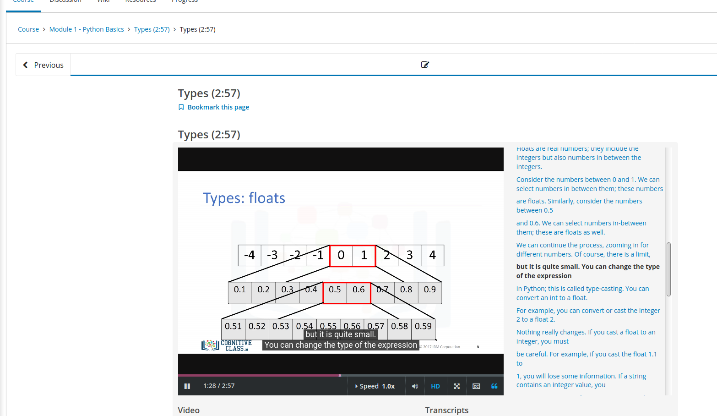

This is the snapshot of course that I have started to study from today.

Coding Challenges Details: Everyday we are given with new question of coding related to the language of java and c. it seems interesting how we imbibe ourselves in depth to understand the logic ,break it and then code for it.

Today’s question was : [Write a C Program to count Uppercase, Lowercase, special character and numeric values for a given String](https://github.com/orgs/alvas-education-foundation/teams/2nd-year/discussions/88)

**Input :** Read a String (combination of character, numeric, special character) from keyboard.  
**Ex: #HaaGs01fOr@haaks07**  
**Output :**  
Upper case letters : 5  
Lower case letters : 8  
Numbers : 4  
Special Characters : 2