**DAILY ONLINE ACTIVITIES SUMMARY**

|  |  |  |  |  |  |  |  |  |
| --- | --- | --- | --- | --- | --- | --- | --- | --- |
| **Date:** | **31 st may 2020** | | | | | **Name:** | **SPOORTHY VV** | |
| **Sem & Sec** | **4th Sem B Sec** | | | | | **USN:** | **4AL18CS087** | |
| **Online Test Summary** | | | | | | | | |
| **Subject** | | **---** | | | | | | |
| **Max. Marks** | | **--** | | **Score** | | | **---** | |
| **Certification Course Summary** | | | | | | | | |
| **Course** | **Python for machine-learning** | | | | | | | |
| **Certificate Provider** | | | **GreatLearning** | | **Duration** | | | **5 hrs** |
| **Coding Challenges** | | | | | | | | |
| **Problem Statement:** [Write a Java program to calculate nPr.](https://github.com/orgs/alvas-education-foundation/teams/2nd-year/discussions/89) | | | | | | | | |
| **Status:executed** | | | | | | | | |
| **Uploaded the report in Github** | | | | | **yes** | | | |
| **If yes Repository name** | | | | | lockdown_coding | | | |
| **Uploaded the report in slack** | | | | | **yes** | | | |

Online Test Details: No test had been conducted

OnlineCertification:

The above is the snapshot of the test conducted and analysis of the test was also provieded by the service provider.

Certification Course Details: Major Pandas was again revised as I am not quite familiar with topic.

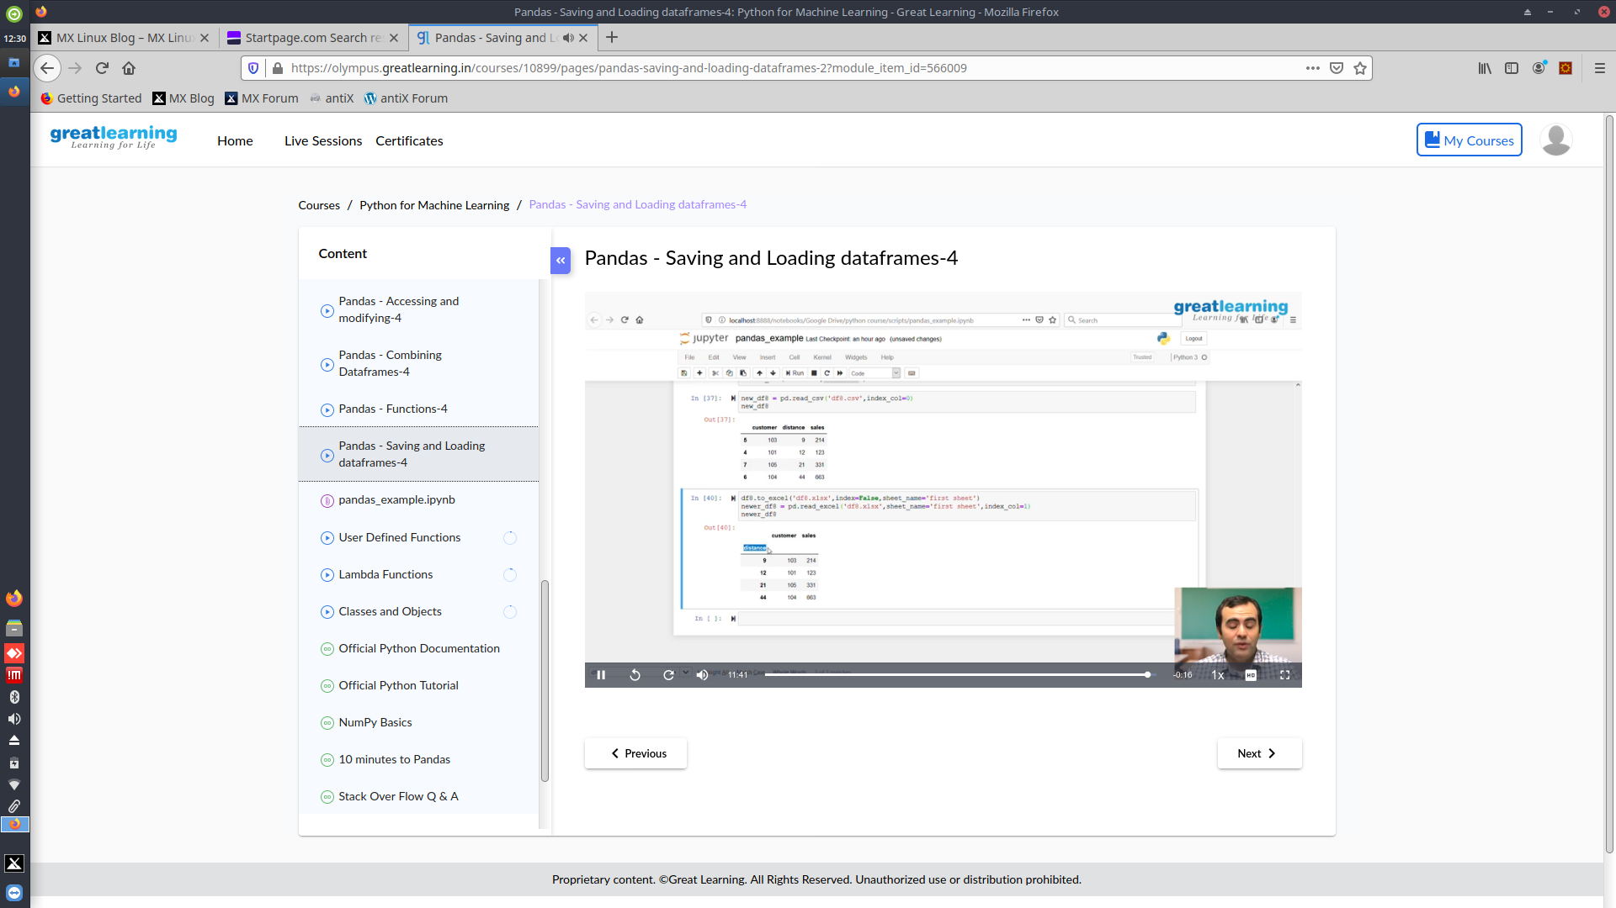

Coding Challenges Details: Everyday we are given with new question of coding related to the language of java and c. it seems interesting how we imbibe self in depth to understand the logic ,break it and then code for it.

Today’s question was : [Write a Java program to calculate nPr.](https://github.com/orgs/alvas-education-foundation/teams/2nd-year/discussions/89)

**nPr** represents n permutation r and value of nPr is **(n!) / (n-r)!.**

**Input:**  
The first line of the input contains **T** denoting the number of testcases. T testcases follow. First line of the test case will be the value of n and r respectively.

Output:  
For each test case, in a new line, output will be the value of nPr.

Constraints:  
**1 <= T <= 100  
1 <= n,r <= 20  
n >= r**

**Example:**  
Input:  
2  
2 1  
10 4  
Output:  
2  
5040

**Github Link :** https://github.com/spoorthyvv/lockdown_coding