**DAILY ONLINE ACTIVITIES SUMMARY**

|  |  |  |  |  |  |  |  |  |
| --- | --- | --- | --- | --- | --- | --- | --- | --- |
| **Date:** | **3 rd June 2020** | | | | | **Name:** | **SPOORTHY V V** | |
| **Sem & Sec** | **4th Sem B Sec** | | | | | **USN:** | **4AL18CS087** | |
| **Online Test Summary** | | | | | | | | |
| **Subject** | | **Object Oriented Concepts** | | | | | | |
| **Max. Marks** | | **30** | | **Score** | | | **19** | |
| **Certification Course Summary** | | | | | | | | |
| **Course** | **Introduction to Html** | | | | | | | |
| **Certificate Provider** | | | **Great learning** | | **Duration** | | | **5 hrs** |
| **Coding Challenges** | | | | | | | | |
| **Problem Statement:** Write a code segment in java to swap two numbers using call by object reference. | | | | | | | | |
| **Status:executed** | | | | | | | | |
| **Uploaded the report in Github** | | | | | **Yes** | | | |
| **If yes Repository name** | | | | | <https://github.com/spoorthyvv/lockdown_coding> | | | |
| **Uploaded the report in slack** | | | | | **Yes** | | | |

Online Test Details: test was conducted between 9:15 to 10:00 am dated 3 june 2020.the test included predction of output for the programs.there were 30 question overall.

The above is the snapshot of the test conducted today and the analysis given by the service provider.

Certification Course Details: Introduction to HTML for begineers is the next course that I have choosen to complete during this week of lockdown.

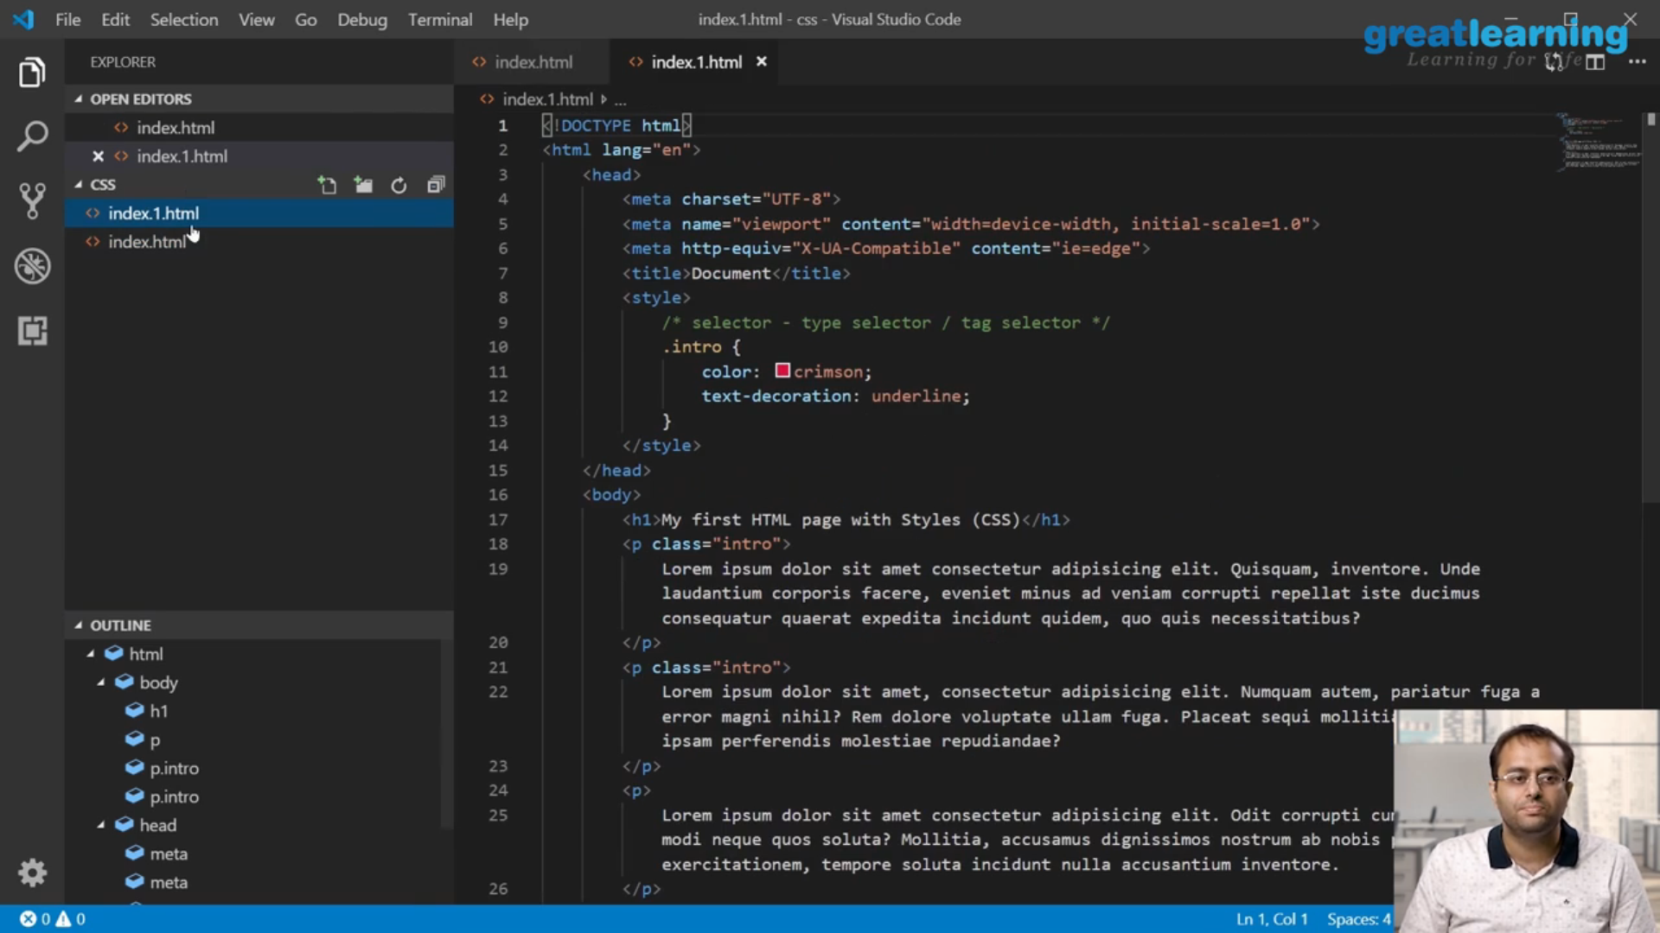

This is the snapshot of course that I have started to study from today.

Coding Challenges Details: Every day we are given with new question of coding related to the language of java and c. it seems interesting how we imbibe our self in depth to understand the logic ,break it and then code for it.

Today’s question was : Write a code segment in java to swap two numbers using call by object reference.

Link: https://github.com/spoorthyvv/lockdown_coding