**DAILY ONLINE ACTIVITIES SUMMARY**

|  |  |  |  |  |  |  |  |  |
| --- | --- | --- | --- | --- | --- | --- | --- | --- |
| **Date:** | **4 thJune 2020** | | | | | **Name:** | **SPOORTHY VV** | |
| **Sem & Sec** | **4th Sem B Sec** | | | | | **USN:** | **4AL18CS087** | |
| **Online Test Summary** | | | | | | | | |
| **Subject** | | **Micro controller and embedded system** | | | | | | |
| **Max. Marks** | | **20** | | **Score** | | | **-** | |
| **Certification Course Summary** | | | | | | | | |
| **Course** | **Introduction to Html** | | | | | | | |
| **Certificate Provider** | | | **Great learners** | | **Duration** | | | **5 hrs** |
| **Coding Challenges** | | | | | | | | |
| **Problem Statement:** write a java program to read three integer values from the keyboard and find the sum of the values. Declare a variable "sum" of type int and store the result in it. | | | | | | | | |
| **Status:executed** | | | | | | | | |
| **Uploaded the report in Github** | | | | | **Yes** | | | |
| **If yes Repository name** | | | | | lockdown_coding | | | |
| **Uploaded the report in slack** | | | | | **Yes** | | | |

Online Test Details: I missed the test due to some power issues.

Certification Course Details: The course choose has practial sessions also which means we have to submit assignment that have been assigned to us after some topics of Html are covered.

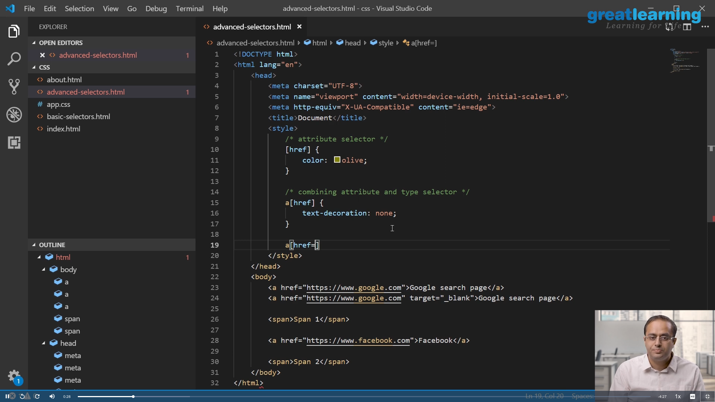This is the snapshot of course that I have started to study from today.

Coding Challenges Details: Every day we are given with new question of coding related to the language of java and c. it seems interesting how we imbibe our self in depth to understand the logic ,break it and then code for it.

Today’s question was : write a java program to read three integer values from the keyboard and find the sum of the values. Declare a variable "sum" of type int and store the result in it.

**Link:** **https://github.com/spoorthyvv/lockdown_coding**