**DAILY ONLINE ACTIVITIES SUMMARY**

|  |  |  |  |  |  |  |  |  |
| --- | --- | --- | --- | --- | --- | --- | --- | --- |
| **Date:** | **6/06/2020** | | | | | **Name:** | **SPOORTHY VV** | |
| **Sem & Sec** | **4th SEM. & ‘B’ SEC.** | | | | | **USN:** | **4AL18CS087** | |
| **Online Test Summary** | | | | | | | | |
| **Subject** | | **DATA COMMUNICATION** | | | | | | |
| **Max. Marks** | | **30** | | **Score** | | | **25** | |
| **Certification Course Summary** | | | | | | | | |
| **Course** | **HTML INTRODUCTION** | | | | | | | |
| **Certificate Provider** | | | **GREAT LEARNING** | | **Duration** | | | **5.1Hrs.** |
| **Coding Challenges** | | | | | | | | |
| **Problem Statement 1: Write a program in C to rotate an array by N positions.**  **Problem Statement 2: Write a Java Program Given an array A of size N containing 0s, 1s, and 2s; you need to sort the array in ascending order.**  **Problem Statement 3: Write a Java Program to find the second-highest number in an array.** | | | | | | | | |
| **Status: Executed** | | | | | | | | |
| **Uploaded the report in Github** | | | | | **Yes** | | | |
| **If yes Repository name** | | | | | lockdown_coding | | | |
| **Uploaded the report in slack** | | | | | **Yes** | | | |

**Online Test Summary: 18CS46 test was scheduled from 9:30 AM to 10:15 AM .The portion for the IA was the 5th module. There were 30 questions and the time assigned was 45 minutes. The questions were MCQ types.**

**Online Certification course Summary:**

**Front end development has always been a major importance in any further projects .This has been enhanced shortly**

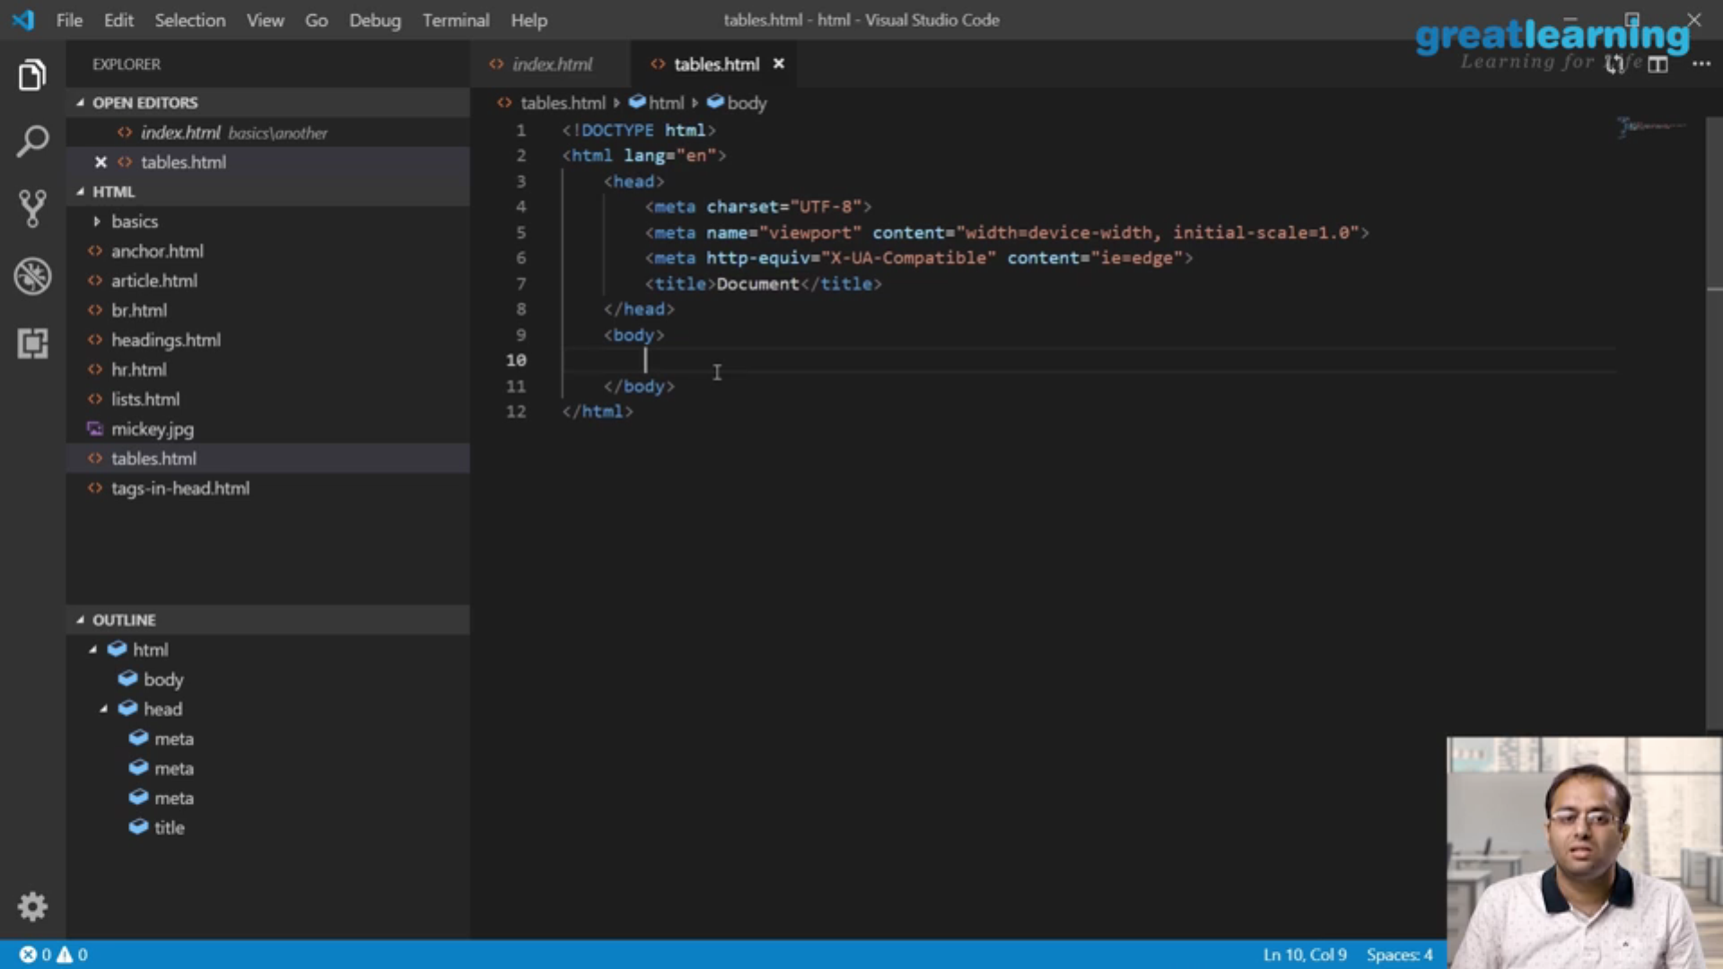**Online Coding Summary:**

**Today I received one program from prof.Venkatesh CSE Dept and from prof.Shilpa Hassan CSE Dept, Prof.Reena Lobo CSE Dept. I have also uploaded it to my Github repository.**

**Link:****http://github.com/spoorthyvv/lockdown_coding**