**DAILY ONLINE ACTIVITIES SUMMARY**

|  |  |  |  |  |  |  |  |  |
| --- | --- | --- | --- | --- | --- | --- | --- | --- |
| **Date:** | **08/06/2020** | | | | | **Name:** | **SPOORTHY VV** | |
| **Sem & Sec** | **IV sem & B section** | | | | | **USN:** | **4AL18CS087** | |
| **Online Test Summary** | | | | | | | | |
| **Subject** | | **Complex Analysis, Probability and Statistical Methods** | | | | | | |
| **Max. Marks** | | **30** | | **Score** | | | **20** | |
| **Certification Course Summary** | | | | | | | | |
| **Course** | **INTRODUCTION TO CYBER SECURITY** | | | | | | | |
| **Certificate Provider** | | | **CISCO** | | **Duration** | | | **10 hours** |
| **Coding Challenges** | | | | | | | | |
| **Problem Statement1:**Write a Java Program to check whether the given matrix is magic square or not.  **Problem Statement2:**C Program to Generate All the Set Partitions of n Numbers Beginning from 1 and so on. | | | | | | | | |
| **Status: Executed** | | | | | | | | |
| **Uploaded the report in Github** | | | | | **YES** | | | |
| **If yes Repository name** | | | | | **lockdown_coding** | | | |
| **Uploaded the report in slack** | | | | | **YES** | | | |

Online Test Summary: 18MAT41 test was scheduled from 9:30am t0 10:10am .The portion for the IA was 2nd module there were 15 questions and the time assigned was 40 minutes the questions were of mcq type.

Online Certification Course Summary: Today I have enrolled for new course which is introduction to cyber security which is pretty interesting.

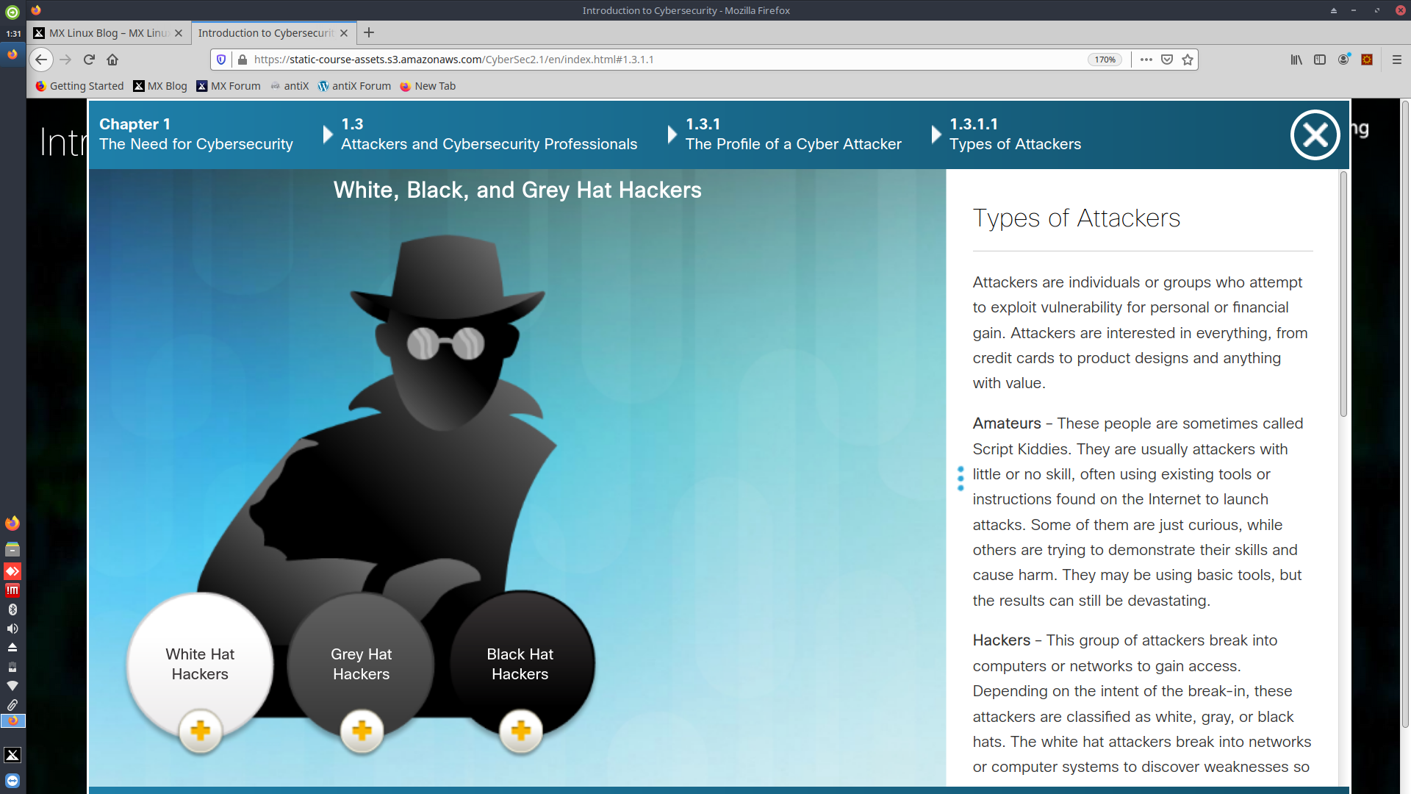Online Coding Summary: **Today I had received one program from prof. Shilpa CSE Dept. and other from prof. Venkatesh CSE Dept. The program is mentioned above in the coding challenges(pg.01). I have also uploaded it to my Github repository.**

**Link :** **https://github.com/spoorthyvv/lockdown_coding**