**DAILY ONLINE ACTIVITIES SUMMARY**

|  |  |  |  |  |  |  |  |  |
| --- | --- | --- | --- | --- | --- | --- | --- | --- |
| **Date:** | **01/07/2020** | | | | | **Name:** | **SPOORTHY VV** | |
| **Sem & Sec** | **4th SEM. & ‘B’ SEC.** | | | | | **USN:** | **4AL18CS087** | |
| **Online Test Summary** | | | | | | | | |
| **Subject** | | **------** | | | | | | |
| **Max. Marks** | | **--** | | **Score** | | | **--** | |
| **Certification Course Summary** | | | | | | | | |
| **Course** | **NETWORK SERVER SECURITY** | | | | | | | |
| **Certificate Provider** | | | **ALISON** | | **Duration** | | | **5Hrs.** |
| **Coding Challenges** | | | | | | | | |
| **Problem Statement 1 : Given two lists, sort the values of one list using the second list .** | | | | | | | | |
| **Status: Executed** | | | | | | | | |
| **Uploaded the report in Github** | | | | | **Yes** | | | |
| **If yes Repository name** | | | | | **lockdown_coding** | | | |
| **Uploaded the report in slack** | | | | | **Yes** | | | |

**Online Test Summary: No internals conducted.**

**Online Certification course Summary:**

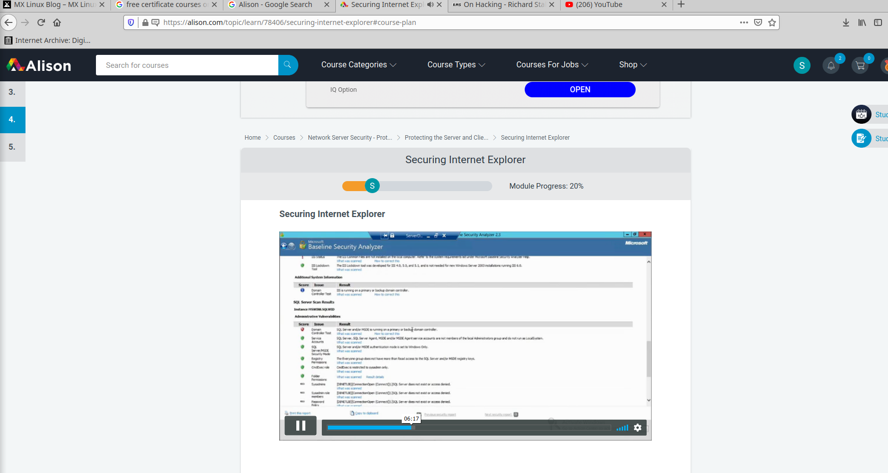**Online Coding Summary: Today I received the program from prof.Vasudev CSE Dept.The program is mentioned above in the coding challenges.I have written a program and uploaded it to my Github repository, as shown in the below.**

**Link :** **https://github.com/spoorthyvv/lockdown_coding**