Predictive Modeling and Risk Scoring for Bank Customer Churn
Research Paper
Author: Spoorti Chandra Belagola
Date: 14-03-2026

Abstract
Customer churn poses a significant challenge for financial institutions because the loss of customers directly affects revenue stability and long-term profitability. This study develops a predictive modeling framework to estimate churn probabilities for bank customers using machine learning techniques. The research utilizes a dataset containing demographic, financial, and engagement-related variables. Predictive models such as Logistic Regression and Random Forest are implemented to identify churn drivers and assign risk scores to customers. Results demonstrate that engagement indicators, product utilization, and financial behavior play critical roles in determining churn risk. The findings highlight how predictive analytics can enable proactive retention strategies in the banking sector.

1. Introduction
In the modern banking environment, customer retention has become a strategic priority for financial institutions. The competitive nature of retail banking means that customers can easily switch to alternative providers offering better services or financial incentives. As a result, banks must develop mechanisms to identify customers at risk of leaving and implement targeted retention strategies.
Customer churn prediction has emerged as an important application of data analytics in banking. Machine learning models allow organizations to analyze historical customer data and detect patterns that signal potential churn behavior. By identifying these patterns early, banks can design proactive engagement strategies to retain high-value customers.

2. Dataset Description
The dataset used in this research contains customer-level information from a European bank. It includes variables related to customer demographics, financial activity, and engagement with banking services. The dataset consists of 10,000 observations and multiple features including credit score, geography, age, tenure, balance, number of banking products, credit card ownership, activity status, and estimated salary.
The target variable in the dataset is 'Exited', which indicates whether a customer has left the bank. A value of 1 represents churn, while 0 represents customers who remain with the bank.

3. Exploratory Data Analysis
Figure 1 shows the overall distribution of customer churn in the dataset.
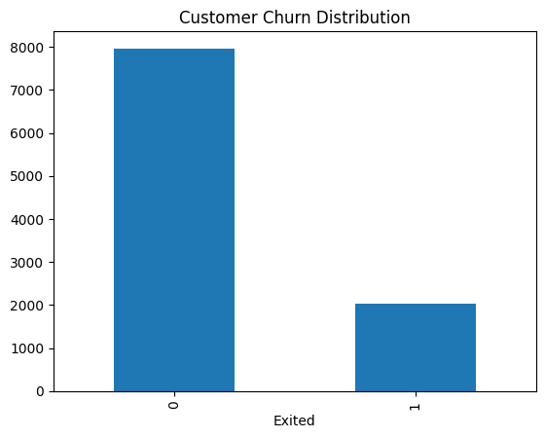
Figure 2 illustrates the age distribution of customers who churned versus those who remained.
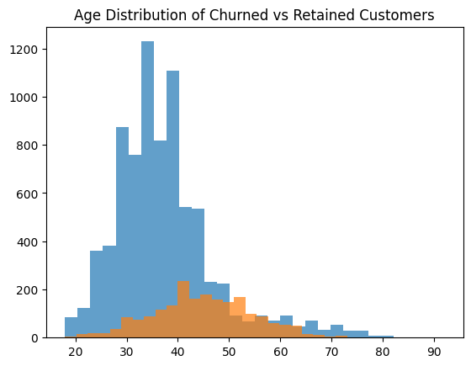
Figure 3 presents the churn patterns across different geographic regions.
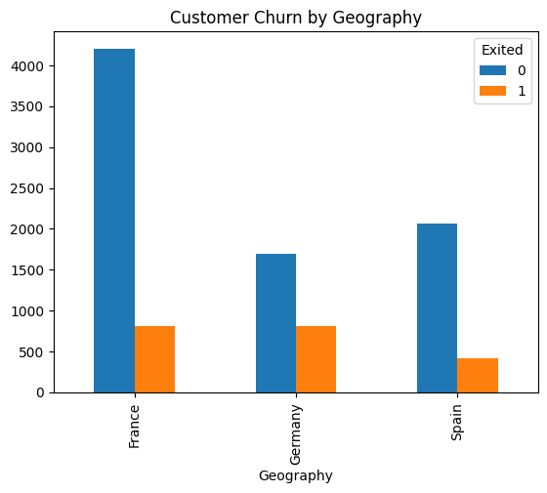
Figure 4 shows the relationship between the number of bank products and churn behavior.
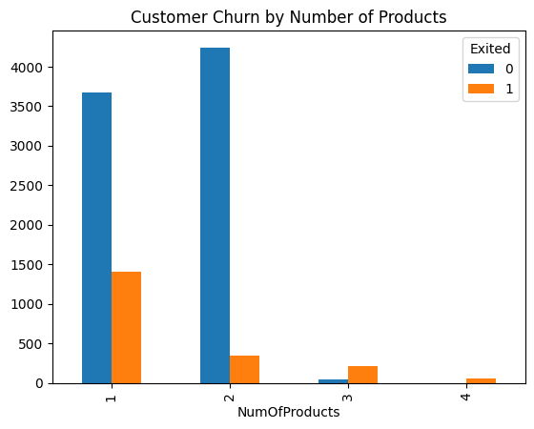

4. Methodology
The analytical process begins with data preprocessing. Non-informative variables such as customer identifiers were removed from the dataset. Categorical variables were converted into numerical representations using one-hot encoding techniques. Feature engineering was applied to create additional variables such as balance-to-salary ratio and age-tenure interaction features.
The dataset was split into training and testing subsets using an 80/20 ratio. Machine learning models including Logistic Regression and Random Forest were trained to predict churn probabilities.

5. Model Results
The Random Forest model demonstrated stronger predictive performance compared to the baseline Logistic Regression model. Feature importance analysis indicated that age, account balance, number of products, and customer activity levels are strong predictors of churn behavior.

6. Business Insights
The results highlight the importance of customer engagement in reducing churn risk. Customers who actively use banking services and maintain multiple financial products are significantly less likely to leave the bank. Conversely, customers with high balances but low engagement levels may represent potential churn risks.

7. Conclusion
This study demonstrates how predictive analytics can support strategic decision-making in retail banking. By leveraging machine learning models, banks can identify high-risk customers and implement proactive retention strategies. Future research may incorporate advanced machine learning models and explainable AI techniques to further enhance model performance and interpretability.

References
1. Verbeke, W., Martens, D., Baesens, B. (2012). Social network analysis for customer churn prediction.
2. Ngai, E. W., Xiu, L., Chau, D. C. (2009). Application of data mining techniques in customer relationship management.
3. Hadden, J., Tiwari, A., Roy, R., Ruta, D. (2007). Computer assisted customer churn management.

