RSVE remake
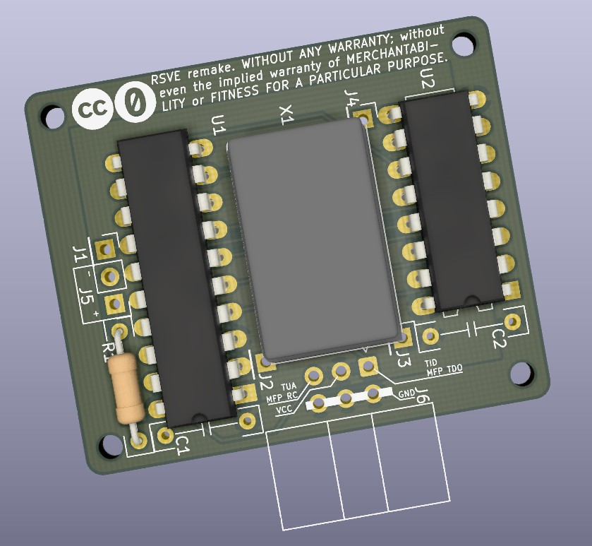
Quick installation guide
By David SPORN
A copy of the original, complete, and german documentation can be found here : https://github.com/sporniket/atari-st-mod-serial-port-upgrade-rsve/tree/main/reference/rsve
This document will guide you roughly to install this remake of the RSVE serial port upgrade into your computer. It is expected that you have a fair understanding of electronic, of the Atari ST computer hardware, and that you are able to perform soldering and rework.
The installation should be easy with a DIP version of the MFP. It may be less obvious with a PLCC version of the MFP, as it may be either directly soldered to the motherboard or installed in a PLCC socket.
I hope that there is no error, and will be happy to fix this document.
Content
(0) Reference material 3
(0.1) Top view of the RSVE PCB 3
(0.2) MFP68901 pinout 3
(1) Installation of the RSVE module 4
(1.1) Locating the pins of interest 4
(1.2) Preparing the Atari ST 4
(1.3) Preparing the RSVE module 4
(1.4) Install the RSVE 4

Reference material

Top view of the RSVE PCB
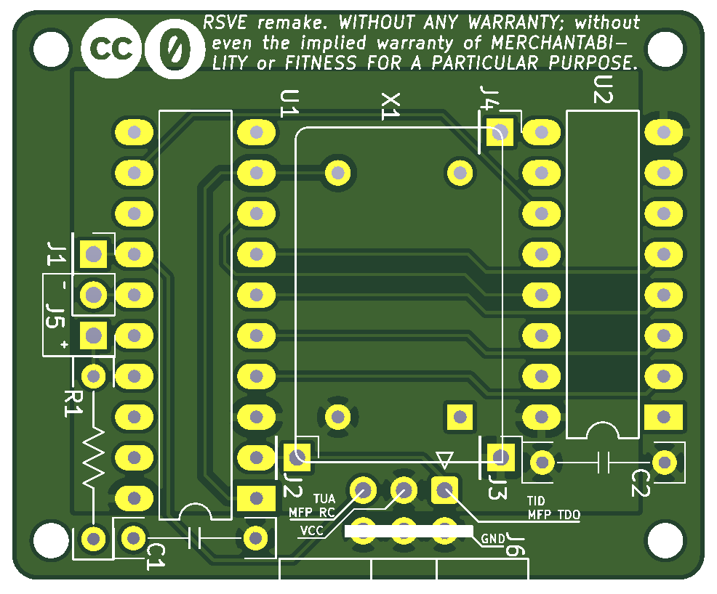

MFP68901 pinout
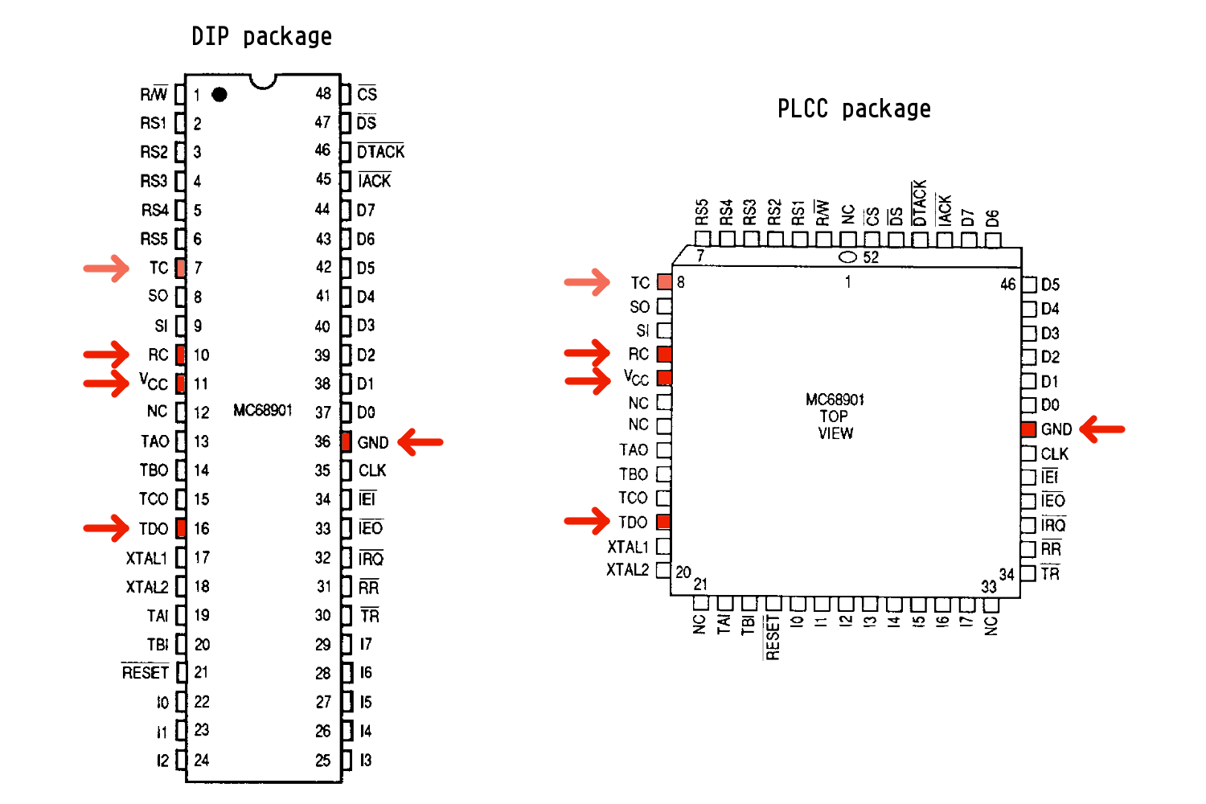

Installation of the RSVE module

Locating the pins of interest
The RSVE will needs 4 connection points to the ST motherboard :
- The MFP's Timer D Output TDO pin ; on the RSVE PCB, it is called TID, and it is the standalone J2 connector point, or pin 1 of J6.
- The MFP's Receiver Clock RC pin ; on the RSVE PCB, it is called TUA, and it is the standalone J1 connector point, or pin 5 of J6.
- The MFP's 5 Volts supply VCC pin ; on the RSVE PCB, it is called VCC, and it is the standalone J3 connector point, or pin 3 of J6. It is called +5V in the original german documentation.
- The MFP's Ground GND pin ; on the RSVE PCB, it is called GND on the RSVE, and it is the standalone J4 connector point, or pins 2,4 and 6 of J6.
You MAY locate the MFP's Transmitter Clock TC pin, in the case you unadvertently break the connection between this pin and the RC pin

Preparing the Atari ST
The preparation of the Atari ST require cutting a trace or an IC leg ! Revert this operation is possible but not trivial.
In an unmodified Atari ST computer, the MFP serial clock pins for the receiver (RC pin) and transmitter (TC pin) are both tied to the Timer D output pin (TDO). The modification consists in breaking this connection. Either by cutting the trace wiring TDO to RC and TD, or by cutting the leg of the TDO pin.

Preparing the RSVE module
One may either solder individual wires to each connectors J1, J2, J3 and J4, or solder a 6-ways ribbon cable to J6. The later seems more convenient for cable management.
Around 30 cm should be enough. Prepare the free end of each wire by pre-tinning them. If using a ribbon cable, you MIGHT want to join all the ground wires together.
Solder a pair of wires to J5 on one side, and to a LED of you choice on the other end.
After all the soldering is done, apply a polyimide tape (a.k.a. 'Kapton' tape) on the underside of the PCB to prevent unwanted contacts.

Install the RSVE
Solder each wire from the RSVE to the correct pin. Use polyimide tape or hot glue to maintain wires, and hopefully avoid pulling them.

After soldering, affix the RSVE PCB as you see fit.

