**A biomechanical approach to infer size-based functional response in aquatic and terrestrial systems**

Portalier S.M.J.1, Cherif M.2, Fussmann G.F.3, Loreau M.4

1: Department of Mathematics and Statistics, University of Ottawa, Ottawa, ON, Canada

2: French National Institute for Agriculture, Food, and Environment (INRAE), Aquatic Ecosystems and Global Change Research Unit, Cestas, France

3: Department of Biology, McGill University, Montreal, QC, Canada

4: Centre for Biodiversity Theory and Modelling, Theoretical and Experimental Ecology Station, CNRS, Moulis, France

**Correspondance:**

Corresponding author: Portalier Sebastien M.J.

Email: [sebastien.portalier@mail.mcgill.ca](mailto:sebastien.portalier@mail.mcgill.ca)

Word count: 2877 words

Number of figures: 2

# **Abstract**

First derivations of predators’ functional response were mechanistic, but subsequent uses of these mechanistically-derived functions tended to be mostly phenomenological. A better understanding of mechanisms underpinning the functional response might lead to novel insights into predator-prey relationships in natural systems. Here we use a novel mechanistic approach that makes explicit consideration of the movement of organisms. Living organisms are constrained by the physical properties of their surrounding medium. In particular, these physical properties, mediated by body size, constrain the ability of both predators and prey to move, and thus affect the functional response. As an example of this approach, we build a model that derives classical parameters of the functional response (i.e., attack rate and handling time) from body size and physical factors. The novelty of this approach is that parameters are not estimated from observational data. The model only needs data on body size and physical properties of the medium, which can be easily measured. Our approach also provides easy ways to validate or falsify hypotheses about predator-prey relationships because discrepancies between predictions and real data point immediately to either errors in the model or missing mechanisms.

**Keywords:** functional response, predator, prey, medium, body size, mechanics

# **Introduction**

The study of prey consumption by a predator (i.e., the functional response) began several decades ago (Gause, 1934; Gause et al., 1936) and was accompanied by the development of a theoretical framework based on mechanistic principles (Lotka, 1923; Volterra, 1926; Beverton and Holt, 1957; Watt, 1959). The model proposed by Holling (1961; 1966) is one of the best known. This mechanistic model defines parameters such as attack rate (the rate at which a predator encounters and captures prey) and handling time (the time needed by the predator to subdue, ingest and digest the captured prey, and during which the predator cannot attack another prey). These parameters can be measured concomitantly, and they give information about factors that constrain predation on a given prey, which is a strength of this mechanistic approach.

Holling’s type-I, II and III models and subsequently derived models (e.g., Rogers (1972)) are still widely used as a framework to derive the values of attack rate and handling time from empirical data (e.g., Andresen and van der Meer, 2010; Farhadi et al., 2010; Papanikolaou et al., 2011)). These approaches give valuable information on the studied systems, and they allow hypothesis testing, such as the effects of temperature (Archer et al., 2019) and predator satiation (Li et al., 2018) on the functional response. However, these studies have been mostly carried out in the laboratory, where many external factors do not play a role (Abrams, 1982). Hence, the results are hard to generalise and transpose to natural situations. Nonetheless, Holling’s model has been a very successful approach founded on mechanistic principles.

Several studies have investigated the role played by specific factors known to affect the functional response. These models have emphasized different features of predator-prey relationships, such as feeding saturation (DeAngelis et al., 1975)⁠ and interactions between predators (Beddington, 1975; Sih, 1979). In particular, the body size of both predator and prey are known to strongly affect the functional response (Aljetlawi et al., 2004; Vucic-Pestic et al., 2010)⁠. Body size is a good predictor of trophic position (Williams et al., 2010)⁠ and affects the overall dynamics of the interaction (Yodzis and Innes, 1992).

However, the surrounding physical medium remains absent or, at least, only implicit in most models, despite its ubiquity in real ecosystems. Although, in his pioneer work, Tansley (1935) stated that organisms should not be separated from their “special environment, with which they form one physical system”, the role played by the physical medium in constraining the functional response remains largely unexplored. Including physical features into predator-prey models is likely to lead to novel insights about species interactions.

# **Physical features of the medium and size-related constraints**

Previous studies that have considered the surrounding medium have usually focused on specific aspects of predation or on specific taxa (Domenici et al., 2011)⁠, or have investigated one specific aspect of the medium such as dimensionality (Pawar et al., 2012)⁠ or complexity (Barrios-O’Neill et al., 2016)⁠. But the overall role played by the surrounding medium acting on the predator-prey relationship, which drives the functional response, remains to be explored.

Clearly, living organisms are constrained by the physical properties of the surrounding medium (Denny, 1993; Denny, 2016; Vogel, 1996)⁠. These properties affect the way organisms move and/or interact with each other in different ways. For example, in aquatic systems, turbidity is an essential factor for predator or prey that rely on visual cues to detect each other (Martens et al., 2015). Another example is turbulence, which controls many planktonic organisms’ suspension within the water column (Rodríguez et al., 2001) and affects contact rate between predators and prey (Kiørboe and Saiz, 1995).

An important aspect of mechanical factors (i.e., gravity, density and viscosity) is that they constrain motion. Aquatic organisms do not experience the effects of gravity as terrestrial organisms usually do because the medium density is much higher in water than in air, which creates higher buoyancy. Since predation usually implies motion, these factors create mechanical constraints acting differently on predators in different physical environments. These mechanical factors are ubiquitous, affect small (Kiørboe and Saiz, 1995) as well as large predators (Howland, 1974; Domenici et al., 2007)⁠ and are usually size-dependent. In particular, medium viscosity and density affect species’ motion through drag, which is why the motion of planktonic organisms has very different features than that of larger organisms. Metrics such as the Reynolds number are commonly used to discriminate between organisms that experience viscous drag (low Reynolds number) and those that experience high inertia (high Reynolds number). These features affect species according to their size and shape (Koehl and Strickier, 1981; Koehl, 1996). Thus, incorporating mechanical constraints into models could lead to a better understanding of the size-based relationship between predators and prey, and hence of the size structure of food webs.

Due to this size dependence, models incorporating physical (including mechanical) factors into predation merge size-related biological and mechanical constraints in classical predator-prey systems. Several studies have begun to investigate this promising avenue. The dimensionality of the physical medium was shown to constrain predator-prey interactions since predators are expected to capture pelagic and flying prey more efficiently than benthic and terrestrial prey (Pawar et al., 2012). Extending this framework to predict pairwise trophic interactions in natural situations, Pawar et al (2019) successfully reproduced some important differences in the consumer-resource size structure of 2D versus 3D communities. However, dimensionality is only one feature of the physical medium. Some studies coupled several physical properties of the medium simultaneously in a plankton model (Baird and Emsley, 1999), including their effects on different resource-use strategies, such as photosynthesis, nutrient uptake and predation (Baird et al., 2006). Addition of these biomechanical mechanisms correctly predicted emergent ecosystem properties, such as deep chlorophyll maxima, where non-biomechanical models were unable to do so (Baird et al 2004). This additional realism was due specifically to the inclusion of effects of hydromechanical processes such as advection and turbulent dissipation on planktonic organisms (Baird et al 2004, 2006). This kind of approach was later extended to marine food webs using an oceanographic model, which proved interesting in its capacity to generate realistic food webs with relatively few generic rules (Baird and Suthers, 2007). But the validation of the model assumptions at a scale smaller than the ecosystem was less successful, due to the small size of planktonic organisms, and the scale at which the model was applied (ocean basins and currents). Similarly, a framework for predicting the optimal motion of larger organisms as a function of size and internal and external factors is under development (Wilson et al., 2015, 2013). The importance of physical factors in determining motion has been acknowledged (Wilson et al., 2015), but their explicit and quantitative inclusion in this framework has started only very recently (Portalier et al 2019).

The main advantage of many models coupling physical and general biological laws is that parameters in the models are mostly related to the body size of predators and prey, a trait that is commonly measured, which makes predictions from the models easily testable. Applying this approach to the study of the functional response would allow for a real novelty since the parameters of the functional response would no longer be measured at the community level, but would be derived from the individual (or species) level. Classical parameters such as attack rate and handling time would become emerging properties of the model. Another strength of this approach is that it allows hypothesis testing, since discrepancies between predicted and observed patterns would point to incomplete or erroneous hypotheses.

In order to illustrate this novel approach, we propose to include some of the mechanical factors related to body size in a theoretical model that predicts the functional response of a given predator consuming a given prey.

# **A case study as an example of new mechanistic approaches**

In a recent study, Portalier et al. (2019)⁠ provided a biomechanical model that uses general laws of mechanics and well-known biological laws, all related to body size, to predict predator−prey interactions. This model fits data remarkably well (Portalier et al., 2019)⁠. The model provides a detailed mechanism for predation, where predators have to move around for searching, capturing and handling their prey. All these aspects depend on the body masses of both the predator and its prey. The parameters of the functional response can be immediately computed from the biomechanical model. Hence, this model provides a novel method to parameterize a functional response based on individual traits, and on using mechanical laws. According to the biomechanical model assumptions, it is well suited for pelagic organisms.

## **Main framework**

This model uses body size and physical features of the medium to predict predator−prey interactions. Hence, the model requires the body masses of both the predator and its prey. The physical parameters are acceleration due to gravity, body density, medium density, and medium viscosity. Then, the model computes all the necessary information to predict feasible predator-prey interactions.

Predation is broken down into three successive sequences: a predator needs to search, capture, and then handle its prey. Each predation sequence leads to a time expenditure and requires motion. Following the idea developed by Bejan and Marden (2006), motion is modelled as an oscillatory process that is decomposed into three sequences. First, an organismal stroke leads to a thrust that propels the body upwards (following Archimedes’ force, but facing gravity and drag (*D*) due to density and viscosity) and forwards (facing drag). It is possible to numerically derive vertical speed from simple mechanical laws:

|  |  |  |
| --- | --- | --- |
|  | $$\dot{v}=\frac{F_{Mv}}{M_{b}}+\frac{gρV_{b}}{M_{b}}-g-D(v,M_{b},ρ_{m},μ)$$ | (1) |

where *v* is instantaneous vertical speed, *FMv* is thrust vertical force, *Mb* is body mass, g is acceleration due to gravity, *Vb* is body volume, *ρ* is medium density, *D* is drag that varies with speed, body mass, density, and medium viscosity (*μ*). Second, when stroke ends, the body continues its ascending movement by inertia until its stops.

|  |  |  |
| --- | --- | --- |
|  | $$\dot{v}=\frac{gρV_{b}}{M_{b}}-g-D({v,M}_{b},ρ_{m},μ)$$ | (2) |

Third, the body returns by inertia to its original vertical position.

|  |  |  |
| --- | --- | --- |
|  | $$\dot{v}=-\frac{gρV_{b}}{M_{b}}+g-D(v,M_{b},ρ_{m},μ)$$ | (3) |

During this vertical oscillation, the body moves forward compared to its original horizontal position over a distance that depends on the forward component of thrust. The instantaneous horizontal speed can be derived using a method similar to vertical speed, but it considers only thrust and drag (see supplementary material for more details). Then, another sequence begins. The model computes the thrust force needed to propel the body (which is constrained by body size), the horizontal distance covered, the speed and the associated energetic cost that maximizes the probability to capture a prey, and the net energy gain from its consumption. Predicted speeds fit data well (Fig 1). Both predator and prey follow the same rules, with the difference that the prey only maximizes its probability to escape predation.

Predation on a given prey requires first its encounter, followed by capture and finally handling. Encounter rate is determined by the speeds of the predator and prey calculated in the model (see above), and then used in a formula according to (Rothschild and Osborn, (1988). The relative speed between the predator and the prey calculated at the time of capture also determines the probability of capture (and therefore the total time for searching a prey that leads to a successful capture), and time for capture. Search time (*ts*) represents the time needed by a predator to contact a prey that leads to a successful capture (e.g., if the capture probability is 0.5, then the predator needs to contact a prey twice on average to successfully capture it). Capture time (*tc*) is the time needed to move towards a prey and seize it. Last, handling time (*th*) is the time needed to consume and digest the prey (handling time is the only component in the model of the functional response that is independent of physical factors). The functional response (*f(N)*) is defined as the inverse of the time needed for searching, capturing and handling one unit of prey of abundance *N*. The function may be written as follows (see supplementary material)

|  |  |  |
| --- | --- | --- |
|  | $$f\left(N\right)=\frac{NβP_{c}}{1+NβP_{c}(t_{c}+t_{h})}$$ | (4) |

*βPc* represents the attack rate, where *β* is the encounter rate (constrained by predator and prey speeds), and *Pc* is the capture probability. Capture time and handling time are taken into account instead of handling time only. Under this form, one can recognize a modified version of Holling's disk equation (1961).

Given the assumptions made on the encounter rate (see Supplementary Material), the functional response behaves as a type-II response. All parameter values change according to both predator and prey sizes, while attack rate, capture probability and capture time also vary with mechanical features of the medium.

## **Validation of the model**

Data were collected in order to test predictions from the model. Most data come from two meta-analyses⁠ (Hirt et al., 2017; Li et al., 2018), as well as our own literature search (cite here if only a couple of papers, or add a table with references in the supplementary material). To be pertinent, data have to mention predator and prey sizes explicitly. Most data are individual-based, which means that two individuals from the same species but with different sizes are treated separately.

Predicted attack rate, capture probability and handling time were compared to real data coming from aquatic systems (Fig. 2). It appears that the model fits the data quite well for attack rate (except for very small organisms, but there is also a limited amount of data) and capture probability. Linking mechanical features from the medium and body size allows a good estimate of attack rate and capture probability for pelagic predators. However, handling time is usually underestimated for small predators, while the model is more accurate for larger predators. This discrepancy for small predators opens the door to many hypotheses that remain to be tested. Note that this parameter is not dependent on mechanical features of the medium, but is determined only by allometric laws. Thus, the results suggest that the relationship between predator size, prey size and handling time is driven by a more complex set of allometric laws that differ between small and large predators (Emerson et al., 1994), or that other factors increase handling time for small predators. Some studies also suggested that handling time may not be static for a given predator, but vary with prey abundance (Okuyama, 2010). These are examples of hypotheses that can be inferred from the analysis of such a model.

# **Conclusions and future directions**

The model proposed here uses the mechanical properties of the medium to develop a mechanistic approach to the functional response. However, it considers only a limited set of physical factors. The model could be improved in several ways. Future studies could include more physical factors such as temperature, which affects the physical properties of the medium (Larsen and Riisgård, 2009), and organisms’ metabolism (Brown et al., 2004). They could also consider factors that affect prey detection such as light and chemical cues. These factors diffuse differently in air and water, the perception ability of predators seems to be related to size (Martens et al., 2015). This novel framework is promising because it provides easy ways to validate or falsify hypotheses. Hence, any discrepancy between predictions and real data points immediately towards an error in the model, or it means that important mechanisms are missing (as shown for handling time in our case study). It can also suggest novel hypotheses to be empirically or theoretically tested.

In our model, processes based on mechanical factors (i.e., speed, attack rate, capture probability) fit data well. Handling time shows a lower goodness of fit, and it is the only one that does not include any physical factors. A better mechanism for handling is thus needed. Ingestion has received some attention in the existing literature, especially for aquatic organisms (Holzman et al., 2012). Mechanisms driving digestion have also received some attention. For example, there are models of gut motility according to prey size and gut volume (Salvanes et al., 1995), although they usually do not include physical factors from the medium that may affect the process (e.g., temperature, pressure). However, both ingestion and digestion models might be difficult to generalize to a large variety of species (and sizes). Moreover, other aspects of handling time are likely to play a role. For instance, prey subjugation before ingestion is an essential aspect. Unfortunately, studies on this topic seem to focus either on dangerous (e.g., poisonous) prey (Mukherjee and Heithaus, 2013), or on specific species (Schatz et al., 1997), which makes them difficult to generalize. Last, predator satiation or hunger remains a fundamental aspect of predator activity (Jeschke et al., 2002). While it has been included in several studies, its underpinning processes remain to be modelled. Therefore, a generic mechanical description of handling that would cover its different components and be valid across a wide range of sizes would represent a significant improvement.

More generally, the strength of this kind of approach is to derive patterns at the community level from measures done at the individual or species level. Thus, the functional response is an emerging property of the system. One could even go further by including other aspects associated to predation such as behavioral features (e.g., predator avoidance, interference between predators, social aspects) that were already considered by Holling (1966). This approach opens up a promising avenue for new studies that would merge the biological part and the physical part of the medium.

# **Acknowledgments**

SP received fundings from the Healthy Forest Partnership.

# **Contribution of authors**

S.P. implemented the model, gathered data, performed simulations and analysis, and led the writing of the manuscript. M.C., G.F. and M.L. provided conceptual advices. All authors discussed the results and contributed equally to earlier drafts.

# **Data accessibility**

Data and the MATLAB code used to implement the model will be stored in a public depository should the manuscript be accepted. During the review process, data and code will be made available in a temporary archive on GitHub: <https://github.com/sportalier/Code_Data_Frontiers_In_Ecology_And_Evolution.git>.

# **References**

Abrams, P. A. (1982). Functional responses of optimal foragers. *Am. Nat.* 120, 382–390. doi:10.1086/283996.

Aljetlawi, A. A., Sparrevik, E., and Leonardsson, K. (2004). Prey-predator size-dependent functional response: derivation and rescaling to the real world. *J. Anim. Ecol.* 73, 239–252. doi:10.1111/j.0021-8790.2004.00800.x.

Andresen, H., and van der Meer, J. (2010). Brown shrimp (Crangon crangon, L.) functional response to density of different sized juvenile bivalves Macoma balthica (L.). *J. Exp. Mar. Bio. Ecol.* 390, 31–38. doi:10.1016/j.jembe.2010.04.027.

Archer, L. C., Sohlström, E. H., Gallo, B., Jochum, M., Woodward, G., Kordas, R. L., et al. (2019). Consistent temperature dependence of functional response parameters and their use in predicting population abundance. *J. Anim. Ecol.* 88, 1670–1683. doi:10.1111/1365-2656.13060.

Baird, M. E., and Suthers, I. M. (2007). A size-resolved pelagic ecosystem model. *Ecol. Modell.* 203, 185–203. doi:10.1016/j.ecolmodel.2006.11.025.

Baird, M. E., Timko, P. G., Suthers, I. M., and Middleton, J. H. (2006). Coupled physical-biological modelling study of the East Australian Current with idealised wind forcing. Part I: Biological model intercomparison. *J. Mar. Syst.* 59, 249–270. doi:10.1016/j.jmarsys.2005.09.005.

Baird, M., and Emsley, S. M. (1999). Towards a mechanistic model of plankton population dynamics. *J. Plankton Res.* 21, 85–126. doi:10.1093/plankt/21.1.85.

Barrios-O’Neill, D., Kelly, R., Dick, J. T. A., Ricciardi, A., MacIsaac, H. J., and Emmerson, M. C. (2016). On the context-dependent scaling of consumer feeding rates. *Ecol. Lett.* 19, 668–678. doi:10.1111/ele.12605.

Beddington, J. R. (1975). Mutual Interference Between Parasites or Predators and its Effect on Searching Efficiency. *J. Anim. Ecol.* 44, 331–340. doi:10.2307/3866.

Bejan, A., and Marden, J. H. (2006). Unifying constructal theory for scale effects in running, swimming and flying. *J. Exp. Biol.* 209, 238–248. doi:10.1242/jeb.01974.

Beverton, R. J. H., and Holt, S. J. (1957). On the dynamics of exploited fish population. *Fish. Investig.* 11, 1–533.

Brown, J. H., Gillooly, J. F., Allen, A. P., Savage, V. M., and West, G. B. (2004). Toward A Metabolic Theory Of Ecology. *Ecology* 85, 1771–1789. doi:10.1890/03-9000.

DeAngelis, D. L., Goldstein, R. A., and O’Neill, R. V (1975). A Model for Tropic Interaction. *Ecology* 56, 881–892. doi:10.2307/1936298.

Denny, M. W. (1993). *Air and Water: The Biology and Physics of Life’s Media*. Princeton University Press Available at: https://books.google.com/books?hl=en&lr=&id=XjNS6v7q130C&pgis=1 [Accessed January 11, 2016].

Denny, M. W. (2016). *Ecological Mechanics: Principles of Life’s Physical Interactions*. Princeton University Press, Princeton, New Jersey Available at: https://books.google.com/books?hl=en&lr=lang_en&id=V2MDCwAAQBAJ&pgis=1 [Accessed December 9, 2015].

Domenici, P., Blagburn, J. M., and Bacon, J. P. (2011). Animal escapology I: theoretical issues and emerging trends in escape trajectories. *J. Exp. Biol.* 214, 2463–2473. doi:10.1242/jeb.029652.

Domenici, P., Claireaux, G., and McKenzie, D. J. (2007). Environmental constraints upon locomotion and predator-prey interactions in aquatic organisms: an introduction. *Philos. Trans. R. Soc. Lond. B. Biol. Sci.* 362, 1929–1936. doi:10.1098/rstb.2007.2078.

Emerson, S. B., Greene, H. W., and Charnov, E. L. (1994). “Allometric aspects of predator-prey interactions,” in *Ecological morphology: integrative organismal biology*, eds. P. C. Wainwright and S. M. Reilly (University of Chicago Press Chicago, IL), 123–139.

Farhadi, R., Allahyari, H., and Juliano, S. A. (2010). Functional Response of Larval and Adult Stages of *Hippodamia variegata* (Coleoptera: Coccinellidae) to Different Densities of *Aphis fabae* (Hemiptera: Aphididae). *Environ. Entomol.* 39, 1586–1592. doi:10.1603/EN09285.

Gause, G. F. (1934). *The struggle for existence*. Williams and Wilkins, Baltimore.

Gause, G. F., Smaragdova, N. P., and Witt, A. A. (1936). Further Studies of Interaction between Predators and Prey. *J. Anim. Ecol.* 5, 1. doi:10.2307/1087.

Hirt, M. R., Jetz, W., Rall, B. C., and Brose, U. (2017). A general scaling law reveals why the largest animals are not the fastest. *Nat. Ecol. Evol.* 1, 1116–1122.

Holling, C. S. (1961). Principles of Insect Predation. *Annu. Rev. Entomol.* 6, 163–182. doi:10.1146/annurev.en.06.010161.001115.

Holling, C. S. (1966). The Functional Response of Invertebrate Predators to Prey Density. *Mem. Entomol. Soc. Canada* 98, 5–86. doi:10.4039/entm9848fv.

Holzman, R., Collar, D. C., Mehta, R. S., and Wainwright, P. C. (2012). An integrative modeling approach to elucidate suction-feeding performance. *J. Exp. Biol.* 215, 1–13. doi:10.1242/jeb.057851.

Howland, H. C. (1974). Optimal strategies for predator avoidance: The relative importance of speed and manoeuvrability. *J. Theor. Biol.* 47, 333–350. doi:10.1016/0022-5193(74)90202-1.

Jeschke, J. M., Kopp, M., and Tollrian, R. (2002). Predator Functional Responses: Discriminating Between Handling And Digesting Prey. *Ecol. Monogr.* 72, 95–112. doi:10.1890/0012-9615(2002)072[0095:PFRDBH]2.0.CO;2.

Kiørboe, T., and Saiz, E. (1995). Planktivorous feeding in calm and turbulent environments, with emphasis on copepods. *Mar. Ecol. Prog. Ser.* 122, 135–145. doi:10.3354/meps122135.

Koehl, M. A. R. (1996). When Does Morphology Matter? *Annu. Rev. Ecol. Syst.* 27, 501–542. doi:10.1146/annurev.ecolsys.27.1.501.

Koehl, M. A. R., and Strickier, J. R. (1981). Copepod feeding currents: Food capture at low Reynolds number. *Limnol. Oceanogr.* 26, 1062–1073. doi:10.4319/lo.1981.26.6.1062.

Larsen, P. S., and Riisgård, H. U. (2009). Viscosity and not biological mechanisms often controls the effects of temperature on ciliary activity and swimming velocity of small aquatic organisms. *J. Exp. Mar. Bio. Ecol.* 381, 67–73.

Li, Y., Rall, B. C., and Kalinkat, G. (2018). Experimental duration and predator satiation levels systematically affect functional response parameters. *Oikos* 127, 590–598. doi:10.1111/oik.04479.

Lotka, A. J. (1923). Contribution to quantitative parasitology. *J. Washingt. Acad. Sci.* 13, 152–158. Available at: http://www.jstor.org/stable/24533190.

Martens, E. A., Wadhwa, N., Jacobsen, N. S., Lindemann, C., Andersen, K. H., and Visser, A. (2015). Size structures sensory hierarchy in ocean life. *Proc. R. Soc. B* 282, 20151346. doi:10.1098/rspb.2015.1346.

Mukherjee, S., and Heithaus, M. R. (2013). Dangerous prey and daring predators: A review. *Biol. Rev.* 88, 550–563. doi:10.1111/brv.12014.

Okuyama, T. (2010). Prey density-dependent handling time in a predator-prey model. *Community Ecol.* 11, 91–96. doi:10.1556/ComEc.11.2010.1.13.

Papanikolaou, N. E., Martinou, A. F., Kontodimas, D. C., Matsinos, Y. G., and Milonas, P. G. (2011). Functional responses of immature stages of Propylea quatuordecimpunctata (Coleoptera: Coccinellidae) to Aphis fabae (Hemiptera: Aphididae). *Eur. J. Entomol.* 108, 391.

Pawar, S., Dell, A. I., and Savage, V. M. (2012). Dimensionality of consumer search space drives trophic interaction strengths. *Nature* 486, 485–9. doi:10.1038/nature11131.

Portalier, S. M. J., Fussmann, G. F., Loreau, M., and Cherif, M. (2019). The mechanics of predator–prey interactions: First principles of physics predict predator–prey size ratios. *Funct. Ecol.* 33, 323–334. doi:10.1111/1365-2435.13254.

Rodríguez, J., Tintoré, J., Allen, J. T., Blanco, J. M., Gomis, D., Reul, A., et al. (2001). Mesoscale vertical motion and the size structure of phytoplankton in the ocean. *Nature* 410, 360–363. doi:10.1038/35066560.

Rogers, D. (1972). Random Search and Insect Population Models. *J. Anim. Ecol.* 41, 369–383. doi:10.2307/3474.

Rothschild, B. J., and Osborn, T. R. (1988). Small-scale turbulence and plankton contact rates. *J. Plankton Res.* 10, 465–474. doi:10.1093/plankt/10.3.465.

Salvanes, A. G. V., Aksnes, D. L., and Giske, J. (1995). A surface‐dependent gastric evacuation model for fish. *J. Fish Biol.* 47, 679–695. doi:10.1111/j.1095-8649.1995.tb01934.x.

Schatz, B., Lachaud, J. P., and Beugnon, G. (1997). Graded recruitment and hunting strategies linked to prey weight and size in the ponerine ant Ectatomma ruidum. *Behav. Ecol. Sociobiol.* 40, 337–349. doi:10.1007/s002650050350.

Sih, A. (1979). Stability and Prey Behavioural Responses to Predator Density. *J. Anim. Ecol.* 48, 79–89. doi:10.2307/4101.

Tansley, A. G. (1935). The Use and Abuse of Vegetational Concepts and Terms. *Ecology* 16, 284–307.

Vogel, S. (1996). *Life in moving fluids: the physical biology of flow*. Princeton University Press, Princeton, New Jersey.

Volterra, V. (1926). Variazioni e fluttuazioni del numero d’individui in specie animali conviventi. *Mem. Acad. Lincei* 6, 31–113.

Vucic-Pestic, O., Rall, B. C., Kalinkat, G., and Brose, U. (2010). Allometric functional response model: body masses constrain interaction strengths. *J. Anim. Ecol.* 79, 249–56. doi:10.1111/j.1365-2656.2009.01622.x.

Watt, K. E. F. (1959). A Mathematical Model for the Effect of Densities of Attacked and Attacking Species on the Number Attacked. *Can. Entomol.* 91, 129–144. doi:10.4039/Ent91129-3.

Williams, R. J., Anandanadesan, A., and Purves, D. (2010). The probabilistic niche model reveals the niche structure and role of body size in a complex food web. *PLoS One* 5, e12092. doi:10.1371/journal.pone.0012092.

Wilson, R. P., Griffiths, I. W., Mills, M. G. L., Carbone, C., Wilson, J. W., and Scantlebury, D. M. (2015). Mass enhances speed but diminishes turn capacity in terrestrial pursuit predators. *Elife* 4. doi:10.7554/eLife.06487.001.

Yodzis, P., and Innes, S. (1992). Body Size and Consumer-Resource Dynamics. *Am. Nat.* 139, 1151–1175. doi:10.1086/285380.

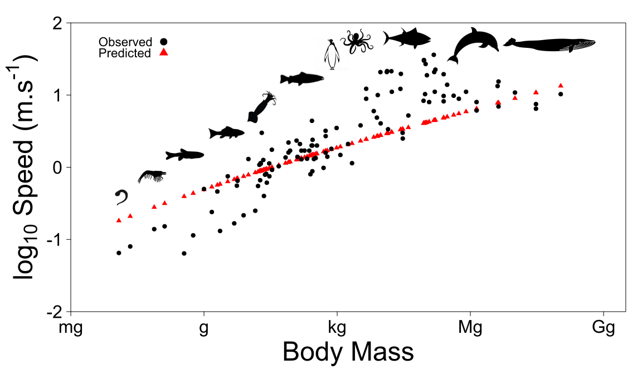

**Figure 1**: Species-specific speed according to body size for organisms moving in aquatic systems. Speed increases with body size since overall muscular power generating thrust increases with size. Despite variation among species, the predicted speed fits data well (data from (Hirt et al., 2017)). However, the model does not predict the relative reduction of speed for very large animals since it does not include any specific mechanism to do so.

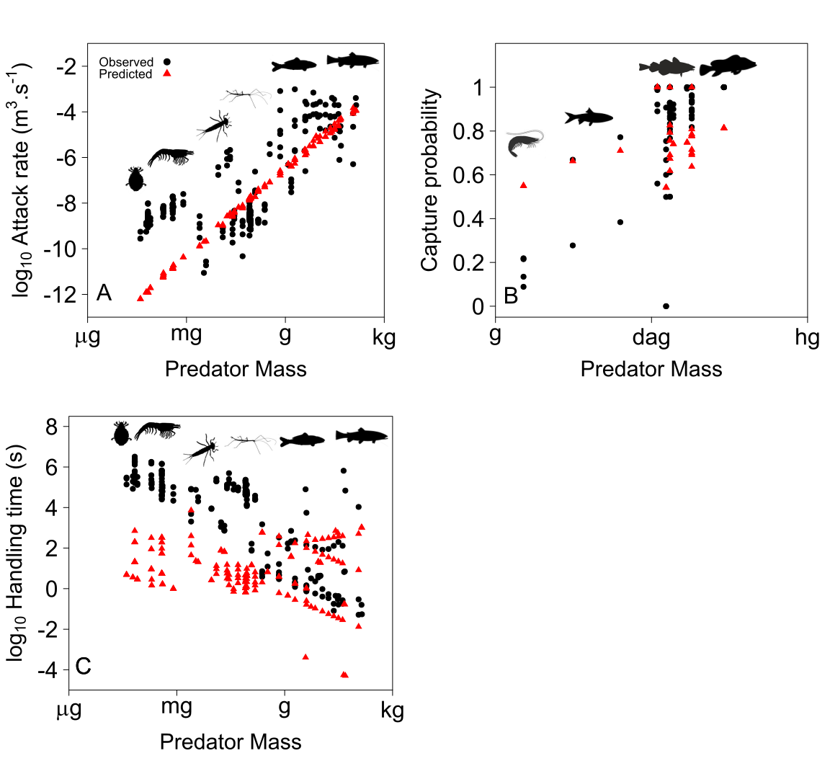

**Figure 2**: Predator attack rate **(A)**, capture probability **(B)** and handling time **(C)** according to predator mass in aquatic systems. The model fits the data quite well for attack rate (except for very small organisms) and capture probability. However, data show some variability. Predictions for handling time are more accurate for relatively large predators than for smaller predators. This suggests that more investigations are needed in order to understand how mechanical factors constrain handling time for predators according to predator and prey sizes.