**Title: A temperature-driven model of phenological mismatch provides insights into the potential impacts of climate change on consumer-resource interactions**

**Authors**: Portalier S.M.J.1, Candau J.N.2, Lutscher F.1,3

**Institutions**:

1: Department of Mathematics and Statistics, University of Ottawa, Ottawa, ON, Canada

2: Natural Resources Canada, Canadian Forest Service, Great Lakes Forestry Centre, Sault Ste. Marie, ON, Canada

3:Department of Biology, University of Ottawa, Ottawa, ON, Canada

**Corresponding author**: Portalier S.M.J.

**Address**: Department of Mathematics and Statistics, STEM Complex, 150 Louis Pasteur Pvt, Ottawa, ON, K1N 6N5, Canada

**Email**: [sportali@uottawa.ca](mailto:sportali@uottawa.ca)

Word count: 5055 words (+48 in the introduction)

Introduction: 947 words + 48 (reminders, in red)

The general model: 1331 words

The case study: 1310 words

Discussion: 1464 words

**Abstract**

1. Anthropogenic climate change increasingly affects species phenology. Because trophic interactions often occur at specific phenological stages, changes in one species' phenology may affect others through phenological mismatch. When a consumer and a resource both exhibit a seasonal resting period, the synchrony of the end of their respective resting periods is fundamental for the persistence of their interaction. Since the consumer and its resource may react differently to changes in temperature regime, the synchrony between them could be altered.
2. our goal is to investigate potential effects of climate change on species’ synchrony.
3. We propose a general theoretical model that determines the duration of the resting period according to temperature, and its effects on the mismatch between phenological stages of two interacting species. We illustrate our approach using the spruce budworm – balsam fir system in eastern Canada.
4. We find that an increase in temperature usually advances the end of the resting period. However, the effects of a warm or cold spell during the resting period strongly vary according to the timing and the duration of the spell. Depending on how a consumer and its resource react to the same temperature shift, the mismatch between them may increase or decrease. The spruce budworm – balsam fir model predicts that an increase in temperature may increase the mismatch between the insect and the tree in southern sites, but may increase the synchrony in northern sites.
5. This type of modelling approach is of prime importance to investigate potential effects of climate change on consumer – resource systems.

**Keywords:**

climate change, phenology, consumer, resource, balsam fir, spruce budworm

**1. Introduction**

Anthropogenic climate change increasingly disrupts ecological interactions (Pachauri et al. 2014). This trend is expected to continue and amplify as interacting species are likely to respond differently to similar environmental changes and selective pressures (Parmesan 2006). Trophic interactions between consumers and resources, which are fundamental to the functioning of ecosystems, may be affected by climate change through: (1) changes in life history traits (fecundity, mortality) of either species (Bale et al. 2002), (2) changes in abundance of consumer and/or resource due to cascading effects from other trophic levels (Both et al. 2009), and (3) differential shifts in the phenology of consumer and/or resource leading to phenological mismatch (Kharouba et al., 2018).

The concept of phenological mismatch has evolved since its inception in the early 1990s and is still debated today (e.g., Singer and Parmesan 2020’s response to Kharouba and Wolkovich, 2020). In its stricter, original form, it states that the recruitment of a consumer is highest if the most energy expensive part of its life cycle is synchronized with the peak availability of its resource (Cushing 1990). The concept was later extended to the case where the phenologies of consumer and resource varied (Visser and Holleman 2001), but still assumed that maximum fitness of the consumer is achieved at phenological synchrony. However, recent observations suggest that, in some systems, phenological mismatch is the historical baseline (Singer and Parmesan 2010). Historical mismatch can result from trade-offs between fecundity and mortality (Singer and Parmesan 2010), mutualistic interactions (Forrest and Thomson 2012) or intraspecific competition (Iwasa et al. 1983). Relaxing the assumption of baseline synchrony complicates predictions of potential climate change impacts. Indeed, if synchrony is the baseline, any differential change will be detrimental to the consumer’s fitness. If mismatch is the baseline, a decrease in asynchrony will likely benefit the consumer (but see Régnière and Nealis 2018) while an increase might exacerbate the detrimental effect of asynchrony to the point of consumer extinction (Singer and Parmesan, 2010).

Many organisms have advanced their phenology in recent decades (Post et al. 2001; Parmesan and Yohe 2003), particularly the timing of spring events at mid-high latitudes (Parmesan 2006; Cohen et al. 2018). In a meta-analysis of 27 pairs of interacting species, Kharouba et al. (2018) found that phenology advanced by an average of 4 days/decade across species since the early 1980s, resulting in significant changes in mismatch. These changes had no consistent direction as 31 interactions shifted closer while 23 shifted further apart. The clearest examples of climate-driven mismatch have been reported for insect herbivores at high altitudes or latitudes (Renner and Zohner 2018), where many organisms rely on a seasonal resting period because temperatures affecting physiological processes tend to be below species optima for most of the year. After a seasonal arrest in development that can last for several months, synchrony between the emergence of phytophagous insects from diapause and the end of their host plants dormancy is critical to the consumer’s fitness (Van Asch and Visser 2007). Spring defoliators have evolved to exploit foliage at its annual optimal nutritional qualities (Mattson and Scriber 1987). This strategy requires a precise phenological match between the consumer and its resource because the quality of foliage declines quickly with foliar expansion. If the consumer emerges too early, it may encounter a long period with no food or poor food quality. If it emerges too late, the nutritional quality of the foliage may degrade more quickly than the consumer can adjust physiologically, thus negatively impacting its fitness.

JNC: I believe that we need to keep the 2 sentences that Frithjof deleted here to explain that we are modelling the second stage of the seasonal resting period.

Predicting the direction and magnitude of climate-change induced phenological shift and mismatch between consumer and resource and the associated risk that it poses to the species is difficult (Samplonius et al. 2021). While patterns of change in phenological synchrony are increasingly observed (Kharouba et al. 2018), they are difficult to explain mechanistically. Different mechanisms can lead to a phenological mismatch between a consumer and its resource. Different species can respond to different climatic factors or to the same factor but in a different way. Species can also face different constraints in phenological plasticity (Both and Visser 2001) or have different costs associated with phenological response (Gienapp and Visser 2006). Several complex mechanistic modelling approaches have begun to explore how consumer—resource dynamics are expected to change across latitude under different scenarios (Scranton and Amarasekare 2017; Amarasekare 2019). Their parameterisation requires detailed knowledge on species’ life-history traits.

We focus on climate-change effects on one particular aspects of the life cycle, namely, the emergence from a seasonal resting period (dormancy, diapause) and its effect on phenological synchrony between a consumer and its resource when both species respond to temperature. Resource consumption occurs after the end of both species’ resting period, which is often the case for insect herbivores in mid-high latitudes, and of crucial importance to the consumer (see above). We present a general but simple model for the end of the resting period that can be parametrized from field observations of physiological processes. We derive approximate formulae for the change in phenology in response to changing climates. Then we use a major insect pest of the Canadian boreal forest, the spruce budworm (SBW), and its main host, balsam fir, to investigate the phenological synchrony between budworm’s emergence from winter diapause and balsam fir’s budburst across a gradient of latitudes and a number of different future climates.

# 2. The general model

We first present a unified description of the mechanisms that determine the duration of the seasonal resting period of a species in terms of accumulation of ambient temperature. Then, we develop the main theoretical results for a single and two interacting species.

Throughout the resting period, organisms accumulate units of some quantity at some instantaneous rate that depends on ambient temperature. The resting period ends when a certain level of the quantity has accumulated. For example, trees accumulate heat (Colombo 1998; Chuine 2000; Desbiens 2007). Many resting insects have temperature-dependent development rates, so that physiological stage ultimately also measures accumulated heat (Cobbold and Powell 2011; Régnière et al. 2012). The concept of accumulating some quantity before progressing to a different stage dates back to models for age- or stage-structured populations (Gurney et al. 1983; Nisbet and Gurney 1983) and is “still the most important assumption in plant and animal phenology modelling” (Chuine and Régnière 2017).

We denote time by *t* in days and temperature by *x = x(t)* in degrees Celsius. The instantaneous rate of accumulation is some nonnegative, increasing function of temperature, denoted by *R = R(x)*. While developmental rates may decrease when temperatures exceed an upper threshold (Amarasekare and Coutinho 2014), such temperatures do not generally arise during the winter resting period in mid-high latitudes. The resting period begins at time *t0* and ends at time *t\** when the accumulated quantity reaches the threshold level *F*. The fundamental equation that connects all these quantities and determines the end of the resting period is

|  |  |  |
| --- | --- | --- |
|  | $$\int_{t_{0}}^{t^{}}{R\left(x\left(t\right)\right)dt}=F.$$ | Eq. 1 |

This equation is equivalent to the stage-duration condition in Nisbet and Gurney (1983).

A typical example for the accumulation rate function is

|  |  |  |
| --- | --- | --- |
|  | $R\left(x\right)=\frac{1}{1+exp⁡\left(b\left(x-c\right)\right)}$, | Eq. 2 |

with parameters *b < 0* and *c* (Chuine 2000; Rebaudo and Rabhi 2018); see Fig. 1A. Temperature patterns during the resting period differ between locations and change due to climate change (Fig. 1B). Different species, such as a consumer and its resource, maybe affected differently (Fig. 1C). Consequently, the end times of their respective resting period may shift differently (Fig. 1D). When temperatures increase, accumulation occurs faster and the phenology advances, i.e., the end time is earlier (Fig. 1D).

In view of our intended application, we also refer to the consumer as the insect and to the resource as the tree. We denote the corresponding end times by *te\** (emergence time) for the consumer (insect) and by *tb\** (budburst time) for the resource (its host tree). We call the difference in end times the *mismatch* between the two species (i.e., *mismatch = te*-tb\**). When the end times of the resting period of two species respond differently to climate change, then the mismatch between the two species will change. This is the fundamental quantity that we study here (Fig. 1D).

Model equation (Eq. 1) can in general not be solved explicitly for the end time, *t\**.. Instead, we derive a general approximation formula for how *t\** changes when future temperature time series (*x2(t)*) deviate from historical expectation (*x1(t)*) by a small amount (see Supplementary Material). We use this formula to evaluate and discuss the impact of climate change on the phenology of a single species and the phenological mismatch between two species in two particular cases: a constant temperature difference throughout the resting period or a warm or cold spell during a short time period. Our results here apply to any general rate accumulation function.

## **Phenology shift of a single species**

When temperatures differ by a constant ($∆x$), we write $x_{2}\left(t\right)=x_{1}\left(t\right)+∆x$. Then the corresponding end times *t2\** and *t1\** are related by

|  |  |  |
| --- | --- | --- |
|  | $$t_{2}^{}=t_{1}^{}-\frac{∆x}{R\left(x_{1}\left(t_{1}^{}\right)\right)}\int_{t_{0}}^{t_{1}^{}}{R^{'}\left(x_{1}\left(t\right)\right)dt}.$$ | Eq. 3 |

When temperatures differ by warm or cold spell of short duration $∆t$ at time *ts* of temperature difference $∆x$ (positive for a warm spell, negative for a cold spell), then the corresponding ends of the seasonal resting phases are related by

|  |  |  |
| --- | --- | --- |
|  | $$t_{2}^{}=t_{1}^{}-∆x∆t\frac{R^{'}\left(x_{1}\left(t_{s}\right)\right)}{R\left(x_{1}\left(t_{1}^{}\right)\right)}.$$ | Eq. 4 |

These linear approximations capture the actual end of the resting period very well (see supplementary Fig. S1).

Both formulas show the expected qualitative pattern that if time series *x2* is warmer than *x1*, i.e., , then the phenology advances, i.e., end of the seasonal resting period *t2\** is before the corresponding *t1\** (since all the terms after the “ $-$” sign are positive). The formulas allow us to quantify the expected shift of the end time of the resting period. The shift depends on the *derivative* of the rate accumulation function. The impact of a short temperature spell is proportional to the derivative, *R'(x(ts))*, at the time of the spell (*ts*). Hence, the phenology is most sensitive to warm or cold spells where $R\left(∙\right)$ is at its maximal slope. For the rate function in Eq. 2, this occurs at temperature *x=c*.

## **Effects on the mismatch between two species**

When heat accumulation occurs independently in each species, the mismatch between the two changes if they respond differently to changes in temperature. The mismatch increases if the phenology of the earlier emerging species advances more quickly and decreases if it advances more slowly. For example, assume that the resource emerges before the consumer and is more sensitive at lower temperatures. Then, if temperatures are higher than historical averages early in the season, the phenology of the resource is likely to advance more than that of the consumer, so that the mismatch increases. Vice versa, if temperatures exceed historical averages only late in the season, when the consumer is more sensitive, the phenology of the consumer is expected to advance more and the mismatch decreases. Hence, a change in mismatch is most likely if the two species are most sensitive at different temperatures, i.e., when the maximal slopes of their respective rate accumulation functions occur at very different temperatures.

We use Eq. 3 and 4 to quantify the changes in mismatch for our two scenarios. When future temperatures differ from historical expectation by a constant ($∆x$), we apply Eq. 3 to each species (*Re* is for the insect, and *Rb* is for the tree) and find

|  |  |  |
| --- | --- | --- |
|  | $$\underset{mismatch2}{\underbrace{t_{e,2}^{}-t_{b,2}^{}}}=\underset{mismatch1}{\underbrace{t_{e,1}^{}-t_{b,1}^{}}}-∆x\left(\frac{\int_{t_{0}}^{t^{}}{R_{e}^{'}\left(x_{1}\left(t\right)\right)dt}}{R_{e}\left(x_{1}\left(t_{e,1}^{}\right)\right)}-\frac{\int_{t_{0}}^{t^{}}{R_{b}^{'}\left(x_{1}\left(t\right)\right)dt}}{R_{b}\left(x_{1}\left(t_{b,1}^{}\right)\right)}\right).$$ | Eq. 6 |

When future time series differ from historical expectation by a short spell of duration $∆t$ and temperature difference $∆x$, we apply the corresponding formula (Eq. 4) to each species and find

|  |  |  |
| --- | --- | --- |
|  | $$\underset{mismatch2}{\underbrace{t_{e,2}^{}-t_{b,2}^{}}}=\underset{mismatch1}{\underbrace{t_{e,1}^{}-t_{b,1}^{}}}-∆x∆t\left(\frac{R_{e}^{'}\left(x_{1}\left(t_{s}\right)\right)}{R_{e}\left(x_{1}\left(t_{e,1}^{}\right)\right)}-\frac{R_{b}^{'}\left(x_{1}\left(t_{s}\right)\right)}{R_{b}\left(x_{1}\left(t_{b,1}^{}\right)\right)}\right).$$ | Eq. 7 |

When the sensitivities of the two species are relatively narrow and non-overlapping peaks, the phenology of one species will advance noticeably only when the spell occurs near its peak temperature. The other species is not affected (Fig. 2A). In reality, the periods of high sensitivity of the two species may overlap more or less. In that case, the change in mismatch is not as easy to predict. If the sensitivity of one species (e.g., the consumer) is much broader than that of the other (the resource), then the phenology of the former will advance noticeably no matter when a warm spell occurs, whereas the phenology of the latter will advance noticeably only when it occurs near its sensitivity peak (Fig. 2B). In addition, the rate function at emergence (the denominators in Eq. 7) may differ between the two species. Consequently, even if the resource is more sensitive than the consumer at the time of the spell ($R_{e}^{'}>R_{b}^{'}$), the difference in parentheses in Eq. 7 can still be negative if the denominator in the first term is much larger than in the second.

Despite their simplicity, these scenarios give us some important insights into the evolution of the mismatch. The advance of the phenology of each species is a nonlinear function of temperature increase and each species has a temperature regime during which its phenology is most sensitive to change, namely when the slope of the rate function is large. These insights are independent of the specific rate function. Further consequences of a change in mismatch of synchrony, in terms of survival, reproduction, or any life history trait, are system-specific. In the following section, we apply the model using realistic temperature time series in order to make predictions for a specific case study, at a given place and time.

# 3. A case study: the spruce budworm – balsam fir system

We describe the spruce budworm – balsam fir system and provide the accumulation function for both species. Then, we list our temperature data sources. Finally, we give the results for this case study. We use R (R core team, 2021) to implement the model, analyze the results, and generate the figures.

## **3.1 Study system**

The spruce budworm (SBW) (*Choristoneura fumiferana*) is the most destructive defoliator of North American boreal forests (Fleming 2000). It feeds primarily on balsam fir (*Abies balsamea*), black spruce (*Picea mariana),* white spruce (*Picea glauca)*, and red spruce (*Picea rubens)*. This univoltine insect has an 8-9 months winter resting period.  The first stage of the resting period ends in late winter and is followed by a quiescent period during which development resumes at a rate dependent on outside temperatures. Resting ends when second instar larvae emerge in late April to late May. Larvae feed on expanding buds and developing needles as soon as they become available. Expanding needles from swelling buds are nutrient rich (Mattson and Scriber 1987). Hence, the success of SBW populations in establishing feeding sites in the spring depends on the synchrony of their development with that of their host trees (Régnière and Nealis 2008). Consequences for late-emerging SBW are severe: larval survival is depressed (from about 60% normal survival down to 10%), development is delayed, and average pupal mass decreases by about 50% (Lawrence et al. 1997). In the boreal forests of eastern Canada, the higher vulnerability of balsam fir to SBW defoliation compared to other host species has been attributed to its early budburst (Blais 1957). The emergence of SBW generally precedes balsam fir budburst by several days (Fig. 3). Balsam fir phenology appears to be related to forcing temperatures but not photoperiod (Osawa et al. 1983).

We assessed historical patterns and climate change predictions of synchrony between SBW’s emergence from diapause and balsam fir’s budburst using an existing model of budworm phenology and a general budburst model fitted to observations of budburst phenology in Canada. Each species has its own accumulation function which we used to illustrate the general theoretical case (see section 2 and Fig. 2).

**3.2 Phenological models**

### **3.2.1 Phenological model of spruce budworm’s spring emergence**

The first stage of SBW diapause is assumed to end in late winter, but the physiological processes and environmental factors that control this are still unknown (Bean 1961). For the heat accumulation rate of the overwintering stage (L2o) of SBW, we use a well-establish model (Régnière, et al. 2012)

|  |  |  |
| --- | --- | --- |
|  | $$R\left(x\left(t\right)\right)=$$ | Eq. 8 |

where

|  |  |  |
| --- | --- | --- |
|  | $$τ=\frac{x\left(t\right)-x_{b}}{x_{m}-x_{b}}$$ | Eq. 9 |

Accumulation occurs only when the temperature lies between a minimal (*xb*) and a maximal value (*xm*). Parameter values for SBW, estimated by Régnière et al. (2012) from laboratory experiments, are $β_{1}=0.194$, $β_{2}=3.0$ , $β_{3}=5.94$, $β_{4}=0.034$, *xb* = 2.5 °C, *xm* = 35 °C and *F=1*. The accumulation rate function is increasing for temperatures up to 31°C, which is well above the temperatures observed during the quiescent stage.

### **3.2.2 Phenological model of balsam fir’s budburst**

Process-based tree phenology models describe the individual or interactive effects of environmental conditions (e.g., temperature or photoperiod) on bud development (Chuine and Régnière 2017). We use the *Uniforc* model of Chuine (2000) to model balsam fir’s budburst phenology. *Uniforc* predicts bud development as a function of temperature in the second stage of seasonal resting (i.e., ecodormancy) that. starts some time after January 1st (Desbiens 2007), when trees have accumulated enough cold to end bud dormancy. The heat accumulation rate is the same as in the theoretical example (Eq. 2). Budburst occurs when accumulation reaches a threshold *F\**. We fitted the model to budburst phenology data (see Supplementary materials), which resulted in the parameter values: *b* = -1.32, *c* = 7.14 °C, *t0* = 87 (March 28th), and *F\** = 18.6.

## **3.3 Historical and future temperature regimes in eastern Canada**

We selected six locations on a latitudinal gradient across eastern Canada where both models are assumed to be valid (Fig. 4) to explore the effects of historical and future temperature regimes on the synchrony between SBW and balsam fir phenology. The temperature data for these locations were calculated using BioSIM (Régnière, et al. 2014). BioSIM interpolates weather station historical data and climate change scenarios across North America. We used data from 1996 to 2016 to explore latitudinal trends of past insect emergence, tree budburst and their mismatch across years.

We used predicted temperatures under different warming scenarios to reveal expected trends for emergence, budburst and mismatch. We selected three different scenarios, known as RCP2.6 (moderate warming), RCP4.5 (intermediate) and RCP8.5 (strong) (van Vuuren et al. 2011). For each scenario, we generated 150 stochastic temperature time series per decade over the 2021-2100 period for each site using BioSIM.

Both models used temperature data with a four-hour time interval, which allows for the capture of warm events within a day.

## **3.4. Mismatch in the spruce budworm - balsam fir system**

### **3.4.1 Spruce budworm – balsam fir system across latitude**

The model predicts median dates of emergence and budburst for each year. Results for past and future data were analyzed using a one-way analysis of variance (see supplementary material for full results). Both emergence (Fig. 5A) and budburst (Fig. 5B) occur later at higher latitudes: *p* < 0.05 between sites 1, 2, 3 (South) and 4, 5, 6 (North), although some discrepancies may occur due to altitude (sites 2 and 4). However, insects and trees are not affected by temperatures in the same way. Hence, the mismatch between both species varies across latitude (*p* < 0.05 between sites 1, 3 and 5, 6) (Fig. 5C). At lower latitudes, emergence is expected to occur 5 to 10 days before budburst. Hence, the majority of the larval population may have time to emerge before budburst occurs, which allows larvae to benefit from an important source of nutrients. Fuentealba et al. (2017) evaluated SBW performance on balsam fir according to their phenological mismatch. We can infer SBW survival to be around 45% and reproductive output (fecundity * survival) to be 45%. At higher latitudes, emergence may sometimes occur before budburst and sometimes after, which would lead to 30% survival and 20% reproductive output.

### **3.4.2 Predicted trends according to warming scenarios**

Across all scenarios, emergence and budburst are expected to occur earlier when temperatures increase, with an amplification through time (see supplementary material). The differences in emergence, budburst and mismatch across latitude is highly significant (*p* < 10-16 for almost all sites and for all scenarios). Warmer scenarios lead to an increase of variance, more than a real shift in date compared to less warm scenarios. Insects and trees react differently to temperature increase. Balsam fir shows an historical (1996-2016) difference between northern and southern sites of 10 days on average. This difference stays approximately the same in case of warmer temperatures (i.e., budburst date is shifted similarly across latitude, see Fig. 5B). By contrast, emergence of SBW is expected to shift differently across latitude (about 15 days difference compared to 10 historically, see Fig. 5A).

    Therefore, the mismatch is affected. Southern sites are expected to show emergence occurring before budburst most of the time. In case of a moderate warming scenario (RCP2.6), the waiting time is expected to be short, which would allow the larvae to have access to a rich source of nutrients, which could be beneficial for the insect. In case of greater warming (RCP4.5, RCP8.5), variance may lead to emergence occurring too early some years, leading to larvae dying from starvation, which may lead to stronger population variances among years.

    In northern sites, all warming scenarios lead to an increased synchrony between the insect and its host. The overall pattern appears similar to what is currently expected in southern sites. However, the variance is expected to be greater with warmer scenarios, which may increase insect mortality from time to time, when emergence occurs too late.

# 4. Discussion

We propose a temperature-driven mechanistic model to determine the end of the seasonal resting period. We investigate the effects of temperature on species phenology, and its consequences on consumer-resource synchrony (mismatch), across latitude and under future climate scenarios.

## **4.1 Expected impacts of climate change on phenological mismatch between consumer and resource**

A growing body of literature shows phenological shifts of species due to climate change with different species shifting at different rates (Visser and Both 2005; Donnelly et al. 2011; Kharouba et al. 2018). By linking development with temperature, our modelling approach predicts the expected phenological shift under various future climate scenarios for species whose resting periods are determined by temperature. The change in phenology is determined by the interaction of the new temperature pattern and the slope of the rate accumulation function (*R’*); see Eq. 8 and Supplementary Material. Consecutive spells will have additive effects: several warm spells will advance phenology several times, while a cold spell may cancel effects of a warm spell.

Consumers often require some form of temporal synchrony to efficiently exploit a resource. . As an effect of climate change, the degree of synchrony in consumer-resource systems can increase or decrease, but the mechanisms behind this difference are unclear (Kharouba et al. 2018). We focused on the duration of the seasonal resting period, which constitutes a significant stage in many species’ life cycle. As different species react differently to temperature changes, we applied our model to each species separately to predict whether their degree of synchrony will increase or decrease as temperature patterns change. The accumulation functions in our model can be estimated from observational data (see Section 3) or obtained from mechanistic models for the physiological processes within an individual (Cartenì et al. 2018). Our model predictions apply very generally and independently of subsequent species interactions.

The population- and community-level consequences of changes in mismatch depend on the specific consumer-resource system or food web. For example, an increase of the phenological mismatch may limit the consumer’s food intake, which affects its biomass, its life cycle, and potentially even its ability to persist in the considered geographic zone (Simmonds et al. 2020). If a subsidiary resource is available, the consumer may switch resources (Stålhandske et al. 2016). A decrease of the phenological mismatch may lead to a stronger depletion of the resource. Both of these outcomes may cause ripple effects through the food web. Thus, a shift in relative phenology between the consumer and its resource can affect species demography in many ways (Miller-Rushing et al. 2010), as well as their geographic distribution. Our work improves our ability to predict the direction and the magnitude of the change in phenological synchrony, a research challenge identified by earlier studies (Kharouba et al. 2018).

## **4.2 The spruce budworm - balsam fir system and its general implications**

We apply our general theory to predict the future mismatch between spruce budworm and balsam fir across latitude under different warming scenarios. According to the general theory, a warm spell occurring at any time during the heat accumulation period is likely to affect the insect more than the tree (see Fig. 2B, and section 2.2.2) because of the insect’s wider sensitivity period. Therefore, under several warm spells, the insect will advance its phenology more than the tree. Simulations with realistic temperature time series (showing several warm spells) confirm the theoretical results. Under an increase of temperatures, insect phenology would advance by 15 days on average, while the tree phenology would advance by 7 days on average. The expected overall mismatch increases by approximately 7 days on average (see Fig. 5 and section 3.4.2).

Budworms have to emerge within two weeks of budburst to have access to the rich source of nutrients. A shift in phenology increasing the likelihood of this pattern would in turn increase larval survival and population persistence in previously non-favourable regions. Under historical temperature regimes, budworm emergence date in northern sites is close to budburst date, which causes the budworm to emerge too late in some years, while emergence in southern sites occurs within 15 days before budburst. An increase of the mismatch benefits the insect in northern sites since it would emerge before budburst most of the time. A shift in phenology that leads to emergence occurring too early or too late could cause severe budworm mortality and prevent its persistence in some parts of its current distribution. Conversely, an increase in the persistence of the insect in other regions will increase damages to host trees.

Our model assumes that neither the consumer nor the resource affects the phenology of the other species. Only temperature drives phenology. Recent observations of interactions between defoliation and host phenology suggest that severe defoliation by budworm may advance budburst phenology (Deslauriers et al. 2019). According to our model, an increase in temperature should increase the mismatch by advancing the budworm phenology more than that of the tree. If defoliation leads to an advance in phenology for the tree, then the resulting mismatch would stay close to the historical mismatch, which would reduce the benefit of this physiological response for the tree.

## **4.3 Future extensions**

Our study provides novel insights into the effects of climate change on species phenology. Further studies may consider specific features that we do not include. First, our study is limited to cases where the phenology is directly constrained by environmental variables (more specifically temperature). Organisms can also use temperature (or any other environmental variables) indirectly as cues for predicting an optimal time window to have access to resources or convenient environmental conditions (e.g., photoperiod, rainfall) (McNamara et al. 2011).

Second, we measure mismatch as the time lag between peaks of consumer demand and resource availability. Some authors have argued that more precise measurements should take into account the shape and location of the phenological distributions around these peaks (e.g., Lindén (2018) while others showed that, in some cases, time lag between phenological peak dates was a better predictor of resource availability than the overlap between phenological distributions (Ramakers et al. 2020).

Third, to understand the impact of a change in mismatch on population- and community dynamics, one needs to “close the life cycle”, which can be highly system-specific (see above). Rising temperatures are likely to affect metabolism (Brown et al. 2004) and development rate (Sharpe and DeMichele 1977). Physiology-based models for tree developmental rates exist (Cartenì et al. 2018) and can be merged with our model. Temperature-dependent life cycle models for SBW have been parametrized (Regniere et al 2012) and can be combined with our model to study the impacts of climate change on the SBW-balsam fir system. In a different but related approach, Amarasekare (2019) examined global patterns of how ectotherm consumer-resource systems respond to climate change, specifically to increasing temperature and/or amplitude of variation. These models are built on mechanistically derived rate functions (Amarasekare and Coutinho 2013) and had previously been applied to competition (Amarasekare and Coutinho 2014) and phenological shift (Scranton and Amarasekare 2017). All these studies are based on the theory of stage-structured populations (Gurney et al, 1983, Nisbet and Gurney 1983) with stage-durations evaluated similarly to our fundamental Eq. 1., but turned into delay differential equations. In those equations, individuals of all life stages can exist simultaneously, whereas in the SBW, different developmental stages have minimal overlap, and the reproductive stage does not co-occur with larval stages.

The models by Amarasekare and co-workers also require highly detailed information on the temperature dependence of life traits (e.g., fecundity, development, mortality), which is available only for a limited number of species. Another difference between their approach and ours is that our resource (e.g., the tree) has a much longer life cycle (decades) than the consumer (the insect) (a year).

Our theoretical framework can be applied to other consumer-resource systems. The concrete example of the SBW – balsam fir system informs the required methodology. To estimate the mismatch, the two rate accumulation functions must be calibrated accurately. It appears that the model is sensitive to the temporal resolution of the temperature time series. There are two timescales at which temperatures affect the outcome of the model. The first one occurs at the daily scale. Average daily temperatures lead to different results than a four-hour time interval for temperatures (used throughout the present study) since variations within a day may allow for development during a few hours, even when the average temperature over the whole day may not.

The second one occurs at a broader timescale (e.g., weekly). For the study system, temperature data modelled by BioSim (Régnière, et al. 2014) lead to realistic emergence and budburst dates when compared to real data (see section 3.2) and to a phenological mismatch, i.e., budworm usually emerging before budburst, similar to field observations (Pureswaran et al. 2019). More simplistic distributions that do not contain any warm spell can lead to the opposite pattern (i.e., budburst occurs first). Realistic temperatures show warm periods during days with low average temperatures (i.e., late winter – early spring), which advance the insect phenology compared to daily averaged simplified distributions. The tree is less sensitive to these short warm events.

The modelling approach presented here allows for investigation of potential effects of climate change on consumer-resource systems. Synchrony / mismatch between a consumer and its resource is fundamental to predict future species distribution. Future studies may go further by including more complex mechanistic approaches (e.g., energy budget models) in order to model the whole life cycle of the consumer, which could lead to new insights on the dynamics of the systems. Our model could be linked to models that explore the consequences of phenological mismatch on the population dynamics of consumer – resource systems (e.g., Bewick et al. (2016)).

# Acknowledgement

The authors thank Remi Saint-Amant for his helpful guidance to obtain temperature data from BioSIM, Dr. Jacques Régnière for sharing data on balsam fir phenology, and two anonymous reviewers. This study was funded by the Healthy Forest Partnership.

# Authors’ contribution

All authors conceptualized the study. FL and SP built the theoretical model. SP calibrated the tree model, gathered the temperature data, and performed the simulations. SP, JNC and FL analyzed the results, wrote and edited the manuscript.

# Data Availability

Code will be stored on Zenodo public depository. Data on balsam fir phenology can be made available on demand to Dr. J. Régnière (Natural Resources Canada).

# References

Amarasekare, P. 2019. Effects of Climate Warming on Consumer-Resource Interactions: A Latitudinal Perspective. - Front. Ecol. Evol. 7: 146.

Amarasekare, P. and Coutinho, R. M. 2013. The intrinsic growth rate as a predictor of population viability under climate warming (W Gurney, Ed.). - J. Anim. Ecol. 82: 1240–1253.

Amarasekare, P. and Coutinho, R. M. 2014. Effects of temperature on intraspecific competition in ectotherms. - Am. Nat. 184: E50-65.

Bale, J. S. et al. 2002. Herbivory in global climate change research: direct effects of rising temperature on insect herbivores. - Glob. Chang. Biol. 8: 1–16.

Bean, J. L. 1961. Predicting emergence of second-instar spruce budworm larvae from hibernation under field conditions in minnesota. - Ann. Entomol. Soc. Am. 54: 175–177.

Bewick, S. et al. 2016. How resource phenology affects consumer population dynamics. - Am. Nat. 187: 151–166.

Blais, J. R. 1957. Some relationships of the spruce budworm, Choristoneura fumiferana (Clem.) to black spruce, Picea mariana (Moench) Voss. - For. Chron. 33: 364–372.

Both, C. and Visser, M. E. 2001. Adjustment to climate change is constrained by arrival date in a long-distance migrant bird. - Nature 411: 296–298.

Both, C. et al. 2009. Climate change and unequal phenological changes across four trophic levels: constraints or adaptations? - J. Anim. Ecol. 78: 73–83.

Brown, J. H. et al. 2004. Toward A Metabolic Theory Of Ecology. - Ecology 85: 1771–1789.

Cartenì, F. et al. 2018. The physiological mechanisms behind the earlywood-to-latewood transition: a process-based modeling approach. - Frontiers in Plant Science 9: 1053.

Chuine, I. 2000. A united model for budburst of trees. - J. Theor. Biol. 207: 337–347.

Chuine, I. and Régnière, J. 2017. Process-based models of phenology for plants and animals. - Annu. Rev. Ecol. Evol. Syst. 48: 159–182.

Cobbold, C. A. and Powell, J. A. 2011. Evolution stabilises the synchronising dynamics of poikilotherm life cycles. - Bull. Math. Biol. 73: 1052–1081.

Cohen, J. M. et al. 2018. A global synthesis of animal phenological responses to climate change. - Nat. Clim. Chang. 8: 224–228.

Colombo, S. J. 1998. Climatic warming and its effect on bud burst and risk of frost damage to white spruce in Canada. - For. Chron. 74: 567–577.

Cushing, D. H. 1990. Plankton production and year-class strength in fish populations: An update of the match/mismatch hypothesis. - Adv. Mar. Biol. 26: 249–293.

Desbiens, M. 2007. Relation phénologique entre le débourrement des bourgeons chez le sapin baumier et l’émergence des larves de deuxième stade de la tordeuse des bourgeons de l’épinette, Choristoneura fumiferana (Lepidoptera: Tortricidae).

Deslauriers, A. et al. 2019. Phenological shifts in conifer species stressed by spruce budworm defoliation (M Ball, Ed.). - Tree Physiol. 39: 590–605.

Donnelly, A. et al. 2011. A review of climate-driven mismatches between interdependent phenophases in terrestrial and aquatic ecosystems. - Int. J. Biometeorol. 55: 805–817.

Fleming, R. A. 2000. Climate change and insect disturbance regimes in Canada’s boreal forests. - World Resour. Rev. 12: 521–548.

Forrest, J. and Thomson, J. D. 2012. Pollinator experience, neophobia and the evolution of flowering time. - Proc. R. Soc. B Biol. Sci. 276: 935–943.

Fuentealba, A. et al. 2017. How does synchrony with host plant affect the performance of an outbreaking insect defoliator? - Oecologia 184: 847–857.

Gienapp, P. and Visser, M. E. 2006. Possible fitness consequences of experimentally advanced laying dates in Great Tits: differences between populations in different habitats. - Funct. Ecol. 20: 180–185.

Gurney, W. S. C. et al. 1983. The Systematic Formulation of Tractable Single-Species Population Models Incorporating Age Structure. - J. Anim. Ecol. 52: 479–495.

Iwasa, Y. et al. 1983. Emergence patterns in male butterflies: A hypothesis and a test. - Theor. Popul. Biol. 23: 363–379.

Kharouba, H. M. and Wolkovich, E. M. 2020. Disconnects between ecological theory and data in phenological mismatch research. - Nat. Clim. Chang. 10: 406–415.

Kharouba, H. M. et al. 2018. Global shifts in the phenological synchrony of species interactions over recent decades. - Proc. Natl. Acad. Sci. 115: 5211–5216.

Lawrence, R. K. et al. 1997. White spruce and the spruce budworm: Defining the phenological window of susceptibility. - Can. Entomol. 129: 291–318.

Lindén, A. 2018. Adaptive and nonadaptive changes in phenological synchrony. - Proc. Natl. Acad. Sci. U. S. A. 115: 5057–5059.

Mattson, W. and Scriber, M. 1987. Feeding ecology of insect folivores of woody plants: nitrogen, water, fiber, and mineral considerations. - In: Slansky, F. and Rodriguez, J. (eds), The Nutritional Ecology of Insects, Mites, and Spiders. John Wiley & Sons, New York, pp. 105–146.

McNamara, J. M. et al. 2011. Cues and the optimal timing of activities under environmental changes. - Ecol. Lett. 14: 1183–1190.

Miller-Rushing, A. J. et al. 2010. The effects of phenological mismatches on demography. - Philos. Trans. R. Soc. B Biol. Sci. 365: 3177–3186.

Nisbet, R. M. and Gurney, W. S. C. 1983. The systematic formulation of population models for insects with dynamically varying instar duration. - Theor. Popul. Biol. 23: 114–135.

Osawa, A. et al. 1983. A stochastic model of balsam fir bud phenology utilizing maximum likelihood parameter estimation (Abies balsamea, Quebec). - For. Sci. 29: 478–490.

Pachauri, R. K. et al. 2014. Climate change 2014: synthesis report. Contribution of Working Groups I, II and III to the fifth assessment report of the Intergovernmental Panel on Climate Change. - Ipcc.

Parmesan, C. 2006. Ecological and evolutionary responses to recent climate change. - Annu. Rev. Ecol. Evol. Syst. 37: 637–669.

Parmesan, C. and Yohe, G. 2003. A globally coherent fingerprint of climate change impacts across natural systems. - Nature 421: 37–42.

Post, E. et al. 2001. The timing of life-history events in a changing climate. - Proc. R. Soc. B Biol. Sci. 268: 15–23.

Pureswaran, D. S. et al. 2019. Phenological synchrony between eastern spruce budworm and its host trees increases with warmer temperatures in the boreal forest. - Ecol. Evol. 9: 576–586.

Ramakers, J. J. C. et al. 2020. Comparing two measures of phenological synchrony in a predator–prey interaction: Simpler works better (A Phillimore, Ed.). - J. Anim. Ecol. 89: 745–756.

Rebaudo, F. and Rabhi, V.-B. 2018. Modeling temperature-dependent development rate and phenology in insects: review of major developments, challenges, and future directions. - Entomol. Exp. Appl. 166: 607–617.

Régnière, J. and Nealis, V. G. 2008. The fine-scale population dynamics of spruce budworm: survival of early instars related to forest condition. - Ecol. Entomol. 33: 362–373.

Régnière, J. and Nealis, V. G. 2018. Two sides of a coin: host-plant synchrony fitness trade-offs in the population dynamics of the western spruce budworm. - Insect Sci. 25: 117–126.

Régnière, J. et al. 2012. Predicting insect distributions under climate change from physiological responses: spruce budworm as an example. - Biol. Invasions 14: 1571–1586.

Régnière, J. et al. 2014. BioSIM 10: User’s manual, A. Nat. Resour. Can., Can. For. Serv. - Laurentian Forestry Centre, Québec (Quebec). Inf. Rep. LAU-X-137E.

Renner, S. S. and Zohner, C. M. 2018. Climate change and phenological mismatch in trophic interactions among plants, insects, and vertebrates. - Annu. Rev. Ecol. Evol. Syst. 49: 165–182.

Samplonius, J. M. et al. 2021. Strengthening the evidence base for temperature-mediated phenological asynchrony and its impacts. - Nat. Ecol. Evol. 5: 155–164.

Schoolfield, R. M. et al. 1981. Non-linear regression of biological temperature-dependent rate models based on absolute reaction-rate theory. - J. Theor. Biol. 88: 719–731.

Scranton, K. and Amarasekare, P. 2017. Predicting phenological shifts in a changing climate. - Proc. Natl. Acad. Sci. U. S. A. 114: 13212–13217.

Sharpe, P. J. H. and DeMichele, D. W. 1977. Reaction kinetics of poikilotherm development. - J. Theor. Biol. 64: 649–670.

Simmonds, E. G. et al. 2020. Phenological asynchrony: a ticking time‐bomb for seemingly stable populations? (E Cleland, Ed.). - Ecol. Lett. 23: 1766–1775.

Singer, M. C. and Parmesan, C. 2010. Phenological asynchrony between herbivorous insects and their hosts: Signal of climate change or pre-existing adaptive strategy? - Philos. Trans. R. Soc. B Biol. Sci. 365: 3161–3176.

Singer, M. and Parmesan, C. 2020. Misunderstanding mismatch. in press.

Stålhandske, S. et al. 2016. Phenological matching rather than genetic variation in host preference underlies geographical variation in host plants used by orange tip butterflies. - Biol. J. Linn. Soc. 119: 1060–1067.

Van Asch, M. and Visser, M. E. 2007. Phenology of forest caterpillars and their host trees: The importance of synchrony. - Annu. Rev. Entomol. 52: 37–55.

van Vuuren, D. P. et al. 2011. The representative concentration pathways: an overview. - Clim. Change 109: 5–31.

Visser, M. E. and Holleman, L. J. M. 2001. Warmer springs disrupt the synchrony of oak and winter moth phenology. - Proc. R. Soc. B Biol. Sci. 268: 289–294.

Visser, M. E. and Both, C. 2005. Shifts in phenology due to global climate change: the need for a yardstick. - Proc. R. Soc. B Biol. Sci. 272: 2561–2569.

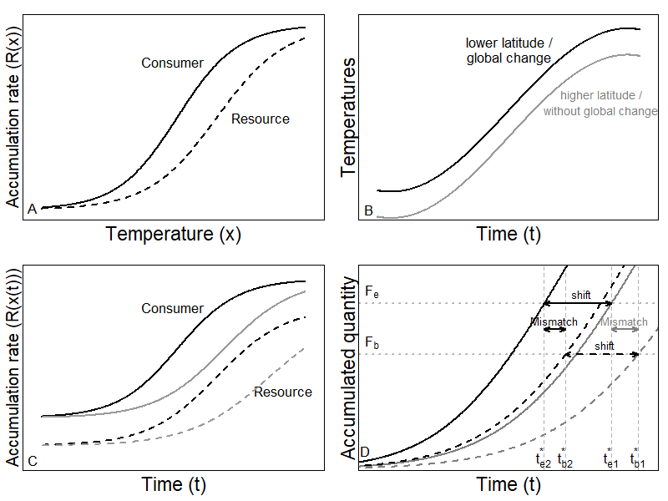

**Figure 1**: Illustration of theoretical development. (A) The rate accumulation function for two different species (solid line is consumer and dashed line is resource). (B) Two simplified temperature time series (black line is warmer and grey line is cooler). (C) Four combinations of rate accumulation; each species with two different temperature time series. (D) The resulting end of the resting phase for the consumer in cooler (grey solid line) and warmer (black solid line) temperatures and for the resource in cooler temperatures (black dashed line). The difference within species (grey vs. black line) indicates the shift in emergence in space (due to latitude or altitude) or time (due to global change). The difference between species (solid vs. dashed line) indicates the mismatch in the end of the seasonal resting phase for a fixed temperature regime (same location and same time). Accumulation functions for both the consumer and the resource use Eq. 2 with the following parameter values: *bc* = -1.32, *cc* = 7.14, *br* = -1.16, *cr* = 8.14.

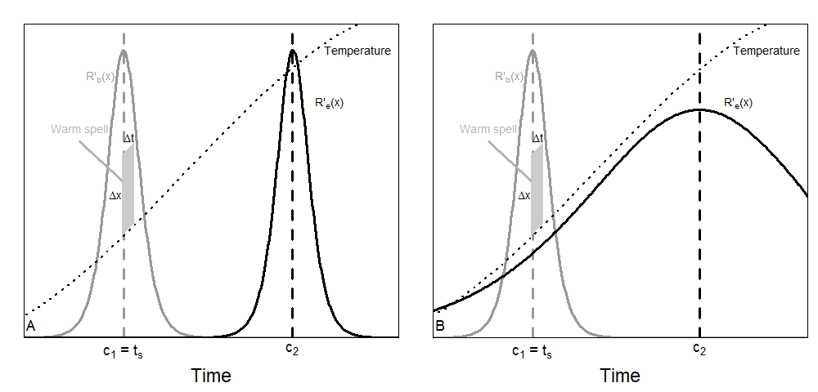

**Figure 2**: Sensitivity of resource accumulation functions, *R’(x(t))*, for two species when there is no (A) or some (B) overlap. In (A), the warm spell indicated will advance the phenology of species 1 (grey curve) but not alter that of species 2 (black curve). In (B), the same warm spell will advance both phenologies. For this illustration, we used the accumulation function in Eq 2 for species 1 with parameter values for balsam fir (see section 3.4.1). We used the same function for species 2 in (A), but with *c* = 15.2. In (B), we used the accumulation function for spruce budworm in Eq. 8 with corresponding parameter values (see section 3.2.1). The temperature is chosen according to Eq. 5 (from January to June).

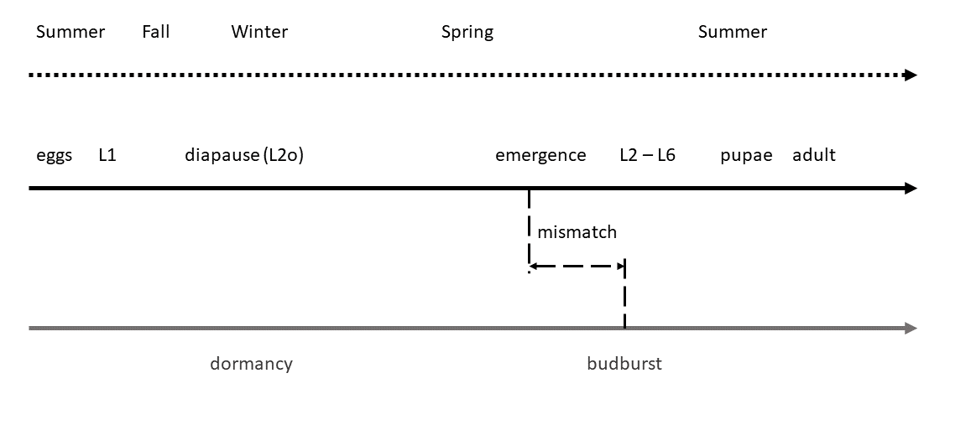

**Figure 3**: life cycles of balsam fir and spruce budworm. Black line represents SBW life cycle, and grey line is balsam fir life cycle.

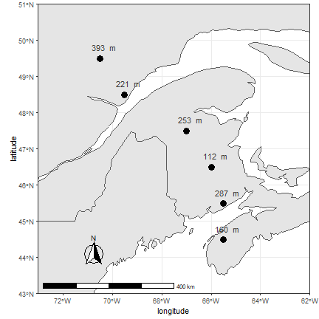

**Figure 4**: Location of the sample sites where temperature data were collected for past and future trends. Points are located across a gradient of latitude in Nova-Scotia, New Brunswick, and Quebec. Altitude is indicated above each point.

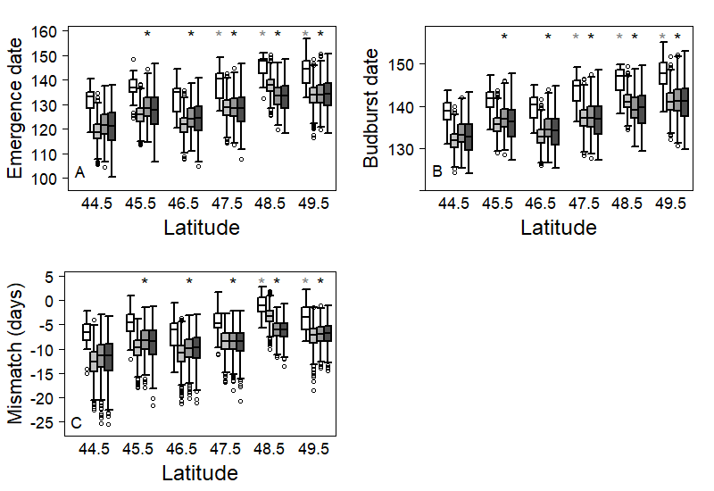

**Figure 5**: Latitudinal distribution of (A) median emergence date of SBW (Julian days), (B) median budburst date, and (C) mismatch between emergence and budburst date. For each latitude, the white box (left one) represents the 1996-2016 period. Grey boxes represent expected outcomes according to RCP 2.6 (light grey), RCP 4.5 (dark grey), and RCP 8.5 (black) scenarios over 2021 to 2100.  A black (grey) star means that the corresponding site shows a significant difference with the most southern site for present (future) predicted trait. Both emergence and budburst are expected to occur later at higher latitudes. Overall warming scenarios, both events are expected to occur earlier in the year. Nowadays, emergence is expected to occur 5 to 10 days before budburst at low latitudes, while at higher latitudes, emergence may sometimes occur before budburst and sometimes after.  For all warming scenarios, an increase in mismatch is expected. At low latitudes, emergence may occur too early some years, which may lead to low survival of SBW. At higher latitudes, emergence is expected to systematically occur a few days before budburst, which would increase survival of SBW.