**Title: A temperature-driven model of phenological mismatch provides insights into the potential impacts of climate change on consumer-resource interactions**

**Authors**: Portalier S.M.J.1, Candau J.N.2, Lutscher F.1,3

**Institutions**:

1: Department of Mathematics and Statistics, University of Ottawa, Ottawa, ON, Canada

2: Natural Resources Canada, Canadian Forest Service, Great Lakes Forestry Centre, Sault Ste. Marie, ON, Canada

3:Department of Biology, University of Ottawa, Ottawa, ON, Canada

**Corresponding author**: Portalier S.M.J.

##### **Address**: Department of Mathematics and Statistics, STEM Complex, 150 Louis Pasteur Pvt, Ottawa, ON, K1N 6N5, Canada

##### **Email**: [sportali@uottawa.ca](mailto:sportali@uottawa.ca)

##### Word count: 5573 words

Introduction: 1043 words

The general model: 1643 words 1327 words

The case study: 1346 words

Discussion: 1538 words (214 additional words can be removed, see my comments)

**Abstract**

1. Anthropogenic climate change is increasingly affecting species phenology. Because trophic interactions often occur at specific phenological stages, changes in one species' phenology may affect others through phenological mismatch. In the case of a consumer and a resource that both exhibit a seasonal resting period, the synchrony of the end of their respective resting period is fundamental for the persistence of their interaction. Since the consumer and its resource may react differently to a change in temperature regime, the synchrony between them will likely be altered.
2. The goal of this study is to investigate the potential effects of climate change of species synchrony.
3. We propose a general theoretical model that determines the duration of the resting period according to temperature, and its effects on the mismatch between phenological stages of two interacting species. We illustrate our approach using the spruce budworm – balsam fir system in eastern Canada.
4. We found that an increase in temperature would usually advance the end of the resting period. However, the effects of a warm or cold spell during the resting period would strongly vary according to the time and the duration of the spell. Depending on the way each species reacts to the same temperature shift, the mismatch between the consumer and its resource may increase or decrease. The spruce budworm – balsam fir model predicts that an increase in temperature may increase the mismatch between the insect and the tree in southern sites, but may increase the synchrony in northern sites.
5. This type of modelling approach is of prime importance to investigate potential effects of climate change on consumer – resource systems.

**Keywords:**

Balsam fir, consumer, climate change, phenology, resource, spruce budworm

**1. Introduction**

Anthropogenic climate change has increasingly disrupted ecological interactions for the past century (Pachauri et al., 2014). This trend is expected to continue and amplify as interacting species are likely to respond differently to similar environmental changes and selective pressures (Parmesan, 2006). Trophic interactions between consumers and resources, which are fundamental to the functioning of ecosystems, may be affected by climate change through: (1) direct changes in life history traits (e.g., fecundity, mortality) of consumer and/or resource (Bale et al., 2002), (2) changes in abundance of consumer and/or resource due to cascading effects from other trophic levels (e.g., changes in the consumer’s predators) (Both, et al., 2009), and (3) differential shifts in the phenology of consumer and/or resource leading to phenological mismatch (Kharouba et al., 2018).

The concept of phenological mismatch has evolved since its inception in the early 1990s and is still debated today (e.g., Singer & Parmesan, 2020’s response to Kharouba & Wolkovich, 2020). In its stricter, original form, it states that the recruitment of a consumer is highest if the most energy expensive part of its life cycle is in synchrony with the peak availability of its resource (Cushing, 1990). The concept was later extended to the case where the phenologies of consumer and resource varied (Visser & Holleman, 2001), but still assumed that maximum fitness of the consumer is achieved at phenological synchrony. However, recent observations suggest that, in some systems, phenological mismatch is the historical baseline (Singer & Parmesan, 2010). Historical mismatch can result from trade-offs between fecundity and mortality (Singer & Parmesan, 2010), mutualistic interactions (Forrest & Thomson, 2012) or intraspecific competition (Iwasa et al., 1983). Relaxing the assumption of baseline synchrony complicates predictions of potential climate change impacts. Indeed, if synchrony is the baseline, any differential change will be detrimental to the consumer’s fitness. If the baseline is a mismatch, a change that decreases asynchrony will likely be beneficial to the consumer (but see Régnière & Nealis, 2018) while the opposite might exacerbate the detrimental effect of asynchrony to the point of extinction of the consumer (Singer & Parmesan, 2010).

Many organisms have advanced their phenology in recent decades (Post et al., 2001; Parmesan & Yohe, 2003), particularly the timing of spring events at mid-high latitudes (Parmesan, 2006; Cohen et al., 2018). In a meta-analysis of 27 pairs of interacting species, Kharouba et al. (2018) found that phenology advanced by an average of 4 days/decade across species since the early 1980s. Interacting species have advanced their phenology by similar magnitudes, resulting in relatively small (6.1 days/decade) but significant increases in mismatch. The observed mismatch had no consistent direction as 31 interactions shifted closer while 23 shifted further apart. The clearest examples of climate-driven mismatch have been reported for insect herbivores at high altitudes or latitudes (Renner & Zohner, 2018), where many organisms rely on a seasonal resting period because temperatures affecting physiological processes tend to be below species optima for most of the year. After a seasonal arrest in development that can last for several months, synchrony between the emergence of phytophagous insects from diapause and the end of their host plants dormancy, is critical to the consumer’s fitness (Van Asch & Visser, 2007). Spring defoliators have evolved to exploit foliage at its annual optimal nutritional qualities, i.e., high concentration in nutrient and water and low concentrations in fibre and secondary metabolites (Mattson & Scriber, 1987). This strategy requires a precise phenological match between the consumer and its resource because the quality of foliage declines quickly with foliar expansion. If the consumer emerges too early, it may encounter a long initial period with no food or poor food quality. If it emerges too late, the speed at which the nutritional quality of the foliage degrades may outpace the consumer’s capacity to adjust physiologically, thus negatively impacting its fitness.

The seasonal resting phase of many organisms is divided into two successive stages called endodormancy and ecodormancy in perennial woody plants, and diapause and quiescence in insects (Chuine & Régnière, 2017). Development and metabolism are generally inhibited by internal factors (e.g., depletion of energy reserves, hormones) in the first stage and by external factors (e.g., temperature, photoperiod) in the second. In our study system, the consumer and its resource show a seasonal resting period during part of the year (e.g., during winter). For both, we assume that the first stage is accomplished early in the winter before the return of favourable conditions, a common case in temperate and colder climates, and that temperature is the main driver that triggers the end of the second stage and therefore the resting period. We will refer to the second stage of the seasonal resting period simply as the “resting period”.

Science is currently unable to predict the direction or the magnitude of phenological mismatch between consumer and resource induced by climate change and the associated risks that it poses to species (Samplonius et al., 2021). While patterns of change in phenological synchrony are observed at an increasing rate because of climate change (Kharouba et al. 2018), they have been difficult to explain mechanistically. Different mechanisms can lead to a phenological mismatch between a consumer and its resource. Different species can respond to different climatic factors or to the same factor but in a different way. Species can also face different constraints in phenological plasticity (Both & Visser, 2001) or have different costs associated with phenological response (Gienapp & Visser, 2006).

The aim of this study is to investigate potential effects of climate change on the phenological synchrony between a consumer and its resource when both species respond to the same climatic factor (i.e., temperature). The interaction occurs at the end of both species’ resting periods, which is often the case for insect herbivores in mid-high latitudes. We begin with the general theoretical aspects that determine the duration of the resting period according to temperature, and their effects on synchrony / mismatch between phenological stages of the two species. Then we use a major insect pest of the Canadian boreal forest, the spruce budworm (SBW), and its main host, balsam fir, as a case study. We investigate the phenological synchrony between budworm’s emergence from winter diapause and balsam fir’s budburst across a gradient of latitudes and a number of different future climates.

# 2. The general model

We first present a unified description of the mechanisms that determine the duration of the resting period of a speciesin terms of accumulation of ambient temperature. Then, we develop the main theoretical results for a single and two interacting species.

Throughout the resting period, organisms accumulate units of some quantity at some instantaneous rate that depends on ambient temperature. The resting period ends when a certain level of the quantity has accumulated. For example, trees accumulate heat (Colombo, 1998;Chuine, 2000; Desbiens, 2007). Many resting insectshave temperature-dependent development rates, so that physiological stage ultimately also measures accumulated heat (Cobbold & Powell, 2011; Régnière, et al., 2012). The concept of accumulating some quantity before progressing to a different stage dates back to models for age- or stage-structured populations (Gurney et al 1983, Nisbet and Gurney, 1983) and is “still the most important assumption in plant and animal phenology modelling” (Chuine & Régnière, 2017).

We denote time by *t* in days and temperature by *x = x(t)* in degrees Celsius. The instantaneous rate of accumulation is some nonnegative, increasing function of temperature, denoted by *R = R(x)*. While developmental rates may decrease when temperatures exceed an upper threshold (Amarasekare & Coutinho, 2014), such temperatures do not generally arise during the winter resting period in mid-high latitudes. The resting period begins at time *t0* and ends at time *t\** when the accumulated quantity reaches the threshold level *F*. The fundamental equation that connects all these quantities and determines the end of the resting period is

|  |  |  |
| --- | --- | --- |
|  | $$\int_{t_{0}}^{t^{*}}{R\left(x\left(t\right)\right)dt}=F.$$ | Eq. 1 |

This equation is equivalent to the stage-duration condition in Nisbet & Gurney (1983).

A typical example for the accumulation rate function is

|  |  |  |
| --- | --- | --- |
|  | $R\left(x\right)=\frac{1}{1+exp⁡\left(b\left(x-c\right)\right)}$, | Eq. 2 |

with parameters *b < 0* and *c* (Chuine, 2000; Rebaudo & Rabhi, 2018); see Fig. 1A. Temperature patterns during the resting period differ between locations and change due to climate change (Fig. 1B). Different species, such as a consumer and its resource, maybe affected differently (Fig. 1C). Consequently, the end times of their respective resting period may shift differently (Fig. 1D). When temperatures increase, accumulation occurs faster and the phenology advances, i.e., the end time is earlier (Fig. 1D).

In view of our intended application, we also refer to the consumer as the insect and to the resource as the tree. We denote the corresponding end times by *te\** (emergence time) for the consumer (insect) and by *tb\** (budburst time) for the resource (its host tree). We call the difference in end times the *mismatch* between the two species (i.e., *mismatch = te*-tb\**). When the end times of the resting period of two species respond differently to climate change, then the mismatch between the two species will change. This is the fundamental quantity that we study here (Fig. 1D).

Model equation (Eq. 1) can in general not be solved explicitly for the end time, *t\**.. Instead, we derive a general approximation formula for how *t\** changes when future temperature time series (*x2(t)*) deviate from historical expectation (*x1(t)*) by a small amount (see Supplementary Material). We use this formula to evaluate and discuss the impact of climate change on the phenology of a single species and the phenological mismatch between two species in two particular cases: a constant temperature difference throughout the resting period or a warm or cold spell during a short time period. Our results here apply to any general rate accumulation function.

### **Phenology shift of a single species**

When temperatures differ by a constant ($∆x$), we write $x_{2}\left(t\right)=x_{1}\left(t\right)+∆x$. Then the corresponding end times *t2\** and *t1\** are related by

|  |  |  |
| --- | --- | --- |
|  | $$t_{2}^{*}=t_{1}^{*}-\frac{∆x}{R\left(x_{1}\left(t_{1}^{*}\right)\right)}\int_{t_{0}}^{t_{1}^{*}}{R^{'}\left(x_{1}\left(t\right)\right)dt}.$$ | Eq. 3 |

When temperatures differ by warm or cold spell of short duration $∆t$ at time *ts* of temperature difference $∆x$ (positive for a warm spell, negative for a cold spell), then the corresponding ends of the seasonal resting phases are related by

|  |  |  |
| --- | --- | --- |
|  | $$t_{2}^{*}=t_{1}^{*}-∆x∆t\frac{R^{'}\left(x_{1}\left(t_{s}\right)\right)}{R\left(x_{1}\left(t_{1}^{*}\right)\right)}.$$ | Eq. 4 |

These linear approximations capture the actual end of the resting period very well (see supplementary Fig. S1).

Both formulas show the expected qualitative pattern that if time series *x2* is warmer than *x1*, i.e., , then the phenology advances, i.e., end of the seasonal resting period *t2\** is before the corresponding *t1\** (since all the terms after the “ $-$” sign are positive).The formulas allow us to quantify the expected shift of the end time of the resting period. The shift depends on the *derivative* of the rate accumulation function. The impact of a short temperature spell is proportional to the derivative, *R'(x(ts))*, at the time of the spell (*ts*). Hence, the phenology is most sensitive to warm or cold spells where $R\left(∙\right)$ is at its maximal slope. For the rate function in Eq. 2, this occurs at temperature *x=c*.

### **Effects on the mismatch between two species**

When heat accumulation occurs independently in each species, the mismatch between the two changes if they respond differently to changes in temperature. The mismatch increases if the phenology of the earlier emerging species advances more quickly and decreases if it advances more slowly. For example, assume that the resource emerges before the consumer and is more sensitive at lower temperatures. Then, if temperatures are higher than historical averages early in the season, the phenology of the resource is likely to advance more than that of the consumer, so that the mismatch increases. Vice versa, if temperatures exceed historical averages only late in the season, when the consumer is more sensitive, the phenology of the consumer is expected to advance more and the mismatch decreases. Hence, a change in mismatch is most likely if the two species are most sensitive at different temperatures, i.e., when the maximal slopes of their respective rate accumulation functions occur at very different temperatures.



We use Eq. 3 and 4 to quantify the changes in mismatch for our two scenarios. When future temperatures differ from historical expectation by a constant ($∆x$), we apply Eq. 3 to each species (*Re* is for the insect, and *Rb* is for the tree) and find

|  |  |  |
| --- | --- | --- |
|  | $$\underset{mismatch2}{\underbrace{t_{e,2}^{*}-t_{b,2}^{*}}}=\underset{mismatch1}{\underbrace{t_{e,1}^{*}-t_{b,1}^{*}}}-∆x\left(\frac{\int_{t_{0}}^{t^{*}}{R_{e}^{'}\left(x_{1}\left(t\right)\right)dt}}{R_{e}\left(x_{1}\left(t_{e,1}^{*}\right)\right)}-\frac{\int_{t_{0}}^{t^{*}}{R_{b}^{'}\left(x_{1}\left(t\right)\right)dt}}{R_{b}\left(x_{1}\left(t_{b,1}^{*}\right)\right)}\right).$$ | Eq. 6 |

When future time series differ from historical expectation by a short spell of duration $∆t$ and temperature difference $∆x$, we apply the corresponding formula (Eq. 4) to each species and find

|  |  |  |
| --- | --- | --- |
|  | $$\underset{mismatch2}{\underbrace{t_{e,2}^{*}-t_{b,2}^{*}}}=\underset{mismatch1}{\underbrace{t_{e,1}^{*}-t_{b,1}^{*}}}-∆x∆t\left(\frac{R_{e}^{'}\left(x_{1}\left(t_{s}\right)\right)}{R_{e}\left(x_{1}\left(t_{e,1}^{*}\right)\right)}-\frac{R_{b}^{'}\left(x_{1}\left(t_{s}\right)\right)}{R_{b}\left(x_{1}\left(t_{b,1}^{*}\right)\right)}\right).$$ | Eq. 7 |

When the sensitivities of the two species are relatively narrow and non-overlapping peaks, the phenology of one species will advance noticeably only when the spell occurs near its peak temperature. The other species is not affected (Fig. 2A). In reality, the periods of high sensitivity of the two species may overlap more or less. In that case, the change in mismatch is not as easy to predict. If the sensitivity of one species (e.g., the consumer) is much broader than that of the other (the resource), then the phenology of the former will advance noticeably no matter when a warm spell occurs, whereas the phenology of the latter will advance noticeably only when it occurs near its sensitivity peak (Fig. 2B). In addition, the rate function at emergence (the denominators in Eq. 7) may differ between the two species. Consequently, even if the resource is more sensitive than the consumer at the time of the spell (), the difference in parentheses in Eq. 7 can still be negative if the denominator in the first term is much larger than in the second.



Despite their simplicity, these scenarios give us some important insights into the evolution of the mismatch. The advance of the phenology of each species is a nonlinear function of temperature increase and each species has a temperature regime during which its phenology is most sensitive to change, namely when the slope of the rate function is large. These insights are independent of the specific rate function. Further consequences of a change in mismatch of synchrony, in terms of survival, reproduction, or any life history trait, are system-specific. In the following section, we apply the model using realistic temperature time series in order to make predictions for a specific case study, at a given place and time.

## **3. A case study: the spruce budworm – balsam fir system**

We describe the spruce budworm – balsam fir system and provide the accumulation function for both species. Then, we list our data sources and explain the fitting methods for the spruce budworm - balsam fir system. Finally, we give the results for this case study. We use R (R core team, 2020) to implement the model, analyze the results, and generate the figures. Past and future temperature data were obtained using BioSIM ((Régnière, et al., 2014).

### **3.1 Study system**

The spruce budworm (SBW) (*Choristoneura fumiferana*) is the most destructive defoliator of North American boreal forests (Fleming, 2000). It feeds primarily on balsam fir (*Abies balsamea*), black spruce (*Picea mariana),* white spruce (*Picea glauca)*, and red spruce (*Picea rubens)*. This univoltine insect has an 8-9 months winter resting period (diapause).  The first stage ends in late winter and is followed by a quiescent period during which development resumes at a rate dependent on outside temperatures. Diapause ends when second instar larvae emerge from their hibernacula (cocoon-like structure) in late April to late May. Larvae feed on expanding buds and developing needles as soon as they become available. Expanding needles from swelling buds are nutrient rich with a maximum concentration of nitrogen and mineral elements (Mattson & Scriber, 1987). Hence, the success of SBW populations in establishing feeding sites in the spring depends on the synchrony of their development with that of their host trees (Régnière & Nealis, 2008). Consequences for late-emerging SBW are severe: larval survival is depressed (from about 60% normal survival down to 10%), development is delayed, and average pupal mass decreases by about 50% (Lawrence et al., 1997). In the boreal forests of eastern Canada, the higher vulnerability of balsam fir to SBW defoliation compared to other host species has been attributed to its early budburst (Blais, 1957). The emergence of SBW generally precedes balsam fir budburst by several days. Balsam fir phenology appears to be related to forcing temperatures but not photoperiod (Osawa et al., 1983).

We assessed historical patterns and climate change predictions of synchrony between SBW’s emergence from diapause and balsam fir’s budburst using an existing model of budworm phenology and a general budburst model fitted to observations of budburst phenology in Canada. Each species has its own accumulation function which we used to illustrate the general theoretical case (see section 2.2.2 and Fig. 2).

**3.2 Phenological models**

### **3.2.1 Phenological model of spruce budworm’s spring emergence**

The first stage of SBW diapause is assumed to end in late winter, but the physiological processes and environmental factors that control this are still unknown (Bean, 1961). For the heat accumulation rate of the overwintering stage (L2o) of SBW, we use a well-establish model (Régnière, et al., 2012)

|  |  |  |
| --- | --- | --- |
|  | $$R\left(x\left(t\right)\right)=\left\{\begin{aligned}β_{1}\left[\frac{1}{1+exp⁡\left(β_{2}-β_{3}^{τ}\right)}-exp⁡({\left(τ-1\right)}/{β_{4})}\right],ifx_{b}≤x\left(t\right)≤x_{m} \\ 0,otherwise\end{aligned}\right.$$ | Eq. 8 |

where

|  |  |  |
| --- | --- | --- |
|  | $$τ=\frac{x\left(t\right)-x_{b}}{x_{m}-x_{b}}$$ | Eq. 9 |

Accumulation occurs only when the temperature lies between a minimal (*xb*) and a maximal value (*xm*). Parameter values for SBW, estimated by Régnière et al. (2012) from laboratory experiments, are $β_{1}=0.194$, $β_{2}=3.0$ , $β_{3}=5.94$, $β_{4}=0.034$, *xb* = 2.5 °C, *xm* = 35 °C and *F=1*. The accumulation rate function is increasing for temperatures up to 31°C, which is well above the temperatures observed during the quiescent stage.

### **3.2.2 Phenological model of balsam fir’s budburst**

Process-based tree phenology models describe the individual or interactive effects of environmental conditions (e.g., temperature or photoperiod) on bud development (Chuine & Régnière, 2017). We use the *Uniforc* model of Chuine (2000) to model balsam fir’s budburst phenology. *Uniforc* predicts bud development as a function of temperature in the second stage of seasonal resting (i.e., ecodormancy) that. starts some time after January 1st (Desbiens, 2007), when trees have accumulated enough cold to end bud dormancy. The heat accumulation rate is the same as in the theoretical example (Eq. 2). Budburst occurs when accumulation reaches a threshold *F\**. We fitted the model to budburst phenology data (see Supplementary materials), which resulted in the parameter values: *b* = -1.32, *c* = 7.14 °C, *t0* = 87 (March 28th), and *F\** = 18.6.

## **3.3 Historical and future temperature regimes in eastern Canada**

We selected six locations on a latitudinal gradient across eastern Canada (Fig. 4) to explore the effects of historical and future temperature regimes on the synchrony between SBW and balsam fir phenology. The temperature data for these locations were calculated using BioSIM (Régnière, et al., 2014). BioSIM interpolates weather station historical data and climate change scenarios across North America. We used data from 1996 to 2016 to explore latitudinal trends of past insect emergence, tree budburst and their mismatch across years.

We used predicted temperatures under different warming scenarios to reveal expected trends for emergence, budburst and mismatch. We selected three different scenarios, known as RCP2.6 (moderate warming), RCP4.5 (intermediate) and RCP8.5 (strong) (van Vuuren et al., 2011). For each scenario, we generated 150 stochastic temperature time series per decade over the 2021-2100 period for each site using BioSIM.

Both models used temperature data with a four-hour time interval, which allows for the capture of warm events within a day.

## **3.4. Mismatch in the spruce budworm - balsam fir system**



### **3.4.2 Spruce budworm – balsam fir system across latitude**

The model predicts median dates of emergence and budburst for each year. Results for past and future data were analyzed using a one-way analysis of variance (see supplementary material for full results). Both emergence (Fig. 6A) and budburst (Fig. 6B) occur later at higher latitudes: *p* < 0.05 between sites 1, 2, 3 (South) and 4, 5, 6 (North), although some discrepancies may occur due to altitude (sites 2 and 4). However, insects and trees are not affected by temperatures in the same way. Hence, the mismatch between both species varies across latitude (*p* < 0.05 between sites 1, 3 and 5, 6) (Fig. 6C). At lower latitudes, emergence is expected to occur 5 to 10 days before budburst. Hence, the majority of the larval population may have time to emerge before budburst occurs, which allows larvae to benefit from an important source of nutrients. Fuentealba, et al. (2017) evaluated SBW performance on balsam fir according to their phenological mismatch. According to their study, we can infer SBW survival to be around 45% and reproductive output (fecundity * survival) to be 45%. At higher latitudes, emergence may sometimes occur before budburst and sometimes after, which would lead to 30% survival and 20% reproductive output.

### **3.4.3 Predicted trends according to warming scenarios**

Across all scenarios, emergence and budburst are expected to occur earlier when temperatures increase. The differences in emergence, budburst and mismatch across latitude is highly significant (*p* < 10-16 for almost all sites and for all scenarios). Warmer scenarios lead to an increase of variance, more than a real shift in date compared to less warm scenarios. Insects and trees react differently to temperature increase. Balsam fir shows an historical (1996-2016) difference between northern and southern sites of 10 days on average. This difference stays approximately the same in case of warmer temperatures (i.e., budburst date is shifted similarly across latitude, see Fig. 6B). By contrast, emergence of SBW is expected to shift differently across latitude (about 15 days difference compared to 10 historically, see Fig. 6A).

    Therefore, the mismatch is affected. Southern sites are expected to show emergence occurring before budburst most of the time. In case of a moderate warming scenario (RCP2.6), the waiting time is expected to be short, which would allow the larvae to have access to a rich source of nutrients. Thus, a moderate warming could be beneficial for the insect at low latitudes. In case of greater warming (RCP4.5, RCP8.5), variance may lead to emergence occurring too early some years, leading to larvae dying from starvation. Thus, a greater temperature increase may lead to stronger population variances among years.

    In northern sites, all warming scenarios lead to an increased synchrony between the insect and its host. The overall pattern appears similar to what is currently expected in southern sites. However, the variance is expected to be greater with warmer scenarios, which may increase insect mortality from time to time, when emergence occurs too late.

# 4. Discussion

We propose a temperature-driven mechanistic model to determine the end of the seasonal resting period of species. We investigate the effects of temperature on species phenology, and its consequences on consumer-resource synchrony, across latitude and under future climate scenarios.

## **4.1 Expected impacts of climate change on phenological mismatch between consumer and resource**

A growing body of literature shows phenological shifts of species due to climate change with different species shifting at different rates (Visser & Both, 2005; Donnelly et al., 2011; Kharouba et al., 2018). By linking development with temperature, our modelling approach predicts the expected phenological shift under various future climate scenarios for a species whose resting period is determined by temperature. More specifically, the change in phenology is determined by the interaction of the new temperature pattern and the slope of the rate accumulation function (*R’*); see Eq. 8 and Supplementary Material. Consecutive spells will have additive effects: several warm spells will advance phenology several times, while a cold spell may cancel effects of a warm spell.

For a consumer to efficiently exploit a resource, some form of temporal synchrony is often required. Observations of consumer-resource systems show that, as an effect of climate change, their degree of synchrony can increase or decrease, but the mechanisms behind this difference are unclear (Kharouba et al., 2018). We focused on the duration of the seasonal resting period, which constitutes a significant stage in many species’ life cycle. As different species react differently to temperature changes, we applied our model to each species separately to predict whether their degree of synchrony will increase or decrease as temperature patterns change.

A phenological shift of the consumer and its resource may affect their population dynamics and subsequently the larger food web in which they are embedded. For example, an increase of the phenological mismatch may limit the consumer’s food intake, which affects its biomass, its life cycle, and potentially even its ability to persist in the considered geographic zone (Simmonds et al., 2020). If a subsidiary resource is available, the consumer may switch resources (Stålhandske et al., 2016). A decrease of the phenological mismatch may lead to a stronger depletion of the resource. Both of these outcomes may cause ripple effects through the food web. Thus, a shift in relative phenology between the consumer and its resource can affect species demography in many ways (Miller-Rushing et al., 2010), as well as their geographic distribution. Our work, which is based on heat accumulation, improves our ability to predict the direction and the magnitude of the change in phenological synchrony, a research challenge identified by earlier studies (Kharouba et al. 2018).

## **4.2 The spruce budworm - balsam fir system and its general implications**

We apply our general theory to predict the future mismatch between spruce budworm and balsam fir across latitude under different warming scenarios. According to the general theory, a warm spell occurring at any time during the heat accumulation period is likely to affect the insect more than the tree (see Fig. 2B, and section 2.2.2) because of the insect’s wider sensitivity period. Therefore, under several warm spells, the insect will advance its phenology more than the tree. Simulations with realistic temperature time series (showing several warm spells) confirm the theoretical results. Under an increase of temperatures, insect phenology would advance by 15 days on average, while the tree phenology would advance by 7 days on average. The expected overall mismatch increases by approximately 7 days on average (see Fig. 6 and section 3.4.2).

Budworms have to emerge within two weeks of budburst to have access to a rich source of nutrients. A shift in phenology increasing the likelihood of this pattern would in turn increase larval survival and population persistence in previously non-favourable regions. Under historical temperature regimes, budworm emergence date in northern sites is close to budburst date, which causes the budworm to emerge too late in some years, while emergence in southern sites occurs within 15 days before budburst. An increase of the mismatch benefits the insect in northern sites since it would emerge before budburst most of the time. A shift in phenology that leads to emergence occurring too early or too late would cause severe budworm mortality and prevent its persistence in some parts of its current distribution. Conversely, an increase in the persistence of the insect in other regions will increase damages to host trees.

Our model assumes that neither the consumer nor the resource affects the phenology of the other species. Only temperature drives phenology. Recent observations of interactions between defoliation and host phenology suggest that severe defoliation by budworm may advance budburst phenology (Deslauriers et al., 2019). According to our model, an increase in temperature should increase the mismatch by advancing the budworm phenology more than that of the tree. If defoliation leads to an advance in phenology for the tree, then the resulting mismatch would stay close to the historical mismatch, which would reduce the benefit of this physiological response for the tree.

## **4.3 Future extensions**

The present study provides novel insights towards a better understanding of the effects of an increase of temperatures on species phenology. Further studies may consider specific features that we do not include in the model. First, our study is limited to cases where the phenology is directly constrained by environmental variables (more specifically temperature). Organisms can also use temperature (or any other environmental variables) indirectly as cues for predicting an optimal time window to have access to resources or convenient environmental conditions (e.g., photoperiod, rainfall) (McNamara et al., 2011).

Second, we measure mismatch as the time lag between peaks of consumer demand and resource availability. Some authors have argued that more precise measurements should take into account the shape and location of the phenological distributions around these peaks (e.g., Lindén, 2018) while others showed that, in some cases, time lag between phenological peak dates was a better predictor of resource availability than the overlap between phenological distributions (Ramakers et al., 2020).

Third, a change in phenological synchrony will have an effect on the whole life cycle, which would be beyond the scope of the present study. Rising temperatures are likely to affect physiological processes at later life stages, by affecting metabolism for example (Brown, et al., 2004). It is also clear that a change in the mismatch is likely to affect the ecological and evolutionary dynamics of the consumer-resource system. These aspects provide avenue for further studies.

The theoretical framework presented here can be applied to other consumer-resource systems. The concrete example of the spruce budworm - balsam fir system informs the required methodology. To estimate the mismatch, the two rate accumulation functions must be calibrated accurately. It appears that the model is sensitive to the temporal resolution of the temperature time series. There are two timescales at which temperatures affect the outcome of the model. The first one occurs at the daily scale. Average daily temperatures lead to different results than a four-hour time interval for temperatures (used throughout the present study) since variations within a day may allow for development during a few hours, even when the average temperature over the whole day may not.

The second one occurs at a broader timescale (e.g., weekly). For the study system, temperature data modelled by BioSim (Régnière, et al., 2014) lead to realistic emergence and budburst dates when compared to real data (see section 3.2) and to a phenological mismatch, i.e., budworm usually emerging before budburst, similar to field observations (Pureswaran, et al., 2019). More simplistic distributions that do not contain any warm spell can lead to the opposite pattern (i.e., budburst occurs first). Realistic temperatures show warm periods during days with low average temperatures (i.e., late winter - early spring), which advance the insect phenology compared to simplified (cosine) distributions. The tree is less sensitive to these short warm events.

The modelling approach presented here allows for investigation of potential effects of climate change on consumer-resource systems. Synchrony / mismatch between a consumer and its resource is fundamental to predict future species distribution. Future studies may go further by including more complex mechanistic approaches (e.g., energy budget models) in order to model the whole life cycle of the consumer, which could lead to new insights on the dynamics of the systems. Our model could be linked to models that explore the consequences of phenological mismatch on the population dynamics of consumer – resource systems (e.g., Bewick et al., 2016).

# Acknowledgement

The authors thank Remi Saint-Amant for his helpful guidance to obtain temperature data from BioSIM, Dr. Jacques Régnière for sharing data on balsam fir phenology, and two anonymous reviewers. This study was funded by the Healthy Forest Partnership.

# Authors’ contribution

All authors conceptualized the study. FL and SP built the theoretical model. SP calibrated the tree model, gathered the temperature data, and performed the simulations. SP, JNC and FL analyzed the results, wrote and edited the manuscript.

# Data Availability

Code will be stored on Zenodo public depository. Data on balsam fir phenology can be made available on demand to Dr. J. Régnière (Natural Resources Canada).

# References

Amarasekare, P., & Coutinho, R. M. (2014). Effects of temperature on intraspecific competition in ectotherms. *The American Naturalist*, *184*(3), E50-65. doi: 10.1086/677386

Bale, J. S., Masters, G. J., Hodkinson, I. D., Awmack, C., Bezemer, T. M., Brown, V. K., Butterfield, J., Buse, A., Coulson, J. C., Farrar, J., Good, J. E. G., Harrington, R., Hartley, S., Jones, T. H., Lindroth, R. L., Press, M. C., Symrnioudis, I., Watt, A. D., & Whittaker, J. B. (2002). Herbivory in global climate change research: direct effects of rising temperature on insect herbivores. *Global Change Biology*, 8(1), 1–16. doi: 10.1046/j.1365-2486.2002.00451.x

Bean, J. L. (1961). Predicting emergence of second-instar spruce budworm larvae from hibernation under field conditions in minnesota. *Annals of the Entomological Society of America*, 54(2), 175–177. doi: 10.1093/aesa/54.2.175

Bewick, S., Cantrell, R. S., Cosner, C., & Fagan, W. F. (2016). How resource phenology affects consumer population dynamics. *The American Naturalist*, *187*(2), 151–166.

Blais, J. R. (1957). Some relationships of the spruce budworm, Choristoneura fumiferana (Clem.) to black spruce, Picea mariana (Moench) Voss. *The Forestry Chronicle*, *33*(4), 364–372. doi: 10.5558/tfc33364-4

Both, C., van Asch, M., Bijlsma, R. G., Van Den Burg, A. B., & Visser, M. E. (2009). Climate change and unequal phenological changes across four trophic levels: constraints or adaptations? *Journal of Animal Ecology*, *78*(1), 73–83. doi: 10.1111/j.1365-2656.2008.01458.x

Both, C., & Visser, M. E. (2001). Adjustment to climate change is constrained by arrival date in a long-distance migrant bird. *Nature*, *411*(6835), 296–298. doi: 10.1038/35077063

Brown, J. H., Gillooly, J. F., Allen, A. P., Savage, V. M., & West, G. B. (2004). Toward A Metabolic Theory Of Ecology. *Ecology*, *85*(7), 1771–1789. doi: 10.1890/03-9000

Chuine, I. (2000). A united model for budburst of trees. *Journal of Theoretical Biology*, *207*, 337–347. doi: 10.1006/jtbi.2000.2178

Chuine, I., & Régnière, J. (2017). Process-based models of phenology for plants and animals. *Annual Review of Ecology, Evolution, and Systematics*, *48*(1), 159–182. doi: 10.1146/annurev-ecolsys-110316-022706

Cobbold, C. A., & Powell, J. A. (2011). Evolution stabilises the synchronising dynamics of poikilotherm life cycles. *Bulletin of Mathematical Biology*, *73*(5), 1052–1081. doi: 10.1007/s11538-010-9552-1

Cohen, J. M., Lajeunesse, M. J., & Rohr, J. R. (2018). A global synthesis of animal phenological responses to climate change. *Nature Climate Change*, *8*(3), 224–228. doi: 10.1038/s41558-018-0067-3

Colombo, S. J. (1998). Climatic warming and its effect on bud burst and risk of frost damage to white spruce in Canada. *The Forestry Chronicle*, *74*(4), 567–577. doi: 10.5558/tfc74567-4

Cushing, D. H. (1990). Plankton production and year-class strength in fish populations: An update of the match/mismatch hypothesis. *Advances in Marine Biology*, *26*(C), 249–293. doi: 10.1016/S0065-2881(08)60202-3

Desbiens, M. (2007). *Relation phénologique entre le débourrement des bourgeons chez le sapin baumier et l’émergence des larves de deuxième stade de la tordeuse des bourgeons de l’épinette, Choristoneura fumiferana (Lepidoptera: Tortricidae).* ProQuest.

Deslauriers, A., Fournier, M.-P., Cartenì, F., & Mackay, J. (2019). Phenological shifts in conifer species stressed by spruce budworm defoliation. *Tree Physiology*, *39*(4), 590–605. doi: 10.1093/treephys/tpy135

Donnelly, A., Caffarra, A., & O’Neill, B. F. (2011). A review of climate-driven mismatches between interdependent phenophases in terrestrial and aquatic ecosystems. *International Journal of Biometeorology*, *55*(6), 805–817. doi: 10.1007/s00484-011-0426-5

Fleming, R. A. (2000). Climate change and insect disturbance regimes in Canada’s boreal forests. *World Resource Review*, *12*(3), 521–548.

Forrest, J., & Thomson, J. D. (2012). Pollinator experience, neophobia and the evolution of flowering time. *Proceedings of the Royal Society B: Biological Sciences*, *276*(1658), 935–943. doi: 10.1098/rspb.2008.1434

Fuentealba, A., Pureswaran, D., Bauce, É., & Despland, E. (2017). How does synchrony with host plant affect the performance of an outbreaking insect defoliator? *Oecologia*, *184*(4), 847–857. doi: 10.1007/S00442-017-3914-4

Gienapp, P., & Visser, M. E. (2006). Possible fitness consequences of experimentally advanced laying dates in Great Tits: differences between populations in different habitats. *Functional Ecology*, *20*(1), 180–185. doi: 10.1111/j.1365-2435.2006.01079.x

Harper, K., Boudreault, C., DeGrandpré, L., Drapeau, P., Gauthier, S., & Bergeron, Y. (2003). Structure, composition, and diversity of old-growth black spruce boreal forest of the Clay Belt region in Quebec and Ontario. *Environmental Reviews*, *11*(1 SUPPL.), 2003. doi: 10.1139/a03-013

Iwasa, Y., Odendaal, F. J., Murphy, D. D., Ehrlich, P. R., & Launer, A. E. (1983). Emergence patterns in male butterflies: A hypothesis and a test. *Theoretical Population Biology*, *23*(3), 363–379. doi: 10.1016/0040-5809(83)90024-2

Kharouba, H. M., Ehrlén, J., Gelman, A., Bolmgren, K., Allen, J. M., Travers, S. E., & Wolkovich, E. M. (2018). Global shifts in the phenological synchrony of species interactions over recent decades. *Proceedings of the National Academy of Sciences*, *115*(20), 5211–5216. doi: 10.1073/pnas.1714511115

Kharouba, H. M., & Wolkovich, E. M. (2020). Disconnects between ecological theory and data in phenological mismatch research. *Nature Climate Change*, *10*(5), 406–415. doi: 10.1038/s41558-020-0752-x

Lawrence, R. K., Mattson, W. J., & Haack, R. A. (1997). White spruce and the spruce budworm: Defining the phenological window of susceptibility. *Canadian Entomologist*, *129*(2), 291–318. doi: 10.4039/Ent129291-2

Lindén, A. (2018). Adaptive and nonadaptive changes in phenological synchrony. *Proceedings of the National Academy of Sciences of the United States of America*, *115*(20), 5057–5059. doi: 10.1073/pnas.1805698115

Mattson, W., & Scriber, M. (1987). Feeding ecology of insect folivores of woody plants: nitrogen, water, fiber, and mineral considerations. In F. Slansky & J. Rodriguez (Eds.), *The Nutritional Ecology of Insects, Mites, and Spiders* (pp. 105–146). John Wiley & Sons, New York.

McNamara, J. M., Barta, Z., Klaassen, M., & Bauer, S. (2011). Cues and the optimal timing of activities under environmental changes. *Ecology Letters*, *14*(12), 1183–1190. doi: 10.1111/j.1461-0248.2011.01686.x

Miller-Rushing, A. J., Høye, T. T., Inouye, D. W., & Post, E. (2010). The effects of phenological mismatches on demography. *Philosophical Transactions of the Royal Society B: Biological Sciences*, *365*(1555), 3177–3186. doi: 10.1098/rstb.2010.0148

Osawa, A., Shoemaker, C. A., & Stedinger, J. R. (1983). A stochastic model of balsam fir bud phenology utilizing maximum likelihood parameter estimation (Abies balsamea, Quebec). *Forest Science*, *29*(3), 478–490. doi: 10.1093/forestscience/29.3.478

Pachauri, R. K., Allen, M. R., Barros, V. R., Broome, J., Cramer, W., Christ, R., Church, J. A., Clarke, L., Dahe, Q., & Dasgupta, P. (2014). *Climate change 2014: synthesis report. Contribution of Working Groups I, II and III to the fifth assessment report of the Intergovernmental Panel on Climate Change*. Ipcc.

Parmesan, C. (2006). Ecological and evolutionary responses to recent climate change. *Annual Review of Ecology, Evolution, and Systematics*, *37*(1), 637–669. doi: 10.1146/annurev.ecolsys.37.091305.110100

Parmesan, C., & Yohe, G. (2003). A globally coherent fingerprint of climate change impacts across natural systems. *Nature*, *421*(6918), 37–42. doi: 10.1038/nature01286

Post, E., Forchhammer, M. C., Stenseth, N. C., & Callaghan, T. V. (2001). The timing of life-history events in a changing climate. *Proceedings of the Royal Society B: Biological Sciences*, *268*(1462), 15–23. doi: 10.1098/rspb.2000.1324

Pureswaran, D. S., De Grandpré, L., Paré, D., Taylor, A., Barrette, M., Morin, H., Régnière, J., Kneeshaw, D. D. (2015). Climate-induced changes in host tree–insect phenology may drive ecological state-shift in boreal forests. *Ecology*, 96(6), 1480–1491. doi: 10.1890/13-2366.1

Pureswaran, D. S., Neau, M., Marchand, M., De Grandpré, L., & Kneeshaw, D. (2019). Phenological synchrony between eastern spruce budworm and its host trees increases with warmer temperatures in the boreal forest. *Ecology and Evolution*, *9*(1), 576–586. doi: 10.1002/ece3.4779

Ramakers, J. J. C., Gienapp, P., & Visser, M. E. (2020). Comparing two measures of phenological synchrony in a predator–prey interaction: Simpler works better. *Journal of Animal Ecology*, *89*(3), 745–756. doi: 10.1111/1365-2656.13143

Rebaudo, F., & Rabhi, V.-B. (2018). Modeling temperature-dependent development rate and phenology in insects: review of major developments, challenges, and future directions. *Entomologia Experimentalis et Applicata*, *166*(8), 607–617. doi: 10.1111/eea.12693

Régnière, J., & Nealis, V. G. (2008). The fine-scale population dynamics of spruce budworm: survival of early instars related to forest condition. *Ecological Entomology*, *33*(3), 362–373. doi: 10.1111/j.1365-2311.2007.00977.x

Régnière, J., & Nealis, V. G. (2018). Two sides of a coin: host-plat synchrony fitness trade-offs in the population dynamics of the western spruce budworm. *Insect Science*, *25*, 117-126. doi: 10.1111/1744-7917.12407

Régnière, J., Saint-Amant, R., Béchard, A., & Moutaoufik, A. (2014). *BioSIM 10: User’s manual, A. Nat. Resour. Can., Can. For. Serv.* Laurentian Forestry Centre, Québec (Quebec). Inf. Rep. LAU-X-137E.

Régnière, J., St-Amant, R., & Duval, P. (2012). Predicting insect distributions under climate change from physiological responses: spruce budworm as an example. *Biological Invasions*, *14*(8), 1571–1586. doi: 10.1007/s10530-010-9918-1

Renner, S. S., & Zohner, C. M. (2018). Climate change and phenological mismatch in trophic interactions among plants, insects, and vertebrates. *Annual Review of Ecology, Evolution, and Systematics*, *49*(1), 165–182. doi: 10.1146/annurev-ecolsys-110617-062535

Samplonius, J. M., Atkinson, A., Hassall, C., Keogan, K., Thackeray, S. J., Assmann, J. J., Burgess, M. D., Johansson, J., Macphie, K. H., Pearce-Higgins, J. W., Simmonds, E. G., Varpe, Ø., Weir, J. C., Childs, D. Z., Cole, E. F., Daunt, F., Hart, T., Lewis, O. T., Pettorelli, N., Sheldon, B. C., & Phillimore, A. B. (2021). Strengthening the evidence base for temperature-mediated phenological asynchrony and its impacts. *Nature Ecology and Evolution*, 5(2), 155–164. doi: 10.1038/s41559-020-01357-0

Simmonds, E. G., Cole, E. F., Sheldon, B. C., & Coulson, T. (2020). Phenological asynchrony: a ticking time‐bomb for seemingly stable populations? *Ecology Letters*, *23*(12), 1766–1775. doi: 10.1111/ele.13603

Singer, M. C., & Parmesan, C. (2010). Phenological asynchrony between herbivorous insects and their hosts: Signal of climate change or pre-existing adaptive strategy? *Philosophical Transactions of the Royal Society B: Biological Sciences*, *365*(1555), 3161–3176. doi: 10.1098/rstb.2010.0144

Singer, M., & Parmesan, C. (2020). *Misunderstanding mismatch*. doi: 10.32942/osf.io/rxmct

Stålhandske, S., Olofsson, M., Gotthard, K., Ehrlén, J., Wiklund, C., & Leimar, O. (2016). Phenological matching rather than genetic variation in host preference underlies geographical variation in host plants used by orange tip butterflies. *Biological Journal of the Linnean Society*, *119*(4), 1060–1067. doi: 10.1111/bij.12838

Van Asch, M., & Visser, M. E. (2007). Phenology of forest caterpillars and their host trees: The importance of synchrony. *Annual Review of Entomology*, *52*, 37–55. doi: 10.1146/annurev.ento.52.110405.091418

van Vuuren, D. P., Edmonds, J., Kainuma, M., Riahi, K., Thomson, A., Hibbard, K., Hurtt, G. C., Kram, T., Krey, V., Lamarque, J. F., Masui, T., Meinshausen, M., Nakicenovic, N., Smith, S. J., Rose, S. K. (2011). The representative concentration pathways: an overview. *Climatic Change*, 109(1), 5–31. doi: 10.1007/s10584-011-0148-z

Visser, M. E., & Holleman, L. J. M. (2001). Warmer springs disrupt the synchrony of oak and winter moth phenology. *Proceedings of the Royal Society B: Biological Sciences*, *268*(1464), 289–294. doi: 10.1098/rspb.2000.1363

Visser, M. E., & Both, C. (2005). Shifts in phenology due to global climate change: the need for a yardstick. *Proceedings of the Royal Society B: Biological Sciences*, *272*(1581), 2561–2569. doi: 10.1098/rspb.2005.3356

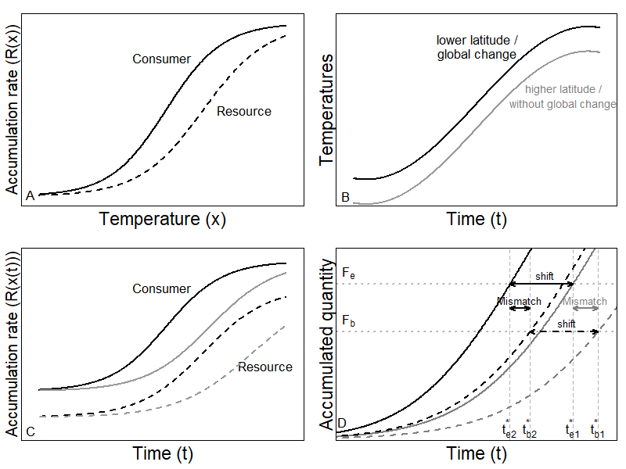

**Figure 1**: Illustration of theoretical development. (A) The rate accumulation function for two different species (solid line is consumer and dashed line is resource). (B) Two simplified temperature time series (black line is warmer and grey line is cooler). (C) Four combinations of rate accumulation; each species with two different temperature time series. (D) The resulting end of the resting phase for the consumer in cooler (grey solid line) and warmer (black solid line) temperatures and for the resource in cooler temperatures (black dashed line). The difference within species (grey vs. black line) indicates the shift in emergence in space (due to latitude or altitude) or time (due to global change). The difference between species (solid vs. dashed line) indicates the mismatch in the end of the seasonal resting phase for a fixed temperature regime (same location and same time). Accumulation functions for both the consumer and the resource use Eq. 2 with the following parameter values: *bc* = -1.32, *cc* = 7.14, *br* = -1.16, *cr* = 8.14.

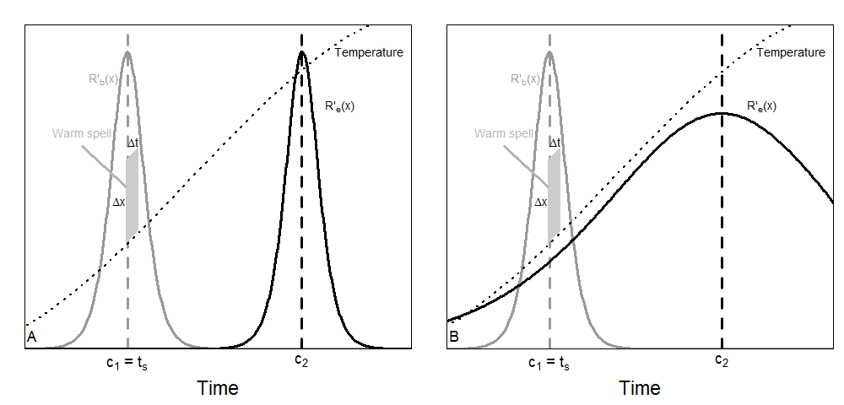

**Figure 2**: Sensitivity of resource accumulation functions, *R’(x(t))*, for two species when there is no (A) or some (B) overlap. In (A), the warm spell indicated will advance the phenology of species 1 (grey curve) but not alter that of species 2 (black curve). In (B), the same warm spell will advance both phenologies. For this illustration, we used the accumulation function in Eq 2 for species 1 with parameter values for balsam fir (see section 3.4.1). We used the same function for species 2 in (A), but with *c* = 15.2. In (B), we used the accumulation function for spruce budworm in Eq. 8 with corresponding parameter values (see section 3.2.1). The temperature is chosen according to Eq. 5 (from January to June).

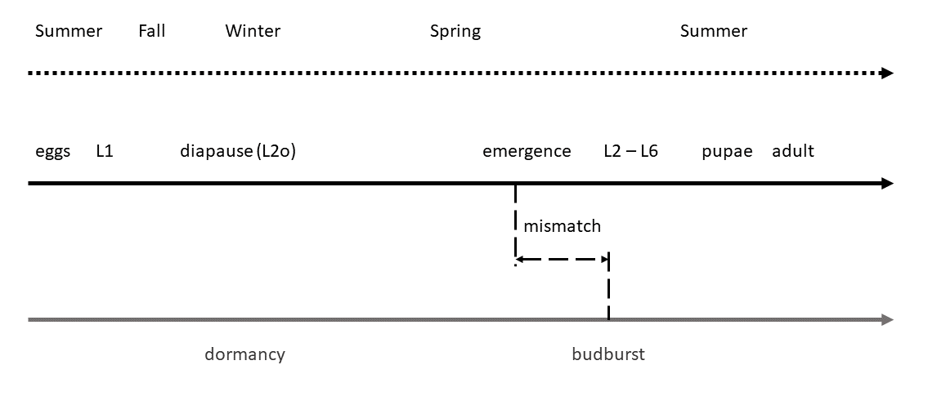

Figure 3: life cycles of balsam fir and spruce budworm. Black line represents SBW life cycle, and grey line is balsam fir life cycle.

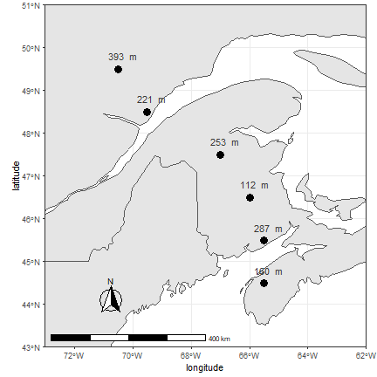

**Figure 4**: Location of the sample sites where temperature data were collected for past and future trends. Points are located across a gradient of latitude in Nova-Scotia, New Brunswick, and Quebec. Altitude is indicated above each point.



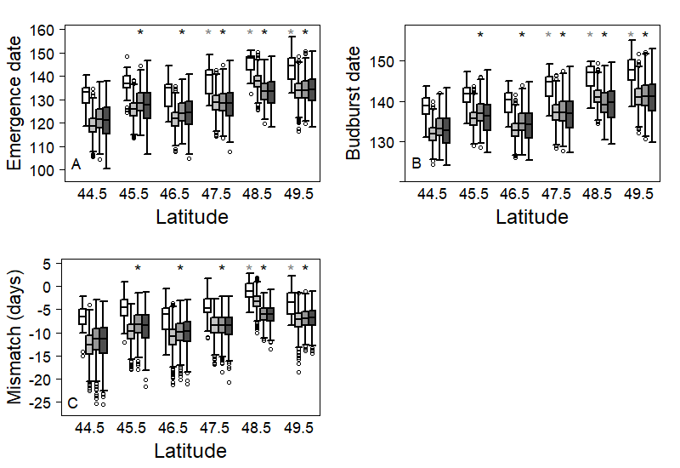

**Figure 5**: Latitudinal distribution of (A) median emergence date of SBW (Julian days), (B) median budburst date, and (C) mismatch between emergence and budburst date. For each latitude, the white box (left one) represents the 1996-2016 period. Grey boxes represent expected outcomes according to RCP 2.6 (light grey), RCP 4.5 (dark grey), and RCP 8.5 (black) scenarios over 2021 to 2100.  A black (grey) star means that the corresponding site shows a significant difference with the most southern site for present (future) predicted trait. Both emergence and budburst are expected to occur later at higher latitudes. Overall warming scenarios, both events are expected to occur earlier in the year. Nowadays, emergence is expected to occur 5 to 10 days before budburst at low latitudes, while at higher latitudes, emergence may sometimes occur before budburst and sometimes after.  For all warming scenarios, an increase in mismatch is expected. At low latitudes, emergence may occur too early some years, which may lead to low survival of SBW. At higher latitudes, emergence is expected to systematically occur a few days before budburst, which would increase survival of SBW.