**Abstract**

The ongoing anthropogenic climate change increasingly affect species phenology. Especially, the seasonal resting period, when organisms remain inactive during part of the year, is often driven by temperature. In the case of a consumer and a resource that both exhibit a seasonal resting period, the synchrony of the end of their respective resting period is fundamental for the persistence of their interaction. Since the consumer and its resource may react differently to a change in temperature regime, the synchrony between them will likely be altered. In this study, we propose a general theoretical model that determines the duration of the resting period according to temperature, and its effects on synchrony or mismatch between phenological stages of two interacting species. We then illustrate our approach using the spruce budworm – balsam fir system in Eastern Canada as a case study. We found that an increase in temperature would usually hasten the end of the resting period. However, the effects of a warm or cold spell during the resting period would strongly vary according to the time and the duration of spell. Depending on the way each species reacts to the same temperature shift, the mismatch between the consumer and its resource may increase or decrease. For the spruce budworm – balsam fir system, our model predicts that an increase in temperature may increase the mismatch between the insect and the tree in Southern cites, but may increase the synchrony in Northern cites. This kind of modelling approach is of primer importance to investigate potential effects of climate change on consumer – resource systems. The study of synchrony between interacting species is fundamental to predict future species distribution.

**1. Introduction**

* First paragraph: general statement. Many species show a dormant stage (e.g., dormancy, diapause, overwintering stage) that helps them to survive during harsh conditions (such as Winter temperatures). It has implications in a context of a consumer-resource system where both consumer and resource rely on environmental cues (i.e., temperature) to determine the end or the duration of this dormant stage. Hence, persistence of such a system depends on the synchrony between the consumer active stage and the resource availability. In a context of climate change, phenological responses of both consumer and resource to temperature should determine whether or not the system may persist.
* The system of interest: spruce budworm and Balsam fir specificities (life cycles)
* The crucial aspect of synchrony between emergence and budburst

(Both, Van Asch, Bijlsma, Van Den Burg, & Visser, 2009)

(Renner & Zohner, 2018)

(W. J.A. Volney & Cerezke, 1992)

(Régnière & Nealis, 2008)

(W. Jan A. Volney & Fleming, 2007)

(Régnière, St-Amant, & Duval, 2012)

(Régnière, Saint-Amant, Béchard, & Moutaoufik, 2014)

(Lawrence, Mattson, & Haack, 1997)

(Mattson & Scriber, 1987)

(Parmesan, 2006)

(Fleming, 2000)

(Cobbold & Powell, 2011)

(Miller-Rushing, Høye, Inouye, & Post, 2010)

(Chuine & Régnière, 2017)

(Régnière, 1990)

(Amarasekare & Coutinho, 2014)

(Deutsch et al., 2008)

This study focuses on systems where both a consumer and its resource show a seasonal resting period during part of the year (e.g., during Winter), and where temperature is the main driver that triggers the end of this resting period. The aim of this study is to investigate potential effects of global warming on the phenological synchrony between a consumer and its resource in the likely case where each species reacts independently from one another to temperatures. We begin with the general theoretical aspects that determine the duration of the resting period according to temperature, and its effects on synchrony / mismatch between phenological stages of the two species. Then, we use a major insect pest of the Canadian boreal forest, the spruce budworm, and its main host, Balsam fir, as a case study. We investigate the phenological mismatch across a gradient of latitudes, and the way this synchrony / mismatch is expected to vary with climate change in the future.

# **2. Methods**

We begin with a unified description of the mechanism that determines the duration of the seasonal resting period in terms of accumulation of ambient temperature. Then we list our data sources and explain the fitting methods.

## **2.1 Theoretical development**

Throughout the seasonal resting phase, an organism accumulates units of some quantity. The instantaneous rate of accumulation depends on the ambient temperature, and the seasonal resting phase ends when a certain level of that quantity has been accumulated. For trees, this quantity can be heat, for example in degree-day models (Colombo, 1998) or more recent nonlinear models [Chuine, Desbien]. For insects, the quantity can be the proportion of the corresponding life-cycle stage that they have completed [Regniere, Cobbold and Powell]. Since the development rate is also temperature dependent, this quantity is ultimately also a measure of accumulated heat.

We denote time by *t* in days and temperature by *x = x(t)* in degrees Celsius. The instantaneous rate of accumulation is some nonnegative function of temperature, denoted by *R = R(x)*. For the range of temperatures that occur during the resting phase, *R(x)* is an increasing function. While developmental rates typically decrease above some maximum tolerable temperature [Amarasekare or refs therein], such temperatures do no arise during the quiescent phase [REF ?]. The quiescent phase begins at some time *t0* and ends at such time *t\** when the accumulated quantity reaches a certain threshold level *F*. The fundamental equation that connects all these quantities and determines the end of the seasonal resting phase is

|  |  |  |
| --- | --- | --- |
|  |  | Eq. |

A typical example for the accumulation rate function is the sigmoidal function

|  |  |  |
| --- | --- | --- |
|  |  | Eq. |

where *b < 0* and *c* are two parameters to be estimated from data [REFS]. When the quantity of interest is the proportion of the life-cycle completed, it is natural to set the threshold level to be *F = 1*. If we divide Eq. 1 by *F* and include the term *1/F* into the function *R* in Eq. 2, we can standardize notation and compare different rate functions. We illustrate the rate function in Eq. 2 as well as the condition in Eq. 1 for two different species and two simplistic temperature time series in Figure 1.

For two different species, e.g., a resource and its consumer, different rate curves can lead to different end times even in the same temperature regime (compare solid and dashed curves in Figure 1, bottom right panel). We call this difference in end times the *mismatch* between the two species. When the climate-change induced shift in end time differs between species, then the mismatch of end times between species will change over time. This is the fundamental quantity that we are interested in here.

Our formula allows us to predict how the end of the seasonal resting phase changes when the temperature time series changes by a small amount. For a first example, if the temperature difference between two years is simply a constant ($∆x$), i.e., $x_{1}\left(t\right)=x_{2}\left(t\right)+∆x$, then the corresponding end times t1* and t2* are related by

|  |  |  |
| --- | --- | --- |
|  |  | Eq. |

For a second example, if the difference in temperature between two years is a short warm spell of duration $∆t$ at time *ts* of temperature difference $∆x$, then the corresponding ends of the seasonal resting phases are related by

|  |  |  |
| --- | --- | --- |
|  |  | Eq. |

In particular, the impact of the spell is proportional to the derivative $R'(x\left(t\right))$ at the time of the spell. Hence, the end time of the seasonal resting period is the most sensitive to warm or cold spells where *R* has its maximal slope. For the rate function in Eq 2, this occurs at temperature $x=c$. We give the mathematical derivation of these results in the appendix.

When we have two species, a consumer and its resource, they each have their rate accumulation function *R*. Different combinations of parameters (e.g., *b*, *c*, and *F*) will typically lead to different end times of the seasonal resting period. We denote these by *te\** (emergence time) for the insect and by *tb\** (budburst time) for the host trees. The difference between the two is the mismatch, i.e., $mismatch=t_{e}^{*}-t_{b}^{*}$.

This quantity is illustrated in the bottom right plot of Figure 1. One would expect that a consumer that crucially relies on a certain resource would have evolved a relatively small mismatch with that resource. However, this does not mean that its accumulation rate curve has to be the same as that of its resource. Even if the functional form is the same, many different parameter combinations in *R(x)* in Eq. 2 lead to the same end time of the resting period. Then the consumer might have its highest sensitivity to cold or warm spells (see Eq. 4) at different temperatures and/or might have a different sensitivity to an overall change in temperatures (see Eq. 3). Hence, the mismatch might increase or decrease with changing temperature patterns. In the following, we explain how we estimated rate accumulation functions and employed different temperature scenarios to see how this mismatch might change in the spruce budworm and balsam fir system in eastern Canada.

## **2.2 The spruce budworm – Balsam fir system**

We present the accumulation rate functions that we used for spruce budworm and Balsam fir and the corresponding literature separately.

### **2.2.1 Model for spruce budworm**

Spruce budworm spends several months in overwintering stage within its hibernaculum (see Introduction section). The heat accumulation rate is defined as follows (Régnière et al., 2012)

|  |  |  |
| --- | --- | --- |
|  |  | Eq. |

where

|  |  |  |
| --- | --- | --- |
|  |  | Eq. |

Accumulation happens only when temperature lies between a minimal value (*xb*) and a maximal value (*xm*). The resulting instantaneous rate of accumulation according to temperature shows a humped-shape profile. Accumulation is integrated through time (see Eq. 1), until *F = 1*. Parameter values for $β_{1}$, $β_{2}$, $β_{3}$, $β_{4}$, *xb*, and *xm* have been estimated for spruce budworm (Régnière et al., 2012). Values are $β_{1}=0.194$, $β_{2}=3.0$, $β_{3}=5.94$, $β_{4}=0.034$, *xb* = 2.5 °C, and *xm* = 35 °C.

### **2.2.2 Model for Balsam fir**

For Balsam fir, we use the Uniforc model published by (Chuine, 2000). The function is the same as in the theoretical example (see above).

|  |  |  |
| --- | --- | --- |
|  | . | Eq. |

Accumulation starts at a given time *t0*, which is posterior to January 1st (Desbiens, 2007), when it is assumed that trees have accumulated enough cold to end bud dormancy. Accumulation is integrated through time (see Eq. 1). Budburst occurs when accumulation reaches a threshold $F≥F^{*}$.

Parameterization has been done in a former study (Desbiens, 2007). However, we refitted the model to explore latitudinal patterns of residuals. Parameter values are *bf*  = -0.1936, *cf* = 10.99 °C, *t0* = 84 (March 25th), and *F\** = 13.63.

We perform sensitivity analysis on both models using partial rank correlation coefficient (Wu, Dhingra, Gambhir, & Remais, 2013).

## **2.3 Temperature data**

We collected temperature data over a gradient of latitude in Eastern Canada (Fig. 3) using BioSIM [REF]. We used data from 1996 to 2016 to explore the latitudinal trends of emergence for the insect, budburst for the tree, and the mismatch between the two events, over latitude and across years.

Last, we used predicted temperatures under different warming scenarios at the same locations in order to gain insights in expected trends for emergence, budburst and mismatch in the future. Selected scenarios are RCP2.6, RCP4.5 and RCP8.5 (van Vuuren et al., 2011).

Both models used temperature data with a four-hourly time interval. It allows for the capture of warm events within a day (i.e., a few hours of warm temperatures, while the average daily temperature stays low).

# **3. Results**

## **3.1 General principles [title to revise]**

We begin illustrating the general principle by calculating budburst and emergence time with a much simplified time series that considers only the long-term mean monthly temperatures. We use a standard cosine function $x(t)=M+Acos(2π{(t-ϕ)}/{365})$, where $M=6.9$ is the mean annual temperature, $A=15$ is the amplitude, and $ϕ=200$ is the offset, so that $t=0$ corresponds to January 1. We use the same functional form of the heat accumulation function for trees and insects, but with different parameter values according to Methods section (see Appendix for details). In this simplified model, the end of the seasonal resting period for the tree (insect) occurs on day 131 (127), the rate curve has its highest slope at 14.6 degrees (23 degrees), and the end of the resting period advanced by about 3.6 (3.8) days per degree increase in mean temperature. Since the rest period of the trees ends earlier and advances faster, the mismatch increases over time, but the difference is small (from Sebastien: I am not sure that I totally got this sentence). The linear approximation in Eq. 3 captures the actual end of resting period very well (Fig. 2).

This simplified example shows us that while the theoretical approximation works, taking the long-term mean daily temperature is not sufficient to accurately predict insect emergence. In fact, insect emergence with this simplified time series is later than budburst, whereas in reality, the insect emerges before budburst. This discrepancy arises because there are (many) days when the mean temperature is below the threshold for insect heat accumulation while the daily maximum temperature exceeds that threshold. For that reason, we generated and used temperature data on four-hour intervals instead of daily values [Regniere].

## **3.2 Fitting and sensitivity**

We analysed the residuals of the fitting of the Balsam fir model in order to check the quality of the fitting. The residuals follow a Normal distribution centered on 0 (Fig. 4A). Even more importantly, no obvious pattern can be observed for the residuals across latitude (Fig. 4B) in the range that we used throughout the study. Hence, the model can be applied with confidence.

In order to test the accuracy of the models, we compared predicted budburst date and emergence date with available data (Pureswaran, Neau, Marchand, De Grandpré, & Kneeshaw, 2019). The corresponding article provides two budburst and emergence dates for two years (2013, 2014) in two sites in Quebec. Measured budburst occurred between day 136 (May 16th) and day 168 (June 17th), in 2013, and between day 149 (May 29th) and day 166 (June 15th), in 2014. The model predicts a median budburst on day 147 (May 27th) in 2013, and day 148 (May 28th) in 2014. Hence, the tree model shows good accuracy.

A similar test was done on the insect model. According to Pureswaran et al. (2018), the emergence peak occurred on day 129 (May 9th) in 2013, and on day 143 (May 23rd) in 2014. The model predicts a median emergence on day 140 (May 20th) in 2013, and day 141 (May 21st) in 2014. The accuracy of the insect model is not as good as that of the tree model.

The sensitivity analysis of the budworm model shows that the model is sensitive to most parameters (Fig. 5A). The only exception is *xm* (the maximal temperature) since very high temperatures are rare during late Winter and Spring, and to a certain extent $β_{1}$. Increasing parameters $β_{2}$, $β_{4}$, and *xb* (minimal temperature) would delay emergence, while increasing $β_{3}$ would strongly hasten development. The sensitivity analysis of the tree model shows that the model is most sensitive to parameters *t0* (when the tree starts accumulating heat) and *bf* (that drives the speed of accumulation). An increase in *t0* would postpone budburst date, while an increase in *bf* would hasten development (Fig. 5B).

## **3.3 Spruce budworm – Balsam fir system across latitude**

Both emergence (Fig. 6) and budburst (Fig. 7) occur later at higher latitudes, although some discrepancies may occur due to altitude. However, insect and tree are not affected by temperatures in the same way. Hence, the mismatch between both events varies across latitude (Fig. 8). On the one hand, at lower latitudes, emergence is expected to occur 5 to 10 days before budburst. Hence, the whole larvae population may have time to emerge before budburst occurs, which allows larvae to benefit from a important source of nutrients. On the other hand, at higher latitudes, emergence may sometimes occur before budburst and sometimes after. Some years, emergence may occur a few days before the budburst, and larvae may have to wait a few days (up to 10 days), while in other years, emergence may occur a few days after budburst. A late emergence may prevent larvae from fully benefitting from this source of nutrient, which may have an effect on survival or even reproduction at later stages. In brief, insects should be more adapted to their host phenology at lower latitude than at higher latitudes, where larvae may experience some years with harsher conditions than others.

## **3.4 Predicted trends according to warming scenarios**

Across all scenarios, emergence and budburst are expected to occur earlier when temperatures increase. There is still a latitudinal pattern. Warmer scenarios lead to an increase of variance, more than a real shift in date compared to less warm scenarios. Insect and tree react differently to temperature increase. The tree shows a difference between northern and southern sites of 10 days on average. This difference stays roughly the same in case of warmer temperatures (i.e., budburst date is shifted similarly across latitude, see Fig. 7). On the other hand, emergence is expected to shift differently across latitude (about 15 days compared to 10 nowadays, see Fig.6).

Therefore, the mismatch is affected. Southern sites are expected to show emergence occurring before budburst most of the time. In case of a moderate warming scenario (RCP2.6), the waiting time is expected to be short, which would allow the larvae to have access to the nutrients. Thus, a moderate warming would be beneficial for the insect at low latitudes. In case of greater warming (RCP4.5, RCP8.5), variance may lead to emergence occurring either too early or too late. Larvae may or may not have access to nutrients depending on years. Thus, a greater temperature increase may lead to strong population variances among years.

On the other hand, in northern sites, all warming scenarios lead to a better synchrony between the insect and its host tree (i.e., a reduced mismatch). The overall pattern looks similar to what is expected nowadays in southern sites. But the variance is expected to be greater with warmer scenarios, which may provoke an increase of insect mortality from time to time, when emergence occurs too late.

# **4. Discussion**

Throughout this study, we investigated the effects of temperatures on the end of the seasonal resting period, and its consequences on consumer-resource synchrony. If a consumer shows a response to temperature that differs from that of its resource, an increase in average temperatures may lead to either an increase or a decrease of the mismatch between the two species (Kharouba et al., 2018). The direction of the change may sometimes be more important than the value of the change itself. Hence, if the resource is available only during a short period of time, while the consumer is present during a much longer period, the sequence of return to active stages (i.e., end of resting period) plays a fundamental role. On the one hand, if the consumer begins its active phase before the resource due to phenological shit, then the consumer may spend more energy to wait for the resource. On the other hand, if the consumer begins its active phase too late, the resource may not be available anymore, which is likely to have detrimental effects on the consumer.

This phenological shift may affect persistence of the consumer and/or its resource. Hence, an increase of the mismatch between the two species may prevent the consumer to interact with the resource, which may prevent the consumer to complete its life cycle, and may lead to a decrease in consumer biomass, or even its extirpation from the ecosystem. In some case, if a subsidiary resource is available, the consumer may switch resource, which has some cascading effects throughout the food chain. On the other hand, an increase in synchrony may lead to a stronger depletion of the resource, which may affect not only the resource itself but all species that interact with it. Thus, this phenological shift between the consumer and its resource may affect the geographic range of species distribution (for the consumer and/or the resource).

In the case of the spruce budworm / Balsam fir system, the mismatch between emergence and budburst shows a latitudinal pattern. At lower latitude, larvae are expected to emergence before budburst, while they may emerge later at higher latitude. In case of warming scenarios, insect would show a greater increase of development than the tree. At lower latitudes, insect may sometimes emerge too early compare to budburst, which could lead to low survival in some years. On the other hand, at higher latitudes, emergence is expected to occur a few days before budburst, which would increase larvae survival compared to nowadays pattern.

Our models predict a median date for emergence or budburst. In the field, some variance is expected around predicted values. A function can be applied in order to generate a time interval around these median values within which emergence or budburst are likely to occur [Regniere]. Since we are interested in mismatch between the two events, we chose not to add this supplementary level of complexity that would blur the main results. Moreover, the variance itself may be affected by a change in temperature regime in a way that is difficult to know, and that may differ among species.

The mismatch between emergence and budburst is critical for the geographic distribution of the spruce budworm. Hence, if emergence occurs within two weeks before budburst, budworm populations may have access to a rich source of nutrients when buds open, which in turn increases the likelihood of larvae survival, and population persistence. On the other hand, if emergence occurs too early (or too late), budworm may run out of energy before budburst (miss the budburst and the access to a rich source of nutrients). In both cases, budworm populations may face persistence issues, which leads to the budworm population may not persist at that location, or budworms may establish on another host (e.g., black spruce) that shows a better synchrony between budburst data and emergence date at that location.

The mismatch between emergence and budburst is the core of this study on the spruce budworm / Balsam fir system. A good estimate of this mismatch relies on accuracy of both models. The models were tested on real data (Pureswaran et al., 2019), and robustness was tested using different sources for temperature data. Results shown throughout this article were obtained using temperature data from BioSim [#ref]. Using this interpolation method for temperature data, both models show a good level of accuracy when compared to real data (see above). However, if another interpolation method is used [#ref], the two models show different behavior. On the one hand, it seems that the tree model is quite robust: the difference in predicted budburst date between the different temperature data is less than a week (usually around 5 days). On the other hand, the insect model is less robust. The BioSim temperature data shows some warm spells throughout late Winter- early Spring period compared to the other interpolation methods. These events trigger insect development more often, which hastens emergence. Hence, emergence is expected to occur two weeks earlier when the BioSim temperature data is used. The source of temperature data is therefore a critical point.

The way temperature is applied on the model is also a major factor. If one considers an average temperature per day, results are different from using a four-hours time interval for temperatures (used throughout the present study). Hence, variations within a day may allow for development during a few hours, while the average temperature over the whole day may be too low to allow for development. A four-hours time interval hastens development. Again, the tree model seems to be more robust since budburst occurs less than a week earlier with the four-hours interval compared to the daily interval. The insect model shows a greater difference (about 10 days earlier using the four-hours interval).

The difference in model robustness according to the source of forcing variables (temperatures) is a critical point and may be explained by the way the models have been calibrated on real data. The calibration of the tree model was done on phenology data collected in Quebec and New-Brunswick. Data comes from trees that experienced real seasonal variations. On the other hand, the calibration of the insect model was done on experimental data (Regniere) coming from budworms that grew under different temperature regimes. Hence, tree observations can be done multiple times at the same location, while random dispersal events of larvae and the fact that L2 instar is tiny (1 or 2 mm length) make sampling on site much more challenging. However, despite these limitations in data collection, it seems that experimental data may not be as accurate as sampling data to calibrate phenological models.

This study also emphasizes the need of real temperature data. For spruce budworm / Balsam fir system shown, simulations done with real temperature data lead to different results than simulations done with theoretical temperatures (using a cosine function). Hence, all things being equal, the theoretical temperatures lead to budburst always occurring before emergence (Fig. 2), while real temperatures lead to emergence mostly occurring before budburst (Fig. 5). The later pattern is consistent with real observations (see above). The difference between the two outputs can be explained by the lack of warm spell in the theoretical distribution (i.e., temperatures increase monotonically from January 1st to Summer). Real temperatures show warm spells during the same period of time, which hastens development of the budworm that is more sensitive than the tree to these short warm events.

More generally, the present study investigates the case of two species for which respective life cycles are driven by an external factor (i.e., temperature). Both life cycles are driven by the same factor, but in different ways. The resulting synchrony between the two species is not direct since neither species A nor B has a direct effect on the life cycle of the other one. It is an indirect synchrony between a consumer and its resource driven by temperature.

This kind of modelling approach is of primer importance to investigate potential effects of global warming on consumer / resource systems. Synchrony / mismatch between a consumer and its resource is fundamental to predict future species distribution. Further studies may go further by including more complex mechanistic approaches (e.g., energy budget models) in order to model the whole life cycle of the consumer, which would lead to new insights on the dynamics of the systems.

* Importance of temperature variations
* Importance of microclimate

# **Appendix**

In this appendix, we give the details for the mathematical derivation of the two sensitivity formulas for the end time of the seasonal resting period of a species. The general equation that connects the start time *t0*, then rate curve *R(x)* and the threshold $F$ to with the end time *t\** of the resting period is

|  |  |  |
| --- | --- | --- |
|  |  | Eq. |

We want to determine how *t\** changes when the temperature *x=x(t)* changes by a small amount. We write the change in temperature as $x(t)+ϵz(t)$, where $ϵz(t)$ is the temperature difference and $ϵ$ is small. Then the end time also depends on $ϵ$, and hence we write $t^{*}=t^{*}(ϵ)$. Our goal is to find the sensitivity of the end time with respect to $ϵ$, which is given by the derivative

|  |  |  |
| --- | --- | --- |
|  |  | Eq. |

When we substitute these expressions into the equation above, $ϵ$ appears twice: once in the upper limit of integration and once in the integrand. To emphasize these two occurrences, we write the right-hand side of the equation as a function two variables, namely

|  |  |  |
| --- | --- | --- |
|  |  | Eq. |

When we differentiate the equation that defines the end time, $I(t^{*},R)=F$, with respect to $ϵ$, we use the chain rule repeatedly and obtain

|  |  |  |
| --- | --- | --- |
|  |  | Eq. |

The derivative of the integral in Eq. 10 with respect to the end time is simply the integrand evaluated at the end time. The derivative of the integral with respect to the integrand is the integral itself since this is linear. The derivative of the rate function with respect to $x$ is the usual derivative and the derivative of $x$ with respect to $ϵ$ is $z$, by our definition above. Then we can solve the above equation for the quantity we are looking for and find

|  |  |  |
| --- | --- | --- |
|  |  | Eq. |

The end time can then be approximated as

|  |  |  |
| --- | --- | --- |
|  |  | Eq. |

There are two interesting special cases that we can study further with this formula. The first is that the temperature increase is the same throughout the period. In that case, we can set $ϵz(t)=Δx$ to be a constant. Then the function $z(t)$ drops out of the above integral and the end time is given by

|  |  |  |
| --- | --- | --- |
|  |  | Eq. |

Since and $R(x)>0$ the end time decreases, i.e., is earlier, if the temperature increases. We knew this already from general consideration, but now we have an explicit expression for how much earlier per degree increase.

The second case in which we can simplify the general formula is that there is a warm spell of relatively short duration at a particular time during the resting phase. Then $ϵz(t)=Δx$ during the spell of duration $Δt$, starting at time $t_{s}$, and $z(t)=0$ otherwise. The the integral in the numerator of Eq. 14 can be approximated by

|  |  |  |
| --- | --- | --- |
|  |  | Eq. |

Hence the expression for the end time is approximately

|  |  |  |
| --- | --- | --- |
|  |  | Eq. |

This means that the end time is most sensitive to a warm spell when the derivative of the rate function is the highest, all other things being equal. For the rate function

|  |  |  |
| --- | --- | --- |
|  |  | Eq. |

we can explicitly calculate the derivative as

|  |  |  |
| --- | --- | --- |
|  |  | Eq. |

which is positive since $b$ is negative. To find the maximum of the derivative, we differentiate again and find

|  |  |  |
| --- | --- | --- |
|  |  | Eq. |

The maximum of $R'$ occurs where $R''=0$, which happens when $x=c$.

# **References**

Amarasekare, P., & Coutinho, R. M. (2014). Effects of temperature on intraspecific competition in ectotherms. *The American Naturalist*, *184*(3), E50-65. doi: 10.1086/677386

Both, C., Van Asch, M., Bijlsma, R. G., Van Den Burg, A. B., & Visser, M. E. (2009). Climate change and unequal phenological changes across four trophic levels: Constraints or adaptations? *Journal of Animal Ecology*, *78*(1), 73–83. doi: 10.1111/j.1365-2656.2008.01458.x

Chuine, I. (2000). A united model for budburst of trees. *Journal of Theoretical Biology*, *207*, 337–347. doi: 10.1006/jtbi.2000.2178

Chuine, I., & Régnière, J. (2017). Process-Based Models of Phenology for Plants and Animals. *Annual Review of Ecology, Evolution, and Systematics*, *48*(1), 159–182. doi: 10.1146/annurev-ecolsys-110316-022706

Cobbold, C. A., & Powell, J. A. (2011). Evolution Stabilises the Synchronising Dynamics of Poikilotherm Life Cycles. *Bulletin of Mathematical Biology*, *73*(5), 1052–1081. doi: 10.1007/s11538-010-9552-1

Colombo, S. J. (1998). Climatic warming and its effect on bud burst and risk of frost damage to white spruce in Canada. *The Forestry Chronicle*, *74*(4), 567–577. doi: 10.5558/tfc74567-4

Desbiens, M. (2007). *Relation phénologique entre le débourrement des bourgeons chez le sapin baumier et l’émergence des larves de deuxième stade de la tordeuse des bourgeons de l’épinette, Choristoneura fumiferana (Lepidoptera: Tortricidae).* ProQuest.

Deutsch, C. A., Tewksbury, J. J., Huey, R. B., Sheldon, K. S., Ghalambor, C. K., Haak, D. C., & Martin, P. R. (2008). Impacts of climate warming on terrestrial ectotherms across latitude. *Proceedings of the National Academy of Sciences of the United States of America*, *105*(18), 6668–6672. doi: 10.1073/pnas.0709472105

Fleming, R. A. (2000). Climate change and insect disturbance regimes in Canada’s boreal forests. *World Resource Review*, *12*(3), 521–548.

Kharouba, H. M., Ehrlén, J., Gelman, A., Bolmgren, K., Allen, J. M., Travers, S. E., & Wolkovich, E. M. (2018). Global shifts in the phenological synchrony of species interactions over recent decades. *Proceedings of the National Academy of Sciences*, *115*(20), 5211–5216. doi: 10.1073/pnas.1714511115

Lawrence, R. K., Mattson, W. J., & Haack, R. A. (1997). White spruce and the spruce budworm: Defining the phenological window of susceptibility. *Canadian Entomologist*, *129*(2), 291–318. doi: 10.4039/Ent129291-2

Mattson, W., & Scriber, M. (1987). Feeding ecology of insect folivores of woody plants: nitrogen, water, fiber, and mineral considerations. In F. Slansky & J. Rodriguez (Eds.), *The Nutritional Ecology of Insects, Mites, and Spiders* (pp. 105–146). John Wiley & Sons, New York.

Miller-Rushing, A. J., Høye, T. T., Inouye, D. W., & Post, E. (2010). The effects of phenological mismatches on demography. *Philosophical Transactions of the Royal Society B: Biological Sciences*, *365*(1555), 3177–3186. doi: 10.1098/rstb.2010.0148

Parmesan, C. (2006). Ecological and Evolutionary Responses to Recent Climate Change. *Annual Review of Ecology, Evolution, and Systematics*, *37*(1), 637–669. doi: 10.1146/annurev.ecolsys.37.091305.110100

Pureswaran, D. S., Neau, M., Marchand, M., De Grandpré, L., & Kneeshaw, D. (2019). Phenological synchrony between eastern spruce budworm and its host trees increases with warmer temperatures in the boreal forest. *Ecology and Evolution*, *9*(1), 576–586. doi: 10.1002/ece3.4779

Régnière, J. (1990). Diapause termination and changes in thermal responses during postdiapause development in larvae of the spruce budworm, Choristoneura fumiferana. *Journal of Insect Physiology*, *36*(10), 727–735. doi: 10.1016/0022-1910(90)90046-I

Régnière, J., & Nealis, V. G. (2008). The fine-scale population dynamics of spruce budworm: survival of early instars related to forest condition. *Ecological Entomology*, *33*(3), 362–373. doi: 10.1111/j.1365-2311.2007.00977.x

Régnière, J., Saint-Amant, R., Béchard, A., & Moutaoufik, A. (2014). *BioSIM 10: User’s manual, A. Nat. Resour. Can., Can. For. Serv.* Laurentian Forestry Centre, Québec (Quebec). Inf. Rep. LAU-X-137E.

Régnière, J., St-Amant, R., & Duval, P. (2012). Predicting insect distributions under climate change from physiological responses: spruce budworm as an example. *Biological Invasions*, *14*(8), 1571–1586. doi: 10.1007/s10530-010-9918-1

Renner, S. S., & Zohner, C. M. (2018). Climate Change and Phenological Mismatch in Trophic Interactions Among Plants, Insects, and Vertebrates. *Annual Review of Ecology, Evolution, and Systematics*, *49*(1), 165–182. doi: 10.1146/annurev-ecolsys-110617-062535

van Vuuren, D. P., Edmonds, J., Kainuma, M., Riahi, K., Thomson, A., Hibbard, K., … Rose, S. K. (2011). The representative concentration pathways: An overview. *Climatic Change*, *109*(1), 5–31. doi: 10.1007/s10584-011-0148-z

Volney, W. J.A., & Cerezke, H. F. (1992). The phenology of white spruce and spruce budworm in northern Alberta. *Canadian Journal of Forest Research*, *22*(2), 198–205. doi: 10.1139/x92-026

Volney, W. Jan A., & Fleming, R. A. (2007). Spruce budworm (Choristoneura spp.) biotype reactions to forest and climate characteristics. *Global Change Biology*, *13*(8), 1630–1643. doi: 10.1111/j.1365-2486.2007.01402.x

Wu, J., Dhingra, R., Gambhir, M., & Remais, J. V. (2013). Sensitivity analysis of infectious disease models: methods, advances and their application. *Journal of The Royal Society Interface*, *10*(86), 20121018. doi: 10.1098/rsif.2012.1018

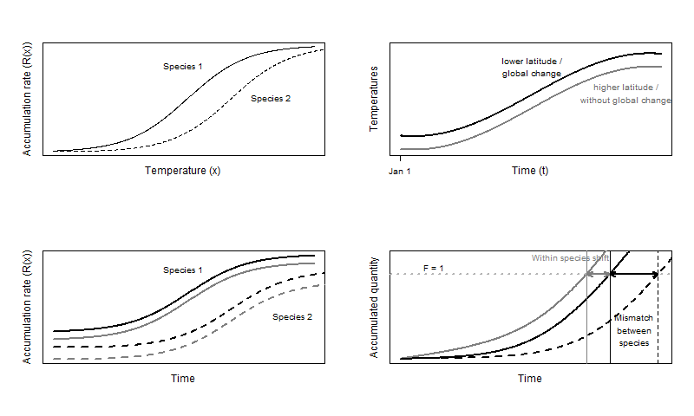

**Figure 1**: Illustration of theoretical development. Top left: The rate accumulation function for two different species (solid and dashed). Top right: two simplified temperature time series (warmer and cooler). Bottom left: Four combinations of rate accumulation; each species with two different temperature time series. Bottom right: The resulting end of the resting phase for species 1 in cooler (blue solid) and warmer (red solid) temperatures and for species 2 in cooler temperatures (blue dashed). The difference within species (blue vs red) indicates the shift in emergence in space (due to latitude or altitude) or time (due to global change). The difference between species (solid vs dashed) indicates the mismatch in the end of the seasonal resting phase for a fixed temperature regime (same location and same time).

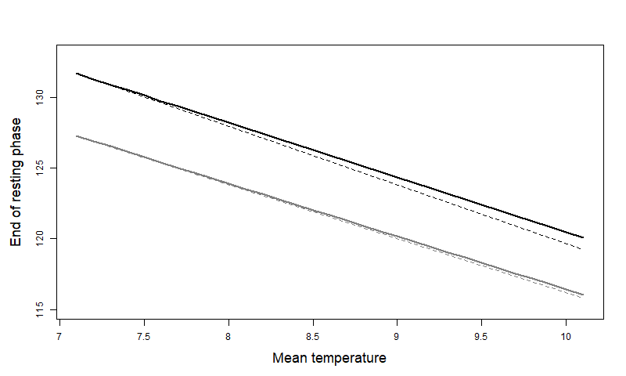

**Figure 2**: End of resting phase from the model with simple time series. Black is the insect, grey is the tree. Solid is the actual value, dashed is the linear approximation.

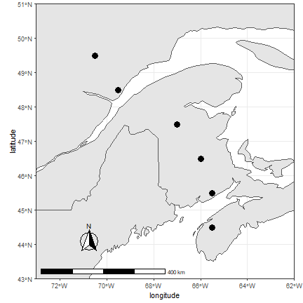

**Figure 3**: Location of the sample sites where temperature date where collected for past and future trends. Points are located across a gradient of latitude in Nova-Scotia, New Brunswick, and Quebec.

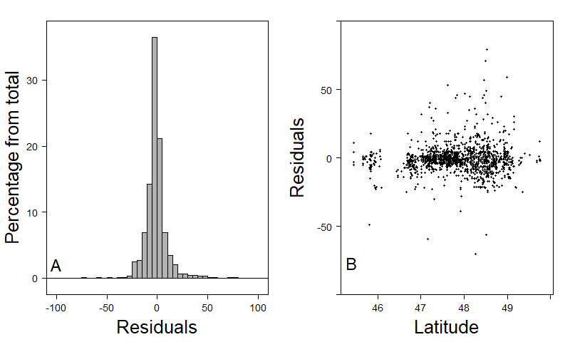

**Figure 4**: Fitting residuals of the Balsam fir model. (A) Residuals follow a Normal distribution centered on 0. (B) No obvious latitudinal patterns can be found on the residuals within the range of latitudes that is used throughout the rest of the study.

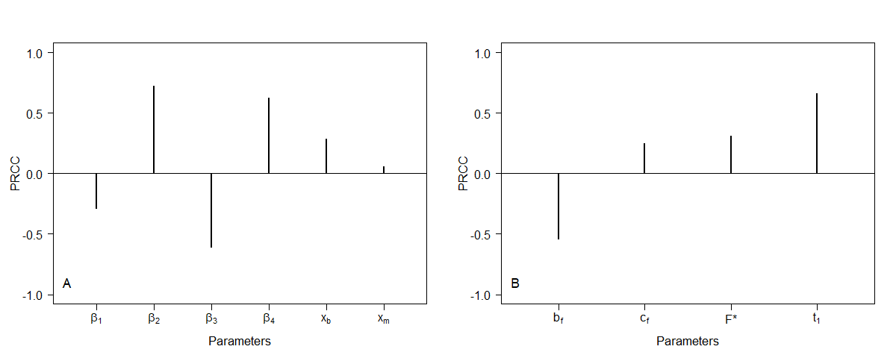

**Figure 5**: Sensitivity analysis with Partial Rank Correlation Coefficient (PRCC) for the budworm model (A) and the tree model (B). The budworm model is sensitive to most parameters especially $β_{2}$, $β_{4}$ and *xb* that delay emergence, and $β_{3}$ that hasten emergence. The tree model is mostly sensitive to *bf* that hasten budburst, and *t1* that delays budburst.

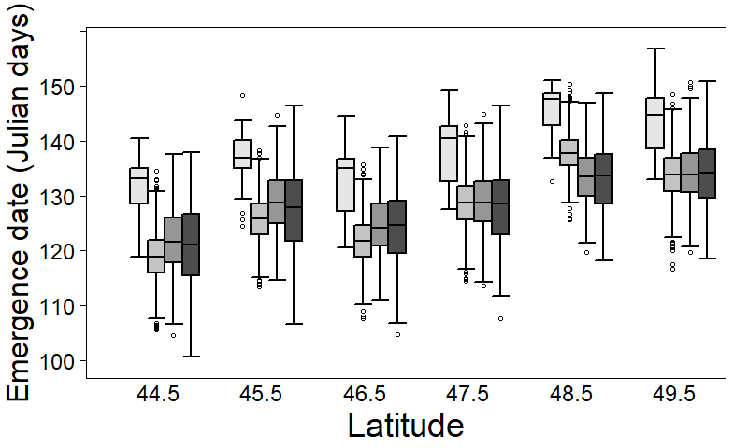

**Figure 6**: Emergence date of L2 instar. For each latitude, the white box (left one) represents budburst date from 1996-2016 period. Grey boxes represent expected budburst date according to RCP 2.6 (light grey), RCP 4.5 (dark grey), and RCP 8.5 (black) scenarios over 2021 to 2100. Emergence date from hibernaculum is expected to occur later at higher latitudes. Over all warming scenarios, emergence is expected to occur earlier in the year (from 10 to 15 days) compared to nowadays conditions. Warmer scenarios generate more variance.

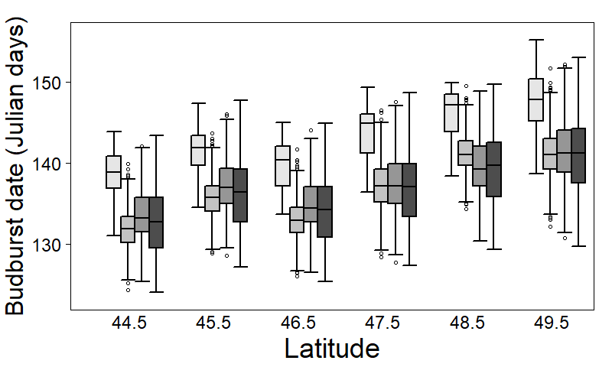

**Figure 7**: Budburst date across latitude (color legend is the same as fig. 4). Budburst is expected to occur at a later date at higher latitudes. Over all warming scenarios, budburst is expected to occur earlier in the year (from 10 to 15 days) compared to nowadays temperature conditions. However, warmer scenarios are expected to cause an increase of the variance in budburst date more than a real shift of the date compared to less warm scenarios.

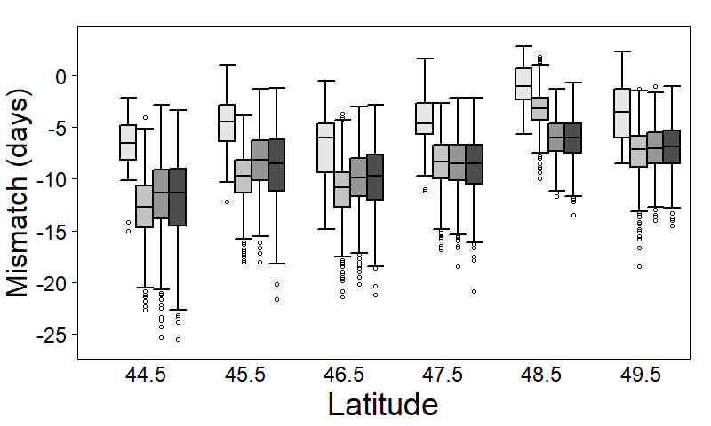

**Figure 8**: Mismatch between emergence and budburst date (color legend is the same as fig. 4). Nowadays, emergence is expected to occur 5 to 10 days before budburst at low latitudes, while at higher latitudes, emergence may sometimes occur before budburst and sometimes afterwards. For all warming scenarios, an increase in mismatch is expected. At low latitudes, emergence may occur too early some years, which may lead to low survival of L2. At higher latitudes, emergence is expected to systematically occur a few days before budburst, which would increase survival of L2.